C PROGRAM

EXPERIMENT NO:1

EXPERIMENT NAME: Generation of number series.

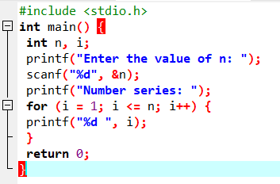

Output:

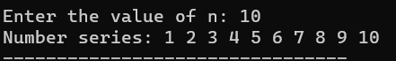

EXPERIMENT NO:2

EXPERIMENT NAME: Generation of even numbers

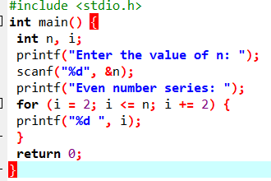

Output:



EXPERIMENT NO:3

EXPERIMENT NAME: Generation of odd numbers.

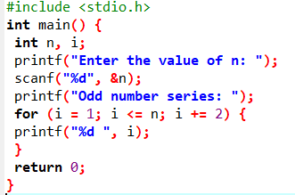

OUTPUT:



EXPERIMENT NO:4

EXPERIMENT NAME: Generation of Fibonacci series.

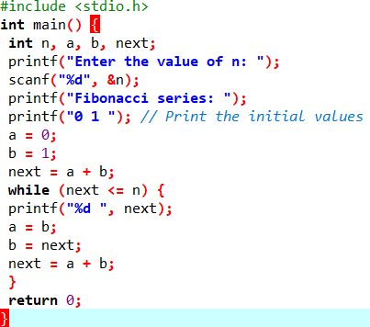

OUTPUT :

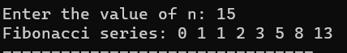

EXPERIMENT NO:5

EXPERIMENT NAME: Summing up series 1+2+3+4…n

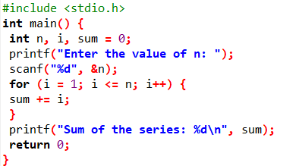

OUT PUT:



EXPERIMENT NO:6

EXPERIMENT NAME: Summing up even number series.

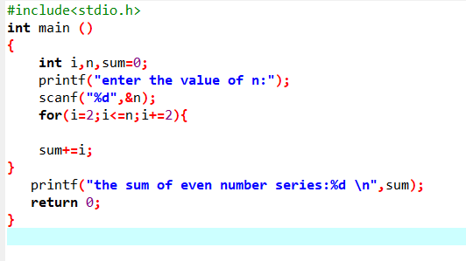

OUT PUT:

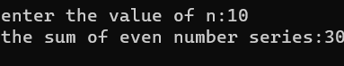

EXPERIMENT NO:7

EXPERIMENT NAME: Summing up odd number series.

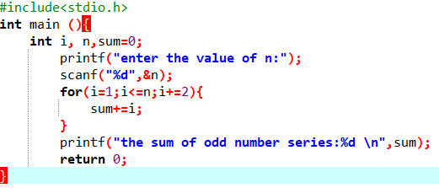

OUT PUT:

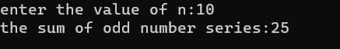

EXPERIMENT NO:8

EXPERIMENT NAME: Summing up 1 – 2 + 3 – 4 + 5…. N

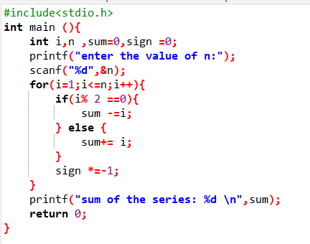

OUT PUT:



EXPERIMENT NO:9

EXPERIMENT NAME: Summing up 12 + 22 + 32 + 42….. +n

