**4.7** Given a string s, find the length of the longest substring without repeating characters.

Example 1: Input: s = "abcabcbb" Output: 3

Explanation: The answer is "abc", with the length of 3.

**AIM**  
To write a program that finds the length of the longest substring without repeating characters in a given string.

**ALGORITHM**

1. Input the string s.
2. Initialize two pointers (start, end) and a set to store unique characters.
3. Move the end pointer through the string:
4. If the character is not in the set, add it and update the maximum length.
5. If the character is already in the set, remove characters from the start pointer until it is unique again.
6. Return the maximum length found.

**PROGRAM AND OUTPUT**

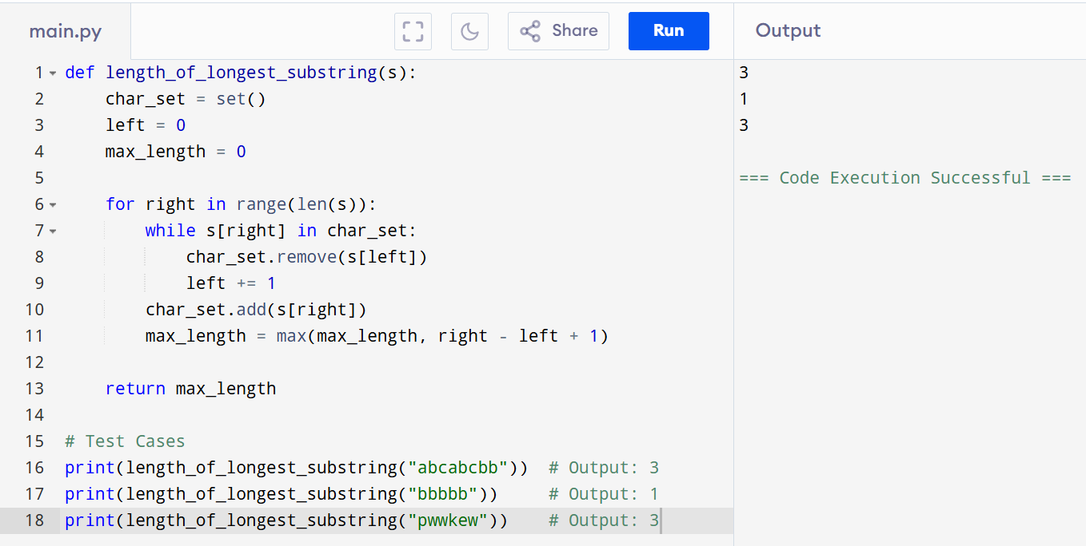

**INPUT**

s = "abcabcbb"

s = "bbbbb"

s = "pwwkew"

**RESULT**  
The program successfully calculates the length of the longest substring without repeating characters for various test cases.

**PERFORMANCE ANALYSIS**

**Time Complexity:** O(n) — each character is visited at most twice.

**Space Complexity:** O(k) — where k is the character set size (up to 128 for ASCII).