**DAY-1**

**1.Find the Square root of a number in C++ using IF-ELSE statement?**

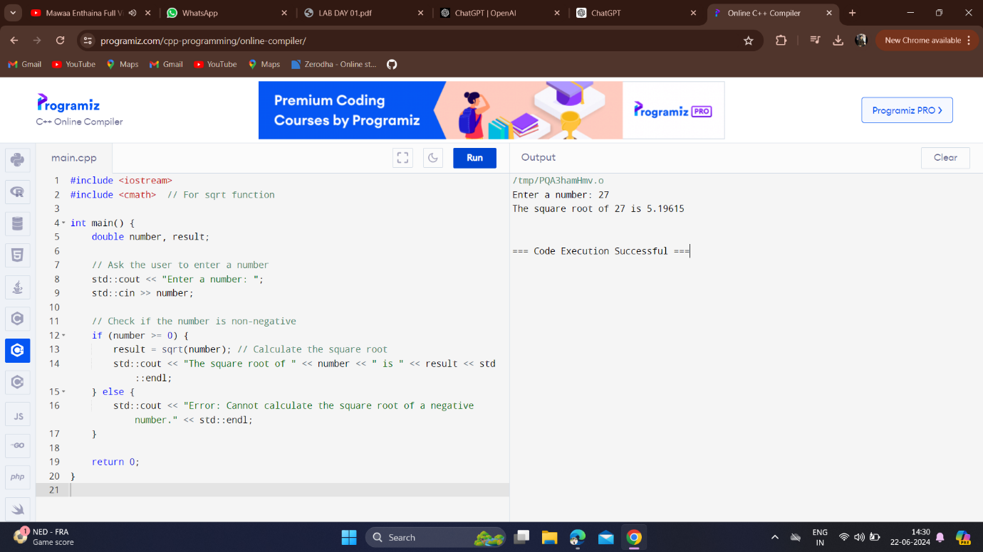

**2.Find the Cube root of a number in in C++ using any conditional statements?**

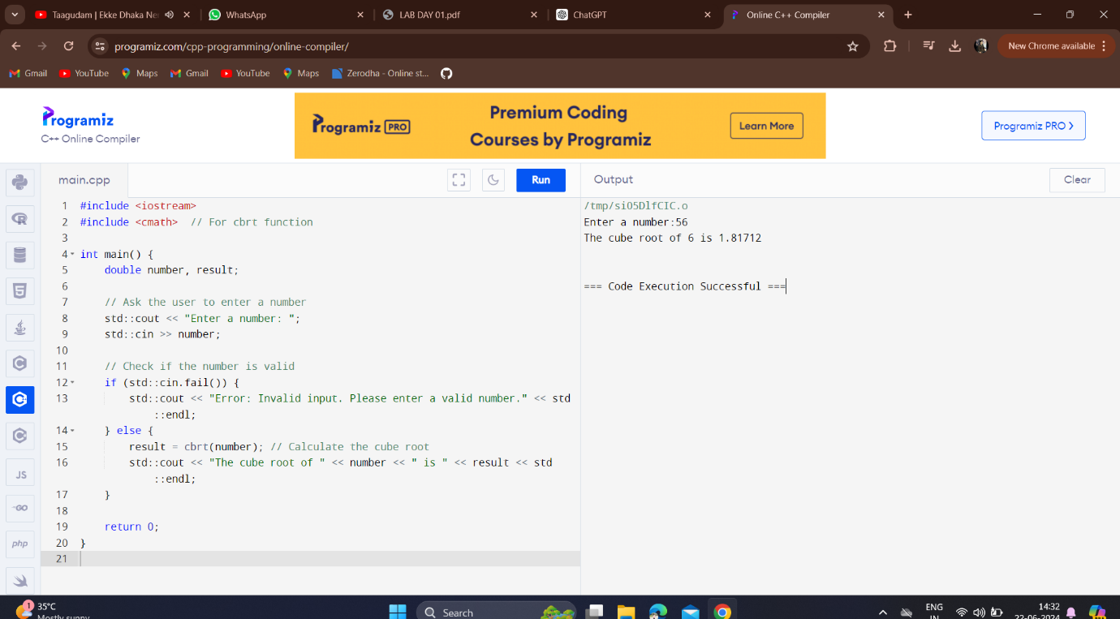

**3.Write a C++ program to check if a number is perfect or not using IF condition?**

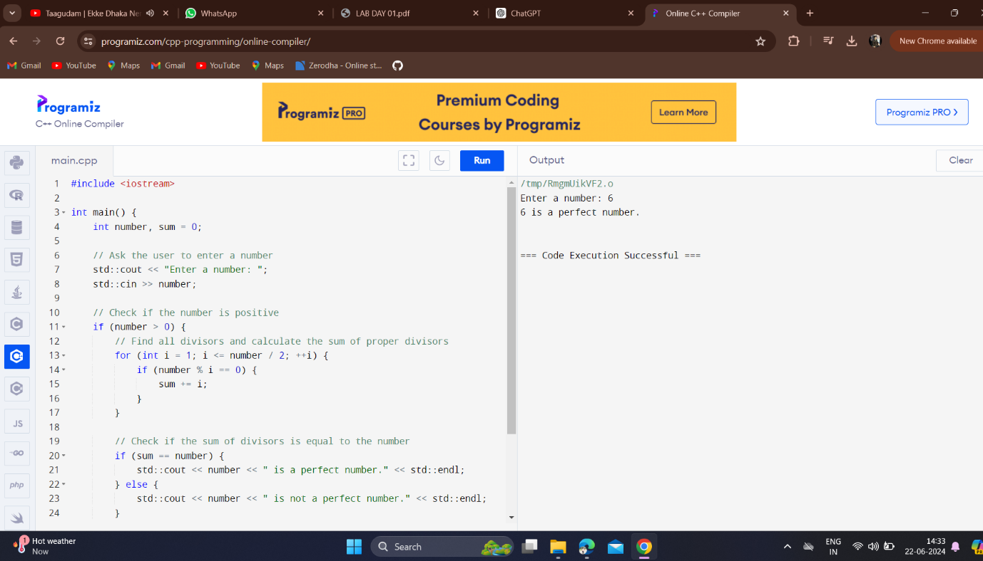

**4.Write a C++ program to check if a number is perfect or not using IF-ELSE condition?** 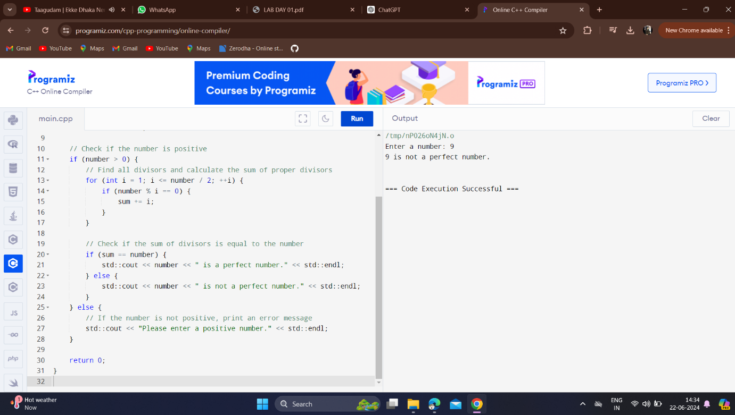

**5.Write a C++ program to find the smallest element missing in a sorted array using WHILE loop?** 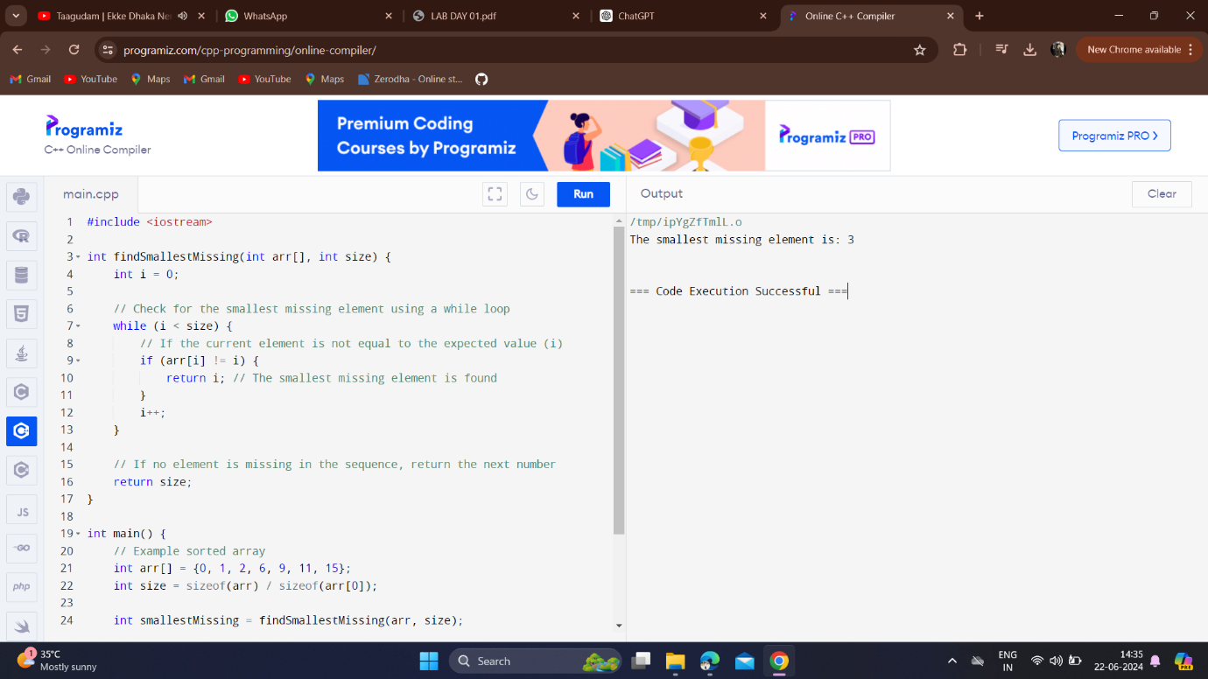

**6. Write a program in C++ to find the sum of n natural numbers using FOR loop?**

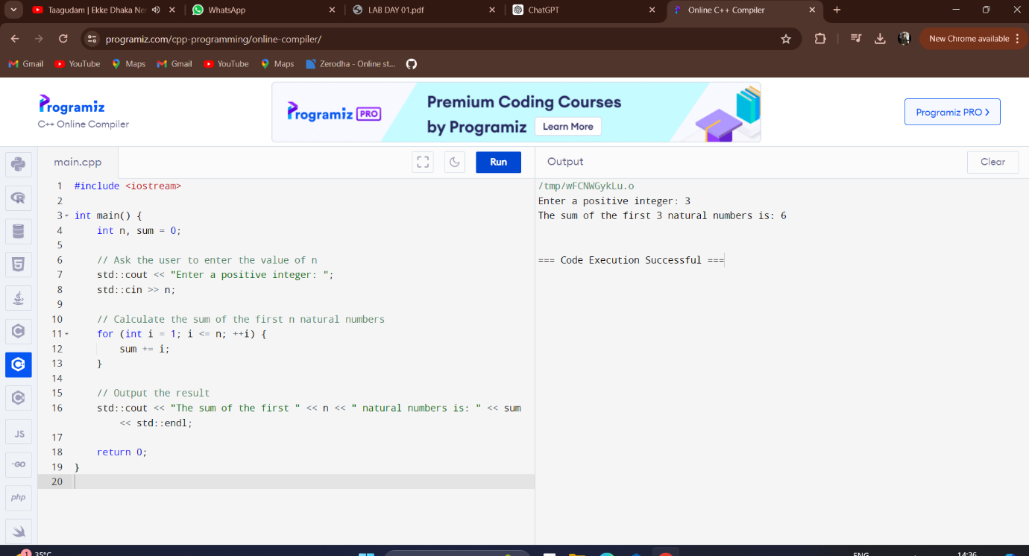

**7. Write a program in C++ to find the sum of n natural numbers using WHILE loop?**

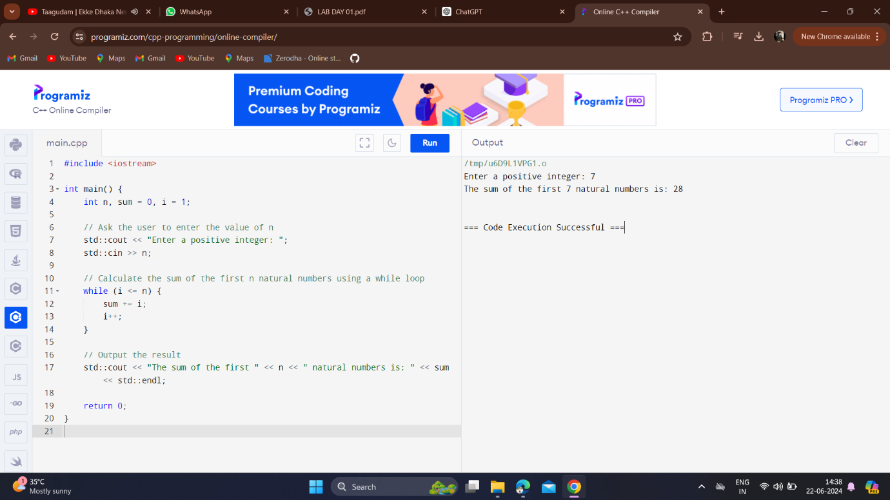

**8. Write a program in C++ to find the sum of n natural numbers using DO WHILE loop?**

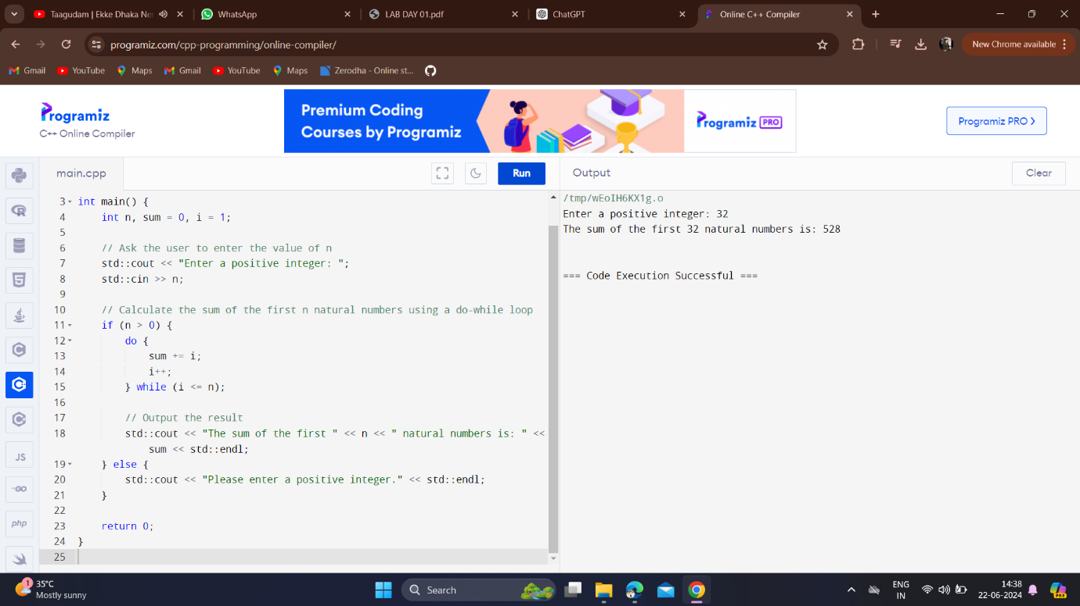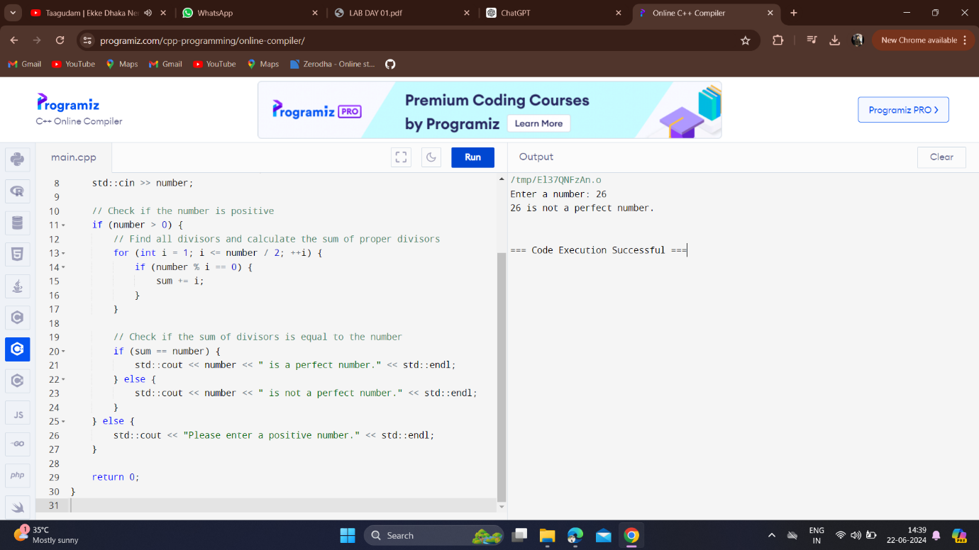

**9.Write a C++ program to check if a number is perfect or not using FOR LOOP condition?** 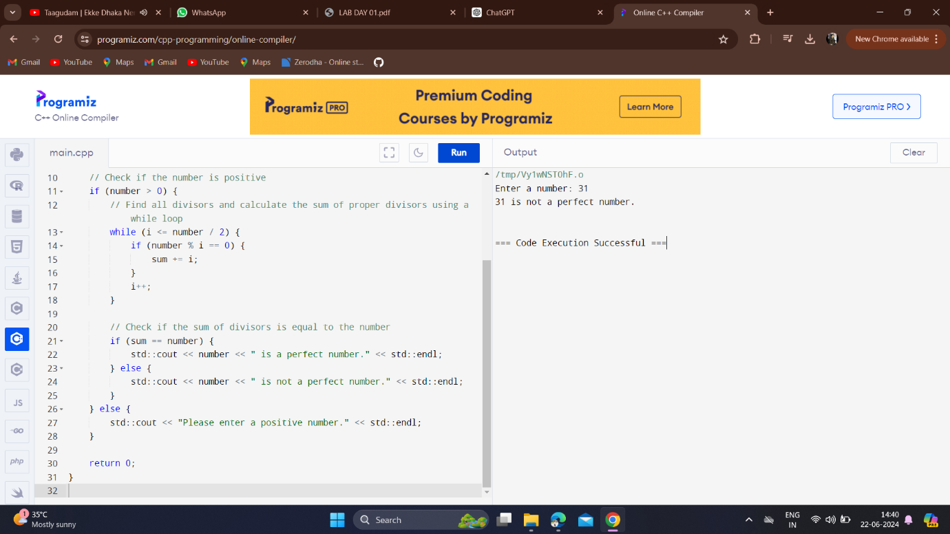

**10.Write a C++ program to check if a number is perfect or not using WHILE condition?**

