**DAY-2**

**EASY:**

**1.Develop a C++ program for default arguments.**

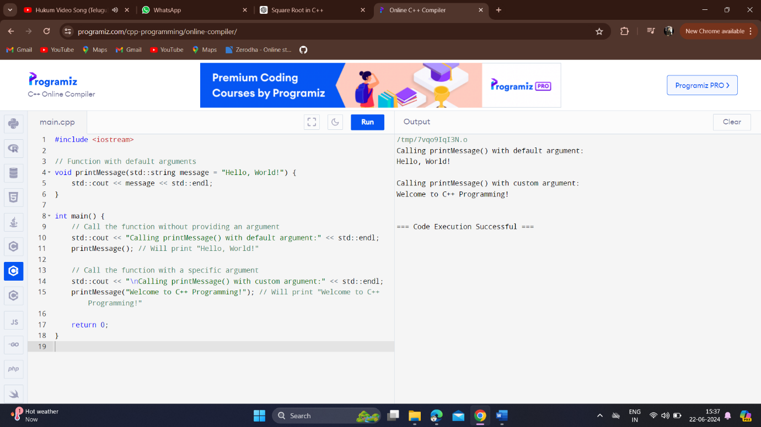

**2.Develop a program to check the entered user name is valid or not using function. Get both the inputs from the user**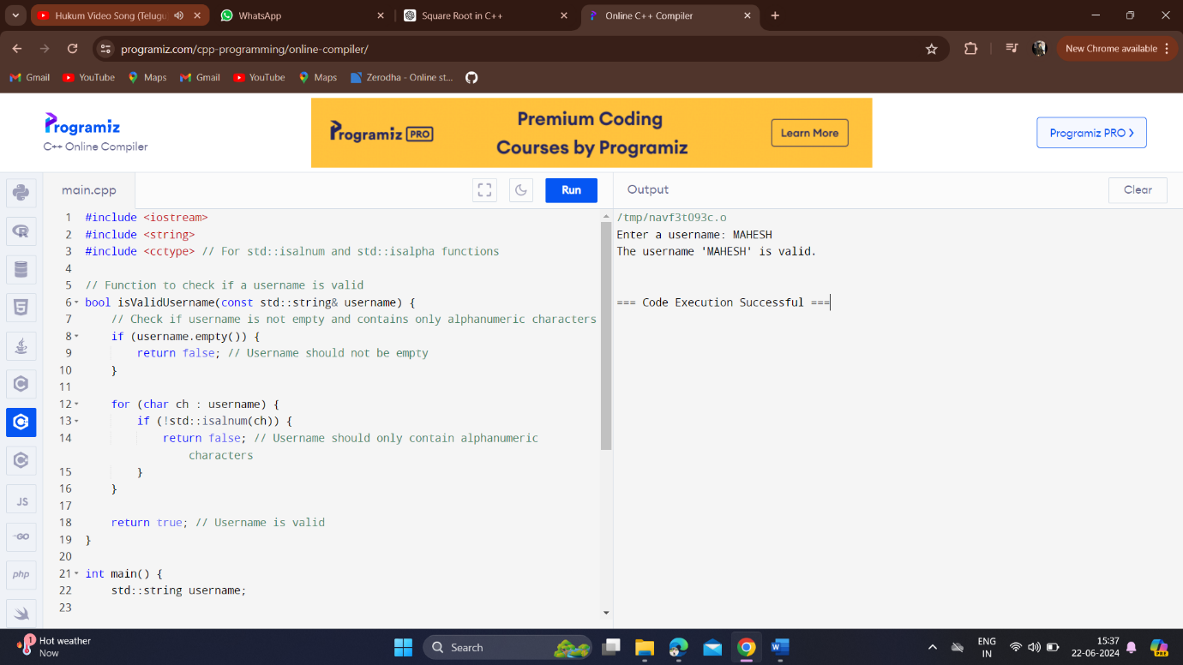

**3.Develop a program to find whether the person is eligible for vote or not. And if that particular person is not eligible, then print how many years are left to be eligible.**

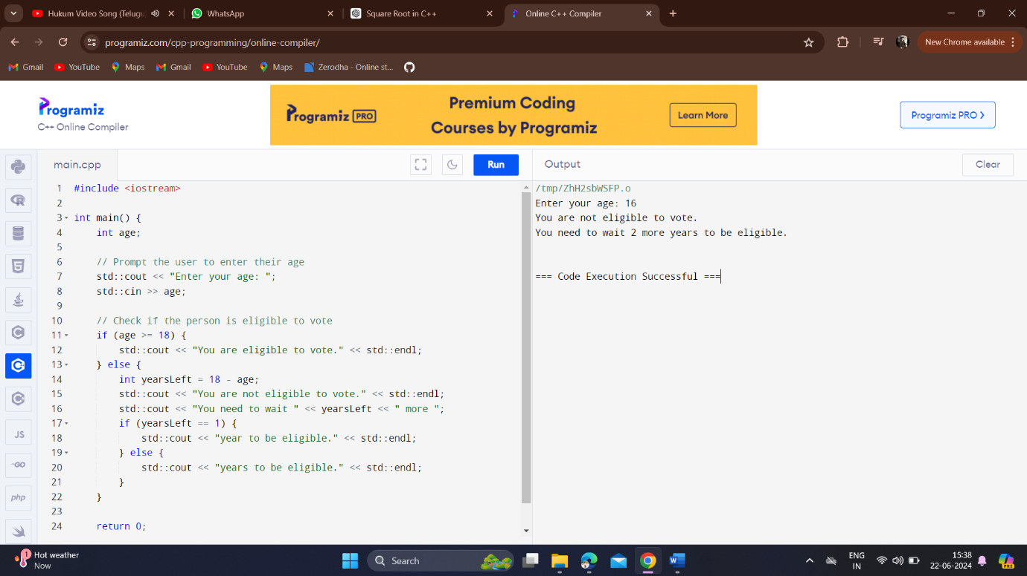

**4.Develop a program using function to calculate the simple interest. Suppose the customer is a senior citizen. He is being offered 12 percent rate of interest; for all other customers, the ROI is 10 percent**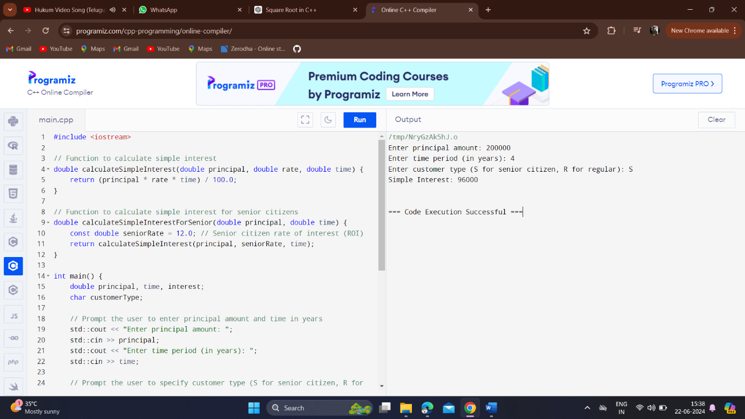

**5.Develop a program using choice to check given string in palindrome or not using inline function.**

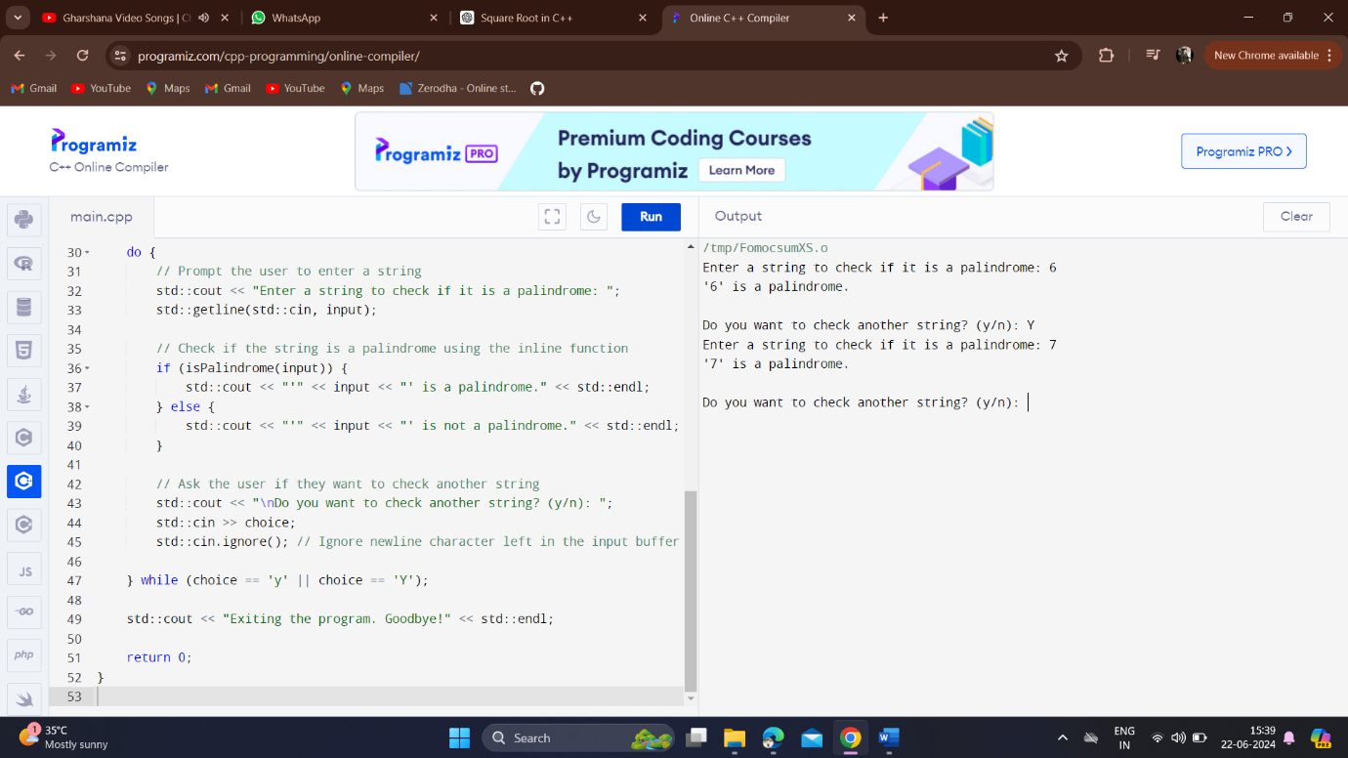

**MEDIUM:**

**1.Develop a C++ program for adding the number using function overloading concept**

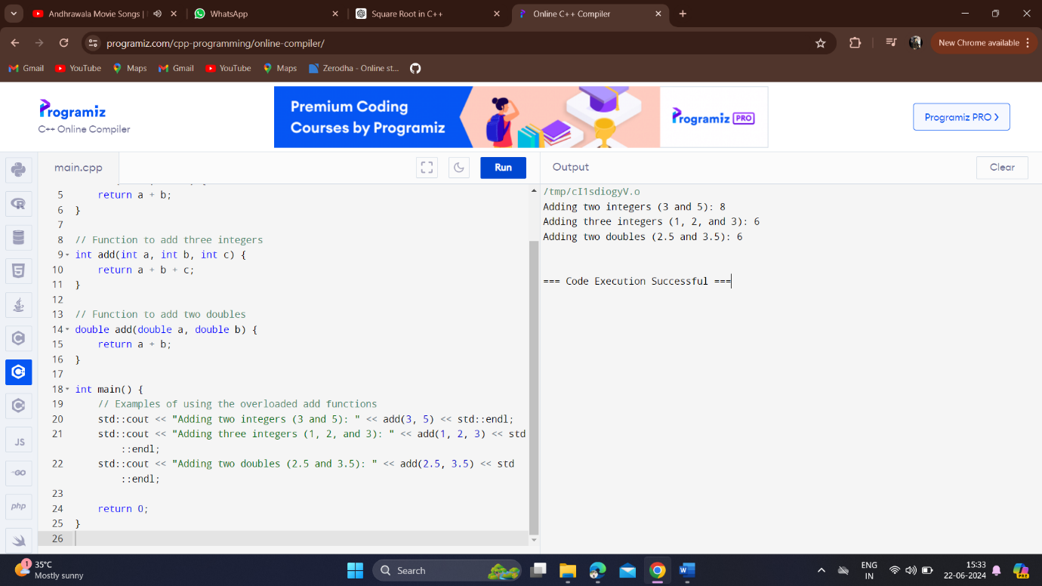

**2.Declare a class box, with length (Public variable) and width (Private variable) use set width () and get width () function to set the width and print the length and width.**

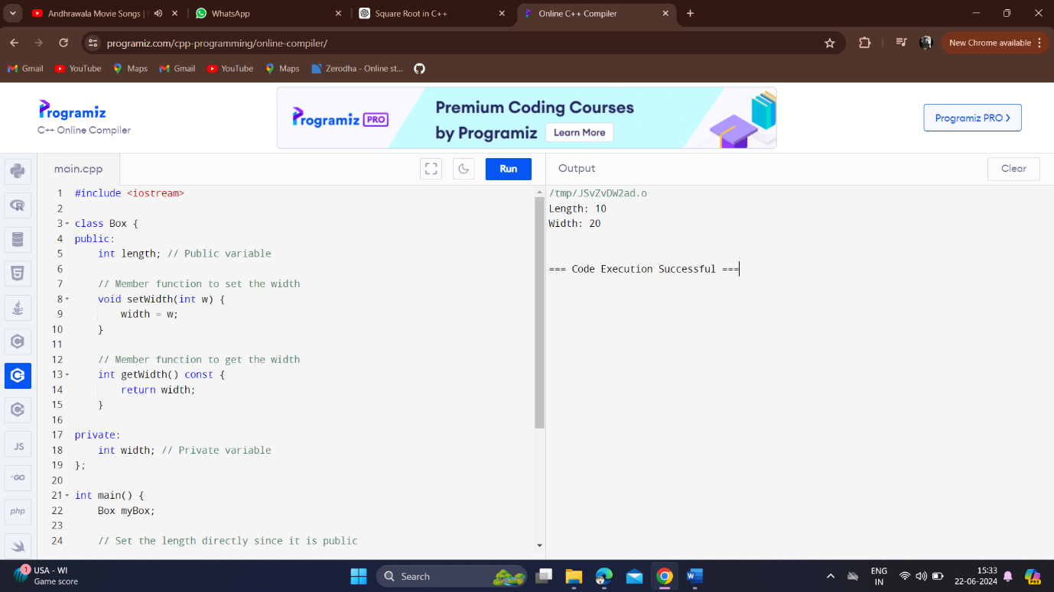

**3.Develop a C++ program for matrix multiplication using arrays.**

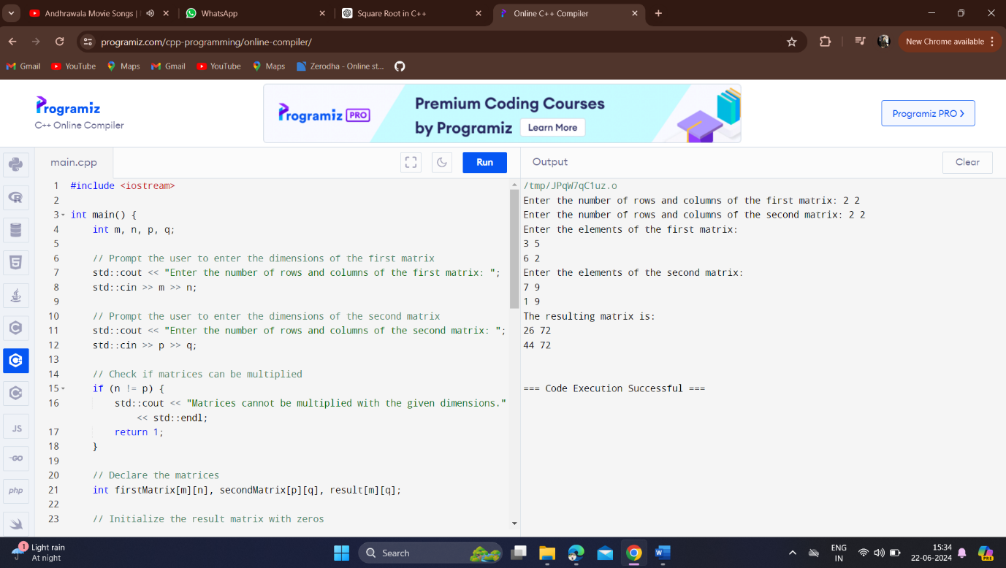

**4.Develop a simple program for static field to count the number of objects created using C++.**

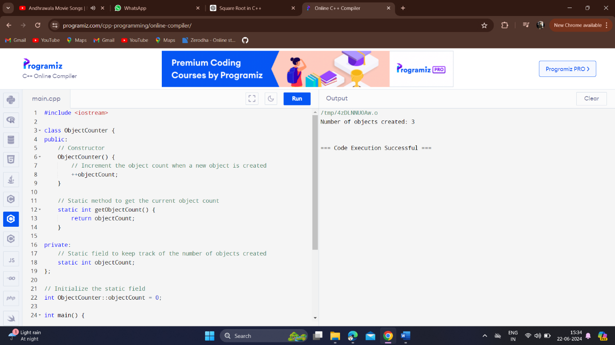

**HARD:**

**1.Develop a C++ program to demonstrate call by value and call by reference mechanism for swapping of number.**

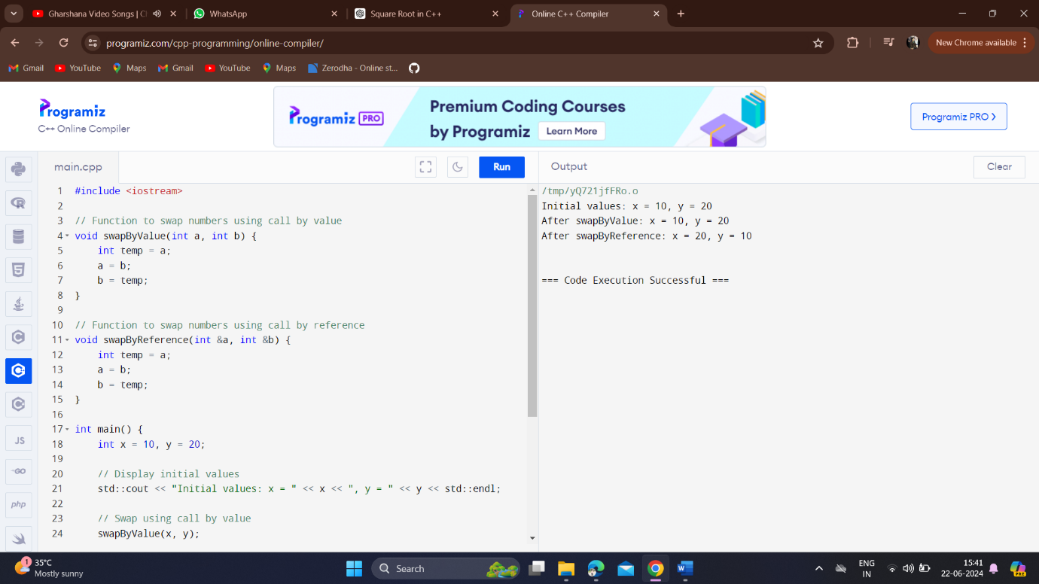

**2.Build a class series and use member function input () for getting a number and member function show () to print Fibonacci series of a number.**

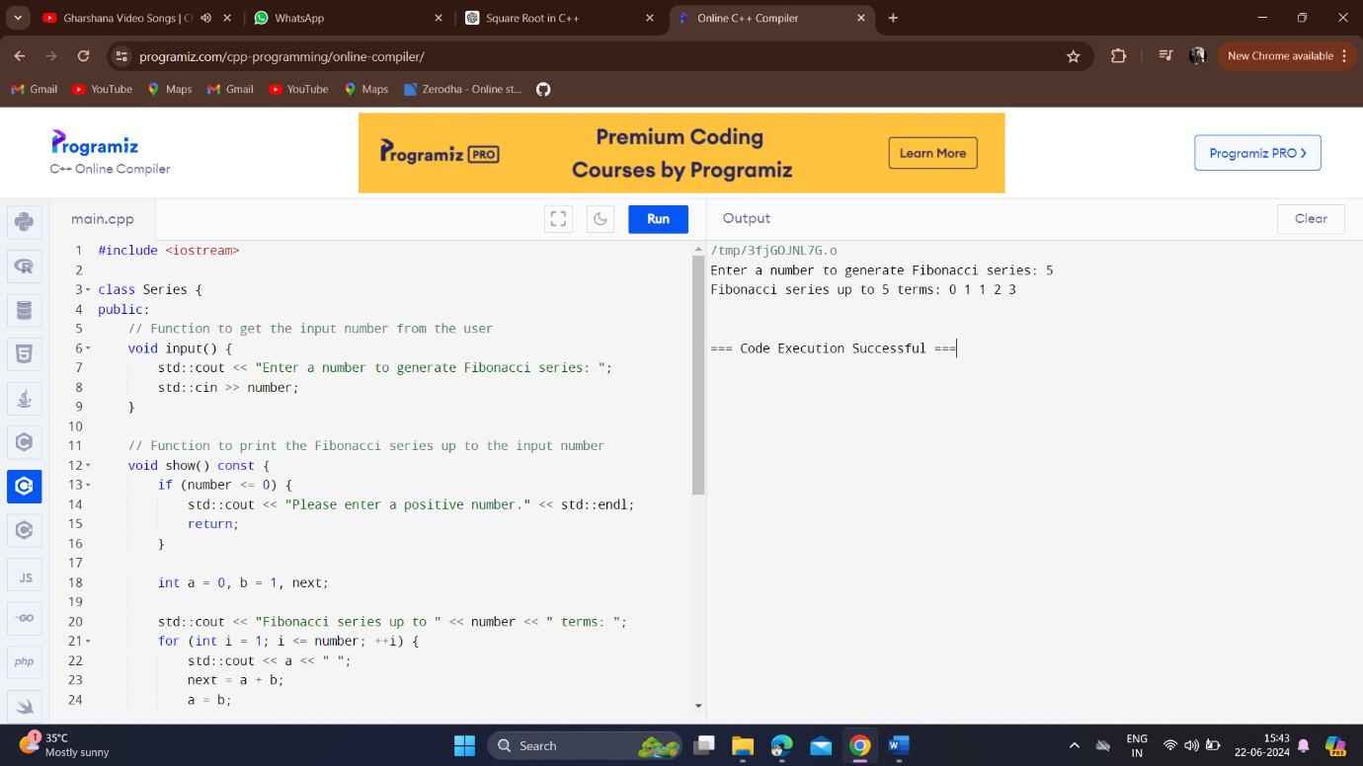

**3.Develop a class in C++ program to compute a record of 10 students, Read the name, Regno, mark1, mark2, mark3 of the student, calculate the average marks and grade for to display it.**

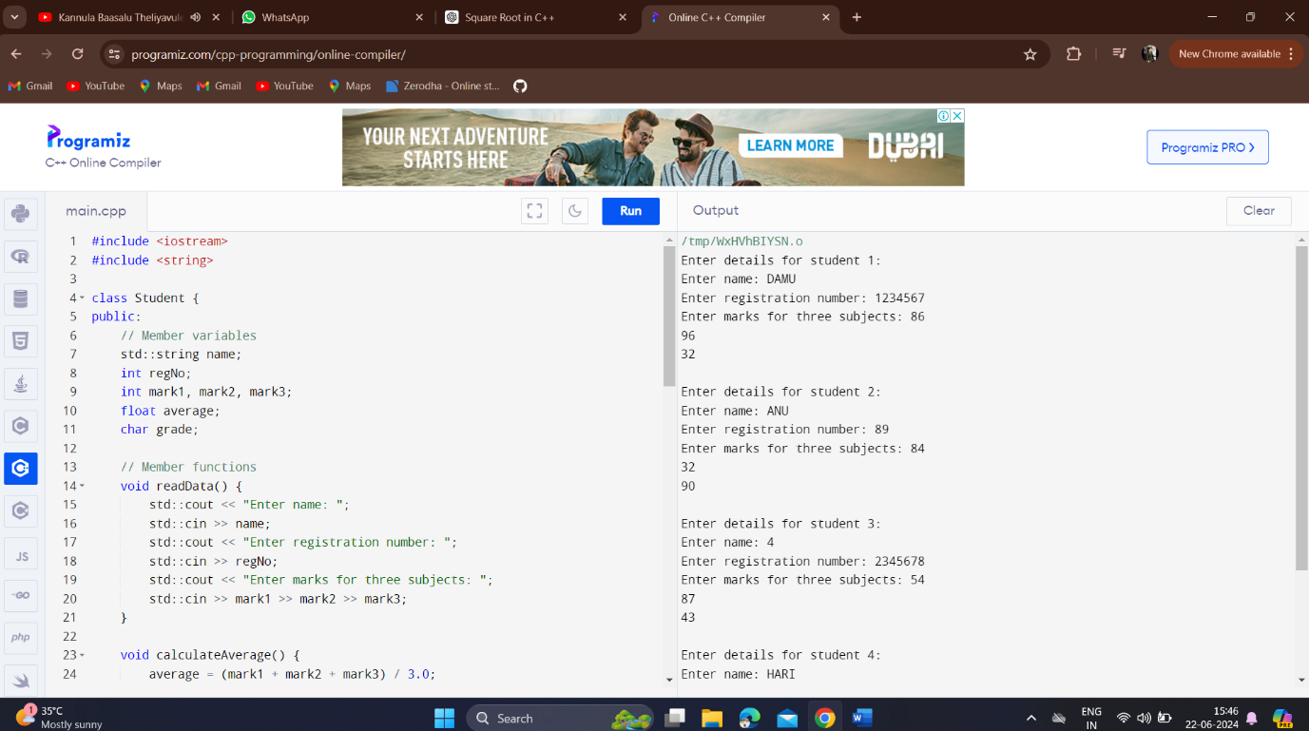

**4.Develop a Program for binary operator overloading in C++**

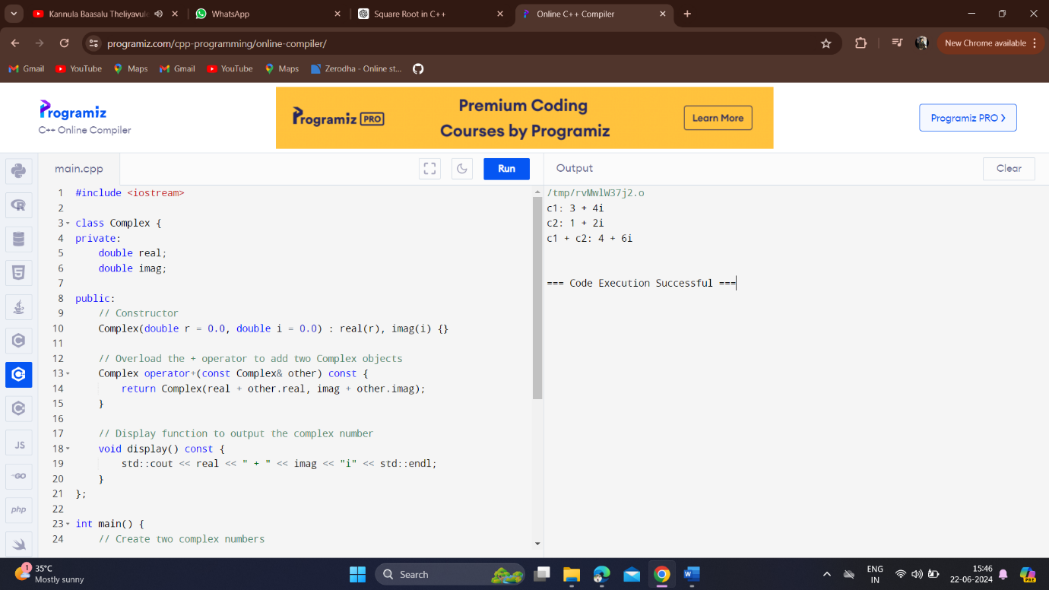

**5.Develop a Program in C++ to calculate income tax for the employee based on the following condition**

