**DAY-3**

**EASY:**

**Write C++ Program to display the cube of the number up to a given integer using Destructor**

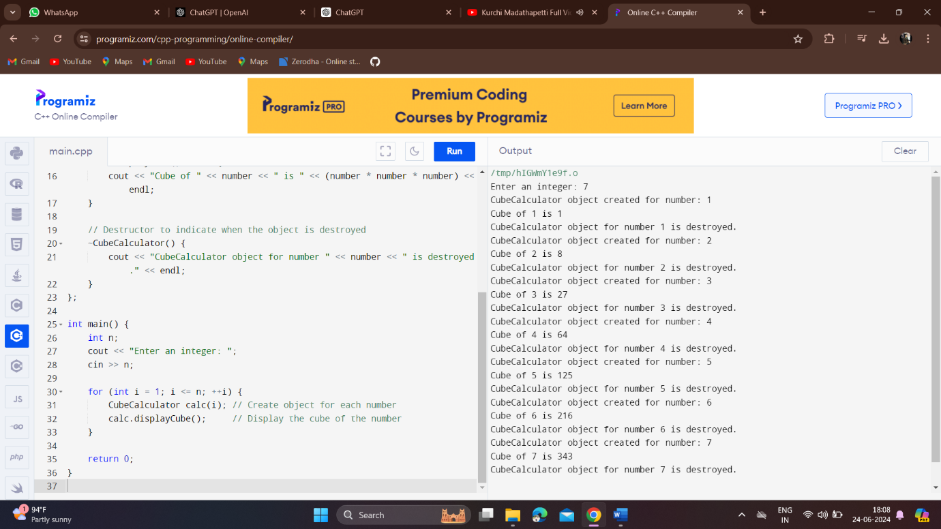

**Write C++ Program to display the cube of the number up to a given integer using constructor overloading**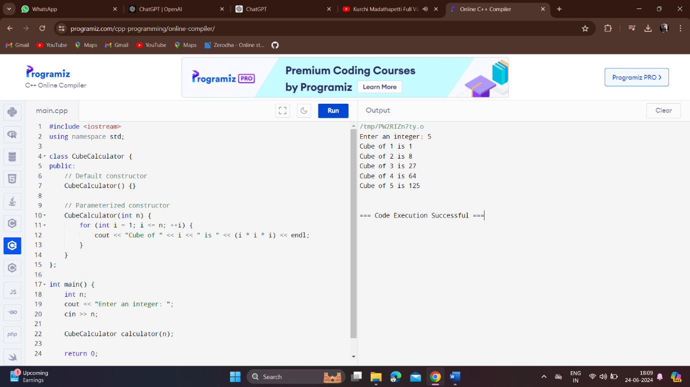

**Write a program in C++ to find the sum of the series using the constructor overloading.**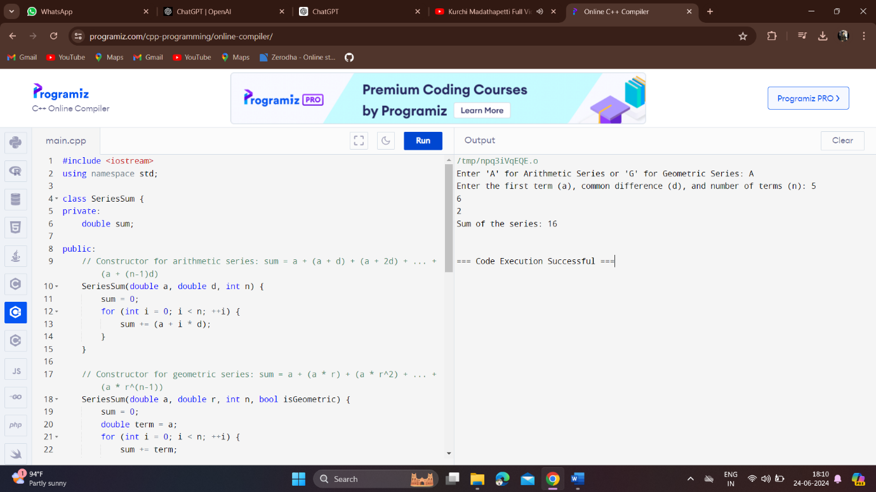

. **Write a program in C++ to print a pattern of right-angle triangle with a number that will repeat a number in the row by using the constructor overloading**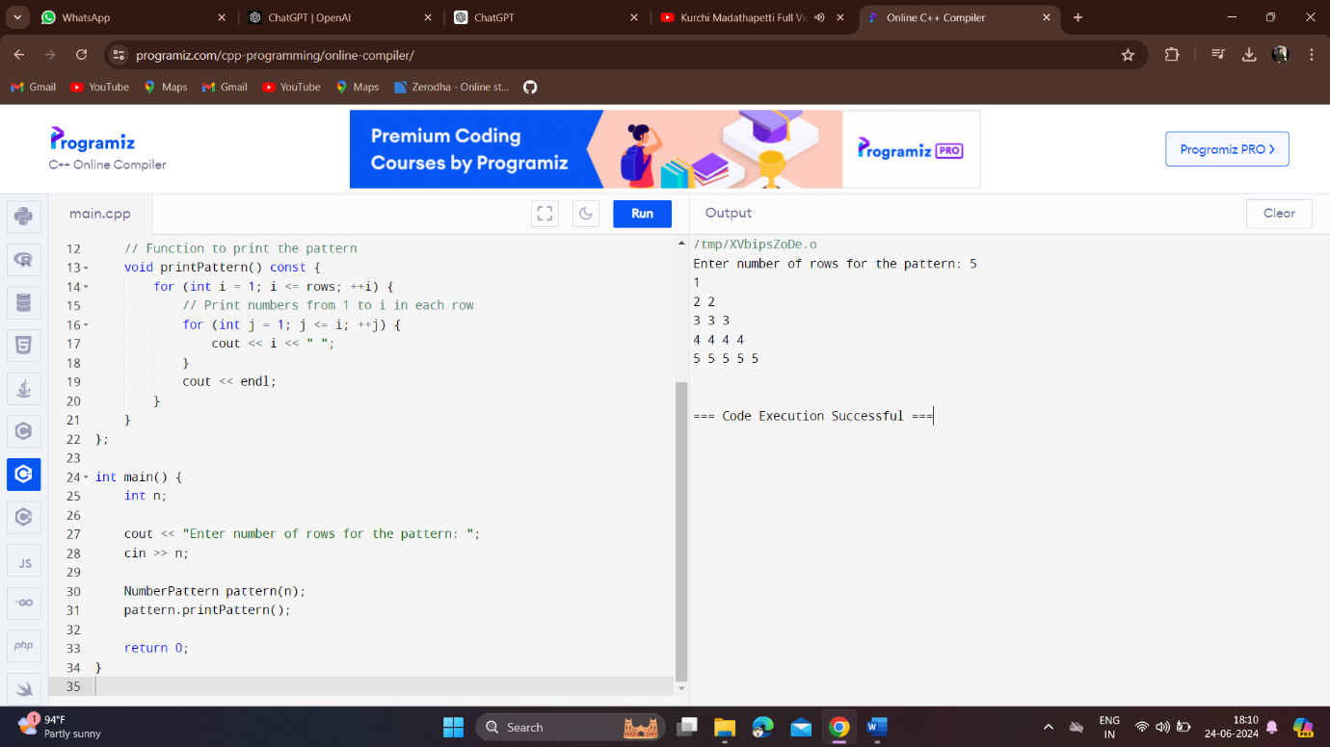

**Write a C++ Program to display the reverse of a number using the constructor overloading**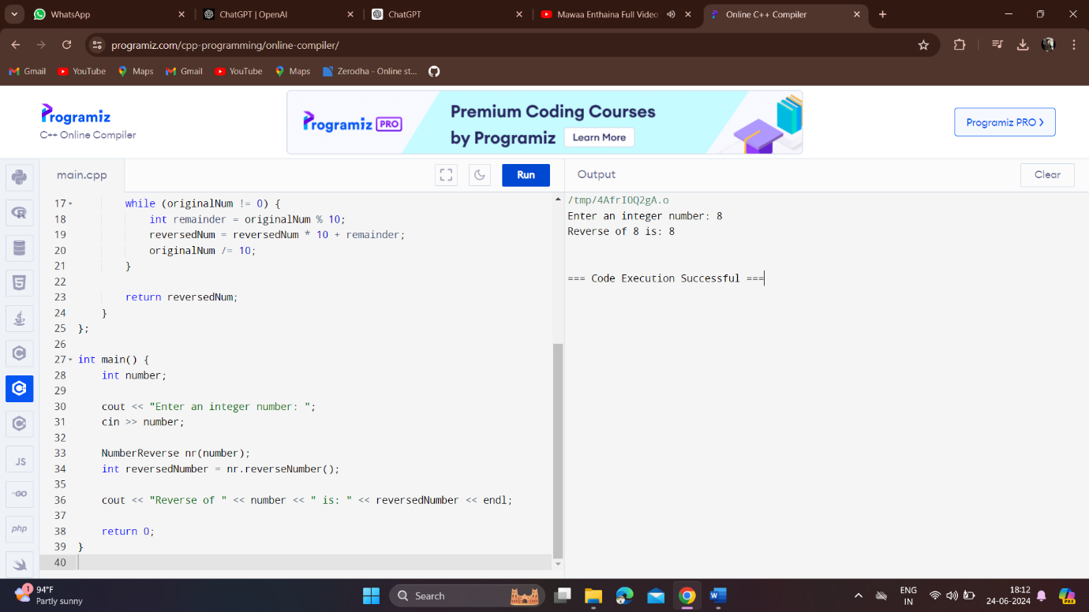

**MEDIUM:**

. **Write a program to find area of Circle, Rectangle and Triangle using constructor overloading.**

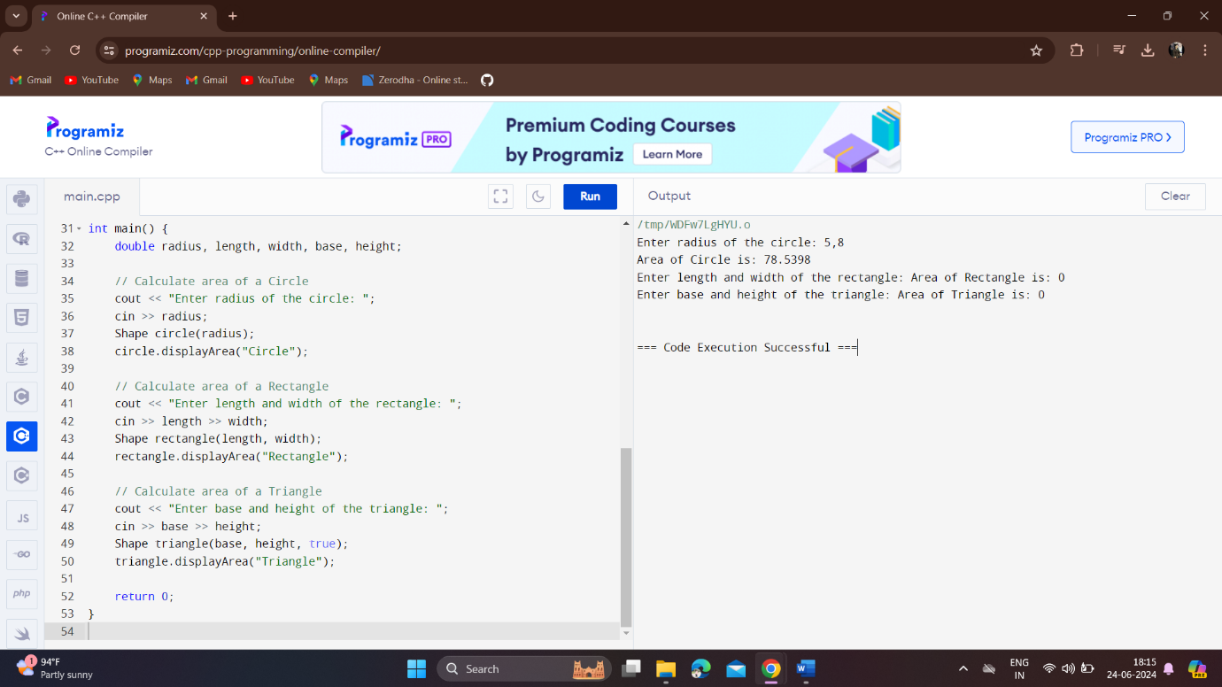

**Write a program to find Cube, Cylinder using constructor overloading**

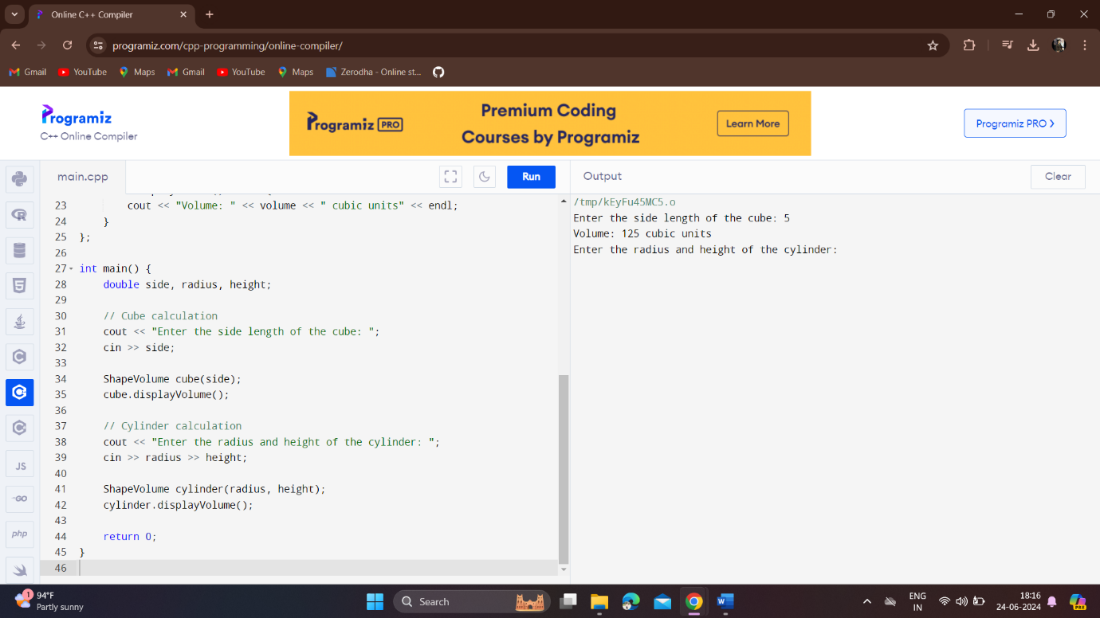

**Write a program to declare the constructor inside the class, and then define it outside of the class by specifying the name of the class.**

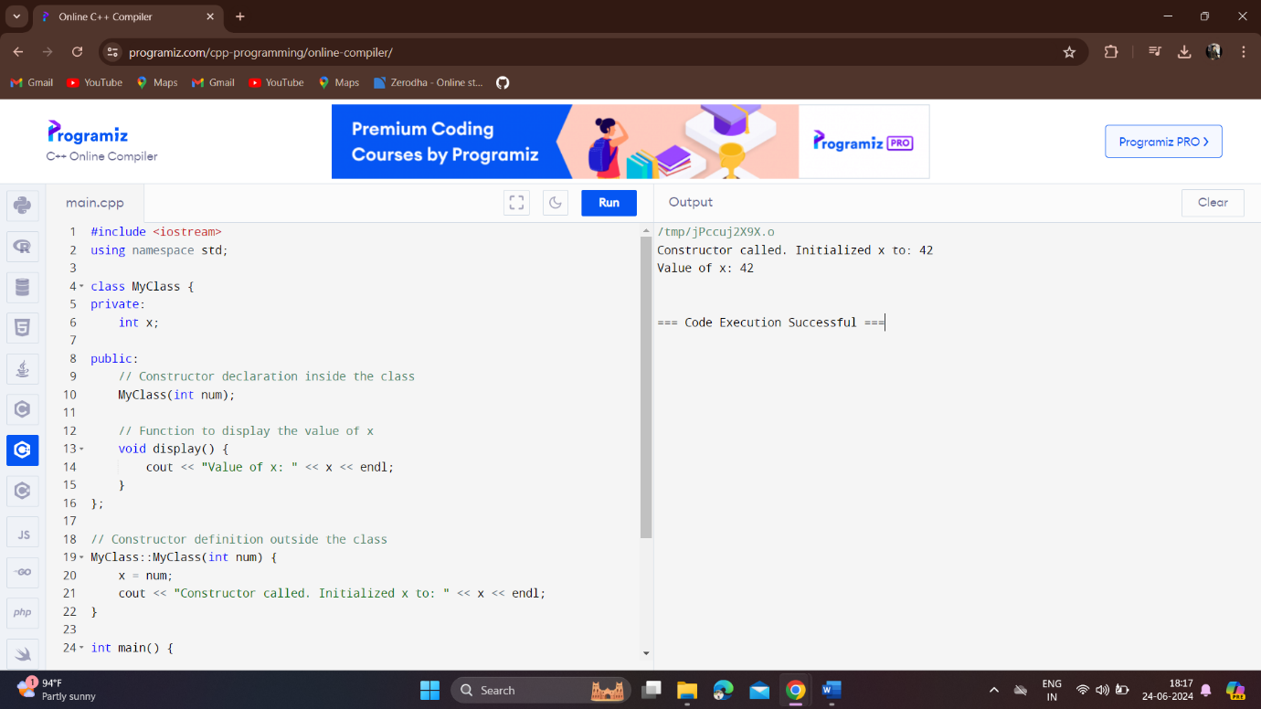

**Write a program in C++ to print Floyd’s Triangle by using the constructor destructor**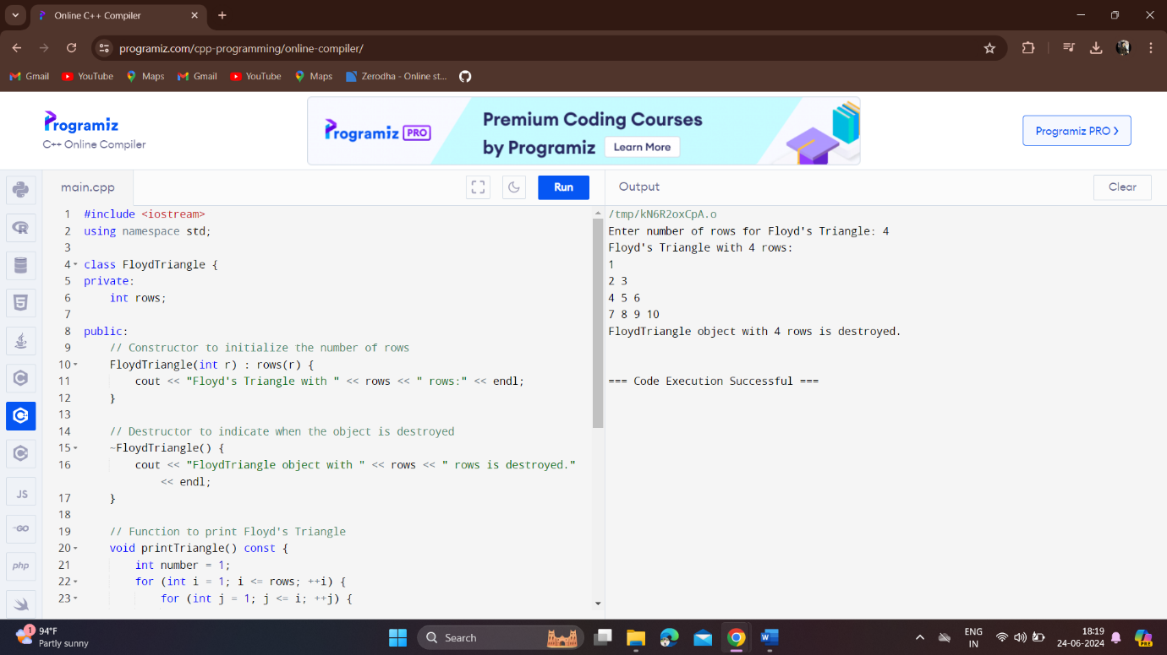

**Write a program in C++ to convert a decimal number into binary without using an array by using the constructor overloading.**

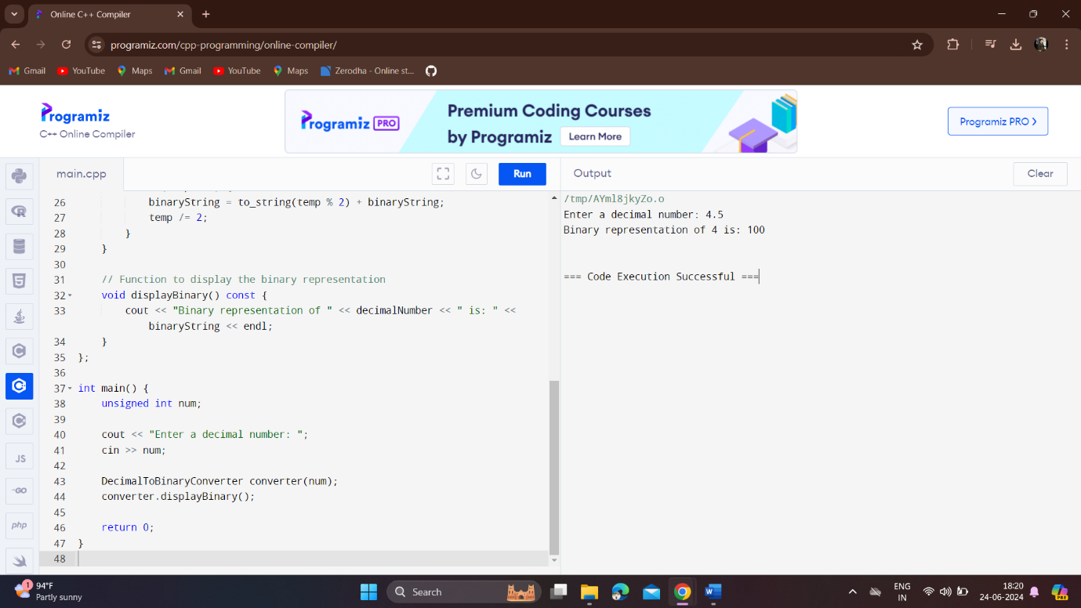

**HARD:**

**Write a program to print the names of students by creating a Student class. If no name is passed while creating an object of the Student class, then the name should be "Unknown", otherwise the name should be equal to the String value passed while creating the object of the Student class.**

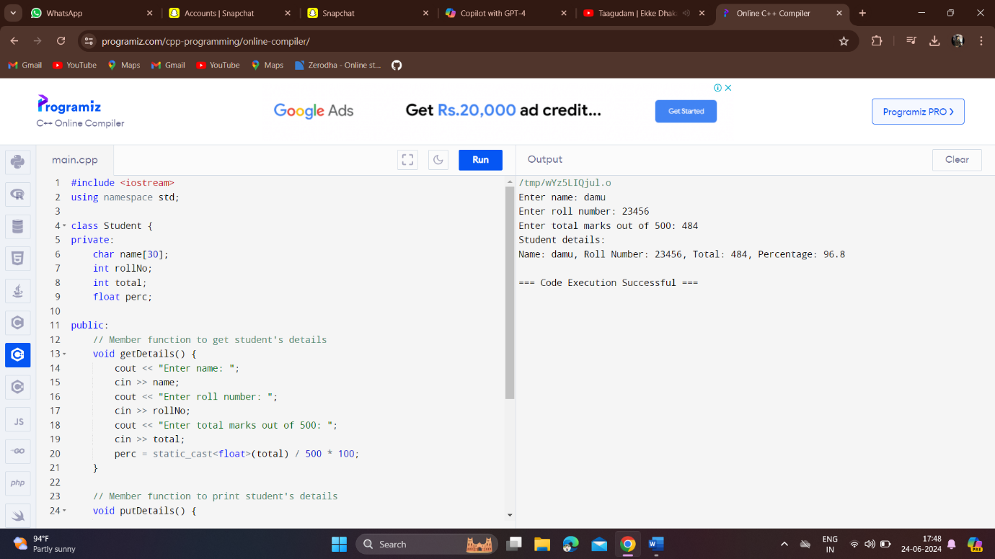

. **Create a class named 'Rectangle' with two data members- length and breadth and a function to calculate the area which is 'length*breadth'. The class has three constructors which are:**

1. **1 - Having no parameter - values of both length and breadth are assigned zero.**
2. **2 - Having two numbers as parameters - the two numbers are assigned as length and breadth respectively.**
3. **3 - Having one number as parameter - both length and breadth are assigned that number.**

**Now, create objects of the 'Rectangle' class having none, one and two parameters and print their areas.**

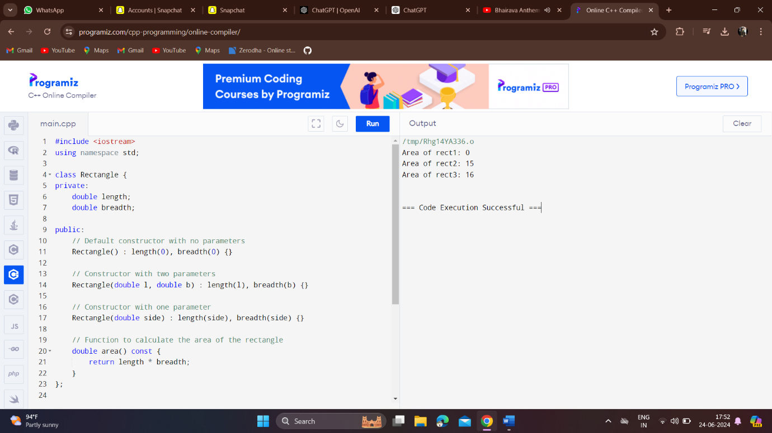

**Suppose you have a Piggie Bank with an initial amount of $50 and you have to add some more amounts to it. Create a class 'AddAmount' with a data member named 'amount' with an initial value of $50. Now make two constructors of this class as follows:**

**1 - without any parameter - no amount will be added to the Piggie Bank**

**2 - having a parameter which is the amount that will be added to the Piggie Bank**

**Create an object of the 'AddAmount' class and display the final amount in the Piggie Bank.**

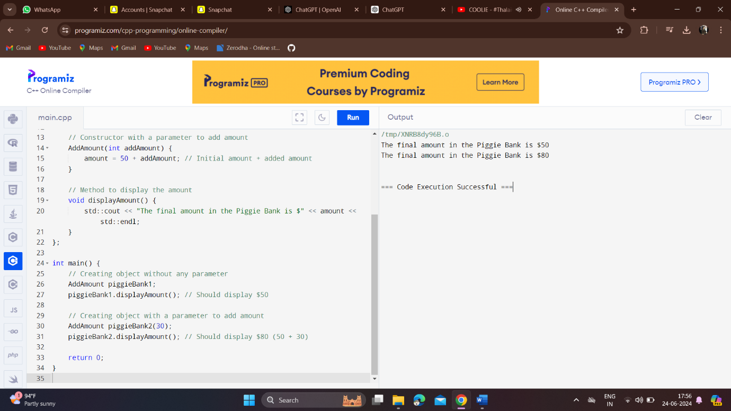

**Create a class to print the area of a square and a rectangle. The class has two functions with the same name but different number of parameters. The function for printing the area of rectangle has two parameters which are its length and breadth respectively while the other function for printing the area of square has one parameter which is the side of the square.**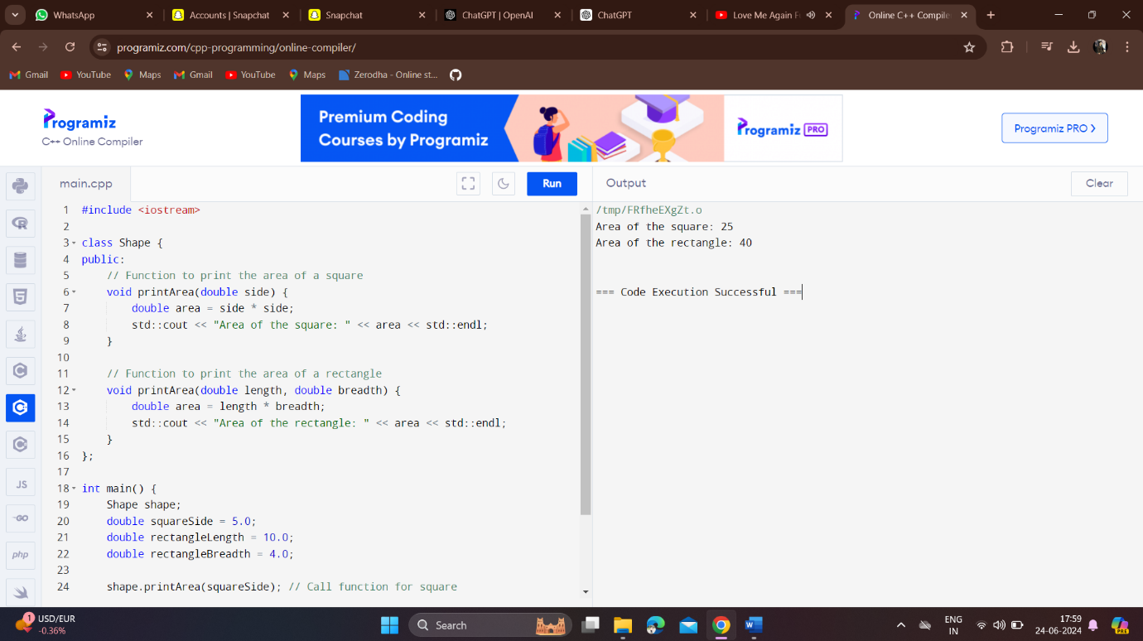

. **Create a class called add for addition of two numbers using operator overloading**