**ASSIGNMENT-1**

1.Write a program to print all the Non-Prime numbers between A and B? Sample Input: A = 12 B = 19

Sample Output:

14, 15, 16, 18

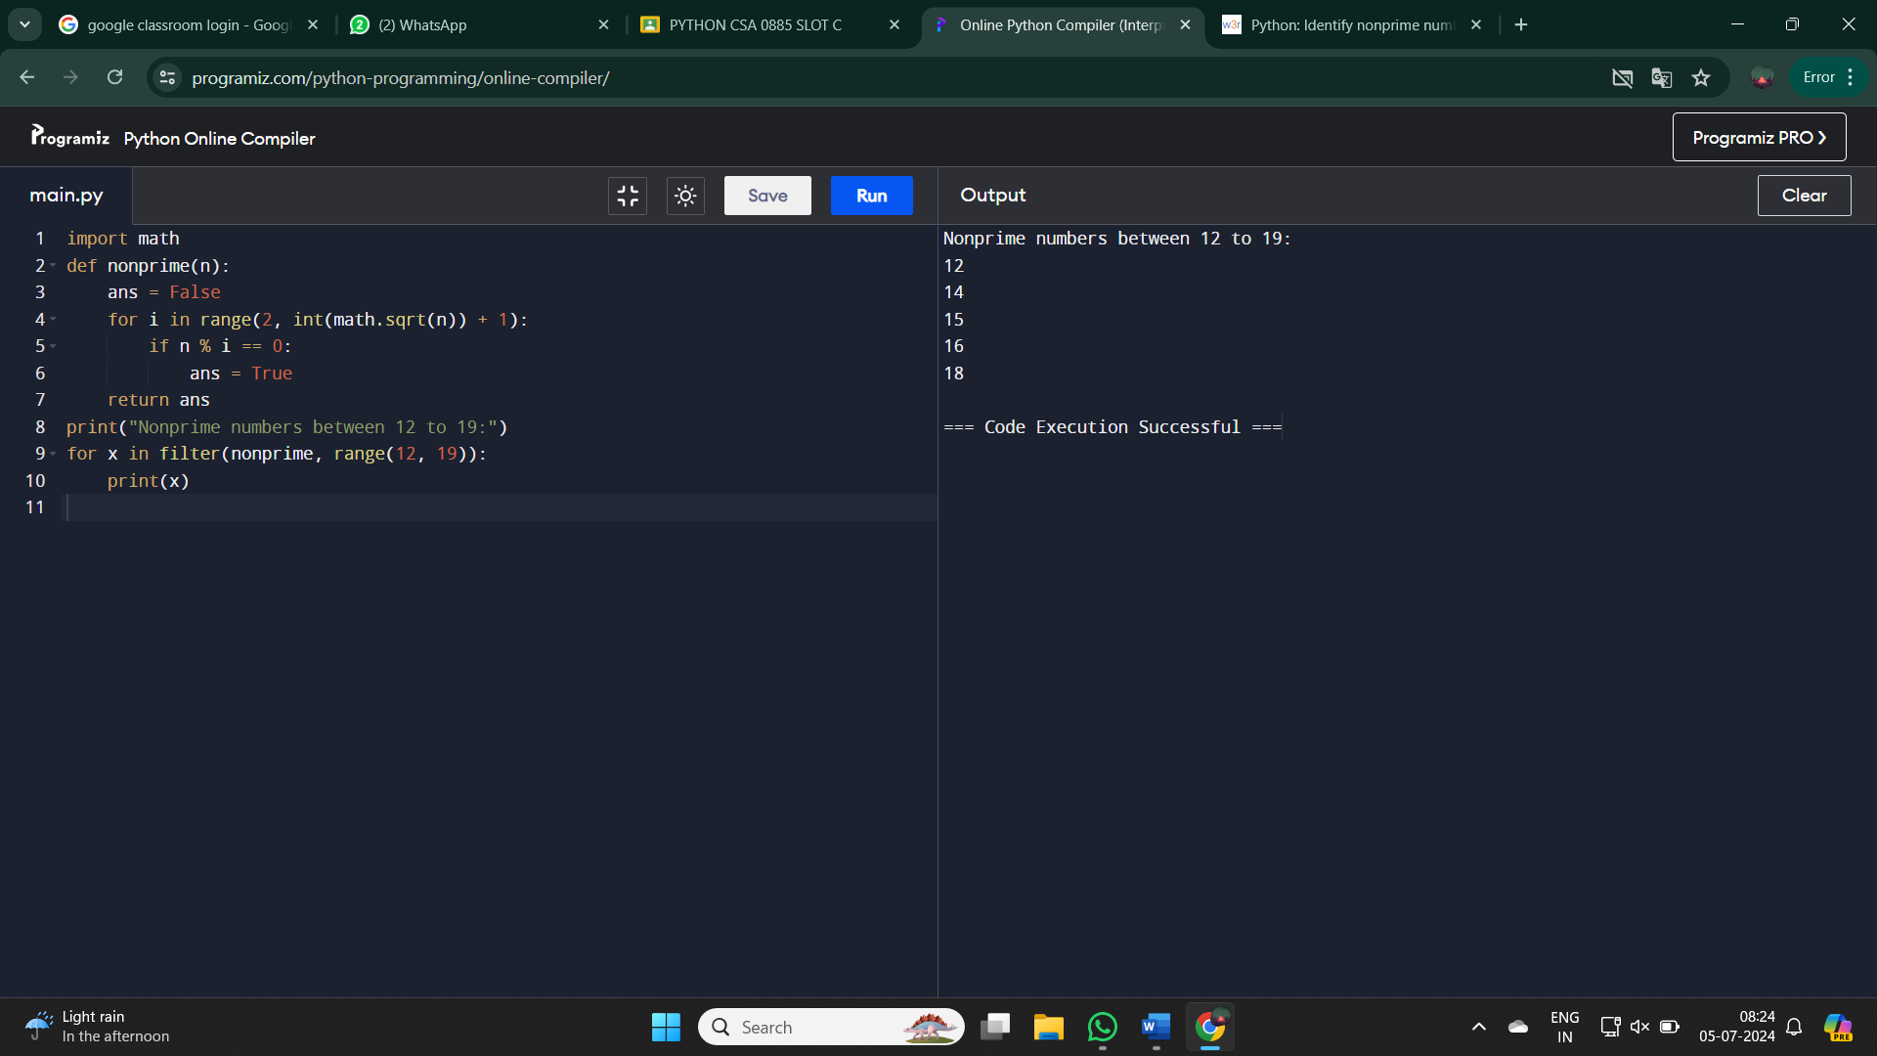

2. Find the year of the given Anniversary is leap year or not. If leap year then print the next Anniversary, if not leap year then print the previous Anniversary.

Sample Input:

Enter Date: 04/11/1947 Sample Output:

Given Anniversary Year: Non Leap Year. Anniversary Date: 04/11/1946

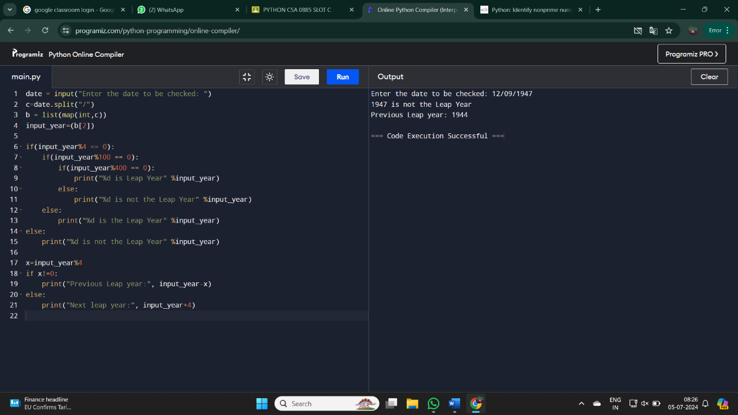

3.Write a program to print the given number is Perfect number or not?

Sample Input: Given Number: 6

Sample Output: Its a Perfect Number

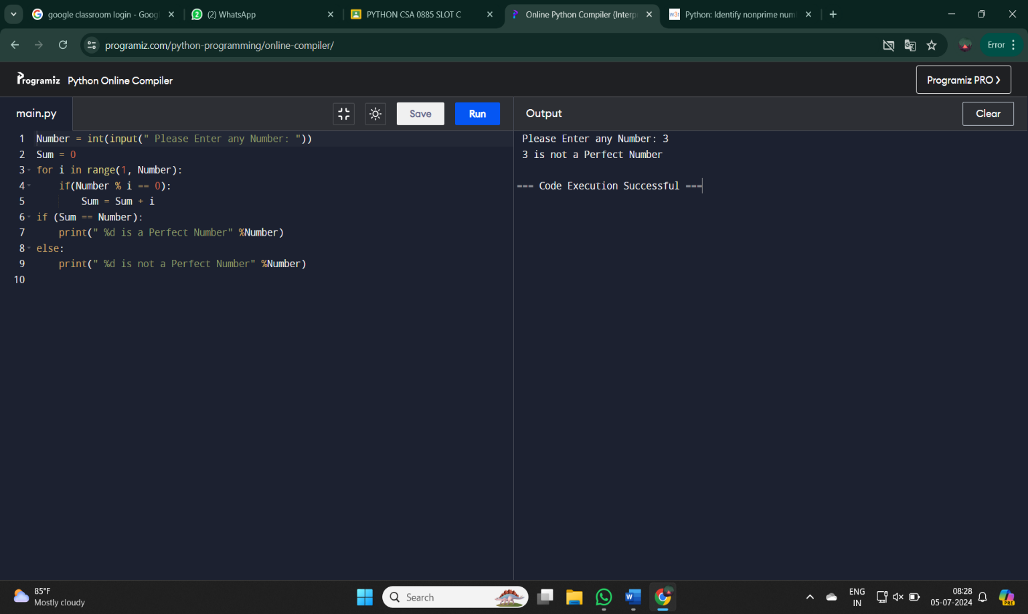

4.Write a program to generate Pythagorean Triplets for the given limit.

Enter upper limit: 10

3 4 5

8 6 10

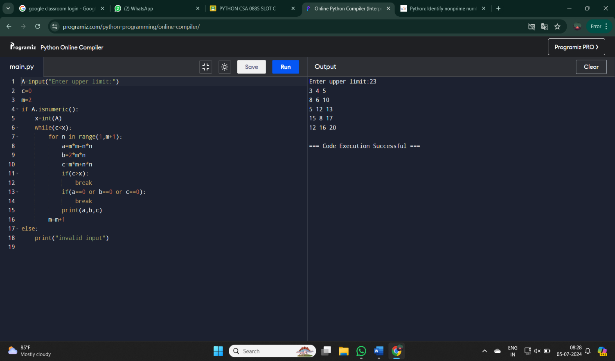

5.Write a program to find the sum of digits of N digit number (sum should be single digit)

Sample Input: Enter N value : 3 Enter 3 digit number: 143

Sample Output: Sum of 3 digit number: 8

