EXP 1:

AIM:
To find and return the first string in the array that is a palindrome. If none exist, return an empty string.

PROGRAM:
def palindrome(words):
for word in words:
if word == word[::-1]:
return word
return ""
print(palindrome(["abc", "car", "ada", "racecar", "cool"]))
print(palindrome(["notapalindrome", "racecar"]))
print(palindrome(["hello", "world"]))

OUTPUT:
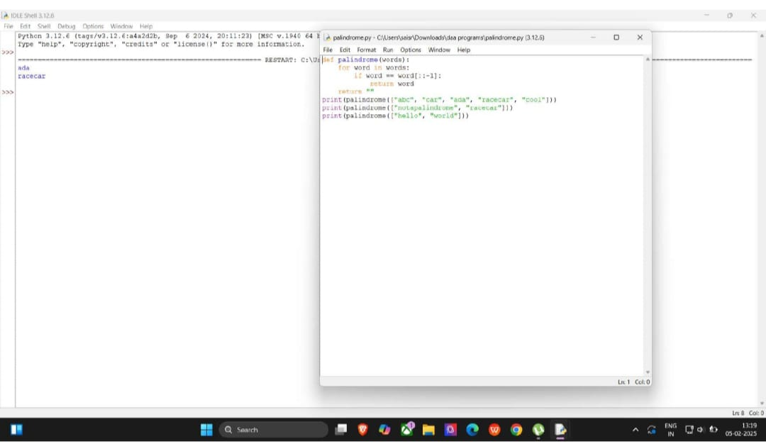
EXP 2:

AIM:
To count how many elements of nums1 appear in nums2 and vice-versa.

PROGRAM:
def matching_indices(nums1, nums2):
set_nums1 = set(nums1)
set_nums2 = set(nums2)
answer1 = sum(1 for num in nums1 if num in set_nums2)
answer2 = sum(1 for num in nums2 if num in set_nums1)
return [answer1, answer2]
print(matching_indices([2,3,2], [1,2]))
print(matching_indices([4,3,2,3,1], [2,2,5,2,3,6]))

OUTPUT:
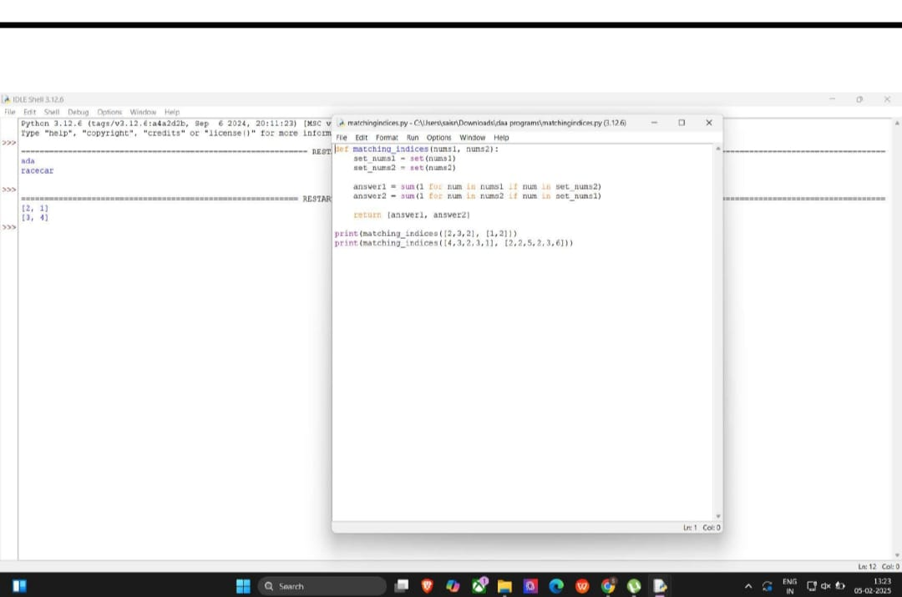

EXP 3:
AIM:
To calculate the sum of squares of distinct elements in every subarray
PROGRAM:
def sum_of_squares(nums):
n = len(nums)
result = 0
for i in range(n):
d_set = set()
for j in range(i, n):
d_set.add(nums[j])
result += len(d_set) ** 2
return result
print(sum_of_squares([1, 2, 1]))
print(sum_of_squares([1, 1])

OUTPUT:
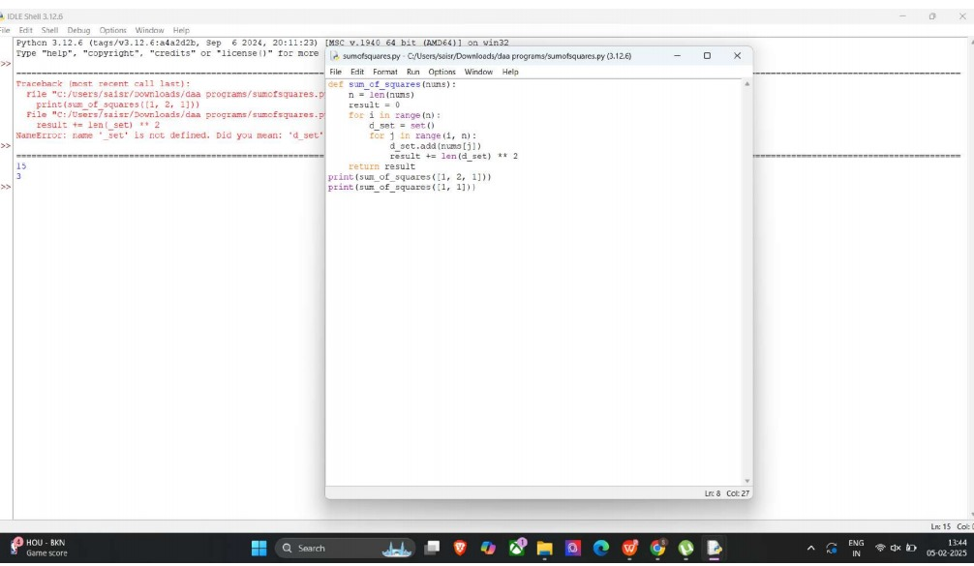
EXP 4:
AIM:
To count pairs where nums[i] == nums[j] and (i * j) is divisible by k.
PROGRAM:
def count_valid_pairs(nums, k):
n = len(nums)
count = 0
for i in range(n):
for j in range(i + 1, n):
if nums[i] == nums[j] and (i * j) % k == 0:
count += 1
return count
print(count_valid_pairs([3,1,2,2,2,1,3], 2))
print(count_valid_pairs([1,2,3,4], 1))

OUTPUT:
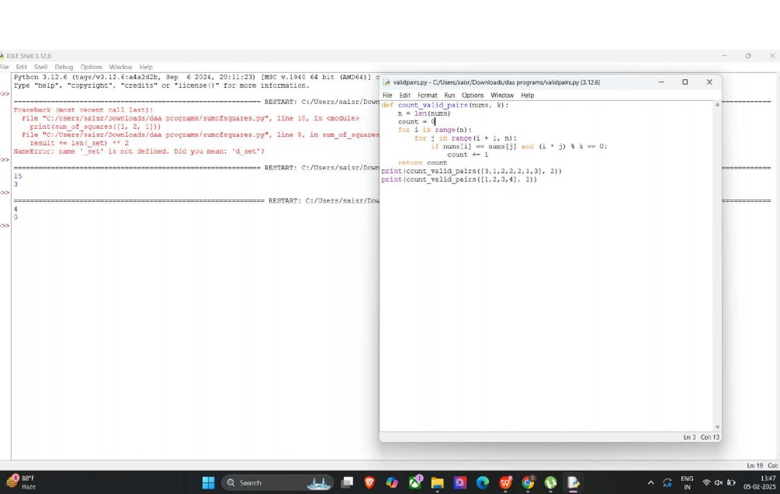

EXP 5:
AIM:
To find the maximum value in an array efficiently
PROGRAM:
def find_max_element(nums):
return max(nums)
print(find_max_element([1, 2, 3, 4, 5]))
print(find_max_element([7, 7, 7, 7, 7]))
print(find_max_element([-10, 2, 3, -4, 5]))

OUTPUT:
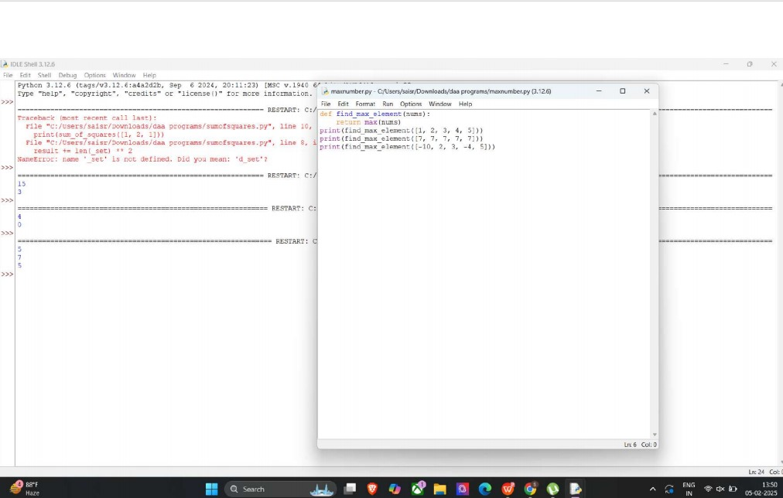

EXP 6:
AIM:
To sort a list and then find the maximum element, handling empty lists properly.
PROGRAM:
def find_max_after_sorting(nums):
if not nums:
return None
nums.sort()
return nums[-1]
print(find_max_after_sorting([]))
print(find_max_after_sorting([5]))
print(find_max_after_sorting([3, 3, 3, 3, 3]))

OUTPUT:
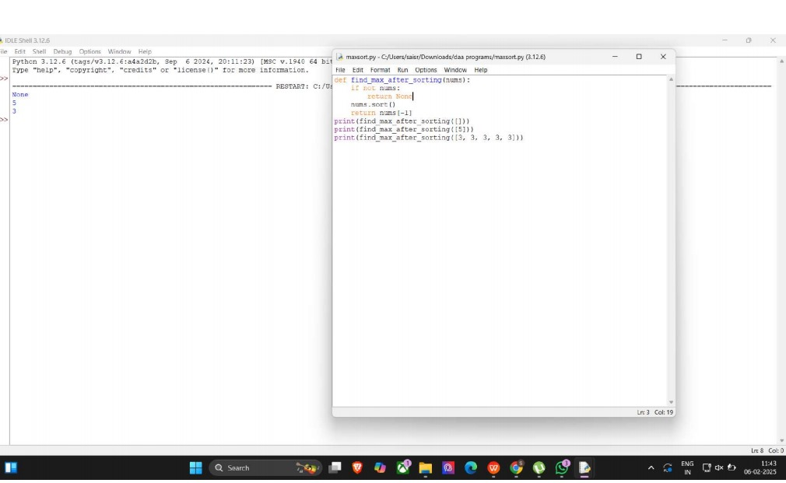

EXP 7:
AIM:
To create a new list with only unique elements and determine space complexity
PROGRAM:
def unique_elements(nums):
return list(set(nums))
print(unique_elements([3, 7, 3, 5, 2, 5, 9, 2]))
print(unique_elements([-1, 2, -1, 3, 2, -2]))
print(unique_elements([1000000, 999999, 1000000]))

OUTPUT:
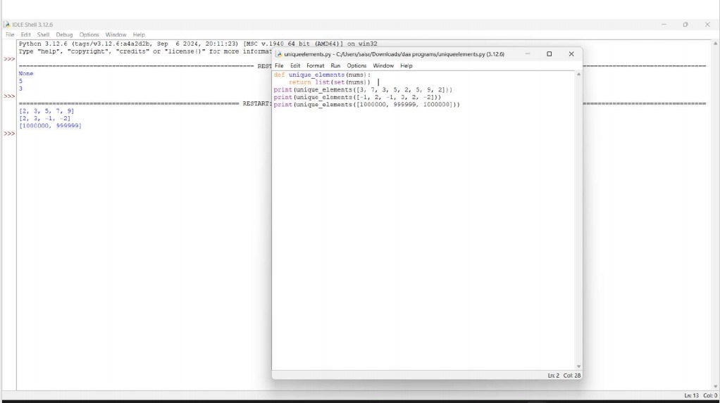

EXP 8:
AIM:
def bubble_sort(arr):
n = len(arr)
for i in range(n - 1):
swapped = False
for j in range(n - 1 - i):
if arr[j] > arr[j + 1]:
arr[j], arr[j + 1] = arr[j + 1], arr[j]
swapped = True
if not swapped:
break
arr = [64, 34, 25, 12, 22, 11, 90]
bubble_sort(arr)
print("Sorted array:", arr)
OUTPUT:
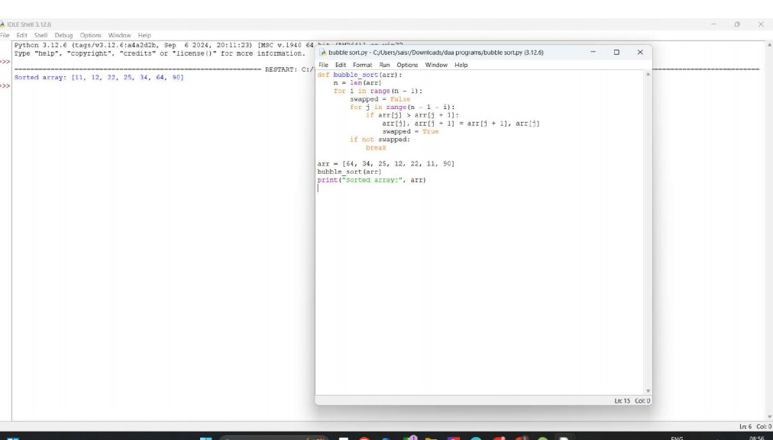

EXP 9:
AIM:
To check if a number exists in a sorted array using Binary Search
PROGRAM:
def binary_search(arr, key):
left, right = 0, len(arr) - 1
while left <= right:
mid = left + (right - left) // 2
if arr[mid] == key:
return mid
elif arr[mid] < key:
left = mid + 1
else:
right = mid - 1
return -1
arr = sorted([3, 4, 6, -9, 10, 8, 9, 30])
key = 10
result = binary_search(arr, key)
if result != -1:
print(f"Element {key} is found at position {result + 1}")
else:
print(f"Element {key} is not found in the array")
OUTPUT: 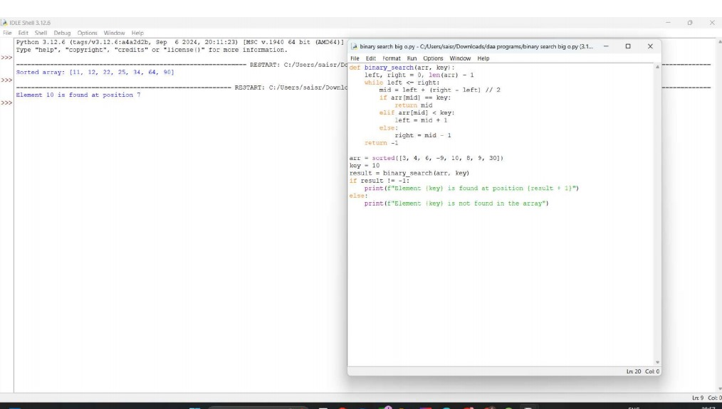

EXP 10:
AIM:
To sort array in O(n log n) without built-in functions
PROGRAM:
def quick_sort(arr, low, high):
if low < high:
pi = partition(arr, low, high)
quick_sort(arr, low, pi - 1)
quick_sort(arr, pi + 1, high)
def partition(arr, low, high):
pivot = arr[high]
i = low - 1
for j in range(low, high):
if arr[j] < pivot:
i += 1
arr[i], arr[j] = arr[j], arr[i]
arr[i + 1], arr[high] = arr[high], arr[i + 1]
return i + 1
arr = [3, 4, 6, -9, 10, 8, 9, 30]
quick_sort(arr, 0, len(arr) - 1)
print("Sorted array:", arr)
OUTPUT: 