17. Implementation of server – client using TCP socket programming

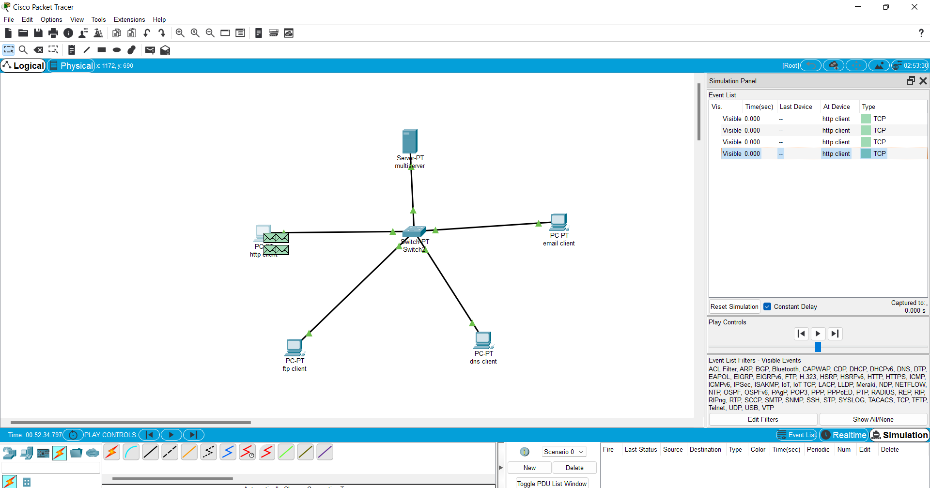

18. Implementation of server – client using UDP socket programming

