Ex.No. 1

Date:

**DDL Commands – CREATE, ALTER, DROP**

**Aim:**

To Create, Alter and Drop the table using Data Definition Language.

**Description**:

Data Definition Language (DDL) statements are used to define the database structure or schema.

DDL Commands: Create, Alter, Drop, Rename, Truncate

 • CREATE - to create objects in the database 

* + ALTER - alters the structure of the database 
* • DROP - delete objects from the database 
  + TRUNCATE - remove all records from a table, including all spaces allocated for the records are removed 
  + RENAME - rename an object 

**SYNTAX:**

**CREATE TABLE**

CREATE TABLE table_name

(

column_name1 data_type,

column_name2 data_type,

column_name3 data_type,

*....*

);

**ALTER A TABLE**

To add a column in a table

ALTER TABLE table_name

ADD column_namedatatype;

To delete a column in a table

ALTER TABLE table_name

DROP COLUMN column_name;

**DROP TABLE**

DROP TABLE table_name;

**TRUNCATE TABLE**

TRUNCATE TABLE table_name;

**Questions:**

1) Create a table name STUDENT with following structure.

|  |  |  |  |  |
| --- | --- | --- | --- | --- |
|  | Column |  |  |  |
| # | Name | Description | Data Type |  |
|  |  |  |
|  |  | Registration |  |  |
| 1 | RegNo | Number | NUMBER(3) |  |
| 2 | Name | Student Name | VARCHAR(15) |  |
|  |  | Gender of the |  |  |
| 3 | Gender | student | CHAR(1) |  |
| 4 | DOB | Date of Birth | DATE |  |
| 5 | MobileNo | Mobile Number | NUMBER(10) |  |
| 6 | City | Location of stay | VARCHAR(15) |  |

2) Create a table name FACULTY with following structure.

|  |  |  |  |  |
| --- | --- | --- | --- | --- |
|  | Column |  |  |  |
| # | Name | Description | Data Type |  |
|  |  |  |
| 1 | FacNo | Faculty Identifier | VARCHAR(4) |  |
| 2 | FacName | Faculty Name | VARCHAR(15) |  |
| 3 | Gender | Gender of faculty | CHAR(1) |  |
| 4 | DOB | Date of Birth | DATE |  |
| 5 | DOJ | Date of Join | DATE |  |
| 6 | MobileNo | Mobile Number | NUMBER(10) |  |

3) Create a table name DEPARTMENT with following structure.

|  |  |  |  |  |
| --- | --- | --- | --- | --- |
|  | Column |  |  |  |
| # | Name | Description | Data Type |  |
|  |  |  |
| 1 | DeptNo | Department Identifier | VARCHAR(4) |  |
| 2 | DeptName | Department Name | VARCHAR(15) |  |
| 3 | DeptHead | Department Head | VARCHAR(4) |  |

4) Create a table name COURSE with following structure.

|  |  |  |  |  |
| --- | --- | --- | --- | --- |
|  | Column |  |  |  |
| # | Name | Description | Data Type |  |
|  |  |  |
| 1 | CourseNo | Course Identifier | VARCHAR(3) |  |
|  |  | Course |  |  |
| 2 | CourseDesc | Description | VARCHAR(14) |  |
| 3 | CourseType | Course Type | CHAR(1) |  |
| 4 | SemNo | Semester Number | CHAR(1) |  |
| 5 | HallNo | Hall Number | VARCHAR(4) |  |
| 6 | FacNo | Faculty Identifier | VARCHAR(4) |  |

1. Modify the table FACULTY by adding a column name DeptNo of datatype VARCHAR(4)

**OUTPUTS:**

1) mysql> create table student(regno int(3),name varchar(15),gender char(1),dob date,mobileno int(1),city varchar(15));

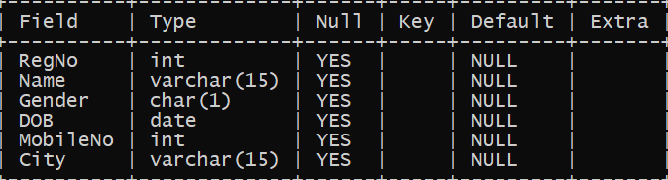

2) mysql> CREATE Table FACULTY(FacNo VARCHAR(4), FacName VARCHAR(15), Gender CHAR(1), DOB DATE, DOJ DATE, MobileNo int(10));

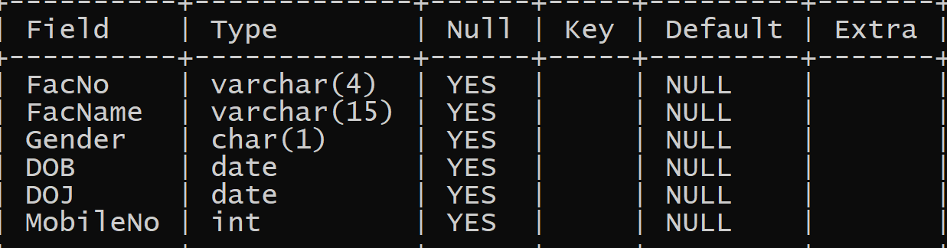

3) mysql> CREATE Table DEPARTMENT(DeptNo VARCHAR(4), DeptName VARCHAR(15), DeptHead VARCHAR(4));

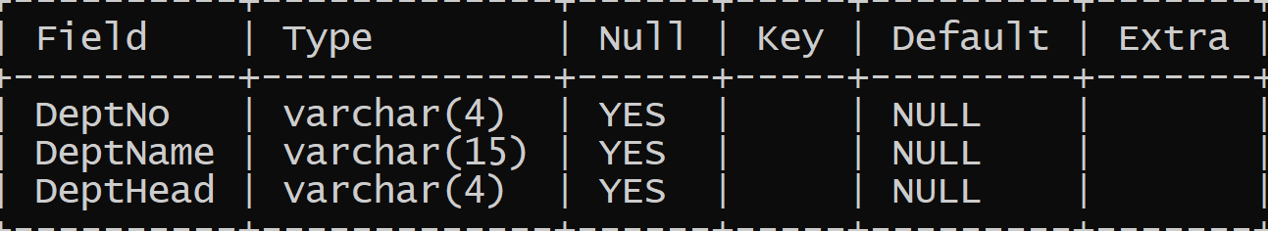

4) mysql> CREATE Table COURSE(CourseNo VARCHAR(3), CourseDesc VARCHAR(14), CourseType CHAR(1), SemNo CHAR(1), HallNo VARCHAR(4), FacNo VARCHAR(4));

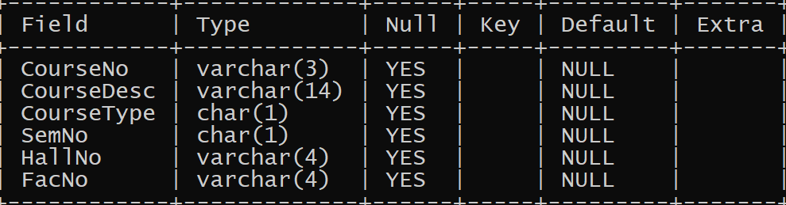

5) mysql> Alter Table FACULTY add DeptNo VARCHAR(4);

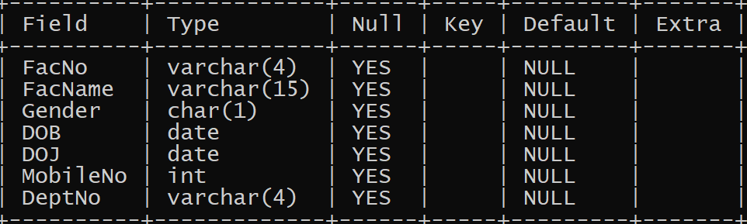

**RESULT:**

Tables are created, altered and modified using DDL commands.