**SIMATS SCHOOL OF ENGINEERING**

**SAVEETHA INSTITUTE OF MEDICAL AND TECHNICAL SCIENCES**

**CHENNAI-602105**

**Online ticket booking system**

**A CAPSTONE PROJECT REPORT**

*Submitted in the partial fulfilment for the award of the degree of*

**BACHELOR OF ENGINEERING**

**IN**

**COMPUTER SCIENCE AND ENGINEERING**

**Submitted by**

**<A. Deekshitha> (192211838)**

**<P. Vijaya Lakshmi > (192210200)**

**Under the Supervision of**

**DR. Yuvaraj**

**Jan-2025**

**DECLARATION**

We, **A. Deekshitha, P. Vijaya Lakshmi** students of **Bachelor of Engineering**, Department of Computer Science and Engineering, Saveetha Institute of Medical and Technical Sciences, Saveetha University, Chennai, hereby declare that the work presented in this Capstone Project Work entitled **Online ticket booking system** is the outcome of our own Bonafide work and is correct to the best of our knowledge and this work has been undertaken taking care of Engineering Ethics.

1. Deekshitha -192211838)

(P. Vijaya Lakshmi -192210200)

Date: 4-01-2025

Place: Chennai

**CERTIFICATE**

This is to certify that the project entitled **“Online ticket booking system”** submitted by **A. Deekshitha, P. Vijaya Lakshmi** has been carried out under my supervision. The project has been submitted as per the requirements in the current semester of B. Tech Informat ion Technology.

Teacher-in-charge

DR. Yuvaraj

**CONTENTS**

|  |  |  |
| --- | --- | --- |
| S. No | Title | Page. No. |
| 1 | ABSTRACT | 3 |
| 2 | INTRODUCTION | 4 |
| 3 | Objectives and Case Description | 5-7 |
| 4 | Pseudocode and Explanation | 7-9 |
| 5 | Results & Discussion,  Future Scope | 9-14 |
| 6 | Conclusion | 14 |
| 7 | REFERENCES | 14-15 |

**ABSTRACT**

An online ticket booking system is a comprehensive platform designed to revolutionize the traditional ticketing process by providing a digital solution for reserving tickets for transportation, events, and entertainment. The system simplifies booking by offering features such as real-time seat availability, secure payment gateways, automated booking confirmations, and cancellation or rescheduling options. It eliminates the need for manual booking methods, saving time and effort for users while reducing operational overhead for service providers. The platform supports multiple devices, ensuring accessibility and convenience for users worldwide, with options for dynamic pricing, notifications, and user account management. For service providers, the system includes administrative tools to monitor bookings, analyze sales, and improve customer management.

The online ticket booking system is a web-based platform designed to automate and simplify the process of reserving tickets for various services, such as transportation, entertainment, and events. The system provides users with a seamless experience to browse available options, check real-time availability, and make bookings from any location, 24/7. It incorporates features such as secure payment gateways, dynamic pricing, automated notifications, and booking history, ensuring a user-friendly and efficient process With robust technology, high scalability, and strong security measures, this system addresses the growing demand for fast, reliable, and eco-friendly ticketing solutions while enhancing user experience and operational efficiency.

**INTRODUCTION**

The online ticket booking system is a web-based application designed to simplify the process of reserving tickets for various events, transportation, and services. This system enables users to browse available options, check real-time availability, and book tickets from the comfort of their homes or on the go. By integrating user-friendly interfaces and secure payment gateways, the platform ensures a seamless booking experience. An online ticket booking system is a digital platform designed to streamline the process of reserving tickets for various services, including travel, entertainment, and events. This system allows users to browse schedules, check real-time availability, and book tickets conveniently from any location, eliminating the need for manual reservations. By incorporating features such as secure payment gateways, automated confirmations, and user-friendly interfaces, the platform enhances the booking experience while saving time and reducing errors. It caters to industries such as transportation, event management, and entertainment, providing a centralized solution for managing bookings. This system not only offers convenience to users but also improves operational efficiency for service providers by automating processes and reducing administrative overhead. The system provides users with a seamless experience to browse available options, check real-time availability, and make bookings from any location, 24/7.

It incorporates features such as secure payment gateways, dynamic pricing, automated notifications, and booking history, ensuring a user-friendly and efficient process. For service providers, the system offers an administrative dashboard to manage bookings, monitor sales, and generate reports, reducing manual intervention and operational costs. Built with robust technologies and incorporating data security measures, the system minimizes errors, enhances customer satisfaction, and addresses the growing demand for a fast and reliable ticketing solution. This platform bridges the gap between users and service providers, making ticket booking accessible, efficient, and eco-friendly.

**Key features** include:

* **User Registration and Login:** Enables users to create accounts and manage their bookings.
* **Real-Time Ticket Availability:** Displays up-to-date information on seat or ticket availability for users.
* **Secure Payment Integration:** Supports multiple payment options such as credit/debit cards, UPI, digital wallets, and net banking**.**
* **Booking Confirmation and E-Tickets:** Automatically sends booking confirmations and e-tickets via email or SMS.
* **Cancellation and Rescheduling:** Provides options for users to cancel or reschedule bookings with applicable terms.
* **Notifications and Alerts:** Sends reminders, updates, and alerts for bookings, cancellations, or special offers.
* **Booking History:** Allows users to view past bookings for reference or rebooking.

**OBJECTIVES**

* **Enhance Convenience:** Provide users with the ability to book tickets anytime, anywhere, without physical queues.
* **Automate the Booking Process:** Replace manual ticketing with an automated system to reduce errors and improve efficiency.
* **Improve Accessibility:** Offer a centralized platform where users can view schedules, prices, and seat availability in real-time.
* **Ensure Secure Transactions:** Integrate robust payment gateways to enable safe and secure online payments.
* **Save Time and Effort:** Minimize the time required for booking, confirming, and managing tickets.
* **Increase Customer Satisfaction:** Provide a seamless, user-friendly experience with features like automated notifications, cancellation, and rescheduling.
* **Support Scalability**: Build a system capable of handling high volumes of traffic and bookings during peak times.
* **Reduce Operational Costs:** Lower administrative expenses for service providers by automating ticketing and reducing the need for physical resources.
* **Enhance Service Provider Efficiency:** Equip service providers with tools for managing bookings, analyzing customer behavior, and optimizing operations.
* **Provide Real-Time Updates:** Keep users informed with live updates on ticket availability, schedules, and booking statuses.
* **Encourage Feedback and Improvement:** Allow users to share their experiences to improve system performance and user satisfaction.

**Case Description:**

The scenario of creating a C++ ONLINE TICKET BOOKING SYSTEM, online ticket booking system addresses the challenges faced by both customers and service providers in traditional ticketing methods. In manual systems, customers often experience long queues, limited accessibility, and delayed processes, while service providers struggle with high operational costs, data mismanagement, and errors. This case study highlights the implementation and functionality of a digital solution to resolve these issues.

The system is designed to provide a seamless experience for booking tickets for various services such as transportation (flights, buses, trains), entertainment (movies, concerts), and events (seminars, conferences). Customers can search for events or services, view real-time availability, and book tickets instantly through an intuitive interface. Payment options are secured with advanced gateways to ensure financial safety and trust. It supports features like automated notifications, cancellations, rescheduling, and feedback collection. The integration of technologies such as real-time databases, cloud hosting, and responsive design ensures scalability, reliability, and accessibility across devices.

**Methods:**

* **Requirement Analysis:**
* Gather requirements from stakeholders (users and service providers) to understand system functionality, features, and performance expectations.
* Identify the scope of the project, such as supported platforms, target audience, and types of tickets to be managed (e.g., travel, events).
* **User Management:** Implement user registration, login, and account management.
* **Search and Filtering:** Develop a search engine with filters based on date, location, and service type.
* **Real-Time Availability:** Integrate a real-time system to display seat or ticket availability.
* **Payment Gateway Integration:** Add support for secure payment methods like PayPal, Stripe, or Razorpay.
* **Booking Confirmation:** Automate email/SMS notifications for booking confirmations and cancellations.
* **Admin Panel:** Create an admin dashboard for managing bookings, monitoring sales, and generating reports. Maintenance and Updates
* **User Training and Documentation:** Provide tutorials, user guides, and FAQs to help users and admins navigate the system effectively.

By following these methods, the online ticket booking system can be developed to deliver a reliable, efficient, and user-centric experience.

**Modules of online ticket booking system:**

* User login
* Even listing
* Ticket booking
* Payment gateway integration
* Ticket cancellation
* Notifications
* Admin event management

**Pseudocode:**

#include <iostream>

#include <vector>

#include <string>

#include <iomanip>

using namespace std;

struct Ticket {

int id;

string event;

string date;

double price;

bool isBooked;

};

class TicketBookingSystem {

private:

vector<Ticket> tickets;

vector<Ticket> bookingHistory;

public:

TicketBookingSystem() {

tickets = {

{1, "Concert: Coldplay", "2025-01-10", 150.0, false},

{2, "Movie: Avengers", "2025-01-12", 12.0, false},

{3, "Play: Hamlet", "2025-01-15", 30.0, false},

{4, "Football Match: Final", "2025-01-20", 75.0, false}

};

}

void view Available Tickets() {

cout << "\nAvailable Tickets:\n";

cout << left << setw(5) << "ID" << setw(25) << "Event" << setw(15) << "Date" << setw(10) << "Price" << endl;

cout << string(55, '-') << endl;

for (const auto &ticket : tickets) {

if (!ticket.isBooked) {

cout << left << setw(5) << ticket.id << setw(25) << ticket.event

<< setw(15) << ticket.date << "$" << ticket.price << endl;

}

}

}

void bookTicket() {

int ticketId;

cout << "\nEnter the Ticket ID to book: ";

cin >> tic

for (auto &ticket : tickets) {

if (ticket.id == ticketId && !ticket.isBooked) {

ticket.isBooked = true;

bookingHistory.push_back(ticket);

cout << "Ticket for " << ticket.event << " booked successfully!" << endl;

return;

}

}

cout << "Invalid Ticket ID or the ticket is already booked.\n";

}

void viewBookingHistory() {

if (bookingHistory.empty()) {

cout << "\nNo tickets booked yet.\n";

return;

}

cout << "\nBooking History:\n";

cout << left << setw(5) << "ID" << setw(25) << "Event" << setw(15) << "Date" << setw(10) << "Price" << endl;

cout << string(55, '-') << endl;

for (const auto &ticket : bookingHistory) {

cout << left << setw(5) << ticket.id << setw(25) << ticket.event

<< setw(15) << ticket.date << "$" << ticket.price << endl;

}

}

void menu() {

int choice;

do {

cout << "\n--- Ticket Booking System ---\n";

cout << "1. View Available Tickets\n";

cout << "2. Book a Ticket\n";

cout << "3. View Booking History\n";

cout << "4. Exit\n";

cout << "Enter your choice: ";

cin >> choice;

switch (choice) {

case 1:

viewAvailableTickets();

break;

case 2:

bookTicket();

break;

case 3:

viewBookingHistory();

break;

case 4:

cout << "Exiting the system. Thank you!\n";

break;

default:

cout << "Invalid choice. Please try again.\n";

}

} while (choice != 4);

}

};

int main() {

TicketBookingSystem system;

system.menu();

return 0;

}

**Result:** When you run the project from any compiler or directly clicking on the executable .exe file you’ll see the following screen shown in the picture

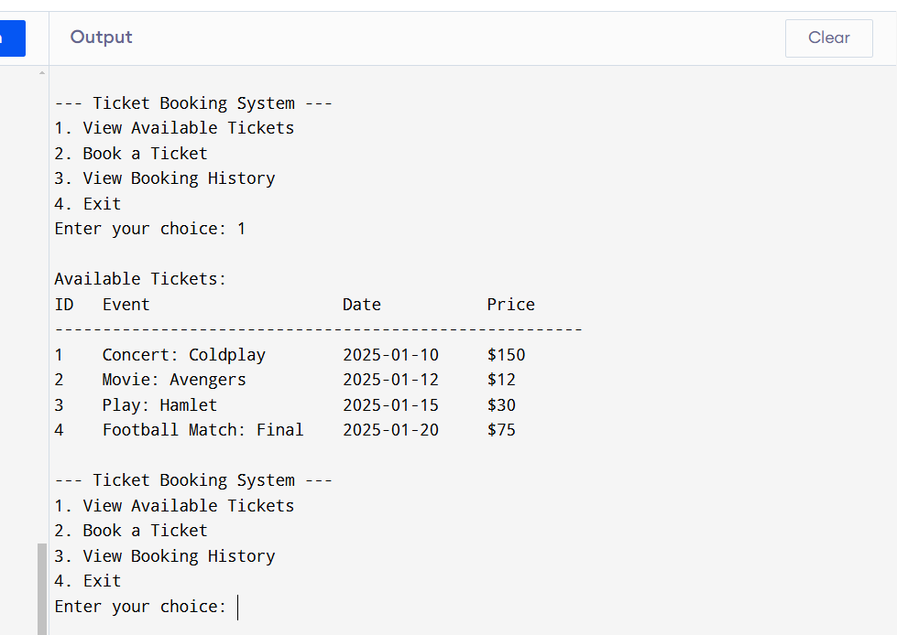

**Discussion:**

Online Ticket Booking System project demonstrates a simple yet effective solution for managing ticket bookings. It is built using C++ and consists of a Ticket structure to store ticket details, including ID, event name, date, price, and booking status. The core of the system is the Online Booking System class, which manages ticket availability, booking operations, and user interaction through a menu-based system. Users can view available tickets, book tickets, and check their booking history. The system uses vectors to store both available tickets and booking history, making it easy to manage and track bookings. While the project successfully mimics a basic ticket booking process, it has certain limitations. It is a single-user system and does not support features like payment integration, ticket cancellation, or multi-user support. Moreover, the data is hardcoded, meaning it is not persistent across sessions. These shortcomings could be addressed with enhancements such as a database for data storage, real-time ticket availability, a graphical user interface (GUI), and the integration of advanced features like payment gateways or booking modification. Despite its simplicity, the project offers a foundation for developing more complex and scalable ticket booking systems.

**Future Scope:**

The future scope of the Online Ticket Booking System is vast, with numerous opportunities for enhancement and expansion. One of the primary improvements would be to introduce multi-user support, allowing multiple users to book tickets simultaneously while managing their individual booking histories. Integrating a database for persistent data storage would be crucial to ensure ticket availability, user details, and booking histories are not lost when the system is closed. Moreover, real-time ticket availability and seat selection could be added to prevent over-booking and allow users to select specific seats for events. Additionally, incorporating a payment gateway would enable users to pay for their tickets online, enhancing the system's functionality. Another area of development is the addition of ticket cancellation and modification features, which would allow users more flexibility in managing their bookings. A more user-friendly graphical user interface (GUI) could also be developed, providing an interactive and visually appealing experience. Finally, mobile app or web-based versions of the system could be created to increase accessibility, allowing users to book tickets on the go. These improvements would not only make the system more robust but also cater to real-world business needs, transforming it into a fully functional, scalable online ticket booking platform.

**Conclusion:**

In conclusion, the Online Ticket Booking System project successfully demonstrates the fundamental concepts of ticket management using C++ programming. It effectively allows users to view available tickets, book tickets, and check their booking history in a simple, text-based interface. While the system serves as a basic prototype, it lays the foundation for more advanced and scalable ticketing platforms. Its simplicity offers a clear understanding of core programming principles such as structuring data, handling user input, and managing lists of objects. However, the system's limitations, such as single-user access, static data, and lack of advanced features like payment integration, highlight areas for future improvement. With enhancements such as multi-user support, real-time updates, payment gateways, and a graphical user interface, the system has significant potential to evolve into a robust, commercially viable solution. This project not only provides a solid base for learning but also offers numerous opportunities for further development and customization to meet real-world needs.

**References:**

[1]. HonghaiKan, Zhimin Yang, Yue Wang, Nana Qi, “Research on ticket booking system

for CDs in Proceedings of the 14th International Conference on Computer Supported Cooperative Work in Design 2010.

[2]. Bao Sun, JiangweiFeng and Ling Liu, “A Study on How to Construct the Prediction Model of ticket Lending of University”, International Conference on Information Science and Technology March 26-28,2011 Nanjing, Jiangsu, China.

[3]. Erxiang Chen, Minghui Liu, “Research and Design on online ticket Management System Based on Struts and Hibernate Framework”, WASE International Conference on Information Engineering2009.

[4]. Michael Hitchens, Andrew Firmage, “The Design of a Flexible Class for online ticket booking system”, in IEEE conference 1998.