COURSE : CSA4728 DEEP LEARNING FOR URBAN PLANNING

NAME : S LOGESH

REG.NO : 192224245

1. Confusion matrix

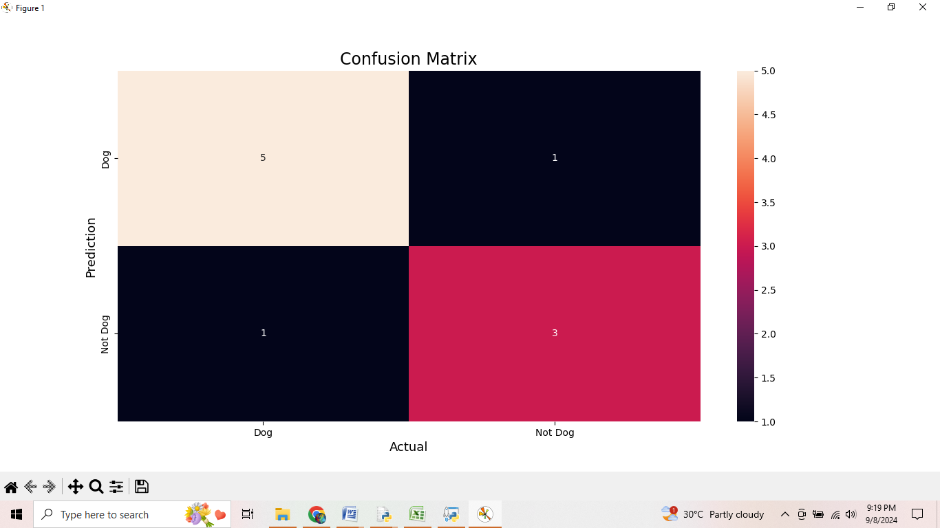

1. 2 class confusion matrix

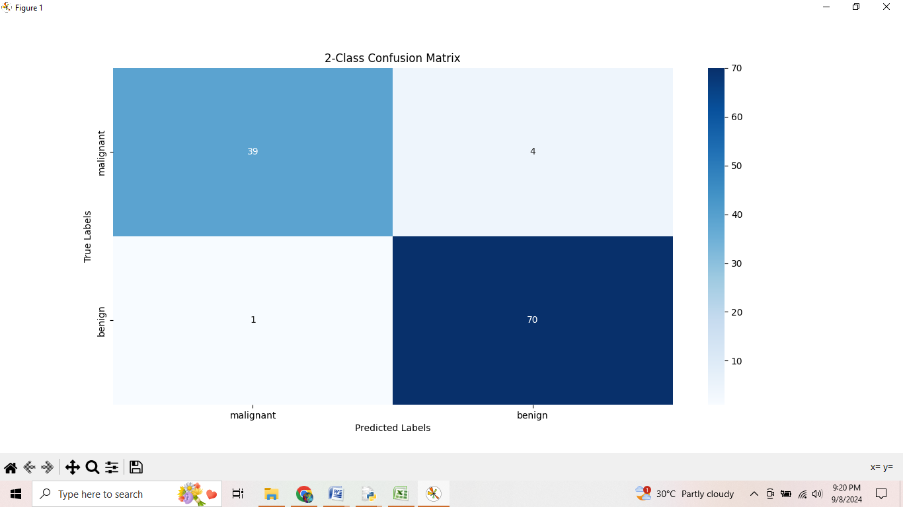

1. Multi class confusion matrix

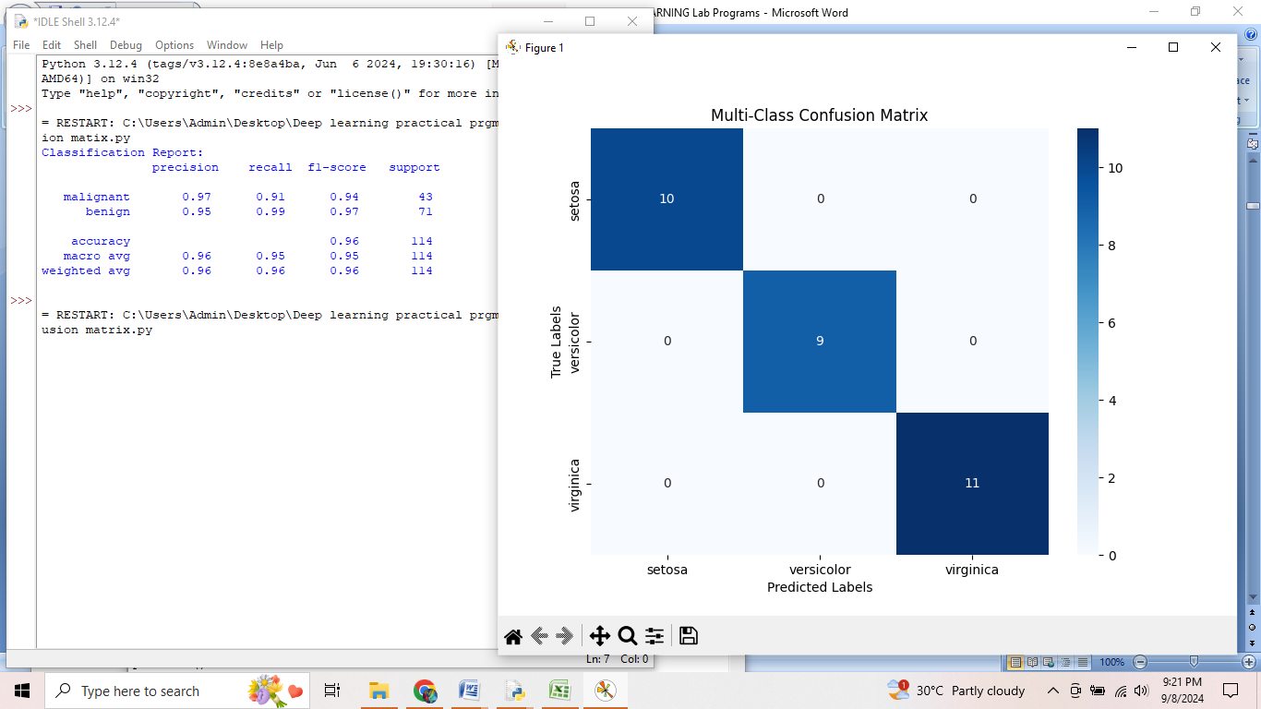

1. Overfitting

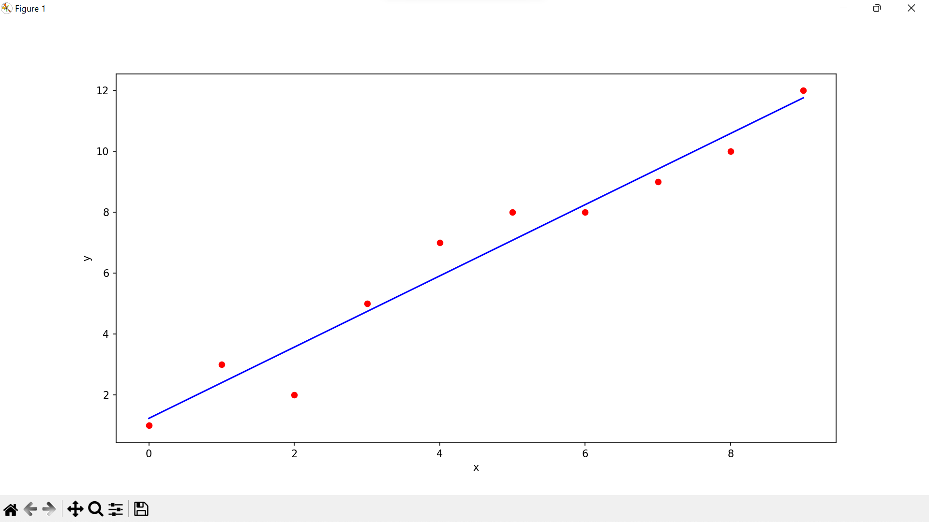

1. Linear regression on iris

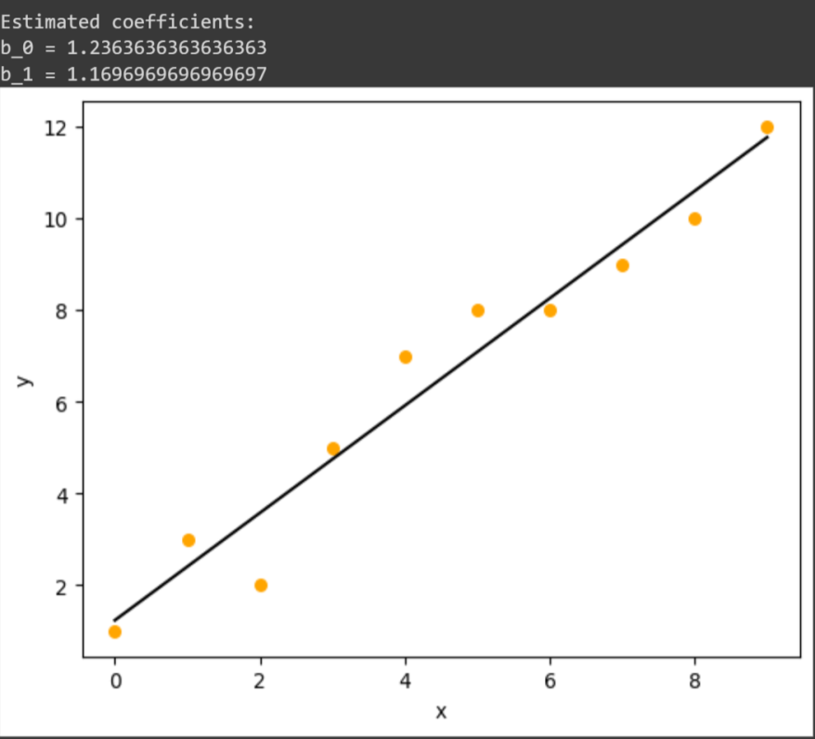

1. Logistic curve

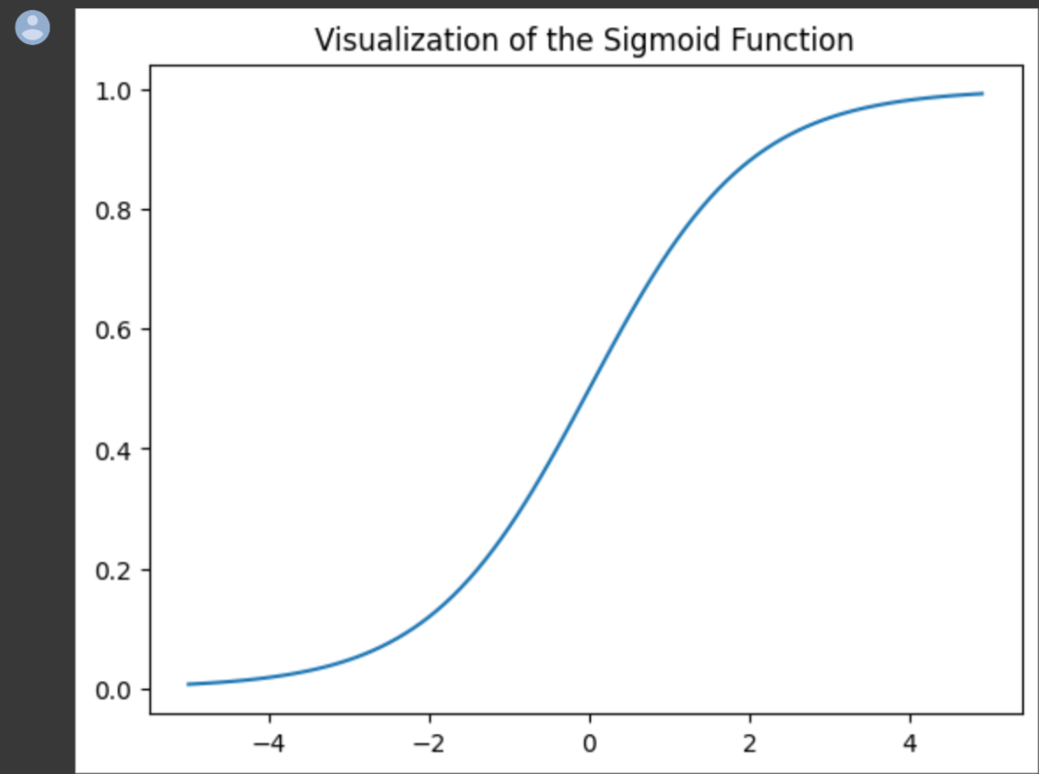

1. KNN using iris

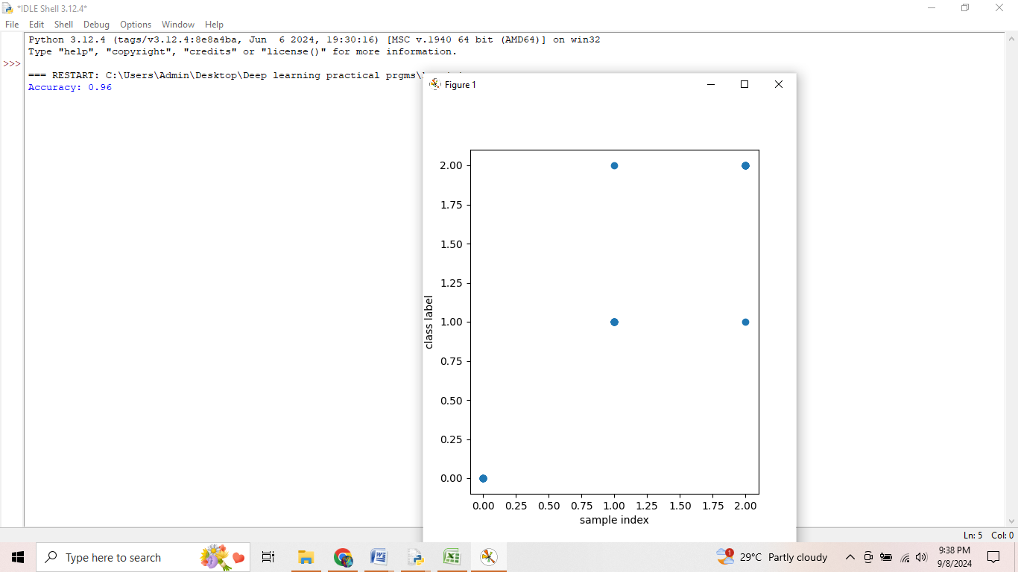

1. Naïve bayes using iris

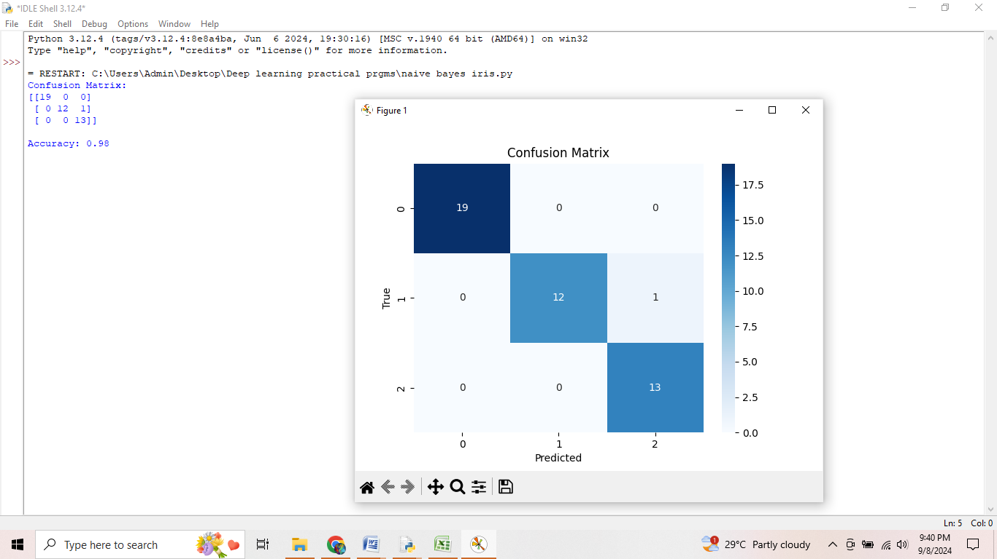

1. Logistic regression using iris

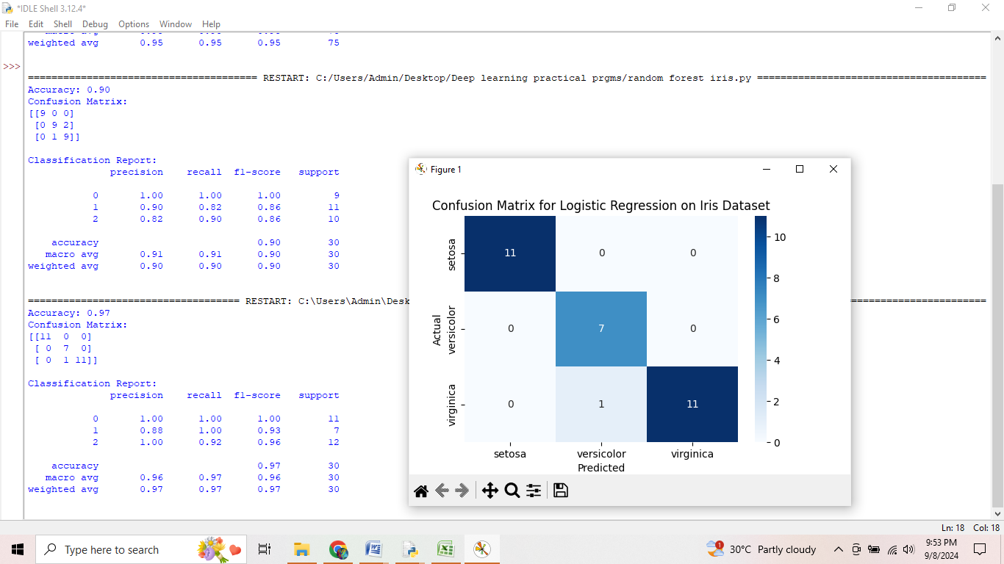

1. Decision tree using iris

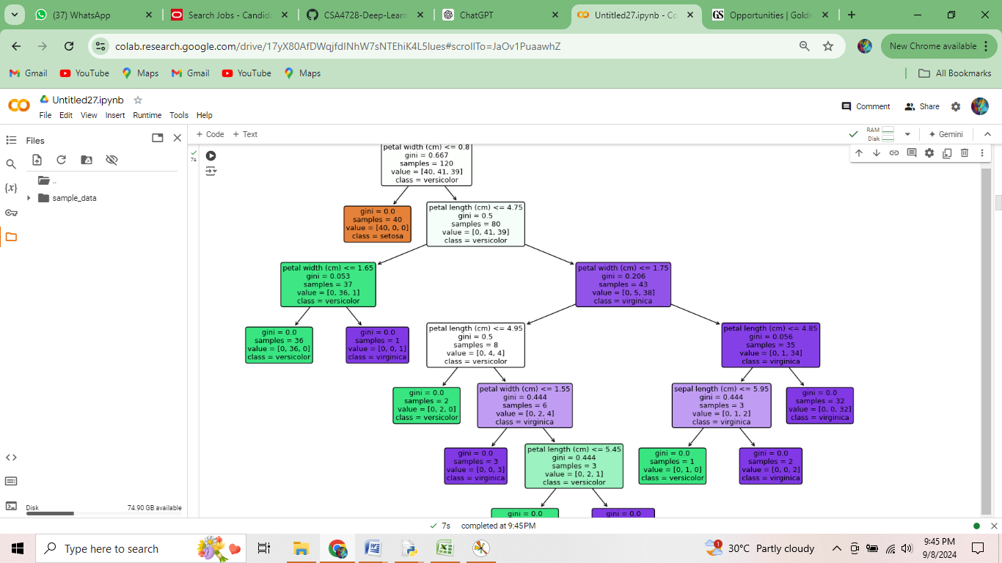

1. SVM using iris

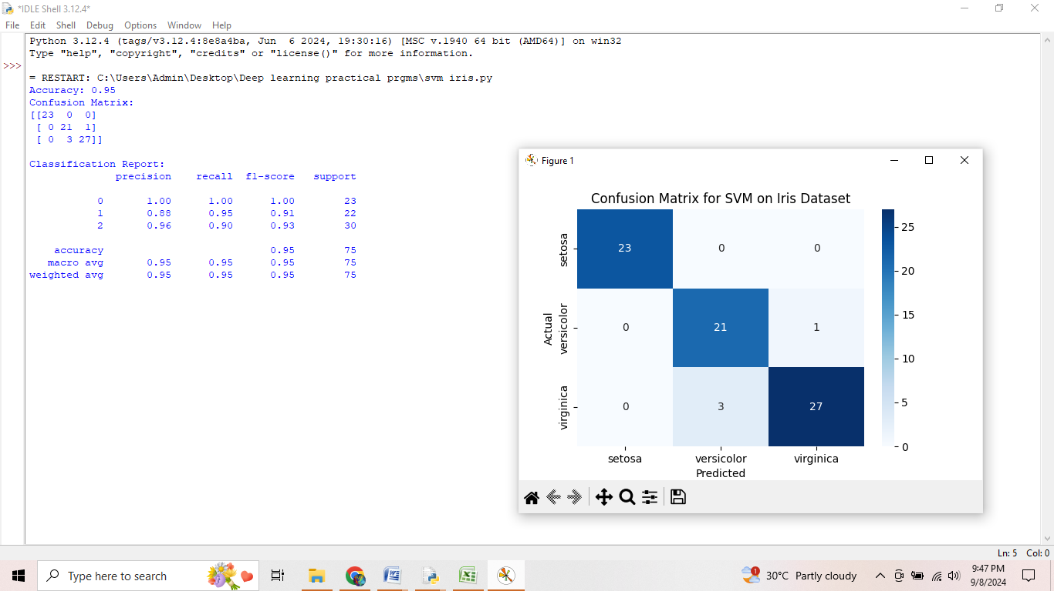

1. Random Forest using iris

