#include <stdio.h> /

int main()

{

int int1, int2;

printf("Input the values for Number1 and Number2 : ");

scanf("%d %d", &int1, &int2);

if (int1 == int2)

printf("Number1 and Number2 are equal\n");

else

printf("Number1 and Number2 are not equal\n");

}

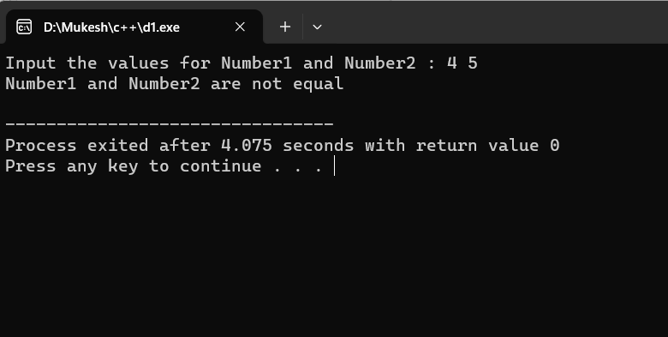

#include <bits/stdc++.h>

using namespace std;

int main()

{

int a, b, c;

cout << "Enter the three numbers a, b & c" << endl;

cin >> a >> b >> c;

if (a >= b) {

if (a >= c) {

cout << "The Largest Among Three Numbers is : "

<< a << endl;

}

else {

cout << "The Largest Among Three Numbers is : "

<< c << endl;

}

}

else {

if (b >= c) {

cout << "The Largest Among Three Numbers is : "

<< b << endl;

}

else {

cout << "The Largest Among Three Numbers is : "

<< c << endl;

}

}

return 0;

}

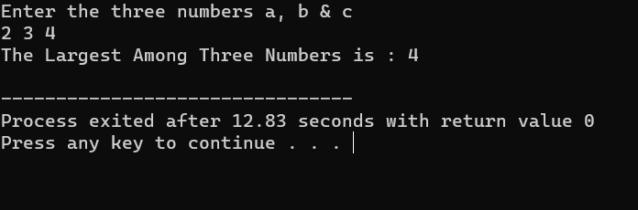

#include <iostream>

using namespace std;

unsigned int factorial(unsigned int n)

{

if (n == 0)

return 1;

return n \* factorial(n - 1);

}

int main()

{

int num = 5;

cout << "Factorial of " << num << " is "

<< factorial(num) << endl;

return 0;

}

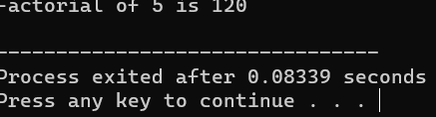

#include <iostream>

using namespace std;

int main()

{

int n = 5;

for (int i = 1; i <= n; i++) {

for (int j = 1; j <= i; j++)

cout << "\* ";

cout << endl;

}

return 0;

}

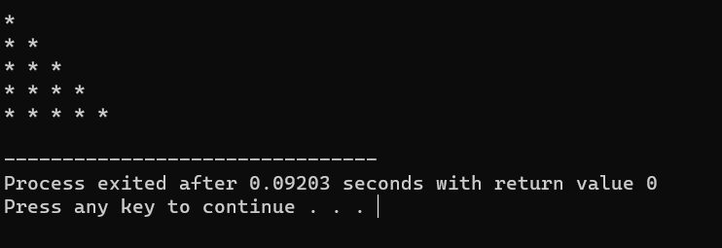

#include <iostream>

using namespace std;

void reverseArrayExtraArray(int arr[], int size) {

int reversedArr[size];

for (int i = 0; i < size; i++) {

reversedArr[i] = arr[size - i - 1];

}

cout << "Reversed Array: ";

for (int i = 0; i < size; i++) {

std::cout << reversedArr[i] << " ";

}

}

int main() {

int originalArr[] = {1, 2, 3, 4, 5};

int size = sizeof(originalArr) / sizeof(originalArr[0]);

reverseArrayExtraArray(origin

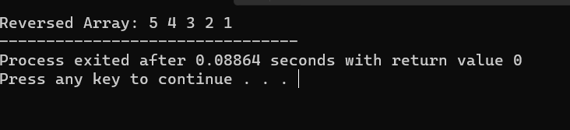

#include <iostream>

using namespace std;

class Person {

private:

int age;

public:

Person() {

age = 20;

}

Person(int a) {

age = a;

}

int getAge() {

return age;

}

};

int main() {

Person person1, person2(45);

cout << "Person1 Age = " << person1.getAge() << endl;

cout << "Person2 Age = " << person2.getAge() << endl;

return 0;

}

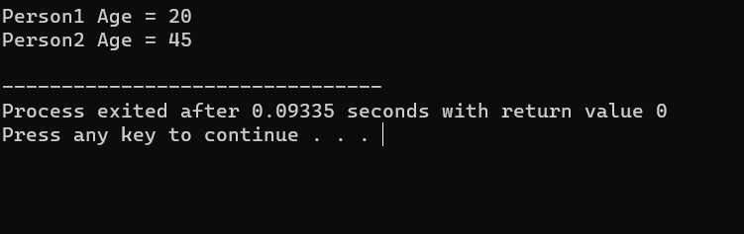

#include <iostream>

using namespace std;

struct student

{

char name[50];

int roll;

float marks;

};

int main()

{

student s;

cout << "Enter information," << endl;

cout << "Enter name: ";

cin >> s.name;

cout << "Enter roll number: ";

cin >> s.roll;

cout << "Enter marks: ";

cin >> s.marks;

cout << "\nDisplaying Information," << endl;

cout << "Name: " << s.name << endl;

cout << "Roll: " << s.roll << endl;

cout << "Marks: " << s.marks << endl;

return 0;

}

