Semantic Health Checks for Reproducible Visual-Feature Benchmarks: A Two-Renderer Failure Analysis
Ming Zhu
Zihang Xue
School of Art and Design, Henan University of Engineering, No.1 Xianghe Road, Longhu, Xinzheng, Zhengzhou, Henan 451191, China
Department of Light Engineering, Qilu University of Technology, No.3501 Daxue Road, Changqing District, Jinan, Shandong 250353, China
Corresponding author: Zihang Xue. Contact details are maintained in the journal submission system.
Abstract
Byte-identical research objects can reproduce semantically inactive computations. We demonstrate this failure in five hand-specified visual-feature composites evaluated on 16,425 controlled Pillow images and a separately implemented 1,250-image OpenCV renderer. An unavailable optional OpenCV module had silently produced a constant 0.5 saliency map in every image. Six dependent fields were therefore constant, removing 15% of the order formula’s absolute weight and 45% of hierarchy’s while all files remained finite, complete, and hash stable. We replace the fallback with an in-repository spectral-residual implementation and introduce fail-fast gates for weighted-feature responsiveness, rank-equivalent baselines, and exported-score boundary mass. In a causal column-replacement analysis, repair changes held-out order correlation from 0.227 to 0.275 and hierarchy from 0.524 to 0.260. With target, feature, score, and baseline development restricted to G-dev, order exceeds its locked elementary baseline by 0.045 (seed-cluster 95% CI $[0.032,0.057]$); the other four composites do not. None of the five names is selective for its nominal engineering target. On the orthogonal OpenCV renderer, all repaired fields remain nonconstant, yet frozen score bounds collapse complexity and intensity to constant zero. Their raw weighted sums retain nominal correlations of 0.895 and 0.674, respectively. Across 120 renderer–descriptor–target intervals, five of six pre-specified operational descriptors preserve the expected sign. The contribution is a layered semantic-health testing pattern and a traced two-renderer failure analysis, not a perceptual scale or natural-image validation.
Semantic health ,Visual features ,Saliency ,Synthetic stress test ,Software testing ,Reproducibility

Introduction
Reproducible image-analysis software can be wrong in a particularly durable way. A fixed environment, deterministic seeds, complete hashes, and byte-identical outputs show that a computation can be repeated; they do not show that a named feature is responsive to image content. Optional computer-vision modules make this distinction consequential. A missing namespace can be caught, replaced with a constant, and propagated through thousands of images while every conventional integrity check still passes.
This paper studies one such failure in a released visual-feature benchmark. The extractor attempted to create an OpenCV fine-grained saliency object. In environments containing core OpenCV but not its optional contrib namespace, the call failed and a broad exception handler returned a constant 0.5 map. Six downstream fields then became constant across 16,425 Pillow-rendered images and 1,250 images from a separate OpenCV renderer. The affected fields carried 15% of the absolute weight in a legacy order formula and 45% in a legacy hierarchy formula. Hashes faithfully reproduced the defect.
The failure motivates three research questions:
- RQ1: Which development-time semantic-health checks expose inactive weighted features and rank-duplicate baselines that finite-value and hash checks miss?
- RQ2: How much can repairing a silent feature fallback change held-out conclusions when target scaling, feature scaling, and baseline choice are confined to development data?
- RQ3: Do repaired signals remain nondegenerate under a separately implemented renderer, and what do complete mechanism–target crossing tables reveal about attribution and scope?
The five weighted composites in the case study are historical software artefacts named complexity, order, harmony, intensity, and hierarchy. They are not externally sourced perceptual scales and are not offered as new scientific definitions. Their value here is diagnostic: they make the propagation of a feature-layer defect observable at formula and conclusion levels. Scene-graph targets are likewise controlled engineering variables, not substitutes for perceived complexity, aesthetics, or preference.
The paper makes four contributions. First, it provides reusable semantic-health gates for non-finite or constant weighted inputs, retained absolute formula weight, exact ties and clipping, and rank-equivalent baseline candidates. Second, it replaces the optional-module path with an in-repository spectral-residual implementation and changes missing, incomplete, or degenerate computation from silent substitution to explicit failure. Third, it reports a pre/post failure analysis under a leakage-controlled protocol: target and feature constants are fitted on G-dev only, elementary baselines are selected on G-dev and locked before G-test, all 25 proxy–target associations are disclosed, and uncertainty resamples rendering seeds as clusters. Fourth, it repeats semantic and mechanism checks in a second internally controlled renderer and releases executable code, images, manifests, tests, environment locks, and artifact hashes.
The intended JVCIR contribution is therefore an image-analysis software result: deterministic reproducibility needs semantic invariants that test whether intermediate representations remain meaningfully connected to the image. The empirical results quantify one failure and repair across two controlled rendering systems. They do not establish natural-image generalisation or human perceptual validity.

Related work

Image complexity as a perceptual and computational target
Visual complexity has been operationalised through element count, organisation, search or encoding effort, edges, entropy, compression, clutter, and learned semantic representations (Donderi 2006; Rosenholtz et al. 2007; Forsythe et al. 2011). Web-page, intermediate-feature, and attention studies further show that both domain and task alter what a complexity score captures (Wu et al. 2013; Saraee et al. 2020; Sun and Firestone 2021). These alternatives are not interchangeable. IC9600 combines 9,600 images, multi-observer scores, and local complexity maps, and demonstrates the value of both detail and contextual branches (Feng et al. 2023). Kyle-Davidson et al. show that low-level properties and semantic information both contribute to perceived scene complexity (Kyle-Davidson et al. 2023). Segment- and class-count models similarly emphasise the importance of interpretable semantic structure across datasets (Shen et al. 2024). Recent JVCIR work explicitly aligns global complexity prediction with regional localisation and eye-tracking evidence (Guo et al. 2026).
Large-scale and personalised aesthetics datasets such as AVA, AADB, PARA, TAD66K, and LAPIS likewise demonstrate that attribute names and predictive claims require explicit annotation scope (Murray et al. 2012; Kong et al. 2016; Yang et al. 2022; He et al. 2022; Maerten et al. 2025). Recent colour-aesthetics benchmarking and self-supervised or meta-learning work further separate dataset, task, and representation choices (He et al. 2023; Yang et al. 2024; Yan et al. 2024). General-purpose learned representations such as CLIP and DINOv2 can supply rich image embeddings (Radford et al. 2021; Oquab et al. 2024), but their reproducible extraction still does not by itself define the target construct.
Those studies reinforce the boundary of the present work. A human-perception claim requires human evidence and natural-image diversity. Our no-human synthetic targets instead provide controlled interventions for debugging image-analysis software. The named legacy formulas are subjects of a failure analysis, not competitors to IC9600 or recent learned methods.

Handcrafted descriptors and saliency dependencies
Classical descriptors remain useful because their operations can be inspected: Canny edge fraction, image entropy, compressed size, mirror similarity, colourfulness (Hasler and Suesstrunk 2003), contrast statistics (Peli 1990), and explicit layout attributes (Ngo et al. 2003). Explicit algebra, however, does not guarantee an active implementation. A formula can list a saliency feature while the runtime supplies a constant.
Saliency itself spans distinct tasks and algorithms. Itti et al. model rapid visual attention from multiscale feature maps (Itti et al. 1998). Hou and Zhang derive a fast saliency map from the residual between an image log spectrum and its local spectral average (Hou and Zhang 2007). We use the latter as a deterministic, dependency-minimal repair because it can be implemented with NumPy FFT and OpenCV core. It is an operational spectral-residual map, not an eye-fixation or salient-object ground truth.

Reproducibility, semantic health, and measurement
Reproducibility programmes rightly emphasise fixed code, environments, seeds, complete artefacts, and strong baselines (Pineau et al. 2021). These controls answer whether the same computation can be reconstructed. Semantic health asks a complementary question: did the computation retain the variation and distinctions required by its declared role? A constant weighted feature, a score dominated by clipping, or two sign-reversed baseline candidates can all be perfectly reproducible.
This distinction parallels construct-validity guidance. A name and a favourable correlation do not establish a measure; evidence must connect operations, constructs, alternatives, and observable consequences (Cronbach and Meehl 1955; Flake and Fried 2020). Our gates are narrower than construct validation: they can reject an inactive computation, but cannot prove that an active computation measures a human construct. This asymmetry is deliberate and makes the checks suitable for continuous integration.

Synthetic stress tests and renderer shift
Synthetic data permit controlled factors and exact manifests, but shared primitives and renderer assumptions limit external validity (Tobin et al. 2017; Torralba and Efros 2011). We therefore separate three claims: recovery within the Pillow generator, response under a separately implemented internal OpenCV renderer, and generalisation to natural images. Only the first two are examined. Complete cross-target tables and mechanism descriptors are used to reveal confounding rather than to label the second renderer “external validation.”

Method

Study scope and software artefacts
The active study contains no human-subject data. It audits five historically specified weighted formulas against five scene-graph engineering targets. The target names—structural clutter, geometric order, palette coherence, visual salience, and focal hierarchy—describe generator variables. The formula names—complexity, order, harmony, intensity, and hierarchy—are retained for traceability, not asserted as perceptual constructs.
Each image is decoded with OpenCV and resized to $512×512$. The extractor computes colour, edge/texture, composition, projection, and saliency descriptors. Legacy fields such as text_block_count and font_size_cv are documented by their exact pixel operations and do not imply OCR, text-block detection, or font measurement. The full field dictionary is released with the code.

Observed failure
The pre-fix saliency function attempted cv2.saliency.StaticSaliencyFineGrained_create(). All exceptions were suppressed and replaced by a $512×512$ map filled with 0.5. Core OpenCV installations do not necessarily expose the optional saliency namespace. Consequently, saliency_mean=0.5, saliency_std=0, and fg_bg_ratio=0 for every image; the saliency centroid was fixed, making the thirds score and both centroid offsets constant as well.
The old output is preserved as a pre-fix control. The failure is evaluated at three levels: field responsiveness, retained absolute weight in each legacy formula, and change in held-out nominal correlation. Pre-fix constant inputs receive zero effective contribution for this comparison and are explicitly marked failed; they are not silently standardised with a unit denominator.

Spectral-residual repair and fail-fast extraction
The repaired function follows the spectral-residual idea of Hou and Zhang (Hou and Zhang 2007). Grayscale input is reduced to $64×64$, Fourier transformed, and represented by log amplitude $L(f)$ and phase $P(f)$. With a $3×3$ local mean $A(f)$, the residual is
$$R(f)=L(f)−A(f),$$
and the spatial response is the squared magnitude of
$$F^{−1}\{exp(R(f)+iP(f))\}.$$
After Gaussian smoothing, min–max normalisation, and resizing, the map must be finite, bounded in $[0,1]$, and nonconstant for a non-uniform internal-resolution input. The implementation uses only NumPy FFT and OpenCV core. Uniform images receive an explicit zero map.
Batch extraction now raises on missing or undecodable images, non-finite values, incomplete output, or duplicate identifiers. OpenCV k-means is seeded from the image bytes so worker scheduling cannot alter colour features. Unit tests use controlled focal locations to require nonconstant maps and changing centroid features.

Reusable semantic-health gates
Before held-out analysis, the development split is subjected to four gates:
- every nonzero-weight feature must exist, be finite, and have sample standard deviation above ${10}^{−12}$;
- retained absolute weight is reported per formula, with a post-fix requirement of 1.0;
- candidate baseline score vectors are compared pairwise, and identical or reversed rankings ($|ρ|=1$ within ${10}^{−12}$) are rejected;
- each score reports feature $z$-clipping, final-boundary clipping, unique values, and the largest exact-tie fraction by split.
These checks are deterministic assertions suitable for automated testing. Passing them establishes computational responsiveness, not construct validity.

Legacy formulas under audit
The five case subjects are fixed weighted sums of standardised features. For example, the order formula assigns weight 0.15 to the saliency-centroid thirds score. The hierarchy formula assigns weights 0.20, 0.15, and 0.10 to saliency dispersion, above-mean salient area, and map mean; those terms represent 45% of its absolute weight. The complete equations and exact field names are released in the protocol script. Because the formulas have no externally identifiable scientific source or validated application, we analyse them only as legacy artefacts whose behaviour should be diagnosed before reuse.

Leakage-controlled scaling and inference
All raw scene-graph target means and sample standard deviations are estimated on G-dev and applied unchanged to validation, G-test, and interaction rows. Each active image feature is likewise standardised using G-dev mean and sample standard deviation, clipped to $[−4,4]$, and combined with its fixed weight. Composite 0.5th and 99.5th percentile bounds are estimated from G-dev raw scores and then frozen. No G-test row contributes to a target, feature, or score-scaling constant.
Primary evaluation reports Spearman correlation for all $5×5=25$ formula–target pairs on G-test. Uncertainty uses 2,000 deterministic percentile-bootstrap draws of the ten rendering seeds as intact clusters. These intervals describe seed sensitivity; ordinary bootstrap sign frequencies are not converted into zero-null $p$ or $q$ values. Selectivity is the absolute nominal correlation minus the largest absolute non-target correlation and is reported descriptively without a universal threshold.
Three non-rank-duplicate elementary baseline candidates are specified per formula. Direction-adjusted correlation is computed on G-dev, the strongest candidate is locked with a lexical tie break, and only then is the paired formula–baseline difference evaluated on G-test with the same cluster draws. Ridge recoverability probes remove G-dev-constant features, select $α∈\{0.1,1,10,100\}$ on G-validation, refit on G-dev plus G-validation, and report cluster intervals on both held-out renderers.

Experiments

Pillow corpus and frozen splits
The primary corpus contains 15,625 base layouts and 800 interaction layouts ($n=16,425$). Its five generator constructs are visual complexity, layout order, colour harmony, visual intensity, and layout hierarchy. One Pillow program renders three styles with a shared primitive vocabulary and target system. G-dev uses poster-like style A and seeds 0–9 ($n=6,250$); G-validation uses banner-like style B and seeds 10–14 ($n=3,125$); G-test uses card-like style C and seeds 15–24 ($n=6,250$). Four interaction conditions contribute 800 additional diagnostic images. Target computation reads scene-graph parameters, whereas the feature program reads image pixels. This path separation prevents direct target-column leakage but not shared causal factors.
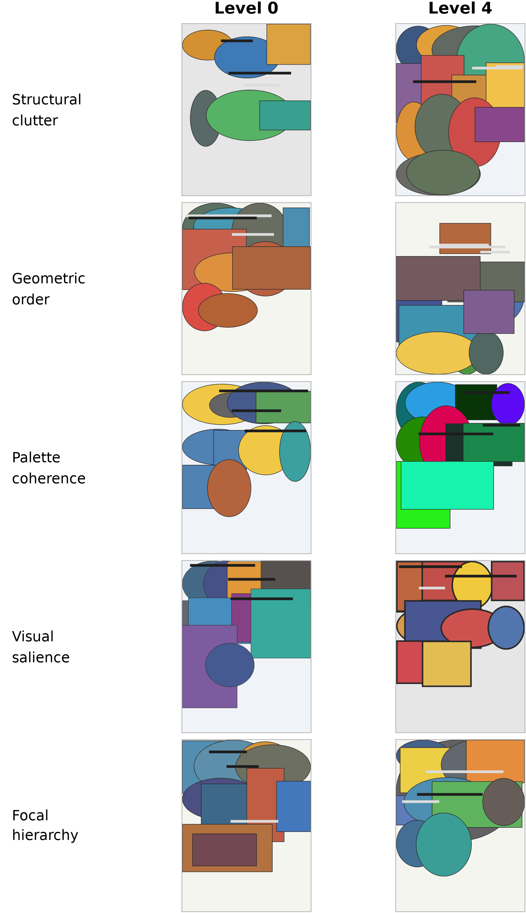
Figure 1. Pillow development examples at the lowest and highest intervention levels. The panels visualise controlled renderer variables, not human perceptual labels.

Pre-fix/post-fix experiment
The preserved pre-fix feature matrix is bound by SHA-256 before re-extraction. The repaired extractor is then run across all 16,425 images. For the causal pre/post comparison, we construct a hybrid matrix by replacing only the ten saliency-derived columns in the pre-fix matrix; this isolates the fallback repair from the separate deterministic k-means change. The fully re-extracted pipeline is reported as the final implementation and bound by its own input hash. Field-level gates compare the six directly affected active columns, and formula-level analysis compares retained absolute weight and nominal G-test association under the same G-dev-only scaling policy.

Development-selected baselines and controls
Each case subject has three elementary candidates. Complexity candidates are grey entropy, Canny edge fraction, and edge fraction multiplied by non-whitespace area. Order candidates are horizontal symmetry, negative local-contrast CV, and whitespace fraction; the earlier $1−symmetry$ candidate was removed because it is rank-equivalent to symmetry. Harmony candidates are the internal colour-harmony score, negative colour entropy, and negative saturation-based colourfulness. Intensity candidates are Lab lightness contrast, HSV value spread, and mean saturation. Hierarchy candidates are saliency dispersion, above-mean salient area, and edge fraction. Selection uses G-dev only.
The ridge control uses every finite numeric feature that varies on G-dev. Regularisation is selected on G-validation and both G-test and the second renderer remain held out. Its purpose is to determine whether the available pixel feature space contains recoverable signal; it is not a perceptual predictor or a formal decision gate.

Separately implemented OpenCV renderer
The second renderer does not import the Pillow drawing functions or scene graph. A 125-row finite-field design assigns five levels to clutter, disorder, palette incoherence, salience, and hierarchy with pairwise-orthogonal factor columns. Ten seeds yield 1,250 images. Direct factor levels provide the OpenCV targets. Protocol-v5 G-dev feature constants and score bounds are applied without retuning.
We report every pairing between the five targets and twelve image descriptors: six pre-fixed operational descriptors and the six repaired saliency-dependent fields. The operational set comprises Canny edge fraction, multiscale Lab residual entropy, JPEG bytes per pixel at fixed quality, Hasler–Suesstrunk colourfulness (Hasler and Suesstrunk 2003), global luminance coefficient of variation, and horizontal mirror similarity. Full crossing tables test whether a nominal response is accompanied by larger non-target responses. For each composite we separately audit the raw weighted sum and the final clipped 0–100 score, because frozen development bounds can collapse an otherwise varying raw score under renderer shift. The second renderer remains internally controlled synthetic evidence, not natural-image or external-team validation.

Reproducibility procedure
Protocol v5 records input hashes, G-dev target and feature constants, score bounds, weighted-feature health, clipping and tie diagnostics, all 25 associations, baseline selection, paired intervals, and ridge controls. Protocol v6 force-renders every OpenCV image, binds caches to complete ordered image hashes, recomputes features and descriptors, and records semantic-health and mechanism-crossing tables. The Tier-B research object includes source, all 17,675 images, manifests, dependency locks, tests, and hash-exact result inventories. A clean-environment run and an intentional stale-payload substitution test are required before promotion.

Results

RQ1: the semantic gates expose a reproducible inactive path
The pre-fix control is complete, finite, and hash stable, yet all six saliency-dependent fields have one value across the 16,425 Pillow images. The repaired extraction returns 16,413 unique map means, 16,409 unique map standard deviations, 12,610 unique salient-area fractions, and 16,425 unique values for each centroid-derived thirds or offset field. All post-fix active weighted features pass the G-dev responsiveness gate; no image is missing and no numeric feature is non-finite.
The defect was concentrated but consequential. Table 1 shows that the constant map removed 15% of the order formula’s absolute weight and 45% of hierarchy’s. Replacing only the ten saliency-derived columns raises order’s nominal G-test correlation from 0.227 to 0.275 ($Δρ=0.047$) but lowers hierarchy from 0.524 to 0.260 ($Δρ=−0.263$). Complexity, harmony, and intensity do not use an affected field and remain unchanged in the saliency-only comparison. The fully re-extracted pipeline, which also makes k-means deterministic, gives 0.623 for complexity and $−0.098$ for harmony; their differences from the saliency-only control are small.
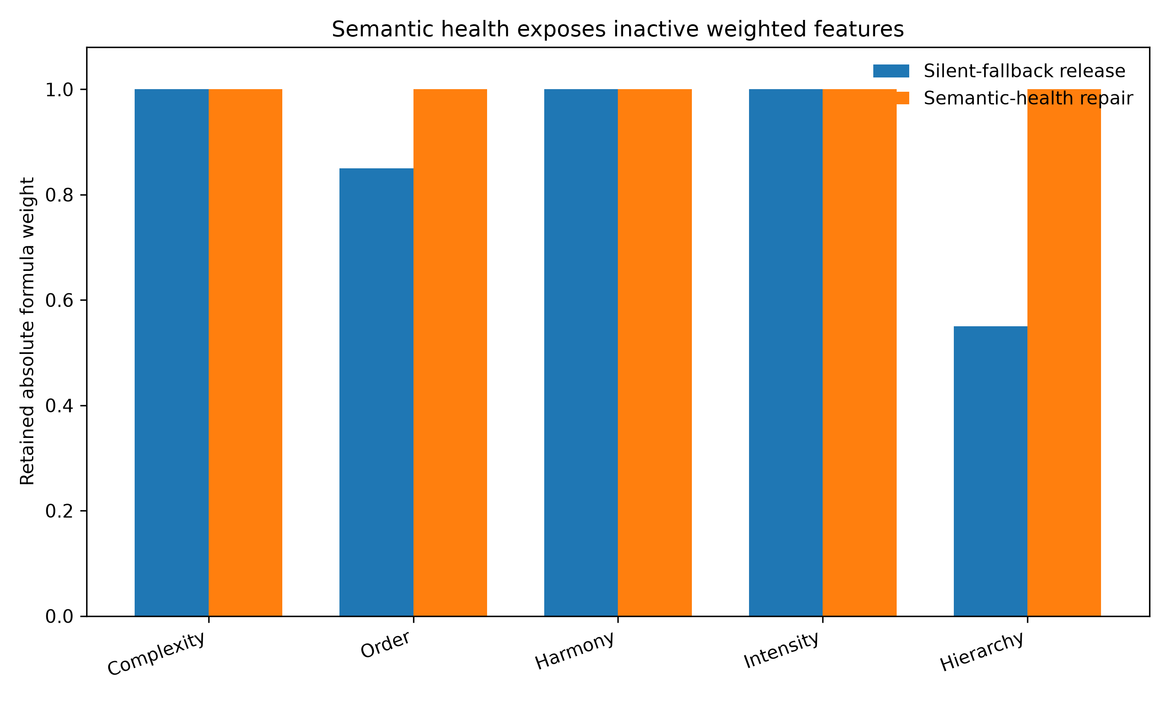
Figure 2. Fraction of absolute formula weight attached to responsive G-dev features before and after repair. Byte-level reproduction did not reveal the lost order and hierarchy terms.
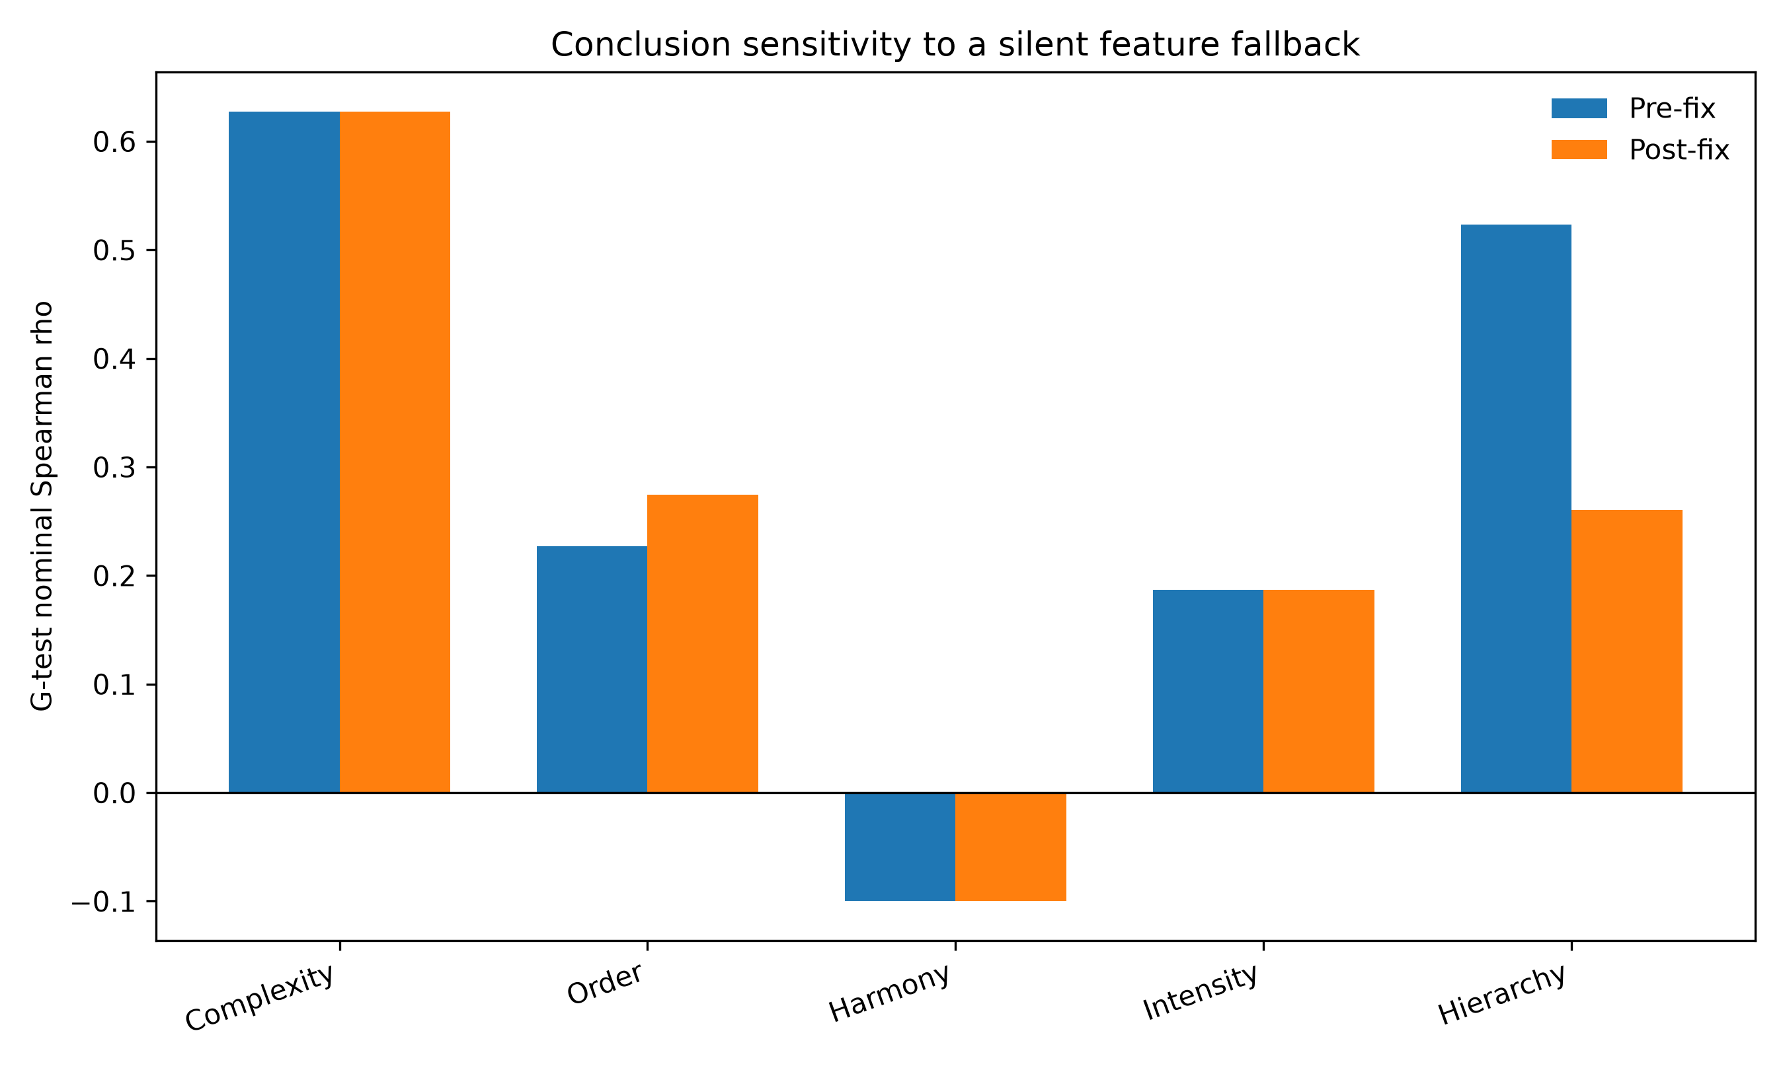
Figure 3. G-test nominal associations before and after replacing only saliency-derived columns. Repair improves order but substantially weakens the previously favourable hierarchy result.
Score-distribution checks reveal additional stress even within the primary renderer. On G-test, final clipping affects 39.3% of complexity values, 25.2% of order, 16.7% of intensity, 5.1% of hierarchy, and 3.0% of harmony. The largest exact tie equals the boundary mass for complexity and order. These scores remain nonconstant on Pillow G-test, but the diagnostics warn that a correlation can depend heavily on a clipped tail.

RQ2: corrected held-out conclusions
Table 2 reports the fully repaired pipeline with target, feature, and score scaling fitted on G-dev only. Complexity has the largest nominal association ($ρ=0.623$, seed-cluster 95% CI $[0.615,0.630]$), but its largest non-target association is stronger ($|ρ|=0.667$), giving a selectivity margin of $−0.044$. Order, intensity, and hierarchy also respond more strongly to another target. Harmony has a small positive margin, but its nominal direction is negative ($ρ=−0.098$). Thus none of the five legacy names is supported as a selective operational label by this controlled G-test.
Development-only baseline selection changes the earlier overbroad “all composites lose” claim (Table 3). The order composite exceeds its G-dev-selected whitespace baseline on G-test by 0.045, with paired cluster interval $[0.032,0.057]$. Complexity is 0.051 below contour density; harmony is 0.290 below negative colourfulness; intensity is 0.137 below luminance spread; and hierarchy is 0.490 below edge coverage. The order gain is real within this protocol, but its negative selectivity margin prevents a broader construct claim.
Pixel-side controls in Table 4 show that the corrected feature matrix contains target information, although transfer varies sharply. On Pillow G-test, ridge correlations range from 0.362 for palette coherence to 0.855 for focal hierarchy. On the OpenCV renderer they range from 0.102 to 0.646. All 38 numeric features vary on G-dev, so these results no longer benefit from nominal-but-constant columns. The weak cross-renderer palette and hierarchy probes limit attribution of a formula failure to the formula alone.

RQ3: feature repair survives, score rescaling does not always survive
All six repaired saliency-dependent fields remain finite and nonconstant on the 1,250 OpenCV images. Their unique counts range from 1,218 for salient-area fraction to 1,250 for five fields. The factor design is exactly pairwise orthogonal (maximum off-diagonal target $|ρ|=0$), whereas the Pillow G-test target system reaches 0.783. This contrast makes the second renderer useful for mechanism crossing, but it is not a natural-image validation set.
At the feature layer, the repair transfers. At the score layer, two formulas collapse. Every OpenCV complexity and intensity raw sum falls below its frozen G-dev 0–100 lower bound; both final scores are therefore constant zero. Order is nonconstant but 74.1% of its final values lie at the upper boundary. Table 6 separates the raw and final results: complexity’s raw sum has $ρ=0.895$ with clutter and intensity’s has $ρ=0.674$ with salience, yet both published-range scores have $ρ=0$. The defect is no longer a missing optional dependency; it is a domain-shift failure of the frozen rescaling layer.
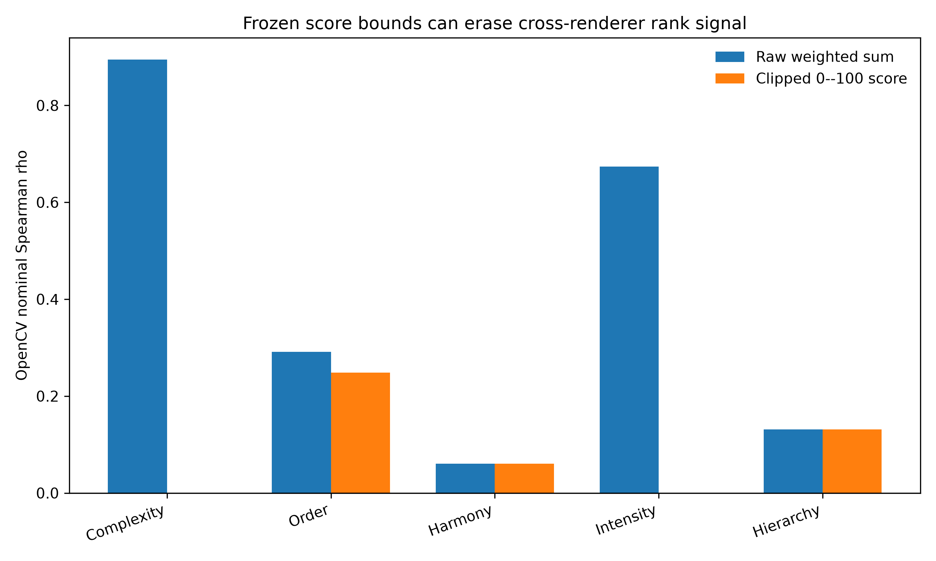
Figure 4. Nominal OpenCV associations before and after the frozen G-dev 0–100 transformation. Complexity and intensity retain rank signal in their raw weighted sums but lose all variation after clipping.
The operational descriptors in Table 5 provide positive and negative mechanism checks. Canny edge fraction, Lab residual entropy, and JPEG bytes per pixel respond positively to clutter in both renderers. Luminance coefficient of variation responds to salience, and mirror similarity responds to order. Hasler–Suesstrunk colourfulness is negatively related to Pillow palette coherence but shows no stable OpenCV response ($ρ=0.005$, interval $[−0.051,0.061]$). Five of six nominal comparators therefore retain the expected interval sign in both internal systems.
The complete crossing table adds a stricter interpretation. Repaired saliency dispersion is negatively associated with Pillow focal hierarchy ($−0.074$) but positively associated with OpenCV hierarchy (0.265); salient-area fraction changes sign; and centroid offsets respond to order with different magnitudes. These mechanisms are active, but their relation to the generator target is not invariant. Likewise, raw OpenCV order and hierarchy remain more responsive to non-targets than to their nominal target. The second renderer therefore confirms software responsiveness while rejecting simple attribution.

Reproducibility outcome
The primary test suite contains 56 tests and passes after the repair. Protocol v5 releases G-dev target and feature constants, weighted-feature health, clipping and tie diagnostics, all 25 G-test associations, baseline candidates and selections, paired intervals, controls, input hashes, and runtime versions. Protocol v6 releases all image hashes, six field-level health rows, five score-level health rows, 120 renderer–descriptor–target intervals, raw and clipped composite tables, and ridge intervals. Clean-environment and package-level verification are reported with the research object rather than inferred from local execution alone.
Table 1. Semantic-health repair on the primary G-test split. Retained weight is the fraction of absolute formula weight attached to nonconstant G-dev inputs. Intervals resample ten seeds as clusters.
Legacy composite | Pre retained | Post retained | Pre-fix $ρ$ | Post-fix $ρ$ | $Δρ$
Complexity | 1.00 | 1.00 | 0.628 | 0.628 | 0.000
Order | 0.85 | 1.00 | 0.227 | 0.275 | 0.047
Harmony | 1.00 | 1.00 | -0.100 | -0.100 | 0.000
Intensity | 1.00 | 1.00 | 0.187 | 0.187 | 0.000
Hierarchy | 0.55 | 1.00 | 0.524 | 0.260 | -0.263
Table 2. Corrected G-test associations after G-dev-only target and feature scaling. All 25 associations are released; the table shows nominal pairs and the strongest non-target response.
Composite | Target | $ρ$ | Seed-cluster 95% CI | Max other $|ρ|$ | Margin
Complexity | Structural clutter | 0.623 | [0.615, 0.630] | 0.667 | -0.044
Order | Geometric order | 0.275 | [0.256, 0.294] | 0.605 | -0.330
Harmony | Palette coherence | -0.098 | [-0.113, -0.081] | 0.065 | 0.033
Intensity | Visual salience | 0.187 | [0.167, 0.207] | 0.504 | -0.317
Hierarchy | Focal hierarchy | 0.260 | [0.227, 0.288] | 0.367 | -0.107
Table 3. Elementary baselines selected on G-dev and locked before paired G-test evaluation. $Δρ=ρ_{composite}−ρ_{baseline}$.
Composite | Locked baseline | Composite $ρ$ | Baseline $ρ$ | $Δρ$ | Seed-cluster 95% CI
Complexity | Contour Density | 0.623 | 0.673 | -0.051 | [-0.059, -0.042]
Order | Whitespace Ratio | 0.275 | 0.229 | 0.045 | [0.032, 0.057]
Harmony | Negative Colourfulness | -0.098 | 0.193 | -0.290 | [-0.320, -0.261]
Intensity | Luminance Spread | 0.187 | 0.324 | -0.137 | [-0.156, -0.120]
Hierarchy | Edge Coverage | 0.260 | 0.750 | -0.490 | [-0.520, -0.465]
Table 4. Pixel-side ridge recoverability probes. Alpha was selected on G-validation; G-dev-constant features were removed; intervals resample ten seeds. These are scope diagnostics, not perceptual validation.
Target | Features | Pillow $ρ$ | Pillow 95% CI | OpenCV $ρ$ | OpenCV 95% CI
Structural clutter | 38 | 0.667 | [0.655, 0.679] | 0.374 | [0.359, 0.387]
Geometric order | 38 | 0.479 | [0.464, 0.494] | 0.514 | [0.501, 0.529]
Palette coherence | 38 | 0.362 | [0.340, 0.386] | 0.102 | [0.039, 0.170]
Visual salience | 38 | 0.718 | [0.713, 0.722] | 0.646 | [0.613, 0.685]
Focal hierarchy | 38 | 0.855 | [0.849, 0.861] | 0.293 | [0.275, 0.314]
Table 5. Pre-fixed operational descriptors on the two controlled renderers. Each cell reports Spearman $ρ$ and its ten-seed cluster interval.
Descriptor | Nominal target | Pillow G-test | Internal OpenCV
Canny edge fraction | Structural clutter | 0.663 [0.656, 0.671] | 0.468 [0.445, 0.491]
Lab residual entropy | Structural clutter | 0.533 [0.520, 0.549] | 0.709 [0.667, 0.764]
JPEG bytes/pixel | Structural clutter | 0.485 [0.469, 0.500] | 0.774 [0.739, 0.812]
Colourfulness | Palette coherence | -0.184 [-0.211, -0.156] | 0.005 [-0.051, 0.061]
Luminance CV | Visual salience | 0.265 [0.245, 0.287] | 0.856 [0.835, 0.889]
Mirror similarity | Geometric order | 0.318 [0.292, 0.344] | 0.640 [0.610, 0.671]
Table 6. Corrected legacy composites on the pairwise-orthogonal internal OpenCV renderer ($n=1,250$, ten seeds). Each association is followed by its seed-cluster 95% interval.
Composite | Final score $ρ$ [95% CI] | Raw sum $ρ$ [95% CI] | Final margin
Complexity | 0.000 [0.000, 0.000] | 0.895 [0.884, 0.904] | 0.000
Order | 0.249 [0.229, 0.268] | 0.291 [0.280, 0.301] | -0.418
Harmony | 0.061 [-0.132, 0.221] | 0.061 [-0.136, 0.222] | -0.217
Intensity | 0.000 [0.000, 0.000] | 0.674 [0.620, 0.730] | 0.000
Hierarchy | 0.131 [0.099, 0.167] | 0.131 [0.098, 0.165] | -0.315

Discussion

What semantic health adds to reproducibility
The central result is not that one saliency algorithm is preferable to another. It is that a deterministic research object can preserve an inactive computation with high fidelity. The pre-fix matrix passed row-count, finite-value, schema, and hash checks. Only a semantic invariant—a weighted saliency feature should vary across diverse non-uniform images—made the defect visible. Retained weight then connected the field failure to formula semantics, and the saliency-only replacement connected it to held-out conclusions.
The same logic exposed a second failure after the first was repaired. OpenCV saliency features varied normally, and the raw complexity and intensity sums strongly tracked their nominal factors. Nevertheless, the final scores were constant because the G-dev percentile map placed the entire second domain below zero before clipping. A feature-health gate alone would have passed; a score-distribution gate caught the collapse. Reproducible visual pipelines therefore need invariants at input, intermediate representation, composite, and exported-score layers.

Repair can invalidate a favourable result
Software repair is sometimes described as a route to improved performance. Here, hierarchy falls by 0.263 when the constant fallback is replaced. The old favourable association depended on the remaining 55% of the formula, especially edge and projection terms; adding the intended saliency variation exposes their mismatch with the target. This is scientifically valuable because it prevents a nonfunctional component from receiving explanatory credit. The order gain is smaller and positive, showing that the direction of correction cannot be assumed.

Development discipline changes baseline claims
Selecting the strongest baseline on G-test had supported an “all five lose” narrative. Selecting on G-dev and locking before G-test leaves four losses but identifies a small order advantage. The correction does not rescue the order label: the composite correlates more strongly with structural clutter than geometric order. It does demonstrate why baseline selection is part of the model-development process and should not be hidden inside final evaluation. Rejecting sign-reversed rank duplicates is equally important for rank-based metrics; $s$ and $1−s$ are not two independent candidates.

Relation to contemporary complexity research
Modern complexity datasets and models combine local detail, global context, semantics, and human annotation (Feng et al. 2023; Kyle-Davidson et al. 2023; Guo et al. 2026). Our controlled engineering targets cover only a subset of low-level and layout mechanisms. The poor selectivity of several formulas and the cross-renderer mechanism reversals are therefore unsurprising and should not be read as evidence against perceptual complexity research. Instead, they show why an operational formula needs an identifiable use case, appropriate reference methods, and evidence at the level claimed.
The present gates are compatible with learned systems. A deep embedding dimension need not vary individually, but a declared score, attention map, localisation head, or ablation pathway can still be assigned a semantic invariant. Examples include nonconstant response to a positive control, preservation of expected ranking under a controlled intervention, bounded clipping under a documented shift, and distinction from a supposedly different baseline. The invariant must be justified by the component’s declared role, not chosen after observing final performance.

Limits
Both renderers are authored and controlled within the project and use simple geometric primitives. Ten seeds support cluster-sensitive intervals but not broad population inference. The five formulas are historical case subjects without externally validated use cases. The spectral-residual map is a deterministic operational descriptor, not fixation or salient-object ground truth. The second renderer establishes neither natural-image generalisation nor independent replication. Human studies remain necessary for perceptual complexity, aesthetics, harmony, or preference.
The raw-versus-clipped OpenCV result also creates a design choice that this paper does not resolve universally. Removing clipping, refitting bounds on the new domain, or using a monotone unbounded output would preserve rank signal, but each changes the score contract. We report the failure rather than retune on the held-out renderer. Future work should predeclare whether cross-domain comparability concerns absolute calibration, rank order, or both.

Practical implications
For a deterministic visual-feature release, we recommend five minimum checks: fail on missing optional dependencies; assert responsiveness for every nonzero-weight input on development controls; report retained formula weight; reject rank-equivalent baseline candidates before selection; and audit exported-score ties and boundary mass on every evaluation domain. These checks are inexpensive relative to feature extraction and can run in continuous integration. Hashes remain essential, but they should bind an artefact only after its semantic gates pass.

Conclusion
A silent optional-dependency fallback produced a complete, finite, deterministic, and semantically inactive saliency path across 17,675 controlled images. Replacing it with fail-fast spectral-residual saliency restored all weighted inputs, raised order’s held-out association by 0.047, and lowered hierarchy’s by 0.263. The latter change shows why repair must be evaluated rather than assumed to improve a result.
The multi-layer gates then detected a different cross-renderer failure: raw complexity and intensity retained strong OpenCV rank signal, but frozen G-dev score bounds collapsed both exported scores to zero. Development-only baseline selection also corrected an overbroad all-five-loss claim. Together, these results show that byte-level reproducibility, feature responsiveness, score health, and evaluation discipline answer different questions.
The contribution is a reusable software-testing pattern and a fully traced two-renderer failure analysis, not a validated perceptual scale or natural-image benchmark. Deterministic visual-feature research objects should bind hashes to computations that have first passed explicit semantic invariants at every layer that carries scientific meaning.

Declaration of competing interest
The authors declare that they have no known competing financial interests or personal relationships that could have appeared to influence the work reported in this paper.

Author contributions
Ming Zhu: Conceptualization, Methodology, Software, Validation, Writing — review and editing. Zihang Xue: Methodology, Software, Formal analysis, Data curation, Visualization, Writing — original draft, Writing — review and editing. Both authors approved the final manuscript.

Data and code availability
The computational pipeline, exact feature definitions, reported tables, and canonical image manifests are in the versioned submission archive. The runnable Tier B release contains all 16,425 Pillow images, all 1,250 internally controlled OpenCV images, the preserved pre-fix control, repaired features, protocol-v5 and protocol-v6 code, G-dev-frozen constants, complete crossing tables, pinned software, checksums, semantic assertions, and forced clean-recomputation logs. No restricted source contributes an empirical row or scaling constant to the active analysis. Historical mixed-licence material remains excluded. Before external submission, this exact archive must be deposited in a repository that issues a persistent identifier; the DOI/URL and release tag must then replace the local placeholder in the submission record.

Ethics statement
The active study contains no human raters, no human-subject data collection, no recruitment, no rating forms, and no scores. Historical human-study material is retained as project records but is excluded from the active no-human pipeline and release package.

Declaration of generative AI and AI-assisted technologies in the manuscript preparation process
During the preparation of this work, the authors used OpenAI ChatGPT and Codex to support language editing, literature organisation, and code review. The authors subsequently reviewed and edited all outputs, verified the cited sources and numerical claims against the released artifacts, and take full responsibility for the content of the article. No generative-AI system was used to create or alter the reported research images or figures.

Funding
This research received no external funding.

Acknowledgments
The authors thank the maintainers of the open-source scientific software used in the reproducibility workflow.

References
Cronbach, Lee J., and Paul E. Meehl. 1955. “Construct Validity in Psychological Tests.” Psychological Bulletin 52 (4): 281–302. https://doi.org/10.1037/h0040957.
Donderi, Don C. 2006. “Visual Complexity: A Review.” Psychological Bulletin 132 (1): 73–97. https://doi.org/10.1037/0033-2909.132.1.73.
Feng, Tinglei, Yingjie Zhai, Jufeng Yang, et al. 2023. “IC9600: A Benchmark Dataset for Automatic Image Complexity Assessment.” IEEE Transactions on Pattern Analysis and Machine Intelligence 45 (7): 8577–93. https://doi.org/10.1109/TPAMI.2022.3232328.
Flake, Jessica K., and Eiko I. Fried. 2020. “Measurement Schmeasurement: Questionable Measurement Practices and How to Avoid Them.” Advances in Methods and Practices in Psychological Science 3 (4): 456–65. https://doi.org/10.1177/2515245920952393.
Forsythe, Alex, Marcos Nadal, Noel Sheehy, Camilo J. Cela-Conde, and Matthew Sawey. 2011. “Predicting Beauty: Fractal Dimension and Visual Complexity in Art.” British Journal of Psychology 102 (1): 49–70. https://doi.org/10.1348/000712610X498958.
Guo, Xiaoying, Liang Li, Tao Yan, Lu Wang, and Yuhua Qian. 2026. “Aligning Computational and Human Perceptions of Image Complexity: A Dual-Task Framework for Prediction and Localization.” Journal of Visual Communication and Image Representation, 104686. https://doi.org/10.1016/j.jvcir.2025.104686.
Hasler, David, and Sabine E. Suesstrunk. 2003. “Measuring Colorfulness in Natural Images.” Human Vision and Electronic Imaging VIII 5007: 87–95. https://doi.org/10.1117/12.477378.
He, Shuai, Anlong Ming, Yaqi Li, Jinyuan Sun, Shuntian Zheng, and Huadong Ma. 2023. “Thinking Image Color Aesthetics Assessment: Models, Datasets and Benchmarks.” 2023 IEEE/CVF International Conference on Computer Vision, 21781–90. https://doi.org/10.1109/ICCV51070.2023.01996.
He, Shuai, Yongchang Zhang, Rui Xie, Dongxiang Jiang, and Anlong Ming. 2022. “Rethinking Image Aesthetics Assessment: Models, Datasets and Benchmarks.” Proceedings of the Thirty-First International Joint Conference on Artificial Intelligence, 942–48. https://doi.org/10.24963/ijcai.2022/132.
Hou, Xiaodi, and Liqing Zhang. 2007. “Saliency Detection: A Spectral Residual Approach.” 2007 IEEE Conference on Computer Vision and Pattern Recognition, 1–8. https://doi.org/10.1109/CVPR.2007.383267.
Itti, Laurent, Christof Koch, and Ernst Niebur. 1998. “A Model of Saliency-Based Visual Attention for Rapid Scene Analysis.” IEEE Transactions on Pattern Analysis and Machine Intelligence 20 (11): 1254–59. https://doi.org/10.1109/34.730558.
Kong, Shu, Xiaohui Shen, Zhe Lin, Radomir Mech, and Charless Fowlkes. 2016. “Photo Aesthetics Ranking Network with Attributes and Content Adaptation.” European Conference on Computer Vision, 662–79. https://doi.org/10.1007/978-3-319-46448-0_40.
Kyle-Davidson, Cameron, Elizabeth Yue Zhou, Dirk B. Walther, Adrian G. Bors, and Karla K. Evans. 2023. “Characterising and Dissecting Human Perception of Scene Complexity.” Cognition 231: 105319. https://doi.org/10.1016/j.cognition.2022.105319.
Maerten, Anne-Sofie, Li-Wei Chen, Stefanie De Winter, Christophe Bossens, and Johan Wagemans. 2025. “LAPIS: A Novel Dataset for Personalized Image Aesthetic Assessment.” Proceedings of the IEEE/CVF Conference on Computer Vision and Pattern Recognition Workshops, 6356–65. https://openaccess.thecvf.com/content/CVPR2025W/CVEU/html/Maerten_LAPIS_A_novel_dataset_for_personalized_image_aesthetic_assessment_CVPRW_2025_paper.html.
Murray, Naila, Luca Marchesotti, and Florent Perronnin. 2012. “AVA: A Large-Scale Database for Aesthetic Visual Analysis.” 2012 IEEE Conference on Computer Vision and Pattern Recognition, 2408–15. https://doi.org/10.1109/CVPR.2012.6247954.
Ngo, David Chek Ling, Lian Seng Teo, and John G. Byrne. 2003. “Modelling Interface Aesthetics.” Information Sciences 152: 25–46. https://doi.org/10.1016/S0020-0255(02)00404-8.
Oquab, Maxime, Timothée Darcet, Théo Moutakanni, et al. 2024. “DINOv2: Learning Robust Visual Features Without Supervision.” Transactions on Machine Learning Research. https://openreview.net/forum?id=a68SUt6zFt.
Peli, Eli. 1990. “Contrast in Complex Images.” Journal of the Optical Society of America A 7 (10): 2032–40. https://doi.org/10.1364/JOSAA.7.002032.
Pineau, Joelle, Philippe Vincent-Lamarre, Koustuv Sinha, et al. 2021. “Improving Reproducibility in Machine Learning Research: A Report from the NeurIPS 2019 Reproducibility Program.” Journal of Machine Learning Research 22 (164): 1–20. https://jmlr.org/papers/v22/20-303.html.
Radford, Alec, Jong Wook Kim, Chris Hallacy, et al. 2021. “Learning Transferable Visual Models from Natural Language Supervision.” Proceedings of the 38th International Conference on Machine Learning, Proceedings of machine learning research, vol. 139: 8748–63. https://proceedings.mlr.press/v139/radford21a.html.
Rosenholtz, Ruth, Yuanzhen Li, and Lisa Nakano. 2007. “Measuring Visual Clutter.” Journal of Vision 7 (2): 17:1–22. https://doi.org/10.1167/7.2.17.
Saraee, Elham, Mona Jalal, and Margrit Betke. 2020. “Visual Complexity Analysis Using Deep Intermediate-Layer Features.” Computer Vision and Image Understanding 195: 102949. https://doi.org/10.1016/j.cviu.2020.102949.
Shen, Tingke, Surabhi S. Nath, Aenne Brielmann, and Peter Dayan. 2024. “Simplicity in Complexity: Explaining Visual Complexity Using Deep Segmentation Models.” arXiv Preprint arXiv:2403.03134, ahead of print. https://doi.org/10.48550/arXiv.2403.03134.
Sun, Zekun, and Chaz Firestone. 2021. “Curious Objects: How Visual Complexity Guides Attention and Engagement.” Cognitive Science 45 (4): e12933. https://doi.org/10.1111/cogs.12933.
Tobin, Josh, Rachel Fong, Alex Ray, Jonas Schneider, Wojciech Zaremba, and Pieter Abbeel. 2017. “Domain Randomization for Transferring Deep Neural Networks from Simulation to the Real World.” 2017 IEEE/RSJ International Conference on Intelligent Robots and Systems, 23–30. https://doi.org/10.1109/IROS.2017.8202133.
Torralba, Antonio, and Alexei A. Efros. 2011. “Unbiased Look at Dataset Bias.” 2011 IEEE Conference on Computer Vision and Pattern Recognition, 1521–28. https://doi.org/10.1109/CVPR.2011.5995347.
Wu, Ou, Weiming Hu, and Lei Shi. 2013. “Measuring the Visual Complexities of Web Pages.” ACM Transactions on the Web 7 (1): 1:1–34. https://doi.org/10.1145/2435215.2435216.
Yan, Xingao, Feng Shao, Hangwei Chen, and Qiuping Jiang. 2024. “Hybrid CNN-Transformer Based Meta-Learning Approach for Personalized Image Aesthetics Assessment.” Journal of Visual Communication and Image Representation 98: 104044. https://doi.org/10.1016/j.jvcir.2023.104044.
Yang, Shuai, Zibei Wang, Guangao Wang, et al. 2024. “A Self-Supervised Image Aesthetic Assessment Combining Masked Image Modeling and Contrastive Learning.” Journal of Visual Communication and Image Representation 101: 104184. https://doi.org/10.1016/j.jvcir.2024.104184.
Yang, Yuzhe, Liwu Xu, Leida Li, et al. 2022. “Personalized Image Aesthetics Assessment with Rich Attributes.” 2022 IEEE/CVF Conference on Computer Vision and Pattern Recognition, 19829–37. https://doi.org/10.1109/CVPR52688.2022.01924.

