SIMATS ENGINEERING
ASSESSMENT TOOL 2
COURSE NAME: Ethical Hacking
COURSE CODE: ITA14

CO2: Foot printing Tools: Conducting Competitive Intelligence, DNS Zone Transfers, Introduction to Social
Engineering: Social Engineering Attacks and Countermeasures.

- As a Security Analyst, perform an OSINT-based email enumeration assessment on the target domain tesla.com using theHarvester in Kali Linux. Collect publicly available email addresses, subdomains,hosts, and IP addresses associated with the organization. Categorize the discovered email addresses into likely roles such as Support, Sales, Human Resources, Administration, and Technical Teams. Analyze how the gathered information could assist an attacker during the reconnaissance phase and explain how it could be used for spear-phishing, credential harvesting, and impersonation attacks. Finally, recommend at least five countermeasures to reduce information leakage and social engineering risks, and submit a report with screenshots, commands executed, findings, risk analysis, and recommendations.
A)

Aim
To perform an OSINT-based reconnaissance assessment using theHarvester and understand how publicly available information may be used during the reconnaissance phase of a cyber attack.

Tool Used
- Kali Linux
- theHarvester

Command
theHarvester -d tesla.com -b bing
Alternative:
theHarvester -d tesla.com -b yahoo
or
theHarvester -d tesla.com -b crtsh

Screenshot
(Insert Screenshot of Terminal showing command execution)

Sample Findings (Illustrative)
Category | Example
Domain | tesla.com
Emails | Publicly available business email addresses (if any)
Subdomains | careers.tesla.com, shop.tesla.com
Hosts | mail.tesla.com
IP Address | Public IP associated with discovered hosts
Note: Include only information you actually collected in your lab. Do not fabricate or rely on stale data.

Categorization of Email Addresses
Email Pattern | Possible Department
support@ | Support Team
sales@ | Sales Department
hr@ | Human Resources
admin@ | Administration
it@ | Technical Team

Risk Analysis
The information collected during OSINT can assist attackers in the reconnaissance phase by:
- Identifying employees and departments.
- Mapping organizational infrastructure.
- Discovering email naming conventions.
- Understanding publicly exposed services.
Potential misuse includes:
Spear Phishing
Attackers can send highly personalized emails pretending to be company executives or trusted departments.
Credential Harvesting
Fake login pages may be sent to employees to steal usernames and passwords.
Impersonation
Attackers can impersonate IT support or HR staff using known email formats to gain trust.

Countermeasures
- Limit public exposure of employee email addresses.
- Use security awareness training for employees.
- Enable Multi-Factor Authentication (MFA).
- Implement SPF, DKIM, and DMARC.
- Monitor public information leakage regularly.
- Use email filtering and anti-phishing solutions.
- Verify sensitive requests through secondary communication channels.

Conclusion
OSINT tools like theHarvester help security teams identify publicly exposed organizational information. Proper security controls can reduce the risk of reconnaissance and social engineering attacks.

2) As a cybersecurity awareness consultant, you are required to conduct a phishing awareness simulation using GoPhish and dummy employee accounts provided in the lab. Create an email template, launch a campaign, monitor user interactions, and generate a report showing delivery rate, email open rate, and click rate. Based on the results, provide recommendations to improve user awareness against phishing attacks.

A)

Aim
To perform a phishing awareness simulation using GoPhish and evaluate employee awareness.

Tool Used
- GoPhish
- Kali Linux

Steps
- Start GoPhish.
- Login to the GoPhish dashboard.
- Create a landing page.
- Create an email template.
- Add dummy employee accounts.
- Launch the phishing campaign.
- Monitor campaign statistics.
- Generate the report.

Sample Email Template
Subject:
Password Expiration Notice
Body:
Dear Employee,

Your company password will expire today.

Please click the link below to reset your password.

https://company-login.example

Thank you,
IT Support Team
(Use only dummy domains and accounts in the lab.)

Screenshot
- GoPhish Dashboard
- Email Template
- Campaign Launch
- Campaign Results

Sample Campaign Report
Metric | Value
Emails Sent | 20
Delivered | 20
Open Rate | 16 (80%)
Click Rate | 6 (30%)
Credentials Submitted | 0 (or your lab result)

Analysis
The campaign demonstrates how phishing emails can influence user behavior. Employees who clicked links may require additional awareness training.

Recommendations
- Conduct regular phishing simulations.
- Provide security awareness training.
- Encourage reporting of suspicious emails.
- Enable MFA.
- Verify email sender addresses.
- Avoid clicking unknown links.
- Use secure email gateways.

Conclusion
Regular phishing simulations improve employee awareness and help organizations reduce the risk of successful phishing attacks.

3) Using Nmap Aggressive Scan (-A) on scanme.nmap.org, gather detailed information about the target including operating system details, open ports, and service versions. Assume you are an attacker and describe how the collected information could be leveraged to conduct a social engineering attack against the IT support team. Prepare a report explaining the attack methodology and defensive recommendations.

A)
Aim
To perform an Nmap Aggressive Scan on scanme.nmap.org and understand how service information can influence social engineering risks.

Tool Used
- Kali Linux
- Nmap

Command
nmap -A scanme.nmap.org

Screenshot
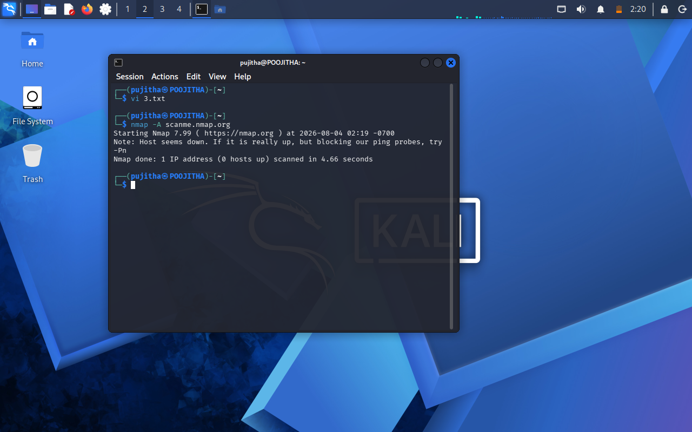

Sample Findings
Item | Result
Target | scanme.nmap.org
Status | Host Up
Open Ports | 22, 80
SSH | OpenSSH (version shown in your scan)
HTTP | Apache/Nginx (as reported by Nmap)
OS Detection | Linux (best match reported by Nmap)
Use the actual output from your scan rather than copying sample values.

Social Engineering Attack Methodology
An attacker could:
- Identify publicly exposed services.
- Learn the operating system and software versions.
- Call the IT support team while pretending to troubleshoot an issue related to those services.
- Build credibility by referencing legitimate technologies discovered during reconnaissance.
- Attempt to obtain passwords or persuade staff to install unauthorized software.

Defensive Recommendations
- Do not disclose technical information over phone or email.
- Verify caller identity before sharing sensitive information.
- Conduct regular security awareness training.
- Use MFA for privileged accounts.
- Restrict unnecessary service exposure.
- Keep operating systems and software updated.
- Monitor logs for suspicious activity.

Conclusion
Nmap helps identify exposed services and system details. Although valuable for defenders, such information can also strengthen social engineering attempts if not managed carefully. Organizations should minimize unnecessary information exposure and train employees to verify requests before acting.

