SIMATS ENGINEERING (SAVEETHA SCHOOL OF ENGINEERING) Department of Computer Science and Engineering
ASSESSMENT TOOL 2 – EXPERIMENTATION
Course Code: | ITA03 | Course Title: | Mobile computing
CO Assessed: | CO2 | Assessment: | Assessment Tool 2 – EXPERIMENTATION
Weightage: | 30 % of CIA | Total Marks: | 100 marks
CO2 Statement: | Compare mobile communication technologies, including multiple access techniques and network evolution, based on performance and applications.
Student Name: | Sadda Rajeswari | Reg. No.: | 192312140
Section / Batch: | ECE | Date: | 24/10/2026

Code of Conduct
I Sadda Rajeswari(192312140) certify that this submission is my original work and that I have adhered to the guidelines specified for this assessment. I understand that any violation of academic integrity rules will result in disciplinary action.
Signature of the Student: Sadda Rajeswari

Instructions
• This test contains FIVE questions.
• Duration: 60 minutes (homework)

Faculty In-charge | Course Coordinator | Head of Department
Signature: _______________ | Signature: _______________ | Signature: _______________
Date: ___________________ | Date: ___________________ | Date: ___________________

Annexure A - QUESTIONS
1. Figma-Based Mobile IP Communication Workflow Analysis (BL4 – Analyze) Design an interactive Figma prototype illustrating the complete workflow of Mobile IP communication when a Mobile Node moves from its Home Network to a Foreign Network. Your design should include the Home Agent (HA), Foreign Agent (FA), Correspondent Node (CN), Care-of Address (CoA), Registration Process, and Packet Tunneling.
Analyze the communication process by identifying:
● The purpose of each network component.
● Points where packet delay or packet loss may occur.
● The effect of node mobility on communication performance.
● Possible improvements to reduce latency.
Deliverables:
● Figma (.fig) design
● GitHub repository containing exported images/PDF and documentation (README).

Ans: Aim
To design and analyze the Mobile IP communication process when a Mobile Node (MN) moves from its Home Network to a Foreign Network while maintaining communication with a Correspondent Node (CN).

  - System architecture

Home Network

Home Agent (HA)

Registration and packet tunnelling

Foreign Network

Foreign Agent (FA) — Care-of Address (CoA)

Mobile Node (MN)

Correspondent Node (CN)

Sends data to the Mobile Node's home address.

Figma design guide: Create these components using rectangles, icons, connectors, and arrows. Label each arrow with the packet or message type.

  - Functions of network components

Component | Purpose
Mobile Node (MN) | Mobile device that moves between networks.
Home Agent (HA) | Maintains the MN's home address and current location information.
Foreign Agent (FA) | Assists the MN in a foreign network in Mobile IPv4.
Care-of Address (CoA) | Identifies the MN's current point of attachment to the foreign network.
Correspondent Node (CN) | Device or server communicating with the MN.
Registration | Updates the HA with the MN's current CoA.
Packet tunneling | Encapsulates packets and forwards them from the HA toward the CoA.
1.3 Mobile IP communication workflow
- Home network: The MN initially communicates using its permanent home IP address.
- Movement: The MN enters a foreign network and detects that it has changed networks.
- CoA assignment: The MN obtains a Care-of Address through the FA or another supported address configuration mechanism.
- Registration: The MN registers its CoA with the HA, normally through a registration request and reply in Mobile IPv4.
- Packet tunneling: The CN sends packets to the MN's home address. The HA intercepts them and tunnels them to the CoA.
- Packet delivery: The packet is decapsulated at the tunnel endpoint and delivered to the MN.

  - Performance analysis

Issue | Effect | Improvement
Registration delay | Communication pauses during location updates. | Faster registration and optimized signaling.
Packet tunneling | Extra routing can increase latency. | Route optimization where supported.
Handoff delay | Packets may be lost during network switching. | Fast handoff and buffering.
Network congestion | Increases packet delay and loss. | Congestion control and efficient routing.
Security attacks | Fake registration may redirect traffic. | Authentication, integrity protection and secure signaling.

Effect of mobility: When the MN changes networks, it must obtain a new CoA and update its HA. Communication can continue, but registration and handoff may temporarily increase delay or cause packet loss.
1.5 Figma prototype screens
- Screen 1: MN in Home Network.
- Screen 2: MN moves to Foreign Network.
- Screen 3: CoA assignment and registration.
- Screen 4: Packet tunneling from HA to CoA.
- Screen 5: Performance issues and improvements.
Result: The design demonstrates how Mobile IP maintains communication across networks and identifies possible causes of delay and packet loss.

2. Comparative Network Architecture Design Using Figma (BL4 – Analyze)
Using Figma or draw.io, create a comparative architectural diagram showing both a Cellular Wireless Network and a Mobile Ad Hoc Network (MANET) operating in the same smart city environment. Analyze the architectures by comparing:
● Infrastructure dependency.
● Routing mechanisms.
● Scalability.
● Fault tolerance.
● Mobility support.
● Suitable application scenarios.
Highlight the advantages and limitations of each architecture through annotations in your design. Deliverables:
● Editable design file.
● GitHub repository with screenshots, comparison report, and design assets.

Ans:
Aim
To compare Cellular Wireless Networks and Mobile Ad Hoc Networks (MANETs) in a smart city environment.
2.1 Architecture diagram

A. Cellular Wireless Network
Cellular Core Network
Base Station
Mobile Users
Communication uses cellular infrastructure.

B. Mobile Ad Hoc Network (MANET)
Mobile nodes communicate directly or forward packets through other nodes.
2.2 Comparison
Parameter | Cellular Network | MANET
Infrastructure | Requires base stations and network infrastructure. | Operates without fixed infrastructure.
Routing | Uses cellular access and core-network routing. | Uses protocols such as AODV, DSR or OLSR.
Scalability | Supports large populations with planned capacity. | Scalability depends on node density, bandwidth and routing overhead.
Fault tolerance | A failed base station can disrupt local service. | Alternative paths may help if nodes remain connected.
Mobility | Supports mobility through cellular handover. | Routes must adapt as nodes move.
Energy | User devices communicate with network infrastructure. | Nodes may consume extra energy while forwarding others' packets.
Applications | 4G/5G phones, smart-city broadband, connected services. | Disaster recovery, temporary networks, military and vehicle networks.
2.3 Advantages and limitations
Cellular Network
- Advantages: Wide-area coverage, managed connectivity, high capacity in well-deployed networks.
- Limitations: Depends on infrastructure, coverage and operator availability.
MANET
- Advantages: Quick deployment, no fixed base station required, flexible communication.
- Limitations: Unstable routes, interference, limited battery power and changing network topology.

2.4 Figma design procedure
- Create a frame titled Smart City Network Comparison.
- Divide the frame into two sections.
- Draw the cellular tower, core network and mobile users on the left.
- Draw interconnected cars, phones and laptops on the right.
- Use arrows to indicate packet flow.
- Add green labels for advantages and red labels for limitations.
- Add a comparison table below the diagrams.
Result: The comparison shows that cellular networks are suitable for managed, wide-area connectivity, while MANETs are useful when infrastructure is unavailable or rapid deployment is required.

3. Routing Protocol Visualization and Analysis (BL4 – Analyze)
Develop an interactive visualization using Figma, Mermaid.js, D3.js, or any visualization framework illustrating the operation of one Proactive Routing Protocol and one Reactive Routing Protocol in a mobile wireless network.
Analyze:
● Route discovery process.
● Route maintenance mechanism.
● Routing overhead.
● Delay in establishing communication.
● Performance under high node mobility.
Include a comparative summary explaining which protocol performs better under different mobility conditions.
Deliverables:
● Source code/design files.
● GitHub repository with implementation, screenshots, and analysis report.

Ans:
Aim
To visualize and compare one proactive routing protocol and one reactive routing protocol in a mobile wireless network.
The selected protocols are OLSR (proactive) and AODV (reactive).

3.1 Proactive routing — OLSR
- Optimized Link State Routing (OLSR) maintains routes continuously, even when no data is being transmitted.
- Node A
- HELLO messages discover neighbors
- Topology information is exchanged using control messages
- Routing table is updated
- Data is forwarded using an available route
- Advantages: Low route-discovery delay because routes are maintained in advance.
- Limitations: Periodic control messages consume bandwidth and energy even when traffic is low.

3.2 Reactive routing — AODV
- Ad hoc On-Demand Distance Vector (AODV) discovers a route only when a source node needs to send data.
- Source Node A needs to send data to Node D
- Broadcast Route Request (RREQ)
- Intermediate nodes forward the request
- Destination or an eligible intermediate node returns Route Reply (RREP)
- Data transmission starts
- If a route breaks, AODV uses route-error messages and may discover a replacement route.
3.3 Protocol comparison
Feature | OLSR (Proactive) | AODV (Reactive)
Route discovery | Continuous | On demand
Initial communication delay | Usually low when a valid route exists | Higher when route discovery is required
Routing overhead | Periodic control traffic | Route-request and maintenance traffic
Route maintenance | Updates topology and routes periodically | Detects broken routes and initiates repair or rediscovery
High mobility | Frequent topology changes increase overhead | Frequent route breaks increase rediscovery delay
Best suited for | Networks with frequent communication and relatively stable topology | Networks with intermittent communication and limited need for routes
3.4 Performance analysis
- Low mobility, frequent traffic: OLSR often performs well because routes are readily available.
- Low traffic: AODV may save bandwidth by avoiding continuous topology updates.
- High mobility: Both protocols can experience packet loss and overhead. Performance depends on node density, traffic, link quality and mobility speed.
- Communication delay: OLSR generally has lower initial route-establishment delay; AODV introduces route-discovery delay when a route is not already available.
3.5 Interactive visualization code
Use this HTML file as a simple interactive demonstration. Save it as routing.html and open it in a browser.

Code:

<!DOCTYPE html>
<html>
<head>
<title>Routing Protocol Visualization</title>
<style>
body { font-family: Arial; text-align: center; }
button { padding: 10px; margin: 8px; }
#output { margin: 20px; padding: 20px; background: #e6f2ff; }
</style>
</head>
<body>
<h2>Mobile Network Routing</h2>
<button onclick="olsr()">OLSR - Proactive</button>
<button onclick="aodv()">AODV - Reactive</button>
<div id="output">Select a routing protocol</div>
<script>
function olsr() {
document.getElementById("output").innerHTML =
"<h3>OLSR</h3>Neighbor discovery → Topology updates → Routing table maintained → Data sent with an available route.";
}
function aodv() {
document.getElementById("output").innerHTML =
"<h3>AODV</h3>Route needed → RREQ broadcast → RREP received → Data sent. Broken routes trigger repair or rediscovery.";
}
</script>
</body>
</html>
Result: The visualization demonstrates the difference between maintaining routes continuously and discovering routes only when needed.

4. Mobile IP Application Design for Smart Healthcare (BL4 – Analyze)
Design a Smart Healthcare Mobile IP system using Figma that enables doctors, ambulances, hospitals, and patients to remain connected while moving across different wireless networks. Analyze:
● How Mobile IP maintains uninterrupted communication.
● Challenges during handoff between networks.
● Security vulnerabilities during mobility.
● Possible design improvements to increase reliability.
Provide navigation between screens demonstrating different mobility scenarios. Deliverables:
● Interactive prototype.
● GitHub repository containing design files, exported prototype, and documentation.

Ans:
To design a Smart Healthcare Mobile IP system that maintains communication between ambulances, doctors, hospitals and patients while they move across wireless networks.
4.1 System architecture
- Hospital Network
- Patient records and medical servers
- Home Agent (HA)
- Maintains mobile device location information
- Foreign Network / Care-of Address
- Current network of a moving device
- Ambulance
- Doctor
- Patient
4.2 Working process
- The ambulance sends patient information to the hospital.
- The ambulance moves from one wireless network to another.
- The device obtains a new CoA in the foreign network.
- The device registers its new CoA with the HA.
- The HA tunnels packets to the current location.
- Doctors continue receiving updates, subject to network availability and handoff delay.
4.3 Mobility challenges
Challenge | Effect | Proposed solution
Handoff delay | Temporary interruption in medical communication | Fast handoff and advance network preparation
Packet loss | Missing patient updates | Packet buffering, retransmission and priority handling
Weak signal | Poor audio/video and delayed data | Multiple network options and signal monitoring
Unauthorized access | Patient privacy risk | Strong authentication and role-based access
Data modification | Incorrect medical information | Encryption and integrity verification
Network failure | Interrupted emergency communication | Redundant connectivity and local data caching

4.4 Figma screens and navigation

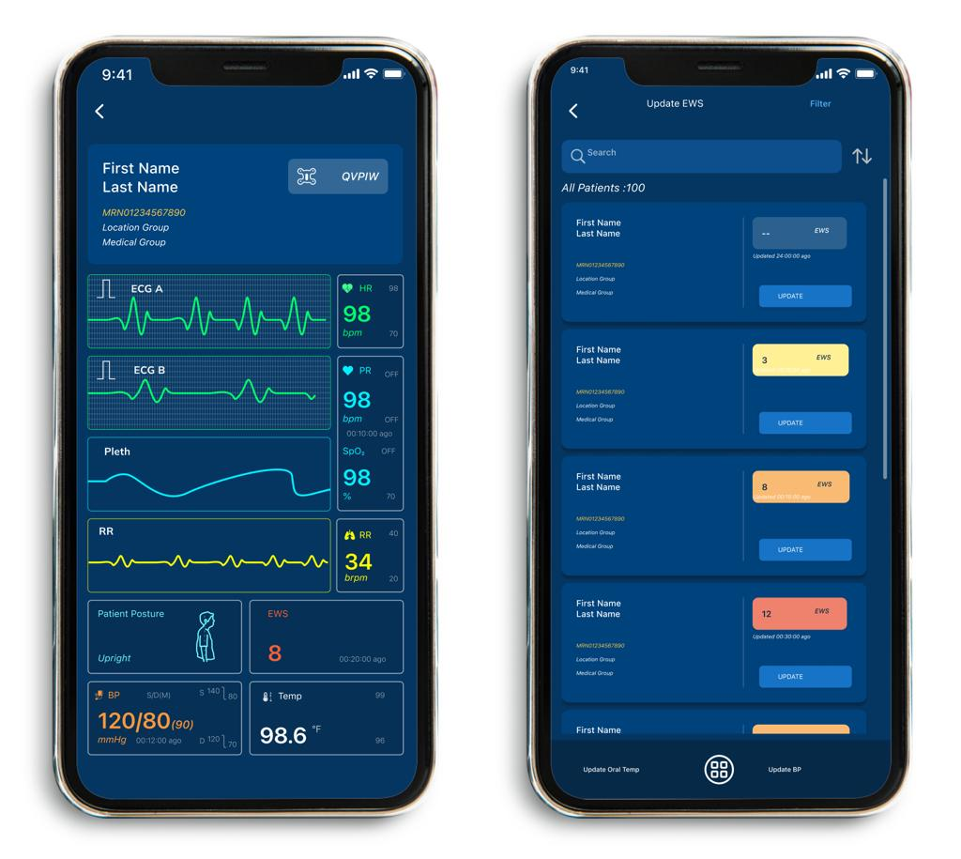
Screen 1 — Healthcare Dashboard
Shows patient vitals, ambulance status and hospital connection.
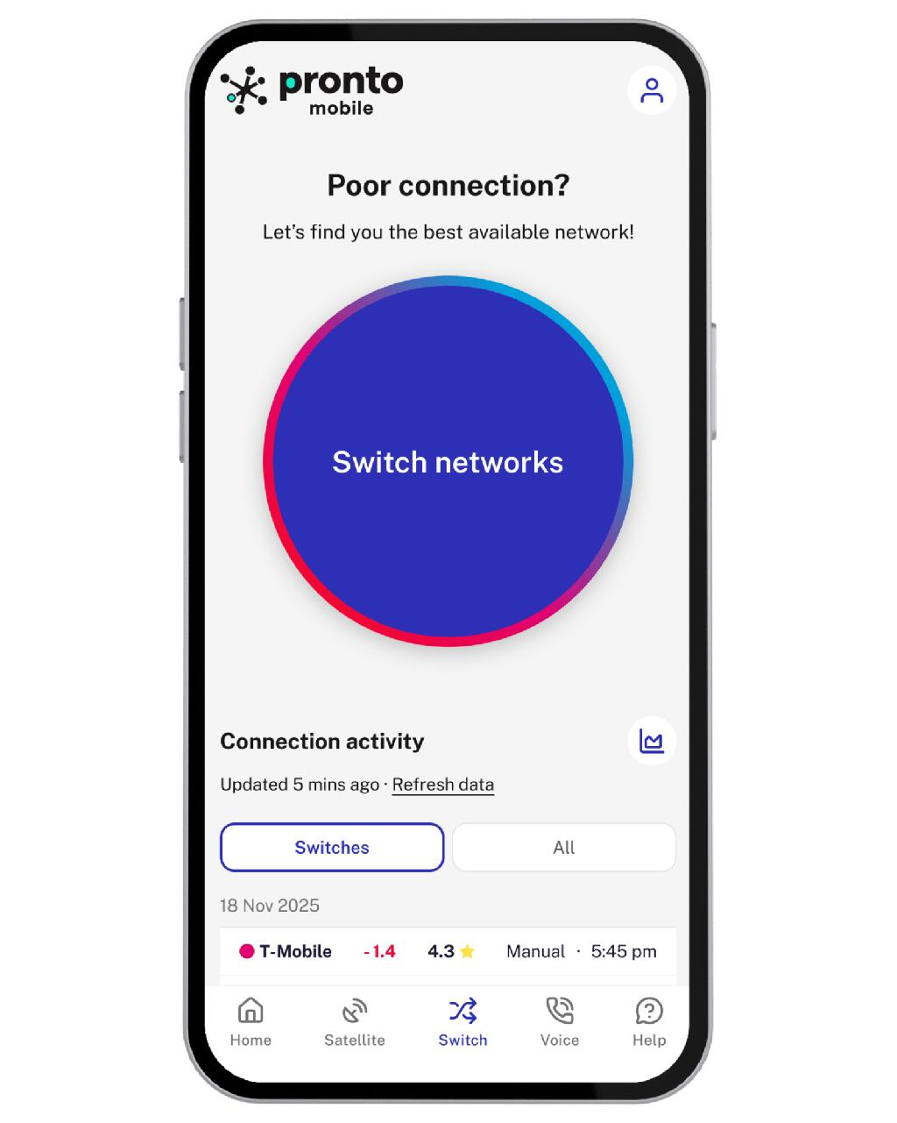
Screen 2 — Network Handoff
Displays the old network, new network and CoA registration status.
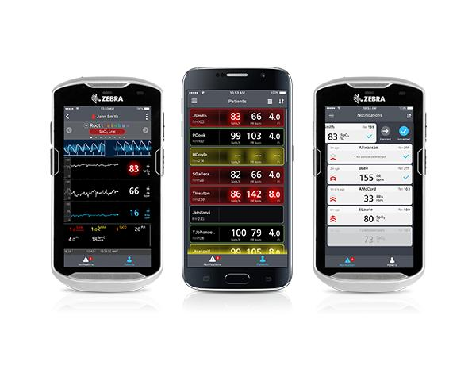
Screen 3 — Patient Monitoring
Shows patient readings, connection status and warning notifications.
In Figma, connect these screens using prototype interactions such as On click → Navigate to.
Result: The proposed system demonstrates how Mobile IP can support communication during mobility, while security, handoff optimization and redundant connections improve reliability. It cannot guarantee uninterrupted communication under all network conditions.

5. Wireless Network Decision Dashboard Using GitHub Project (BL4 – Analyze) Create a web-based dashboard (using HTML/CSS/JavaScript, React, or another programming framework) or an interactive Figma dashboard that helps network engineers determine whether a given scenario should use Mobile IP, Cellular Networks, or Ad Hoc Networks.
The dashboard should analyze multiple parameters such as:
● Node mobility.
● Infrastructure availability.
● Network size.
● Routing complexity.
● Energy consumption.
● Reliability requirements.
The system should justify its recommendation based on the analyzed parameters. Deliverables:
● Source code or Figma project.
● GitHub repository with complete code/design, README, screenshots, and analysis report.

Ans:
Aim
To develop an interactive dashboard that recommends Mobile IP, Cellular Networks or MANET based on the network scenario.
5.1 Decision parameters
Parameter | Purpose
Node mobility | Determines how frequently devices change locations.
Infrastructure availability | Indicates whether base stations or fixed network infrastructure are available.
Network size | Estimates the number of connected nodes.
Routing complexity | Indicates the difficulty of maintaining network paths.
Energy consumption | Considers the battery constraints of mobile devices.
Reliability | Represents the importance of continuous, dependable communication.
5.2 Decision logic
- Mobile IP: Recommended when devices need to retain their IP-based sessions while moving between IP networks, assuming the required Mobile IP support is deployed.
- Cellular Network: Recommended when operator infrastructure is available and managed wide-area connectivity is required.
- MANET: Recommended when fixed infrastructure is unavailable and devices can communicate directly or relay packets through one another.
These technologies are not always mutually exclusive. Mobile IP can operate over cellular or other IP networks, so the dashboard's recommendation is a simplified choice of primary networking approach.
5.3 Interactive dashboard code
Save the following as index.html. It runs directly in a web browser without additional libraries.

<!DOCTYPE html>
<html>
<head>
<title>Wireless Network Decision Dashboard</title>
<style>
body {
font-family: Arial;
background: #f2f5f9;
padding: 25px;
}
.container {
max-width: 650px;
margin: auto;
background: white;
padding: 25px;
border-radius: 12px;
}
label { display: block; margin-top: 15px; }
select, button {
width: 100%;
padding: 10px;
margin-top: 6px;
}
button {
background: #1769aa;
color: white;
border: none;
cursor: pointer;
}
#result {
margin-top: 20px;
padding: 15px;
background: #e5f5e9;
}
</style>
</head>
<body>
<div class="container">
<h2>Wireless Network Decision Dashboard</h2>

<label>Node Mobility</label>
<select id="mobility">
<option value="high">High</option>
<option value="low">Low</option>
</select>

<label>Infrastructure Availability</label>
<select id="infra">
<option value="yes">Available</option>
<option value="no">Unavailable</option>
</select>

<label>Network Size</label>
<select id="size">
<option value="large">Large</option>
<option value="small">Small</option>
</select>

<label>Energy Constraint</label>
<select id="energy">
<option value="high">High</option>
<option value="low">Low</option>
</select>

<label>Reliability Requirement</label>
<select id="reliability">
<option value="high">High</option>
<option value="normal">Normal</option>
</select>

<button onclick="recommend()">Get Recommendation</button>
<div id="result">Your recommendation will appear here.</div>
</div>

<script>
function recommend() {
let mobility = document.getElementById("mobility").value;
let infra = document.getElementById("infra").value;
let size = document.getElementById("size").value;
let energy = document.getElementById("energy").value;
let reliability = document.getElementById("reliability").value;
let result = "";

if (infra === "no") {
result = "MANET";
} else if (reliability === "high" && size === "large") {
result = "Cellular Network";
} else if (mobility === "high") {
result = "Mobile IP";
} else {
result = "Cellular Network";
}

let reason = "";
if (result === "MANET") {
reason = "Infrastructure is unavailable, so peer-to-peer multi-hop communication is suitable.";
} else if (result === "Mobile IP") {
reason = "High mobility makes IP session continuity across networks an important requirement.";
} else {
reason = "Available infrastructure supports managed connectivity and network-wide service.";
}

if (energy === "high") {
reason += " Energy use should be monitored, especially for mobile devices.";
}

document.getElementById("result").innerHTML =
"<h3>Recommended Approach: " + result +
"</h3><p>" + reason +
"</p><p>Validate the choice against coverage, latency, cost and deployment requirements.</p>";
}
</script>
</body>
</html>
5.4 Sample output
Wireless Network Decision Dashboard
- Node mobility
- Low
- High
- Infrastructure
- Available
- Unavailable
- Network size
- Small
- Large
- Energy constraint
- Low
- High
- Reliability requirement
- Normal
- High
- Suggested primary approach

Cellular Network
Available infrastructure supports managed connectivity and wide-area service.
Note: This interactive preview illustrates the decision rules. The HTML file above is the source code to submit.

Result: The dashboard provides a basic recommendation with a justification based on the selected network conditions.

Criterion | Marks
Design Quality (Figma/Programming Tool) | 20
Technical Analysis | 30
Correctness of Mobile Networking Concepts | 20
GitHub Repository Organization & Documentation | 15
Creativity and Visualization | 15
Total | 100 Marks

