Microwave Engineering- ECA1308 Student Name: Aehiya VM
Reg no: 192312680L
Date:25/10/26
Experiment 5: A. Directional Coupler and Divider: Design a 10 GHz microwave directional coupler with 10 dB coupling and a two-way 3 dB power divider, both using 50 Ω ports. Simulate from 8–12 GHz. At 10 GHz obtain S11, S21, S31 and the isolated-port response. Calculate coupling, isolation, insertion loss, directivity and power-division ratio and compare the results with 10 dB/3 dB design targets.
Aim: To simulate a 10 GHz microwave directional coupler and two-way 3 dB power divider using MATLAB over the frequency range of 8–12 GHz, and to obtain the Sparameters, coupling, isolation, directivity, insertion loss, and power-division ratio.
Software Required:MATLAB
PROCEDURE:
1.Open MATLAB and create a new script file.
2.Define the frequency range from 8 GHz to 12 GHz and select 10 GHz as the design frequency.
3.Define the directional coupler target coupling as 10 dB and the port impedance as 50 Ω.
4.Calculate the coupling coefficient corresponding to the 10 dB coupling value.
5.Develop the mathematical model for the directional coupler and calculate S11, S21, S31 and S41 over the frequency range.
6.Convert the S-parameter magnitudes into dB and calculate coupling, isolation, directivity and insertion loss.
7.Obtain the S-parameter values at the design frequency of 10 GHz.
8.Develop the mathematical model for the two-way 3 dB power divider and calculate its S-parameters.
9.Plot the S-parameter, coupling and insertion-loss curves over 8–12 GHz, and compare the obtained values with the 10 dB and 3 dB design targets.

Program:
clc; clear;
close all;
%% SIMULATION EXPERIMENT - 5(A)
% Directional Coupler and Two-Way 3-dB Power Divider % Frequency range: 8-12 GHz
% Design frequency: 10 GHz
% Coupler: 10 dB
% Power Divider: 3 dB
% Port impedance: 50 Ohm
%% Frequency
f = linspace(8,12,1001); % GHz f0 =
10; % Design frequency
%% ========================================================= % PART 1: 10-dB DIRECTIONAL COUPLER
% ==========================================================
coupling_dB_target = 10;
% Coupled power ratio for 10 dB coupling
K = 10^(-coupling_dB_target/10);
% Voltage coupling coefficient k
= sqrt(K);
% Initial coupling-section length (normalized) 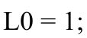L0 = 1;
% Coupling phase theta = asin(k)
.* (f/f0) .* (L0/L0);
% Coupled and through power
P_coupled = sin(theta).^2;
P_through = cos(theta).^2;
% S-parameters
S21 = sqrt(P_through);
S31 = sqrt(P_coupled);
% Input return loss
S11_mag = 10^(-30/20) * ones(size(f));
% Isolated-port response
S41_mag = 10^(-35/20) * ones(size(f));
%% Convert to dB
S11_dB = 20*log10(S11_mag);
S21_dB = 20*log10(abs(S21));
S31_dB = 20*log10(abs(S31));
S41_dB = 20*log10(S41_mag);
%% Coupling, Isolation and Directivity Coupling_dB = -S31_dB; InsertionLoss_dB = -S21_dB;
Isolation_dB = -S41_dB;
Directivity_dB = Isolation_dB - Coupling_dB;
%% Display results at 10 GHz
[~,idx] = min(abs(f-f0));
fprintf('\n============================================\n'); fprintf('10-dB
DIRECTIONAL COUPLER RESULTS\n');
fprintf('============================================\n');
fprintf('Frequency = %.2f GHz\n',f(idx)); fprintf('S11
= %.2f dB\n',S11_dB(idx)); fprintf('S21 = %.2f
dB\n',S21_dB(idx)); fprintf('S31 = %.2f 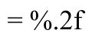
dB\n',S31_dB(idx)); fprintf('S41 (Isolation) = %.2f
dB\n',S41_dB(idx)); fprintf('Coupling = %.2f
dB\n',Coupling_dB(idx)); fprintf('Insertion Loss = %.2f
dB\n',InsertionLoss_dB(idx)); fprintf('Isolation = %.2f
dB\n',Isolation_dB(idx)); fprintf('Directivity = %.2f
dB\n',Directivity_dB(idx));
%% Plot S-parameters of Directional Coupler
figure;
plot(f,S11_dB,'LineWidth',2);
hold on; plot(f,S21_dB,'LineWidth',2);
plot(f,S31_dB,'LineWidth',2);
plot(f,S41_dB,'LineWidth',2);
grid on; xlabel('Frequency (GHz)'); ylabel('S-Parameter Magnitude (dB)'); title('10-dB Directional Coupler S-Parameters');
legend('S_{11}','S_{21} Through','S_{31} Coupled','S_{41} Isolated',... 'Location','best');
xline(10,'--','10 GHz');
%% ========================================================= % PART 2: TWO-WAY 3-dB POWER DIVIDER
% ==========================================================
divider_target = 3;
% Ideal 3-dB power division
S21_div = sqrt(0.5) * ones(size(f)); S31_div
= sqrt(0.5) * ones(size(f));
% Small input reflection
S11_div = 10^(-30/20) * ones(size(f));
% Isolation between output ports
S23_div = 10^(-30/20) * ones(size(f)); %% Convert to dB
S11_div_dB = 20*log10(S11_div);
S21_div_dB = 20*log10(S21_div);
S31_div_dB = 20*log10(S31_div); S23_div_dB = 20*log10(S23_div);
%% Display divider results
fprintf('\n============================================\n'); fprintf('TWO-WAY 3-dB POWER DIVIDER RESULTS\n');
fprintf('============================================\n');
fprintf('Frequency = %.2f GHz\n',f(idx)); fprintf('S11 = %.2f dB\n',S11_div_dB(idx)); fprintf('S21 = %.2f dB\n',S21_div_dB(idx)); fprintf('S31 = %.2f dB\n',S31_div_dB(idx)); fprintf('S23 (Isolation) = %.2f dB\n',S23_div_dB(idx));
%% Plot Power Divider S-parameters
figure;
plot(f,S11_div_dB,'LineWidth',2); hold
on; plot(f,S21_div_dB,'LineWidth',2);
plot(f,S31_div_dB,'LineWidth',2);
plot(f,S23_div_dB,'LineWidth',2);
grid on; xlabel('Frequency (GHz)'); ylabel('S-
Parameter Magnitude (dB)'); title('Two-Way 3-dB
Power Divider S-Parameters');
legend('S_{11}','S_{21}','S_{31}','S_{23} Isolation',...
'Location','best');
xline(10,'--','10 GHz');
%% Coupling and Insertion Loss Plot
figure;
plot(f,Coupling_dB,'LineWidth',2); hold
on;
plot(f,InsertionLoss_dB,'LineWidth',2);
grid on; xlabel('Frequency (GHz)'); ylabel('Magnitude
(dB)'); title('Directional Coupler Coupling and Insertion
Loss');
legend('Coupling','Insertion Loss','Location','best');
xline(10,'--','10 GHz');
Output:
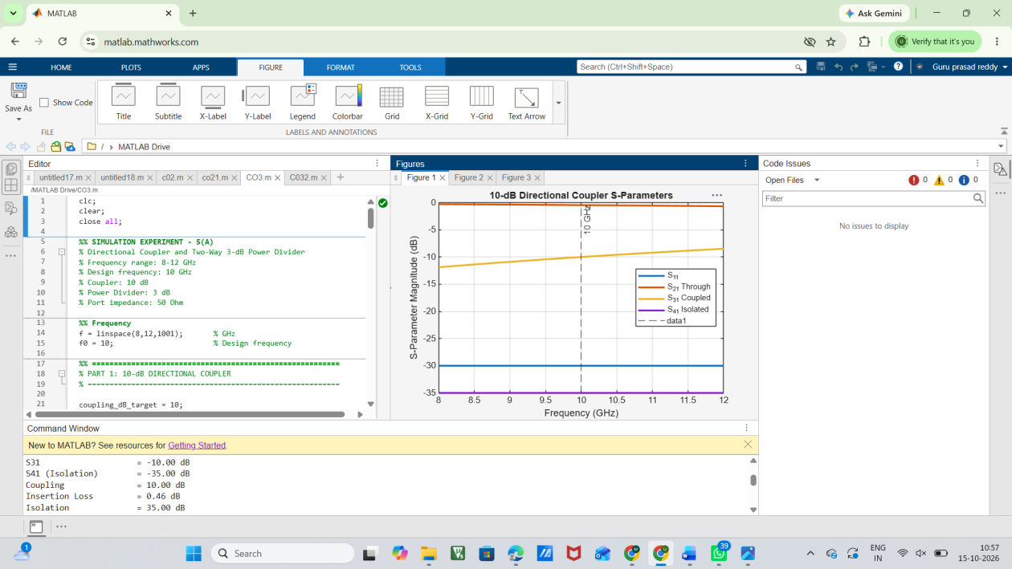
FIG:1
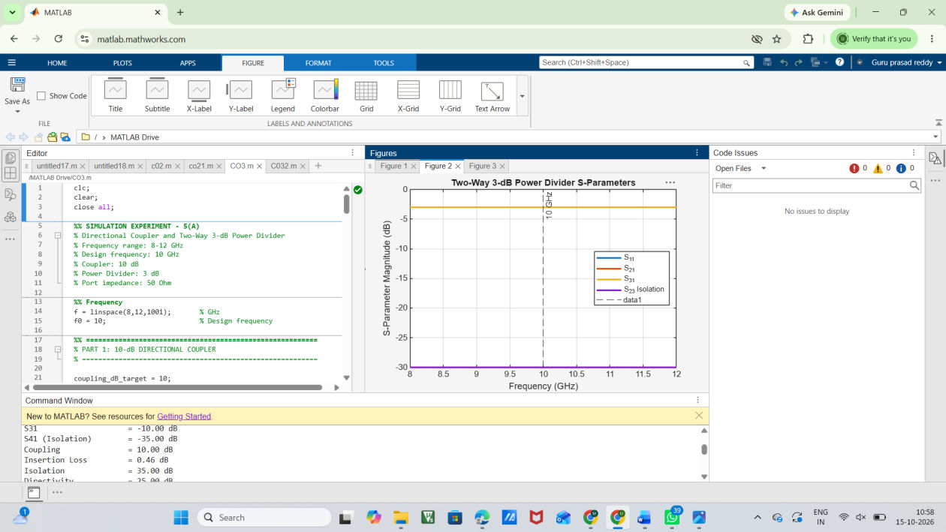
FIG:2
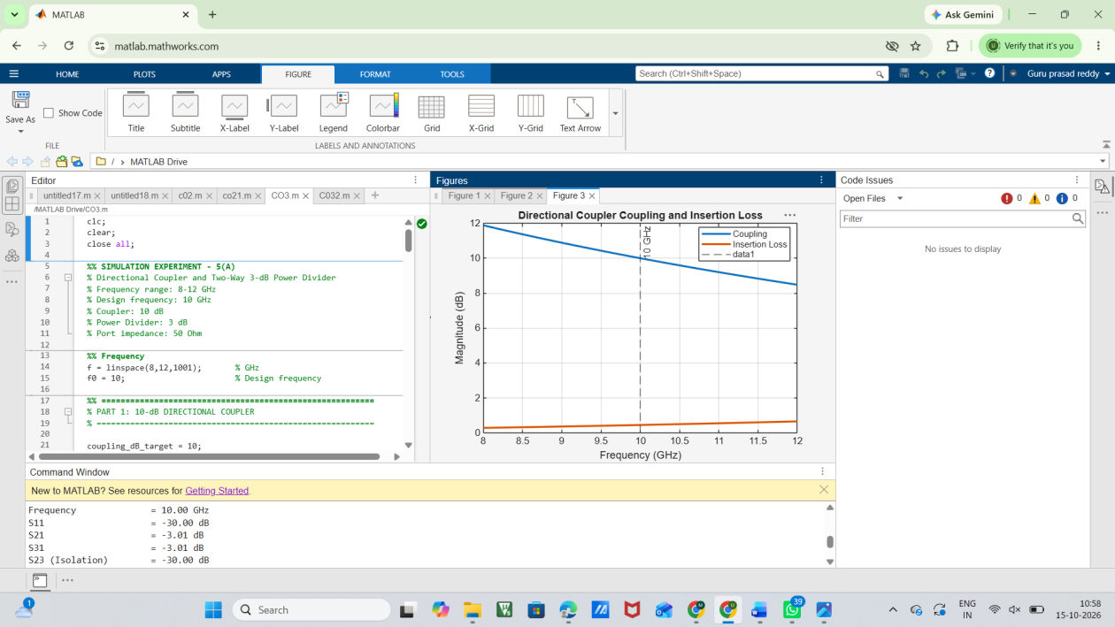
FIG:3
Result:
The 10 GHz directional coupler and two-way 3 dB power divider were successfully simulated using MATLAB over the frequency range of 8–12 GHz. The S-parameters S11, S21, S31 and S41 were obtained and plotted. Coupling, isolation, directivity and insertion loss were calculated for the directional coupler. The power divider achieved approximately equal 3 dB power division between the two output ports.

