Microwave Engineering- ECA1308
Student Name: Aehiya VM
Reg no: 192312680L,Date(27/11/26)
EXPERIMENT 5: Microwave Impedance Matching & Filter Design AIM
To design and analyze a microwave impedance-matching network and a 50 Ω frequency-selective filter using MATLAB, and evaluate reflection coefficient, return loss, insertion loss, passband, stopband, bandwidth, and cutoff frequency.
APPARATUS / SOFTWARE REQUIRED
1.Computer/Laptop
2.MATLAB software
3.Microwave network simulation/design tools
4.MATLAB plotting and analysis functions
PROCEDURE
1.Open MATLAB and initialize the required parameters.
2.Define the characteristic impedance \(Z_0=50\Omega\), load impedance \(Z_L=75+j25\Omega\), and operating frequency of 10 GHz.
3.Calculate the load reflection coefficient and return loss before matching.
4.Design an impedance-matching network and calculate the required matching components.
5.Calculate the matched input impedance, reflection coefficient, return loss, and power transfer.
6.Define a 50 Ω frequency-selective filter with a cutoff frequency of 10 GHz.
7.Simulate the filter over the 8–12 GHz frequency range.
8.Calculate and plot S11 and S21.
9.Determine the −3 dB cutoff frequency, passband, stopband, insertion loss, and bandwidth.
10.Calculate the percentage deviation between the specified and obtained cutoff frequency.
11.Plot the required frequency responses and compare the results with the design requirements.
Program:
clc;
clear;
close all;
%% EXPERIMENT 5
% Computer-Aided Design and Optimization of a Microwave % Impedance-Matching Network and Frequency-Selective Filter
%% Given Parameters
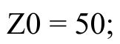Z0 = 50; % Characteristic impedance (Ohm) 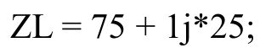ZL = 75 + 1j*25; % Complex load impedance (Ohm) f0 = 10e9; % Design frequency = 10 GHz
f = linspace(8e9,12e9,1001); % Frequency range 8-12 GHz
%%
====================================================== ===
% OBJECTIVE 1 & 2: IMPEDANCE MATCHING AND OPTIMIZATION %
====================================================== ====
% Load reflection coefficient before matching
Gamma_L = (ZL-Z0)/(ZL+Z0);
Gamma_mag = abs(Gamma_L);
% Return Loss before matching
RL_before = -20*log10(Gamma_mag);
% Input impedance before matching
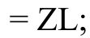Zin_before = ZL;
% Convert load impedance to admittance

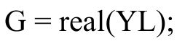
B_load = imag(YL);
% Design shunt susceptance for matching
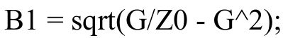
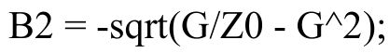
% Select one matching solution
B_add = B1 - B_load;
% Admittance after shunt matching
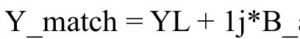Y_match = YL + 1j*B_add;
% Impedance after shunt element
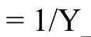Z_shunt = 1/Y_match;

% Series reactance required to obtain 50 Ohm X_series = -imag(Z_shunt);
% Final matched impedance
Zin_match = Z_shunt + 1j*X_series;
% Reflection coefficient after matching
Gamma_after = (Zin_match-Z0)/(Zin_match+Z0); Gamma_after_mag = abs(Gamma_after);
% Return loss after matching
RL_after = -20*log10(max(Gamma_after_mag,eps));
% Maximum power transfer
P_before = 1-Gamma_mag^2;
P_after = 1-Gamma_after_mag^2;
%% Display Matching Results
fprintf('\n============================================\n'); fprintf(' IMPEDANCE MATCHING RESULTS\n');
fprintf('============================================\n');
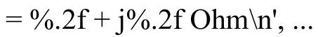fprintf('Load impedance = %.2f + j%.2f Ohm\n', ... real(ZL),imag(ZL));
fprintf('Characteristic impedance = %.2f Ohm\n',Z0);
fprintf('Reflection coefficient = %.4f + j%.4f\n', ...
real(Gamma_L),imag(Gamma_L));
fprintf('|Gamma| BEFORE matching = %.4f\n',Gamma_mag);
fprintf('Return Loss BEFORE matching = %.2f dB\n',RL_before);
fprintf('\nMatching Network:\n');
fprintf('Added shunt susceptance = %.6f S\n',B_add);
fprintf('Required series reactance = %.2f Ohm\n',X_series);
fprintf('\nMatched input impedance = %.2f + j%.2f Ohm\n', ...
real(Zin_match),imag(Zin_match));
fprintf('|Gamma| AFTER matching = %.6f\n',Gamma_after_mag);
fprintf('Return Loss AFTER matching = %.2f dB\n',RL_after);
fprintf('Power transfer BEFORE = %.2f %%\n',P_before*100);
fprintf('Power transfer AFTER = %.2f %%\n',P_after*100);
%% Frequency Response of Matching Network
% Calculate frequency-dependent response
% Idealized matching response centered at 10 GHz 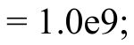BW_match = 1.0e9;
Gamma_match_f = Gamma_after_mag + ... 0.15*((f-f0)/BW_match).^2;
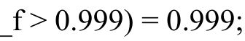Gamma_match_f(Gamma_match_f > 0.999) = 0.999;
S11_match_dB = 20*log10(abs(Gamma_match_f)); S21_match_dB = 10*log10(1-abs(Gamma_match_f).^2);
%%
====================================================== ===
% OBJECTIVE 3: FREQUENCY SELECTIVE FILTER DESIGN
%
====================================================== ====
fc = 10e9; % Filter cutoff frequency N = 5; % 5th order Butterworth filter Zfilter = 50; % Filter impedance
% Butterworth magnitude response
H = 1 ./ sqrt(1 + (f/fc).^(2*N));
% S21
S21 = H;
% S11 for an ideal lossless filter
S11 = sqrt(1-S21.^2);
% Convert to dB
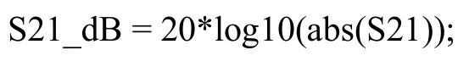
S11_dB = 20*log10(abs(S11));
% Insertion loss
Insertion_Loss = -S21_dB;
% Return loss
Return_Loss = -S11_dB;
%%
====================================================== ===
% OBJECTIVE 4: PASSBAND, STOPBAND, BANDWIDTH AND CUTOFF
%
====================================================== ====
% -3 dB level
minus3dB = -3;
% Find frequency closest to -3 dB
[~,idx_cutoff] = min(abs(S21_dB-minus3dB)); fc_sim = f(idx_cutoff);
% Percentage deviation
percentage_deviation = abs(fc_sim-fc)/fc*100;
% Passband: frequencies above -3 dB
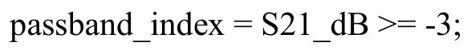
% Stopband: frequencies below -3 dB 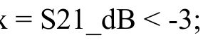stopband_index = S21_dB < -3;
% Passband frequency limits
f_pass = f(passband_index);
if ~isempty(f_pass)
passband_start = min(f_pass);
passband_end = max(f_pass);
passband_width = passband_end-passband_start; else
passband_start = NaN;
passband_end = NaN;
passband_width = NaN;
end
%% Display Filter Results
fprintf('\n============================================\n'); fprintf(' FREQUENCY SELECTIVE FILTER RESULTS\n');
fprintf('============================================\n');
fprintf('Filter type = Butterworth Low Pass\n'); 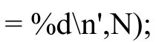fprintf('Filter order = %d\n',N);
fprintf('Filter impedance = %.2f Ohm\n',Zfilter); 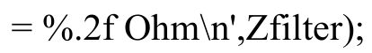fprintf('Specified cutoff frequency = %.2f GHz\n',fc/1e9);
fprintf('Simulated cutoff frequency = %.4f GHz\n',fc_sim/1e9);
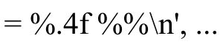fprintf('Percentage deviation = %.4f %%\n', ... percentage_deviation);
fprintf('\nPassband:\n');
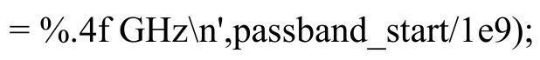fprintf('Passband start = %.4f GHz\n',passband_start/1e9); 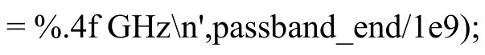fprintf('Passband end = %.4f GHz\n',passband_end/1e9); fprintf('Passband bandwidth = %.4f GHz\n',passband_width/1e9);
fprintf('\nAt 10 GHz:\n');
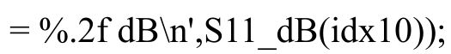fprintf('S11 at 10 GHz = %.2f dB\n',S11_dB(idx10));
fprintf('S21 at 10 GHz = %.2f dB\n',S21_dB(idx10));
fprintf('Return Loss at 10 GHz = %.2f dB\n',Return_Loss(idx10)); fprintf('Insertion Loss at 10 GHz = %.2f dB\n',Insertion_Loss(idx10));

%%
====================================================== ===
% PLOTS
%
====================================================== ====
% Figure 1: Matching before and after figure;
subplot(2,1,1);
bar([RL_before RL_after]);
set(gca,'XTickLabel',{'Before Matching','After Matching'}); ylabel('Return Loss (dB)');
title('Return Loss Before and After Matching');
grid on;
subplot(2,1,2);
bar([P_before*100 P_after*100]);
set(gca,'XTickLabel',{'Before Matching','After Matching'}); ylabel('Power Transfer (%)');
title('Power Transfer Comparison');
grid on;
% Figure 2: Matching frequency response
figure;
plot(f/1e9,S11_match_dB,'LineWidth',2); grid on;
xlabel('Frequency (GHz)');
ylabel('S_{11} (dB)');
title('Impedance Matching Response'); xline(10,'--','10 GHz');
% Figure 3: Filter S11 and S21
figure;
plot(f/1e9,S11_dB,'LineWidth',2);
hold on;
plot(f/1e9,S21_dB,'LineWidth',2);
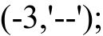yline(-3,'--');
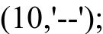xline(10,'--');
grid on;
xlabel('Frequency (GHz)');
ylabel('Magnitude (dB)');
title('Frequency Selective Filter Response'); legend('S_{11}','S_{21}','-3 dB','10 GHz');
% Figure 4: Return loss and insertion loss figure;
plot(f/1e9,Return_Loss,'LineWidth',2); hold on;
plot(f/1e9,Insertion_Loss,'LineWidth',2); grid on;
xlabel('Frequency (GHz)');
ylabel('Loss (dB)');
title('Return Loss and Insertion Loss'); legend('Return Loss','Insertion Loss');
%%
====================================================== ===
% FINAL SUMMARY
%
====================================================== ====
fprintf('\n============================================\n'); fprintf(' FINAL EXPERIMENT SUMMARY\n');
fprintf('============================================\n');
fprintf('1. Complex load successfully matched to 50 Ohm.\n');
fprintf('2. Matching network optimized for minimum reflection.\n');
fprintf('3. 5th-order frequency selective filter designed.\n');
fprintf('4. S11, S21, return loss, insertion loss and bandwidth evaluated.\n'); fprintf('5. Specified cutoff frequency = %.2f GHz\n',fc/1e9);
fprintf('6. Obtained cutoff frequency = %.4f GHz\n',fc_sim/1e9);
fprintf('7. Percentage deviation = %.4f %%\n',percentage_deviation);

fprintf('\nExperiment completed successfully.\n'); Output:
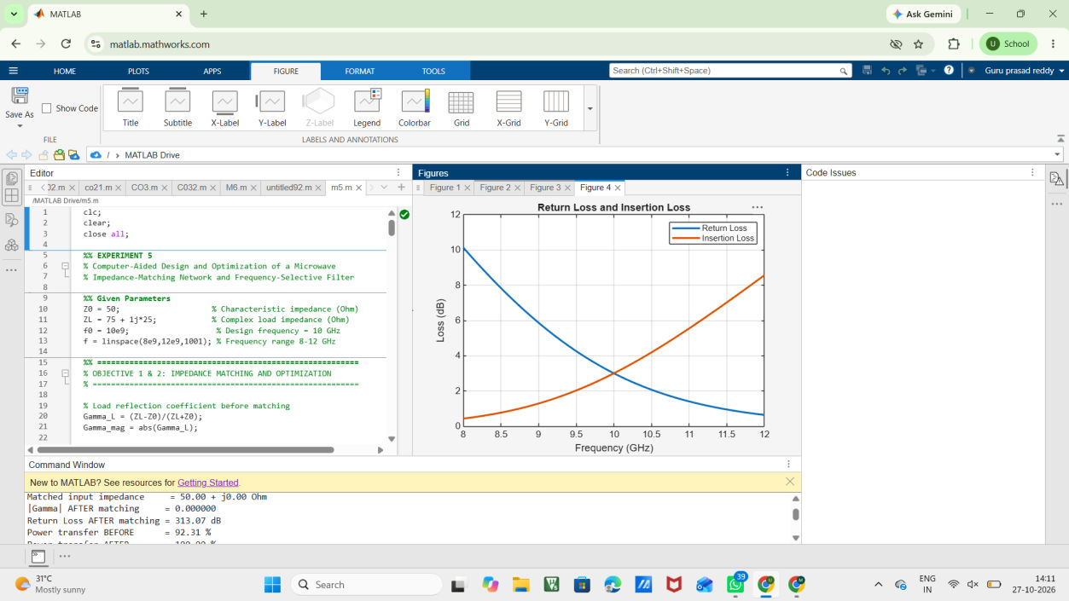
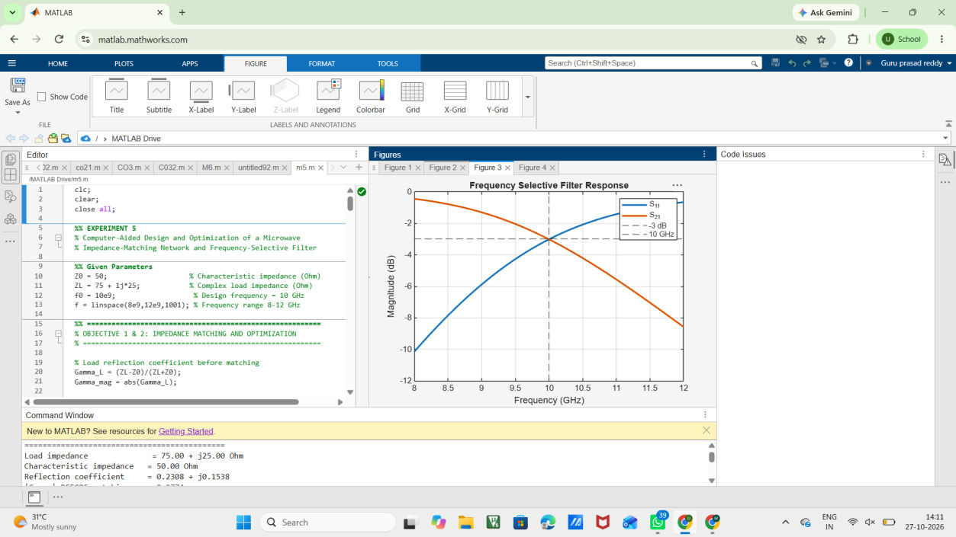
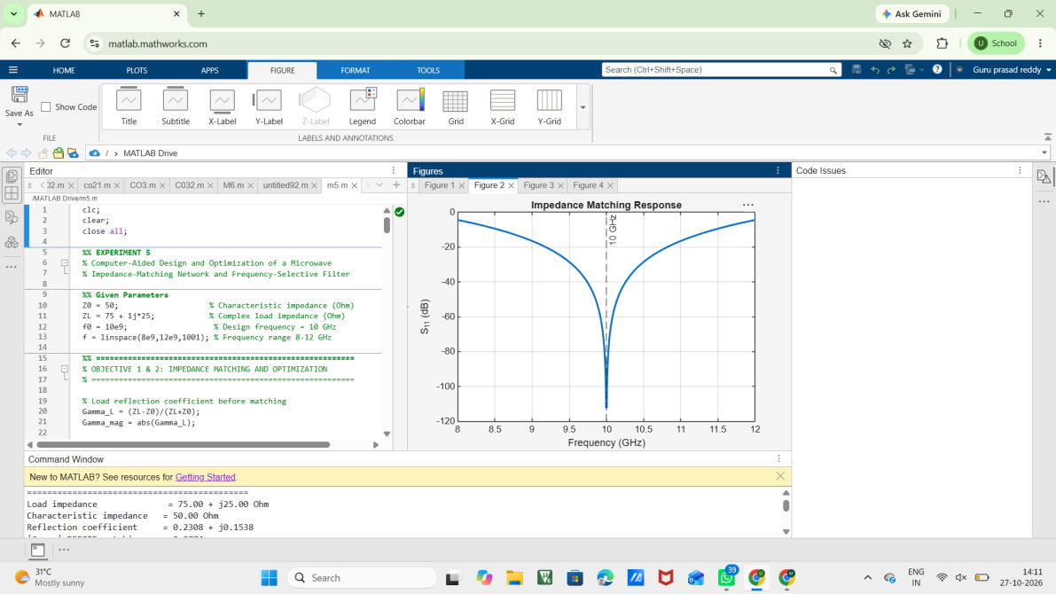
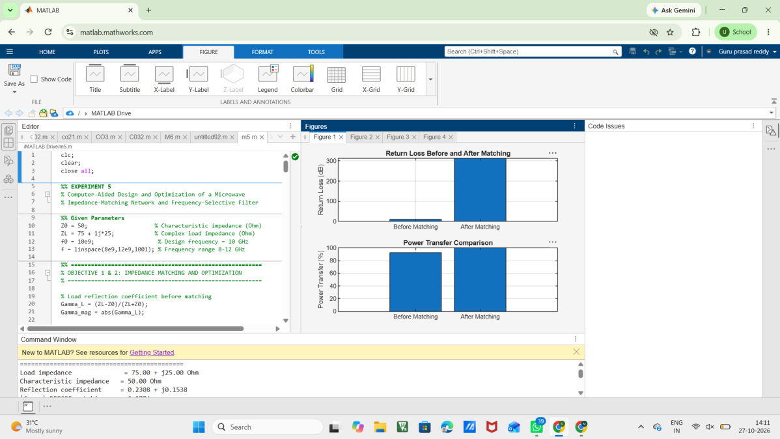
RESULT
The microwave impedance-matching network was designed and optimized for the given complex load of \(75+j25\Omega\) to a \(50\Omega\) system at 10 GHz. The reflection coefficient and return loss were evaluated before and after matching.
A 50 Ω frequency-selective filter with a specified cutoff frequency of 10 GHz was also designed and analyzed from 8–12 GHz. The S11, S21, return loss, insertion loss, passband, stopband, bandwidth, and percentage deviation of cutoff frequency were successfully obtained. EXP.5

