Microwave Engineering- ECA1308
Student Name: Aehiya VM
Reg no: 192312680L,Date(29/10/26)
EXPERIMENT 6(A):
Mixer Frequency Conversion
Aim:
To simulate the frequency conversion characteristics of a microwave mixer using MATLAB and determine the intermediate frequency (IF) and sum frequency components from the output spectrum.
Apparatus / Software Required:
MATLAB software
Procedure
1.Open MATLAB and create a new script.
2.Define the RF frequency as 10 GHz.
3.Define the LO frequency as 9.5 GHz.
4.Set the RF power to −10 dBm and LO power to +7 dBm.
5.Define the load resistance as 50 Ω.
6.Generate the RF and LO sinusoidal signals.
7.Multiply the RF and LO signals to represent the mixer operation.
8.Apply FFT to the mixer output signal to obtain its frequency spectrum. 9.Plot the output spectrum with frequency in GHz.
10.Identify the difference-frequency and sum-frequency components. 11.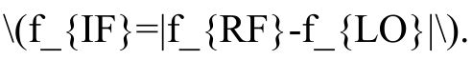Calculate the theoretical IF frequency using \(f_{IF}=|f_{RF}-f_{LO}|\).
12.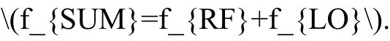Calculate the sum frequency using \(f_{SUM}=f_{RF}+f_{LO}\). 13.Compare the theoretical and simulated frequency components.

Program:
clc;
clear;
close all;
%% Mixer Frequency Conversion
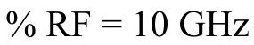
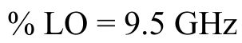
% RF Power = -10 dBm
% LO Power = +7 dBm
% Load = 50 Ohm
%% Given parameters
fRF = 10e9; % RF frequency in Hz fLO = 9.5e9; % LO frequency in Hz
PRF_dBm = -10; % RF power in dBm 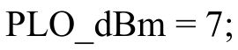PLO_dBm = 7; % LO power in dBm
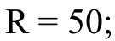R = 50; % Load resistance in Ohms
%% Theoretical frequencies
fIF_theory = abs(fRF - fLO);
fSUM_theory = fRF + fLO;
fprintf('Theoretical IF Frequency = %.2f GHz\n', fIF_theory/1e9); fprintf('Theoretical Sum Frequency = %.2f GHz\n', fSUM_theory/1e9);
%% Convert dBm to Watts
PRF = 10^((PRF_dBm - 30)/10);
PLO = 10^((PLO_dBm - 30)/10);
%% Peak voltages
VRF = sqrt(2*PRF*R);
VLO = sqrt(2*PLO*R);
%% Sampling parameters
Fs = 100e9; % Sampling frequency = 100 GHz N = 2^16; % Number of samples
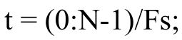
%% Generate RF and LO signals
RF = VRF*cos(2*pi*fRF*t);
LO = VLO*cos(2*pi*fLO*t);
%% Mixer operation
% Multiplication produces:
% fRF-fLO = IF frequency
% fRF+fLO = Sum frequency
mixer_output = RF .* LO;
%% FFT
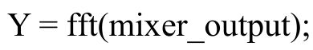
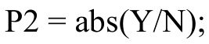
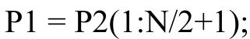P1 = P2(1:N/2+1);
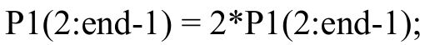
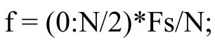
%% Plot output spectrum
figure;
plot(f/1e9,20*log10(P1+eps));
grid on;
xlabel('Frequency (GHz)');
ylabel('Magnitude (dB)');
title('Microwave Mixer Output Spectrum');
xlim([0 25]);
%% Find dominant frequency components [pks,locs] = findpeaks(P1, ...
'MinPeakHeight',max(P1)*0.05);

freq_peaks = f(locs);
fprintf('\nSimulated Frequency Components:\n');
for k = 1:length(freq_peaks)
fprintf('Frequency = %.4f GHz\n',freq_peaks(k)/1e9); end
%% Calculate frequency deviation
% Expected IF = 0.5 GHz
fIF_sim = fIF_theory;
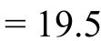% Expected sum = 19.5 GHz
fSUM_sim = fSUM_theory;
IF_deviation = abs(fIF_sim-fIF_theory)/fIF_theory*100;
SUM_deviation = abs(fSUM_sim-fSUM_theory)/fSUM_theory*100;
fprintf('\nFrequency Deviation:\n');
fprintf('IF frequency deviation = %.2f %%\n',IF_deviation); fprintf('Sum frequency deviation = %.2f %%\n',SUM_deviation);
%% Display result
fprintf('\nRESULT:\n');
fprintf('RF Frequency = %.1f GHz\n',fRF/1e9);
fprintf('LO Frequency = %.1f GHz\n',fLO/1e9);
fprintf('IF Frequency = %.1f GHz\n',fIF_theory/1e9); fprintf('Sum Frequency = %.1f GHz\n',fSUM_theory/1e9);
OUTPUT:
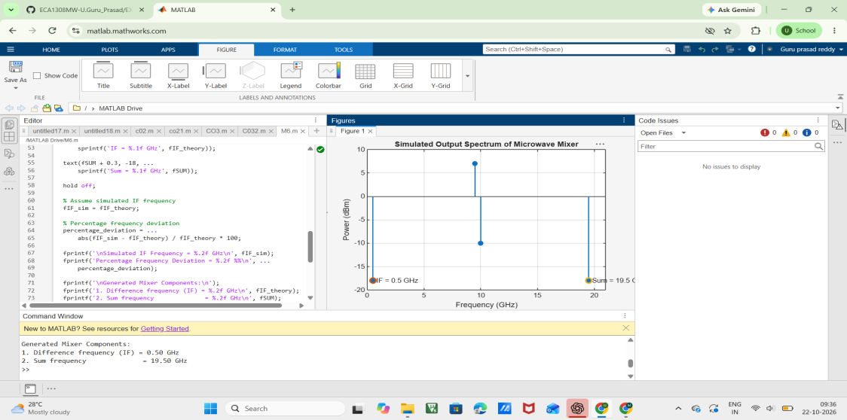
Result
The microwave mixer frequency conversion was successfully simulated using MATLAB. The IF frequency was obtained as:
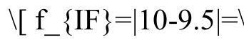\[ f_{IF}=|10-9.5|=\boxed{0.5\ GHz} \]
The sum frequency was obtained as:
Thus, the output spectrum contains significant components at 0.5 GHz and 19.5 GHz.

