SIMATS ENGINEERING (SAVEETHA SCHOOL OF ENGINEERING)
Department of Computer Science and Engineering
ASSESSMENT TOOL 2 – Concept Mapping (5 QUESTIONS)
Course Code: ITA05 | Course Title: Computer Vision
CO Assessed: CO1 – Imitation (BL3) | Assessment: Assessment Tool 2 – Concept Mapping
Weightage: 30% of CIA | Total Marks: 50 (5 Questions × 10 Marks)
CO1 Statement: Apply the fundamental concepts, image formation models, and processing techniques for analyzing Computer Vision systems.
Student Name: ____________________ | Reg. No.: ____________________
Section / Batch: ____________________ | Date: ____________________
Code of Conduct
I __________________________ (Name / Reg No) certify that this submission is my original work and that I have adhered to the guidelines specified for this assessment. I understand that any violation of academic integrity rules will result in disciplinary action.
Signature of the Student: _________________________
Instructions
• This test contains 5 questions, each carrying 10 marks. Total: 50 Marks.
• No negative marking. Unanswered questions carry zero marks.
• No calculators or electronic devices permitted.
• Duration: 60 minutes.

Section / Topic Focus | Q Nos | Marks
Overview of Computer Vision, Features of Computer Vision, and Levels of Computer Vision  Computer Vision pipeline, features, and processing levels | 1 | 10
Digital Image Fundamentals  Image representation, resolution, and image quality | 2 | 10
Image Sensing and Acquisition, Sampling and Quantization  Digital image acquisition, sampling, and quantization process | 3 | 10
Image Formation Models  Real-world scene to digital image formation | 4 | 10
Applications of Image Processing and Computer Vision  Computer Vision capabilities and real-world applications | 5 | 10
GRAND TOTAL: 50 Marks

Annexure A — Concept Mapping: Answers

Q1. Scene Capture to Digital Image Representation Pipeline
The concept map below traces the complete transformation from a real-world scene to its digital image representation, showing the intermediate physical and computational transformations involved.
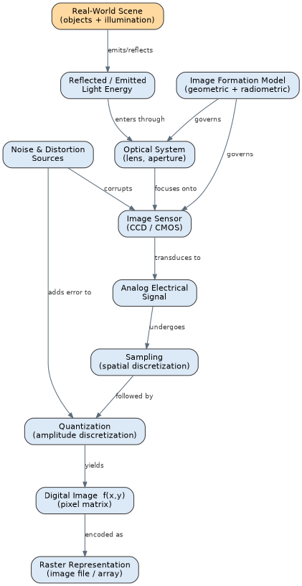
Explanation of the Hierarchy
- A real-world scene reflects or emits light, which is shaped by an image formation model governing geometric (perspective, depth) and radiometric (brightness, reflectance) relationships.
- The optical system (lens, aperture) focuses this light onto an image sensor (CCD/CMOS), which transduces optical energy into an analog electrical signal.
- The analog signal undergoes sampling (spatial discretization into a pixel grid) followed by quantization (mapping continuous amplitude into discrete intensity levels).
- These two steps together yield the digital image function f(x,y), which is finally encoded as a raster representation (pixel matrix / image file).
- Noise and distortion sources corrupt the signal at the sensor stage and introduce quantization error, directly affecting downstream image quality.
Literature Sources Integrated
- R. C. Gonzalez and R. E. Woods, Digital Image Processing, 4th ed., Pearson, 2018.
- R. Szeliski, Computer Vision: Algorithms and Applications, 2nd ed., Springer, 2022.
- R. Jain, R. Kasturi, and B. G. Schunck, Machine Vision, McGraw-Hill, 1995.
- D. Marr, Vision: A Computational Investigation into the Human Representation and Processing of Visual Information, MIT Press, 1982/2010.
- M. Sonka, V. Hlavac, and R. Boyle, Image Processing, Analysis, and Machine Vision, 4th ed., Cengage, 2014.

Q2. Stages of Visual Data Handling in a Computer Vision System
The concept map below shows the hierarchical processing pipeline of a Computer Vision system, from raw data acquisition to a meaningful, interpreted output.
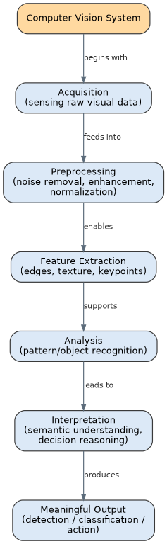
Contribution of Each Stage
- Acquisition: Captures raw visual data from the environment through cameras or sensors — the foundational input stage.
- Preprocessing: Removes noise, enhances contrast, and normalizes illumination/geometry so that later stages operate on cleaner, standardized data.
- Feature Extraction: Identifies distinctive, informative attributes (edges, corners, texture, keypoints) that compactly represent image content.
- Analysis: Applies pattern recognition, classification, or matching algorithms on extracted features to detect or recognize objects/patterns.
- Interpretation: Converts analytical results into semantic, context-aware understanding of the scene (what is happening, and why it matters).
- Together, these stages produce a meaningful output — a detection, classification, or actionable decision — that supports the end application.
Literature Sources Integrated
- R. Szeliski, Computer Vision: Algorithms and Applications, 2nd ed., Springer, 2022.
- D. A. Forsyth and J. Ponce, Computer Vision: A Modern Approach, 2nd ed., Pearson, 2012.
- M. Sonka, V. Hlavac, and R. Boyle, Image Processing, Analysis, and Machine Vision, 4th ed., Cengage, 2014.
- R. Jain, R. Kasturi, and B. G. Schunck, Machine Vision, McGraw-Hill, 1995.
- D. Marr, Vision: A Computational Investigation into the Human Representation and Processing of Visual Information, MIT Press, 1982/2010.

Q3. Resolution and Image Quality Relationships
The concept map below illustrates the cause-and-effect relationship among spatial resolution, intensity resolution, and overall image quality, along with the trade-offs involved.
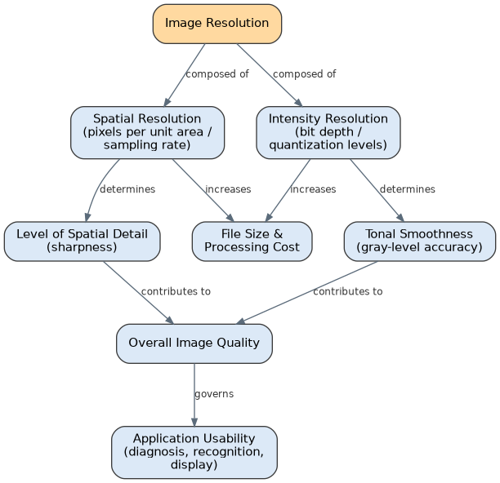
Cause-and-Effect Relationships
- Spatial resolution (number of pixels per unit area / sampling rate) directly determines the level of spatial detail and sharpness an image can capture — higher spatial resolution reveals finer structures.
- Intensity resolution (bit depth / number of quantization levels) determines tonal smoothness — higher bit depth reduces visible banding (false contouring) in gray levels.
- Both factors jointly contribute to overall image quality; a deficiency in either produces visible artifacts (pixelation from low spatial resolution, or contouring from low intensity resolution).
- Image quality governs application usability: medical imaging and forensic analysis demand high resolution on both axes, whereas thumbnails or low-bandwidth previews tolerate lower resolution.
- Increasing either resolution increases file size and computational/processing cost, creating a practical trade-off between quality and efficiency.
Literature Sources Integrated
- R. C. Gonzalez and R. E. Woods, Digital Image Processing, 4th ed., Pearson, 2018.
- M. Sonka, V. Hlavac, and R. Boyle, Image Processing, Analysis, and Machine Vision, 4th ed., Cengage, 2014.
- R. Szeliski, Computer Vision: Algorithms and Applications, 2nd ed., Springer, 2022.
- R. Jain, R. Kasturi, and B. G. Schunck, Machine Vision, McGraw-Hill, 1995.
- D. A. Forsyth and J. Ponce, Computer Vision: A Modern Approach, 2nd ed., Pearson, 2012.

Q4. Factors Influencing Image Acquisition Conditions
The concept map below organizes the major factors affecting image acquisition and traces their downstream impact on processing and application performance.
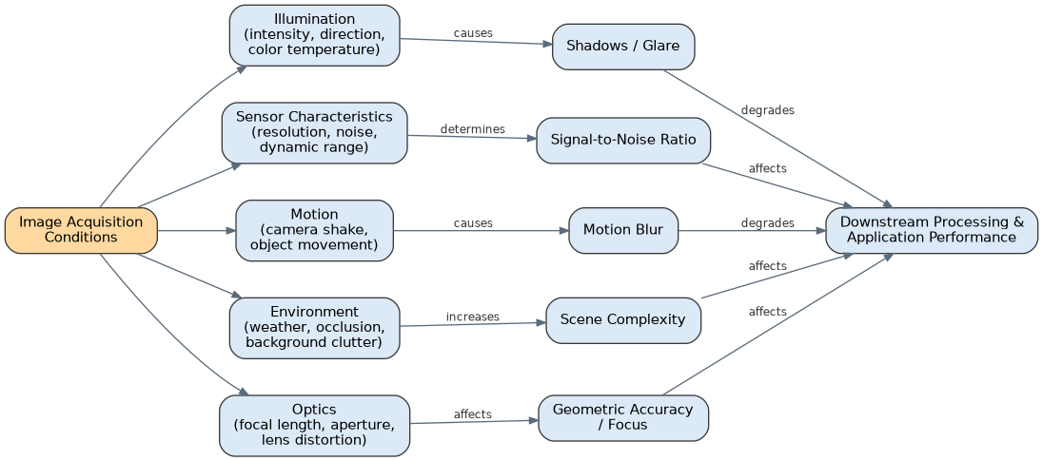
Impact on Downstream Processing
- Illumination (intensity, direction, color temperature) causes shadows and glare, which degrade segmentation and edge-detection accuracy.
- Sensor characteristics (resolution, noise, dynamic range) determine the signal-to-noise ratio, directly affecting feature-detection reliability.
- Motion (camera shake or object movement) causes motion blur, which degrades tracking and reduces recognition accuracy.
- Environmental conditions (weather, occlusion, background clutter) increase scene complexity, affecting object recognition and classification performance.
- Optical factors (focal length, aperture, lens distortion) affect geometric accuracy and focus, influencing measurement precision in downstream tasks.
- All five factors converge on downstream processing and application performance, making acquisition-condition control a critical first step in any CV pipeline.
Literature Sources Integrated
- R. C. Gonzalez and R. E. Woods, Digital Image Processing, 4th ed., Pearson, 2018.
- R. Jain, R. Kasturi, and B. G. Schunck, Machine Vision, McGraw-Hill, 1995.
- M. Sonka, V. Hlavac, and R. Boyle, Image Processing, Analysis, and Machine Vision, 4th ed., Cengage, 2014.
- R. Szeliski, Computer Vision: Algorithms and Applications, 2nd ed., Springer, 2022.
- D. A. Forsyth and J. Ponce, Computer Vision: A Modern Approach, 2nd ed., Pearson, 2012.

Q5. Computer Vision Capabilities and Application Selection
The concept map below links core Computer Vision system capabilities to the real-world applications they enable, and how this fit guides application selection.
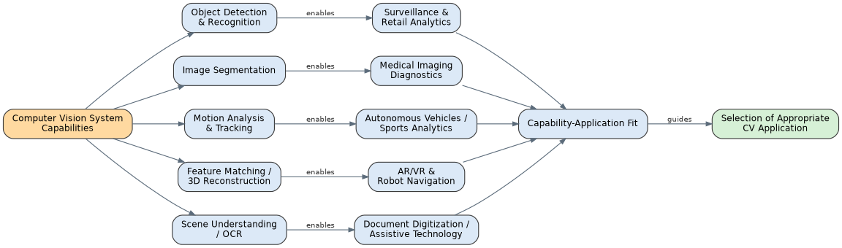
Influence on Application Effectiveness
- Object detection & recognition enables surveillance systems and retail analytics (e.g., footfall counting, shelf monitoring).
- Image segmentation enables precise medical imaging diagnostics by isolating anatomical structures or lesions.
- Motion analysis & tracking enables autonomous vehicle perception and sports performance analytics.
- Feature matching / 3D reconstruction enables augmented/virtual reality experiences and robot navigation in unstructured environments.
- Scene understanding / OCR enables document digitization and assistive technologies for visually impaired users.
- The overall capability-application fit guides practitioners in selecting the most appropriate Computer Vision approach for a given real-world problem.
Literature Sources Integrated
- R. Szeliski, Computer Vision: Algorithms and Applications, 2nd ed., Springer, 2022.
- D. A. Forsyth and J. Ponce, Computer Vision: A Modern Approach, 2nd ed., Pearson, 2012.
- M. Sonka, V. Hlavac, and R. Boyle, Image Processing, Analysis, and Machine Vision, 4th ed., Cengage, 2014.
- R. Jain, R. Kasturi, and B. G. Schunck, Machine Vision, McGraw-Hill, 1995.
- D. Marr, Vision: A Computational Investigation into the Human Representation and Processing of Visual Information, MIT Press, 1982/2010.

