SIMATS ENGINEERING (SAVEETHA SCHOOL OF ENGINEERING)
Department of Computer Science and Engineering
CO5_AT1 — UNCERTAINTY VISUALIZATION LAB

Course Code: | DSA06-06 | Course Title: | Data Handling and Visualization
CO Assessed: | CO5 – Analysis (BL4) | Assessment: | Assessment Tool 1 – Uncertainty Visualization Lab
Weightage: | 20% of CIA | Total Marks: | 25 (5 Questions × 5 Marks)
CO5 Statement: | Analyze and construct visualizations that communicate uncertainty using frequency framing, confidence intervals, trend uncertainty bands, HOPs, bootstrapping, and appropriate axis scales.(BL4)
Student Name: | Janani Priya G | Reg. No.: | 192324041
Section / Batch: | 2023-27 /SLOT C | Date: | 27/08/26

Code of Conduct
I Janani Priya G / 192324041 (Name / Reg No) certify that this submission is my original work and that I have adhered to the guidelines specified for this assessment. I understand that any violation of academic integrity rules will result in disciplinary action.

Signature of the Student: Janani Priya G

Instructions
- This test contains 5 questions, each carrying 5 marks. Total: 25 Marks.
- No negative marking. Unanswered questions carry zero marks.
- No calculators or electronic devices permitted.
- Duration: 90 minutes.
- Show all supporting calculations (e.g., confidence interval bounds, residual standard deviation, bootstrap resample means) where relevant.
- Every diagram must include a title, correctly labeled axes, and a legend where relevant.
- Diagrams may be hand-drawn or clearly described in words if drawing tools are unavailable.

Annexure A – UNCERTAINTY VISUALIZATION LAB

PROBLEM 11 (Bootstrap)
Data: A small sample of 5 patient recovery days: 54, 62, 65, 67, 71.
Task: Perform one bootstrap resample (draw 5 values with replacement) and calculate its mean, then
explain how repeating this process thousands of times and taking the middle 95% of resulting means
gives a confidence interval.

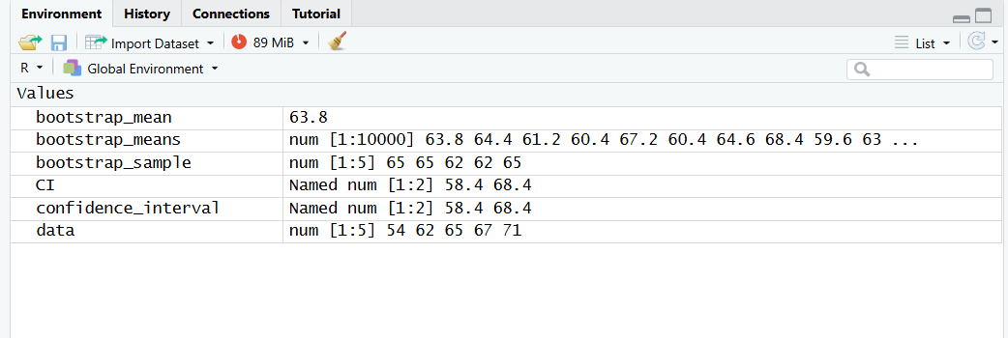
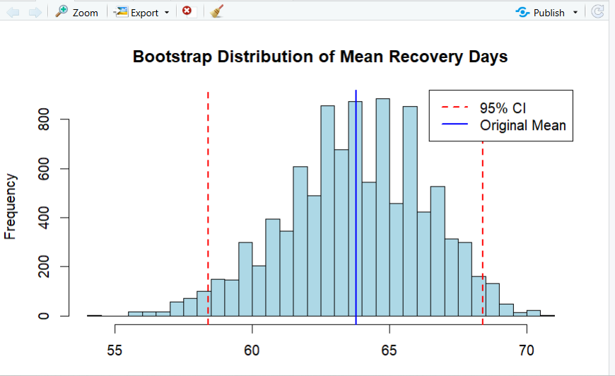

Problem 12
Data: Company revenues for 4 entities: 50000, 800000, 12000000, 200000000 ₹.
Task: Plot this data on both a linear and a logarithmic axis, calculate the ratio between each consecutive
pair of values, and explain which axis reveals the data's structure more clearly, and why

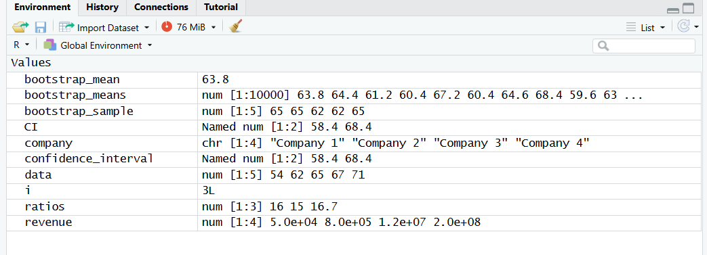

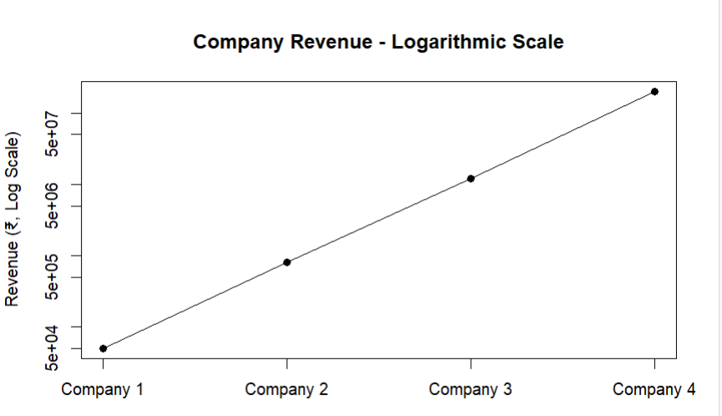

Problem 13
Data: A report states: “There is a 7% chance of a manufactured part failing quality inspection.”
Task: Reframe this probability as a natural frequency statement, and describe how you would build a
10×10 icon array to represent it

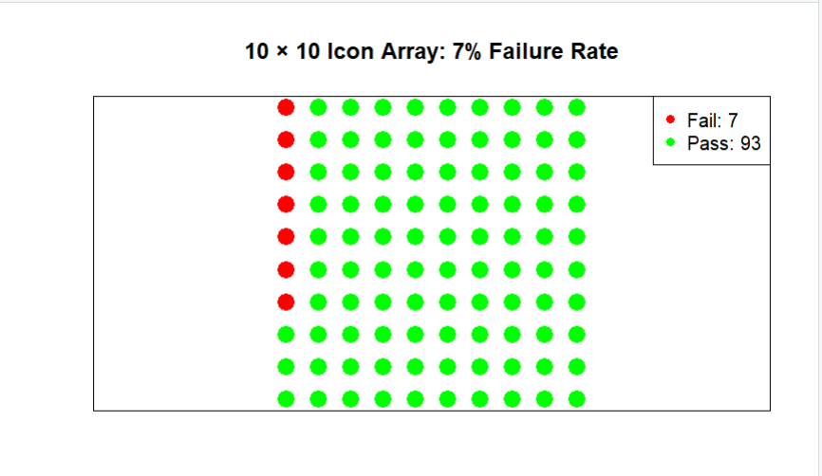
Problem 14
Data: Treatment group vs. Control group recovery rate: 48% ± 2% vs. 52% ± 2% (95% confidence
interval).
Task: Calculate both confidence intervals, determine whether the two overlap, and state whether the
higher figure represents a statistically meaningful lead

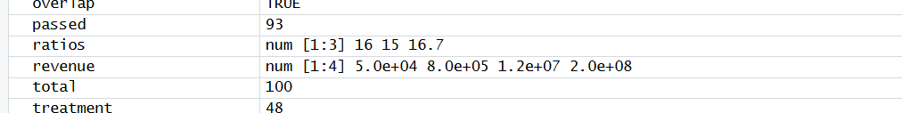
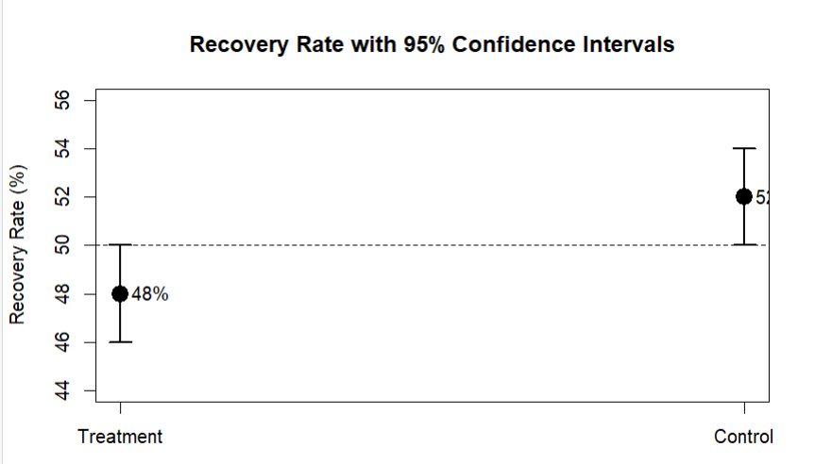

Problem 15
Data: quarterly customer complaints (in tens) over 6 periods: 92, 92, 110, 117, 122, 130.
Task: Fit a linear trend line, compute the residuals and their standard deviation, and state the 95%
uncertainty band width around the trend.

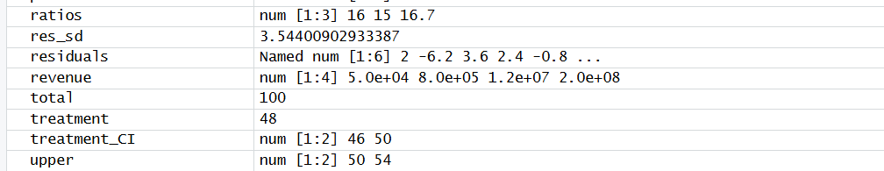

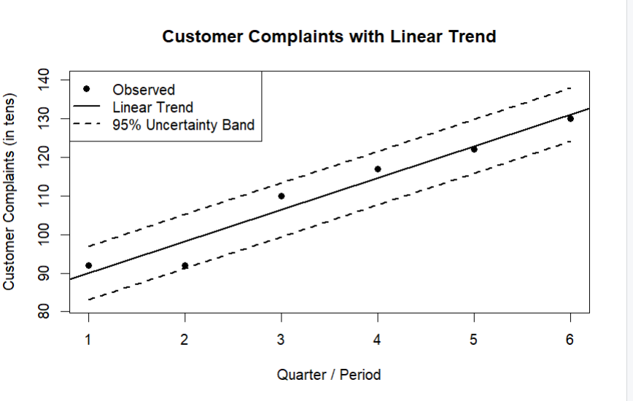

Faculty In-charge | Course Coordinator | Head of Department
Signature: _______________ | Signature: _______________ | Signature: _______________
Date: ___________________ | Date: ___________________ | Date: ___________________

