Activity 18

NAME: KAVIYA M COURSE: MOBILE COMPUTING
REG NO : 192421050 COURSE CODE: ITA0301

Use Figma to create an infographic comparing and contrasting the architectures of Android, iOS, and Windows.

Aim:
To use Figma to create an infographic comparing and contrasting the architectures of Android, iOS, and Windows.

Procedure:
- Define Presentation Structure
- Create a Figma Project
- Design Visual Elements
- Make it Interactive
- Add Annotations and Explanations
- Incorporate Multimedia
- Storyboard Animation
- Test the Prototype
- Collaborate and Gather Feedback
- Finalize and Share

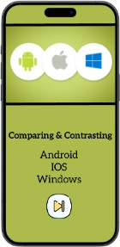
Step By Step Procedure : Interface Of Experiment:

Next Page:

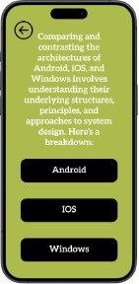

Final Step:
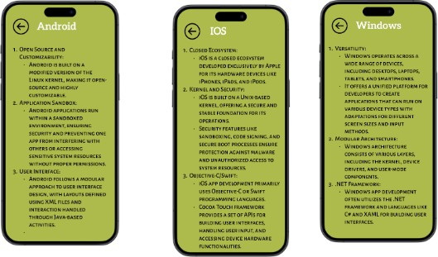

Prototype:

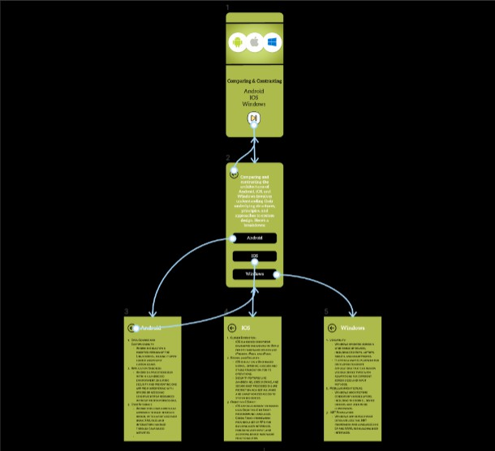

Result:
Hence the comparing and contrasting the architectures of Android, iOS, and Windows is created and executed successfully.

