Experiment 6
6. Execute and display the results for the following commands in Kali Linux Operating Systems:
i) Touch
ii) Pwd
iii) Wget
Aim: To execute and study the touch, pwd, and wget commands in Kali Linux Operating System and observe their outputs.
i) touch Command
Command:
touch sample.txt
ls 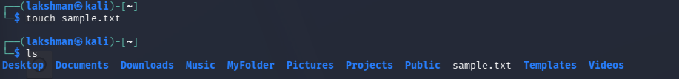
Explanation: The touch command is used to create a new empty file. Here, sample.txt is created in the current directory.
The ls command is used to verify that sample.txt has been created successfully.

ii) pwd Command
Command:
pwd
Explanation: The pwd command stands for Print Working Directory. It displays the complete path of the directory in which the user is currently working.
Your output is:
/home/lakshman
pwd
/home/lakshman
iii) wget Command
Command:
wget https://example.com
ls
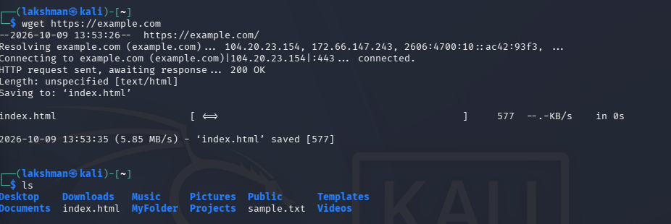
Explanation: The wget command is used to download files or web content from the internet using a URL.
Here, wget https://example.com downloads the webpage and saves it as index.html.
The ls command is then used to verify that index.html was downloaded successfully.
Result: Thus, the touch, pwd, and wget commands were successfully executed in Kali Linux, and their outputs were displayed and verified.

