Experiment 2 – less, more and vi
Aim: Execute and display the results for the following commands in Kali Linux Operating
less command

Command:
1.less command
Explanation: less is used to view the contents of a text file one screen at a time
Command:ls
2.more command
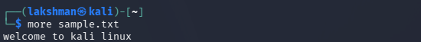
Explanation: more is also used to view a text file page by page.
3. vi Command
Command:
Explanation: Unlike less and more, which are mainly used to view files, vi is used to create and edit files.
To save and exit vi, press Esc, type :wq, and press Enter.
less sample.txt
The Experiment2 directory should now appear in the output.
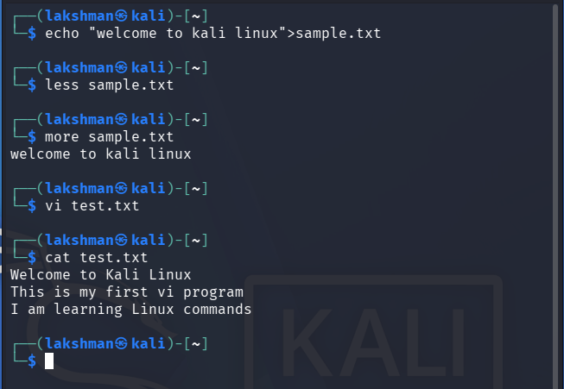
cat test.txt
5. Verify the file:
Press i, type the required text, press Esc, then type :wq and press Enter.
vi test.txt
4. Execute vi:
Press q to exit.
more sample.txt
3. Execute more:
Press q to exit.
less sample.txt
2. Execute less:
echo "Welcome to Kali Linux" > sample.txt
Result: Thus, the less, more, and vi commands were successfully executed in Kali Linux, and their outputs were displayed and verified.

