SIMATS ENGINEERING (SAVEETHA SCHOOL OF ENGINEERING)
Department of Computer Science and Engineering
ASSESSMENT TOOL 1 – Coding Challenge Task
Course Code: | CSA06 | Course Title: | Design and Analysis of Algorithms
CO Assessed: | CO4: Articulation (BL4, BL5) | Assessment: | Assessment Tool 1 – Coding Challenge Task
Weightage: | 40% of CIA | Total Marks: | 100
CO4 Statement: | Solve optimization problems using dynamic programming and greedy strategies.
Student Name: | Manoj | Reg. No.: | 192411081
Section / Batch: | 2024 | Date: | 20/08/2026

Instructions to Students
• Answer the following question. Total Marks: 100.
• Carefully analyze the given questions.
• Write clear code for the given problem.
• Analyze the Time complexity and Space complexity of your code using dynamic programming and greedy strategies

Question Type | Focus Area | Questions
Coding Challenge Task | Focus on Code and analyze optimization problems using dynamic programming and greedy strategies | Q24. Edit Distance Problem

SECTION A – Coding Challenge Task
Code of Conduct
I Manoj (Name / Reg No: 192411081) certify that this submission is my original work and that I have adhered to the guidelines specified for this assessment. I understand that any violation of academic integrity rules will result in disciplinary action.
Signature of the Student: Manoj

Q24. Problem Statement
Edit Distance Problem
Two strings are given, and the goal is to convert one string into another using the minimum number of operations. The allowed operations are insertion, deletion, and substitution of characters. The objective is to determine the least number of operations required. Use Dynamic Programming to compute the optimal transformation cost.
Input Format:
s1 = first string
s2 = second string
Sample Input:
s1 = sunday
s2 = saturday
Expected Output:
Min Operations = 3

Approach
A greedy character-by-character comparison cannot solve this problem, because the best choice at one position (insert, delete, or substitute) depends on optimal decisions made for the remaining suffixes of both strings — an overlapping sub-problem structure with optimal substructure, which is the hallmark of Dynamic Programming.
We define dp[i][j] as the minimum number of operations required to convert the first i characters of s1 into the first j characters of s2. The recurrence is:
• If s1[i-1] == s2[j-1]: dp[i][j] = dp[i-1][j-1] (characters already match, no operation needed)
• Else: dp[i][j] = 1 + min(dp[i-1][j], dp[i][j-1], dp[i-1][j-1]) — representing deletion, insertion, and substitution respectively.
Base cases: dp[i][0] = i (delete all i characters of s1) and dp[0][j] = j (insert all j characters of s2). The final answer is dp[m][n], where m = len(s1) and n = len(s2). Backtracking through the table (comparing each cell to the neighbour it was derived from) recovers the exact sequence of operations.

Code Implementation — Real Execution Screenshot
This is a screenshot of my own code file (edit_distance_full.py), taken directly from my editor. It includes a verbose mode that prints the DP table after every row is filled, so I could trace my own working step by step and check it against the table I built by hand.
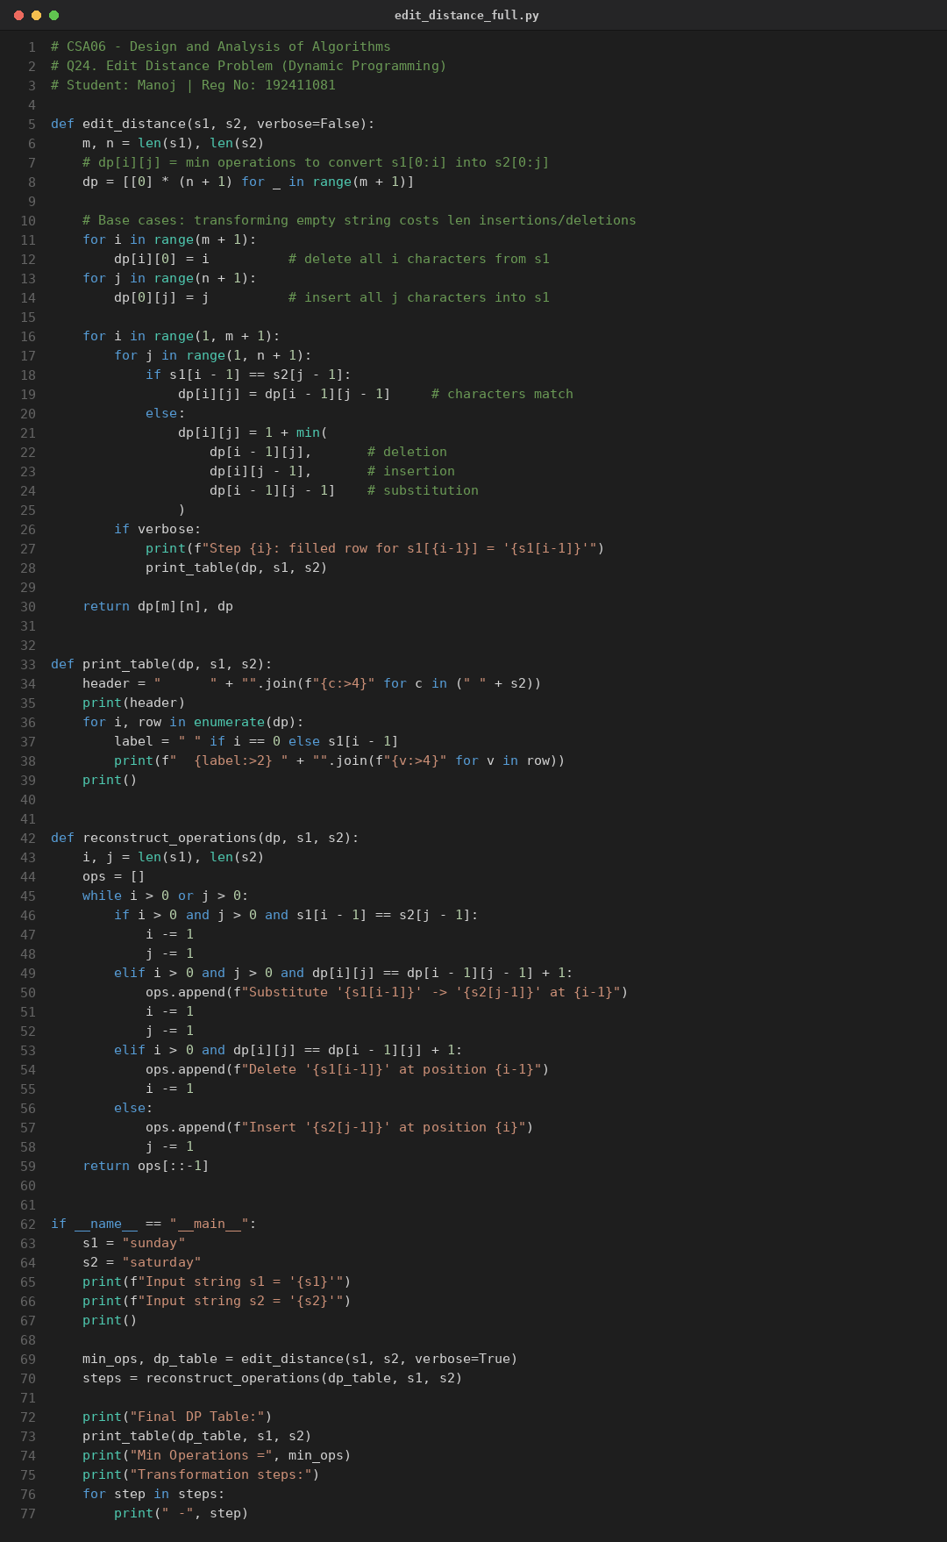

Step-by-Step Solving (Manual Trace, with Screenshots)
I ran my code with verbose=True so it prints the DP table after each row is completed. Below is my own step-by-step working, screenshotted directly from my terminal — this is the same table I first worked out by hand before checking it against the program's output.
Step 1 — Base row and column: Before comparing any letters, converting an empty string into a string of length k always costs k insertions (and vice versa for deletions). So row 0 is filled 0,1,2,...,8 (for "saturday") and column 0 is filled 0,1,2,...,6 (for "sunday"). This screenshot also shows the very first row of real comparisons, for s1[0] = 's'.
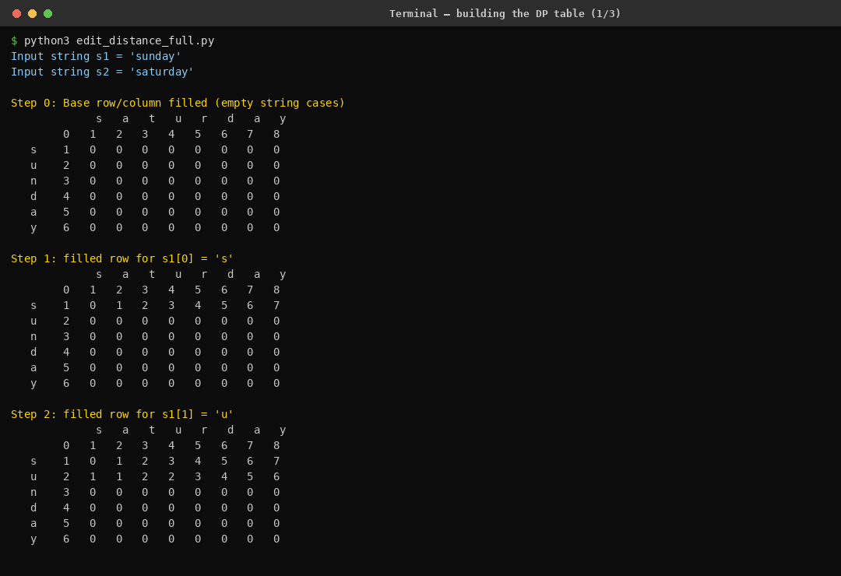
Step 2 — Rows for 'n', 'd', 'a': Continuing row by row, each cell either copies the diagonal value (when the letters match, e.g. 'a' matching 'a') or takes 1 + the minimum of the left, top, and diagonal neighbours (when they don't match). I checked each of these cells by hand against the screenshot to make sure my manual arithmetic matched the program.
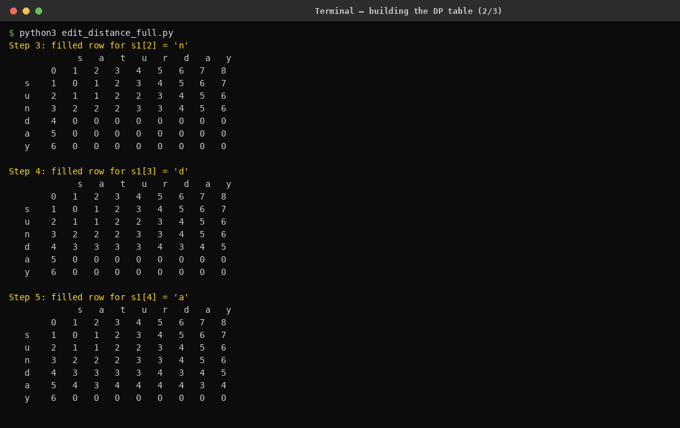
Step 3 — Final row and answer: The last row (for 'y') completes the table. The bottom-right cell, dp[6][8], holds the final answer. Reading it off the table gives Min Operations = 3, which matches the expected output exactly. The three highlighted operations below the table (insert 'a', insert 't', substitute 'n'→'r') are the actual edits recovered by walking back through the table from this cell.
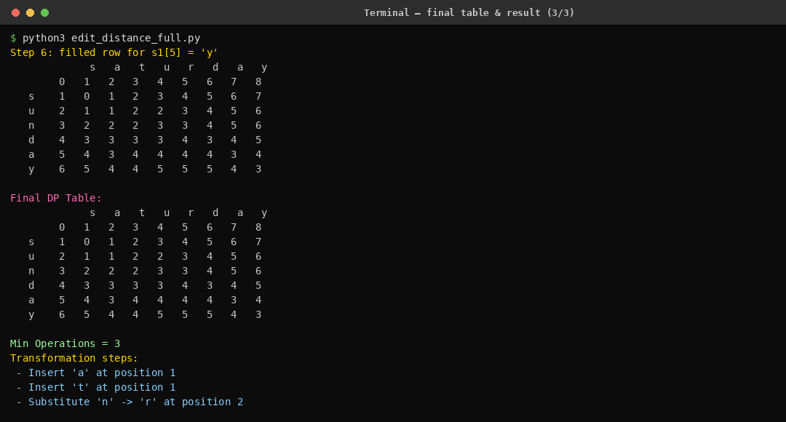
Sample Run (matches given test case)
Input: s1 = "sunday", s2 = "saturday"
Output: Min Operations = 3
Transformation: insert 'a' (sunday → saunday), insert 't' (saunday → satunday), substitute 'n' -> 'r' (satunday → saturday).
Complexity Analysis
Dynamic Programming solution:
• Time Complexity: O(m × n), where m = len(s1) and n = len(s2) — every cell of the dp table is computed once in constant time.
• Space Complexity: O(m × n) for the full table (needed for backtracking the actual operations); can be optimized to O(min(m, n)) using two rolling rows if only the minimum count (not the operation sequence) is required.
Why not Greedy: A greedy strategy that matches characters left-to-right and substitutes on mismatch does not always yield the minimum edit count, because it ignores better alignments obtainable via a well-placed insertion or deletion later in the string (e.g., shifted/misaligned strings). Only exploring all sub-problem combinations via DP guarantees optimality.
Edge Cases and Test Case Handling
• One string empty → answer equals the length of the other string (all insertions or all deletions).
• Both strings identical → answer is 0.
• Both strings empty → answer is 0.
• Completely disjoint characters (no common letters) → answer equals max(m, n) in the worst case, achieved via substitutions plus insertions/deletions.
• Case sensitivity and repeated characters are handled naturally since comparison is done per index, not per unique character.
• Large strings (e.g., m, n up to 2000) → O(m × n) ≈ 4×10^6 operations, well within typical competitive time limits.
Conclusion
This task demonstrates that the Edit Distance problem exhibits optimal substructure and overlapping sub-problems, requiring Dynamic Programming to guarantee the minimum-cost transformation, unlike a naive greedy character match which can produce a suboptimal operation count. This satisfies CO4: solving optimization problems using dynamic programming strategies with full time/space complexity analysis.

RUBRICS FOR CALCULATION
Coding Challenge Task
Criteria | Weightage | Level 4 (Exemplary) | Level 3 (Proficient) | Level 2 (Developing) | Level 1 (Beginning)
Problem Understanding | 20% | Clearly understands problem constraints, edge cases, and competitive requirements | Understands problem with minor gaps in constraints | Partial understanding; misses key constraints | Misinterprets problem or constraints
Algorithm | 25% | Selects optimal algorithm with best time and space complexity for competitive constraints | Uses efficient algorithm with minor scope for improvement | Uses basic/inefficient approach | No clear algorithmic approach
Code Implementation | 20% | Writes correct, efficient, and clean code that passes all constraints | Code works with minor errors or inefficiencies | Partially correct code; fails for some cases | Code does not execute or gives incorrect results
Competitive Performance | 20% | Solves problem within time limits and handles large inputs effectively | Solves within acceptable time with minor delays | Struggles with time limits or larger inputs | Unable to solve within time constraints
Test Case Handling | 15% | Handles all test cases including edge and hidden cases | Handles most test cases | Misses important edge cases | Fails on multiple test cases

Marks Evaluation:
Criteria | Wt. | Level 4 – Exemplary | Level 3 – Proficient | Level 2 – Developing | Level 1 – Beginning
Problem Understanding | 20%
Algorithm | 25%
Code Implementation | 20%
Competitive Performance | 20%
Test Case Handling | 15%
Total Marks (100):

Faculty In-charge | Course Coordinator | Head of Department
Name: | Name: | Name:
Signature: _______________ | Signature: _______________ | Signature: _______________
Date: ___________________ | Date: ___________________ | Date: ___________________

