NAME: P.Manoj
REG NO: 192411081

Q1. Data Preprocessing in Retail Analytics (L3, L4)
Given Dataset
Custome r_ID | Age | Gender | Monthly  _Spend  (₹K) | Purchase _Frequen  cy | Loyalty  _Level
C1 | 23 | M | 20 | 5 | Low
C2 | NaN | Male | 35 | 8 | Medium
C3 | 31 | F | NaN | 10 | High
C4 | 105 | Female | 500 | 50 | High
C5 | 27 | male | 25 | NaN | Low
C6 | 40 | FEMALE | 45 | 12 | Medium
C7 | 36 | M | 38 | 9 | Low
C8 | 42 | Female | 300 | 45 | High

A. Handling Missing Values
- Identify Missing Values
Column Missing Value
Age | C2
Monthly_Spend | C3
Purchase_Frequency | C5

- Two Imputation Techniques
Method 1: Median Imputation
Age
Available values: 23, 31, 105, 27, 40, 36, 42 Sorted:
23, 27, 31, 36, 40, 42, 105
Median = 36 So,
C2 Age = 36
Monthly Spend
Available values: 20, 35, 500, 25, 45, 38, 300 Sorted:
20, 25, 35, 38, 45, 300, 500
Median = 38
So,
C3 Monthly Spend = ₹38K
Purchase Frequency Available values: 5, 8, 10, 50, 12, 9, 45 Sorted:
5, 8, 9, 10, 12, 45, 50
Median = 10
So,
C5 Purchase Frequency = 10
Method 2: k-NN Imputation (k=3) Nearest customers with similar values are used.
Approximate imputed values:
Column k-NN Value

Age (C2) | 35 years
Monthly Spend (C3) | ₹40K
Purchase Frequency (C5) | 9

iii. Computed Imputed Values
Column Median Imputation k-NN Imputation
Age | 36 | 35
Monthly Spend | ₹38K | ₹40K
Purchase Frequency | 10 | 9

Justification
- Median Imputation is simple and less affected by outliers.
- k-NN Imputation uses similar customer records and gives more realistic estimates.
B. Outlier Detection and Treatment
i. Detect Outliers Using Z-score
Formula:
𝑥 − 𝜇
𝑍 =
𝜎

where
- x = value
- μ = mean
- σ = standard deviation
A value is considered an outlier if
|Z| > 3

Age
Values:
23, 36, 31, 105, 27, 40, 36, 42
The value 105 has a very high Z-score.
Outlier: C4

Monthly Spend
Values:
20, 35, 38, 500, 25, 45, 38, 300
Both
- 500
- 300
have very high Z-scores.
Outliers:
- C4
- C8
- Records Containing Extreme Values

Customer | Outlier
C4 | Age = 105, Spend = 500
C8 | Spend = 300

- Treatment
Capping (Winsorization)
Replace extreme values with the maximum acceptable value.
Example:
Age:
105 → 60
Monthly Spend:
500 → 100
300 → 100

Alternative Methods
- Remove the record if it is an incorrect entry.
- Apply log transformation for skewed data.
Justification
Capping preserves customer records while reducing the influence of extreme values.

C. Categorical Data Standardization
- Identify Inconsistencies
Original Gender values:
  - M
  - Male
  - male
  - F
  - Female
  - FEMALE
These represent only two categories but use different formats.
- Standardized Format
Original |  | Standardized
M |  | Male
Male |  | Male
 | male |  | Male
 | F |  | Female
 | Female |  | Female
 | FEMALE |  | Female

Final Cleaned Dataset (Using Median Imputation and Standardization)
Customer  _ID | Age | Gend  er | Monthly_Sp end | Purchase_Frequ ency | Loyalty_L  evel
C1 | 23 | Male | 20 | 5 | Low
C2 | 36 | Male | 35 | 8 | Medium
C3 | 31 | Femal  e | 38 | 10 | High
C4 | 60  (Cappe  d) | Femal  e | 100  (Capped) | 50 | High
C5 | 27 | Male | 25 | 10 | Low
C6 | 40 | Femal  e | 45 | 12 | Medium
C7 | 36 | Male | 38 | 9 | Low
C8 | 42 | Femal  e | 100  (Capped) | 45 | High

Conclusion
  - Missing values were identified and filled using Median Imputation and k-NN Imputation.
  - Outliers were detected using the Z-score method and treated using capping.
  - Gender values were standardized into Male and Female, resulting in a clean dataset suitable for building a recommendation system.
  - Q2. Covariance & Data Reduction in Ecommerce Analytics (L4, L5)
  - Given Dataset
Cust  _ID | A Inco Purchase ge me _Value  (₹K) (₹K) |  |  | Credit_  Score | Ord  ers | Avg_Ba  lance (₹K) | EM  I  (₹) | Customer  _Class
U1 | 24 | 40 | 100 | 650 | 15 | 12 | 500  0 | Low
U2 | 34 | 60 | 150 | 700 | 20 | 18 | 700  0 | Medium
U3 | 44 | 85 | 210 | 720 | 28 | 25 | 900  0 | Medium
U4 | 52 | 120 | 320 | 800 | 35 | 40 | 150  00 | High
U5 | 29 | 45 | 110 | 680 | 18 | 14 | 550  0 | Low
U6 | 39 | 75 | 180 | 710 | 24 | 22 | 850  0 | Medium
U7 | 56 | 150 | 360 | 820 | 40 | 50 | 180  00 | High
U8 | 37 | 70 | 160 | 705 | 22 | 20 | 800  0 | Medium

A. Covariance Analysis
i. Compute Covariance between Income and Purchase_Value
Step 1: Find Mean
Income (₹K)
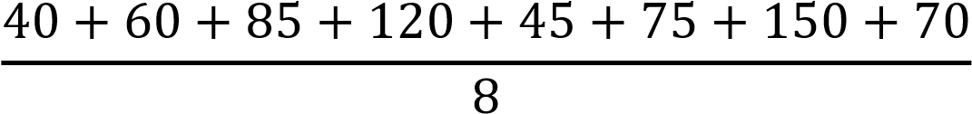 = 80.625

Mean Income = 80.625
Purchase Value (₹K)
= 198.75

Mean Purchase Value = 198.75
Step 2: Partial Calculation
Income (Xi) Purchase (Yi) Xi−X̄ Yi−Ȳ Product
40 | 100 | -40.625 | -98.75 | 4011.72
60 | 150 | -20.625 | -48.75 | 1005.47
85 | 210 | 4.375 | 11.25 | 49.22
120 | 320 | 39.375 | 121.25 | 4774.22
45 | 110 | -35.625 | -88.75 | 3161.72
75 | 180 | -5.625 | -18.75 | 105.47
150 | 360 | 69.375 | 161.25 | 11187.89
70 | 160 | -10.625 | -38.75 | 411.72
Sum of Products = 24,707.43
Step 3: Covariance Formula
Cov(𝑋, 𝑌) = ∑( 𝑋_{𝑖} − 𝑋̅)(𝑌_{𝑖} − 𝑌̅)

𝑛 − 1
24707.43
=
7
Covariance ≈ 3529.63
- Interpretation
Covariance is positive (+3529.63).
This means:
  - As Income increases, Purchase Value also increases.
  - Customers with higher income generally spend more.
- How Covariance Helps
Covariance helps to:
  - Measure how two variables change together.
  - Identify relationships between features.
  - Detect redundant variables.
  - Improve feature selection before building ML models.
B. Feature Selection
- Identify Redundant Attributes Highly related features include:
  - Income ↔ Purchase_Value
  - Income ↔ Avg_Balance
  - Purchase_Value ↔ EMI
  - Orders ↔ Purchase_Value
These attributes contain similar information.
- Selected Features
Choose:
  - Age
  - Income
  - Credit_Score
  - Orders
  - Customer_Class (Target)
Remove:
  - Purchase_Value
  - Avg_Balance
  - EMI

- Justification
  - Removes duplicate information.
  - Reduces computation time.
  - Prevents overfitting.
  - Improves model performance.

C. Data Transformation
- Standardize the Dataset
Standardization Formula:
𝑋 − 𝜇
𝑍 =
𝜎

where
  - X = Value
  - μ = Mean
  - σ = Standard Deviation
Example:
For Income = 40
Mean = 80.625
Standard Deviation ≈ 38.89
𝑍 = 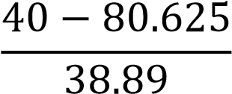 = −1.04

Similarly,
Feature Example Standardized Value
Age |  | -1.30
Income |  | -1.04
Purchase_Value |  | -1.08
Credit_Score |  | -1.44
Orders |  | -1.24
 | Avg_Balance |  | -1.10
 | EMI |  | -1.07

All numerical columns (except Cust_ID and Customer_Class) are converted to Z-scores.

- Why Standardization is Required
Standardization is required because:
  - It brings all features to the same scale.
  - Prevents large-value features (e.g., EMI) from dominating small-value features (e.g., Orders).
  - Improves the performance of machine learning algorithms such as KNN, SVM, PCA, and Logistic Regression.
  - Speeds up model training and increases prediction accuracy.

Final Answer Summary
- Covariance Analysis
  - Mean Income = 80.625
  - Mean Purchase Value = 198.75
  - Covariance = 3529.63 (Positive)
  - Interpretation: Higher income customers tend to have higher purchase values.
- Feature Selection
  - Selected: Age, Income, Credit_Score, Orders
  - Removed: Purchase_Value, Avg_Balance, EMI (redundant/highly correlated)
- Data Transformation
  - Standardized all numerical features using the Z-score formula.
  - Excluded Cust_ID and Customer_Class.
  - Standardization ensures fair comparison between features, faster convergence, and better model performance.
Q3. Data Transformation & Discretization in Education Analytics (L3, L4, L5)
Given Dataset
Student_ID Study_Hours Test_Score Attendance (%) Performance
S1 | 2 | 40 | 60 | Poor
S2 | 3 | 50 | 65 | Average
S3 | 4 | 55 | 70 | Average
S4 | 5 | 65 | 75 | Good
S5 | 6 | 75 | 80 | Good
S6 | 7 | 85 | 85 | Good
S7 | 8 | 90 | 88 | Excellent
S8 | 9 | 95 | 90 | Excellent
S9 | 10 | 98 | 92 | Excellent
S10 | 11 | 100 | 95 | Excellent

A. Equal-Width Binning
i. Apply 3 Bins
Study_Hours
Minimum = 2
Maximum = 11
Range =
𝟏𝟏 − 𝟐 = 𝟗

Number of bins = 3
Bin Width
𝟗
= 𝟑
𝟑

Intervals
Bin Interval
Bin 1 | 2 – 5
Bin 2 | 5 – 8
Bin 3 | 8 – 11
Assign Study_Hours
Student Study_Hours Bin
S1 | 2 | Bin 1
S2 | 3 | Bin 1
S3 | 4 | Bin 1
S4 | 5 | Bin 1
S5 | 6 | Bin 2
S6 | 7 | Bin 2
S7 | 8 | Bin 2
S8 | 9 | Bin 3
S9 | 10 | Bin 3
S10 | 11 | Bin 3

Test_Score
Minimum = 40
Maximum = 100
Range =
100 − 40 = 60

Number of bins = 3
Bin Width
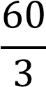 = 20
Intervals
Bin Interval
Bin 1  Bin 2 | 40 – 60
 | 60 – 80
Bin 3 | 80 – 100
Assign Test_Score
Student Score Bin
S1 | 40 | Bin 1
S2 | 50 | Bin 1
S3 | 55 | Bin 1
S4 | 65 | Bin 2
S5 | 75 | Bin 2
S6 | 85 | Bin 3
S7 | 90 | Bin 3
S8 | 95 | Bin 3
S9 | 98 | Bin 3
S10 | 100 | Bin 3

B. Equal-Frequency Binning
There are 10 records.
Divide into 3 bins with approximately equal records.
Study_Hours
Bin Values
Bin 1 2, 3, 4, 5
Bin Values
Bin 2 6, 7, 8
Bin 3 9, 10, 11
Test_Score
Bin Values
Bin 1 40, 50, 55, 65
Bin 2 75, 85, 90
Bin 3 95, 98, 100

Equal-Frequency Assignment
Student | Study_Hours Bin | Test_Score Bin
S1 | Bin 1 | Bin 1
S2 | Bin 1 | Bin 1
S3 | Bin 1 | Bin 1
S4 | Bin 1 | Bin 1
S5 | Bin 2 | Bin 2
S6 | Bin 2 | Bin 2
S7 | Bin 2 | Bin 2
S8 | Bin 3 | Bin 3
S9 | Bin 3 | Bin 3
S10 | Bin 3 | Bin 3

C. Concept Hierarchy Construction
Study_Hours
Hours Category
2 – 4 |  | Low
 | 5 – 7 |  | Medium
 | 8 – 11 |  | High
Assignment
Student Study_Hours Category
S1 | 2 | Low
S2 | 3 | Low
S3 | 4 | Low
S4 | 5 | Medium
S5 | 6 | Medium
S6 | 7 | Medium
S7 | 8 | High
S8 | 9 | High
S9 | 10 | High
S10 | 11 | High

Test_Score
Score Category
40 – 59 | Poor
60 – 79 | Average
80 – 100 | Excellent
Assignment
Student | Score | Category
S1 | 40 | Poor
S2 | 50 | Poor
S3 | 55 | Poor
S4 | 65 | Average
S5 | 75 | Average
S6 | 85 | Excellent
S7 | 90 | Excellent
S8 | 95 | Excellent
S9 | 98 | Excellent
S10 | 100 | Excellent

Final Answer Summary
- Equal-Width Binning
  - Study_Hours: Bin width = 3 o Bins: 2–5, 5–8, 8–11
  - Test_Score: Bin width = 20 o Bins: 40–60, 60–80, 80–100
- Equal-Frequency Binning
  - Divided the 10 records into 3 bins with nearly equal numbers of records:
    - Bin 1: 4 records o Bin 2: 3 records
    - Bin 3: 3 records
- Concept Hierarchy
  - Study_Hours: Low (2–4), Medium (5–7), High (8–11)
  - Test_Score: Poor (40–59), Average (60–79), Excellent (80–100)
This transformation makes continuous data easier to interpret and improves decision-making in education analytics.
Q4. Normalize the following data
Given Data:
200, 300, 400, 600, 1000

- Min-Max Normalization (Min = 0, Max = 1)
Formula
′ = 𝑋 − 𝑋min
𝑋
𝑋max − 𝑋min

Here,
  - Minimum = 200
  - Maximum = 1000
′ = 𝑋 − 200 = 𝑋 − 200
𝑋
1000 − 200 800

Calculations
Original Value Normalized Value
200 | (200−200)/800 = 0.000
300 | (300−200)/800 = 0.125
400 | (400−200)/800 = 0.250
600 | (600−200)/800 = 0.500
1000 | (1000−200)/800 = 1.000
Min-Max Normalized Data
0.000, 0.125, 0.250, 0.500, 1.000

- Z-Score Normalization
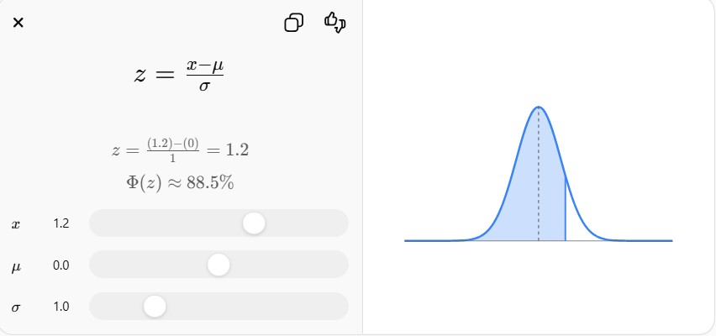
Formula
𝑋 − 𝜇
𝑧 =
𝜎

Step 1: Mean
200 + 300 + 400 + 600 + 1000 2500
𝜇 = = = 500
5 5

Mean = 500

Step 2: Standard Deviation
𝜎
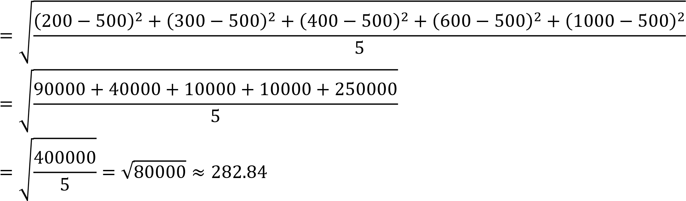

Standard Deviation ≈ 282.84

Step 3: Calculate Z-scores
Original Value Z-score
200 | −1.06
300 | −0.71
400 | −0.35
600 | 0.35
1000 | 1.77
Z-Score Normalized Data
−1.06, −0.71, −0.35, 0.35, 1.77

Final Answer
- Min-Max Normalization
Original Normalized
200 | 0.000
300 | 0.125
400 | 0.250
600 | 0.500
1000 | 1.000
- Z-Score Normalization
Original Z-score
200 | −1.06
300 | −0.71
400 | −0.35
600 | 0.35
1000 | 1.77
Data Transformation in Online Shopping Behavior Analysis (L3, L4, L5) Given Dataset
Customer_ID Visit_Duration (seconds)
C1 | 15
C2 | 30
C3 | 45
C4 | 60
C5 | 120
C6 | 300
C7 | 600
C8 | 900
C9 | 1800
C10 | 3600

A. Equal-Frequency Binning
There are 10 records.
Divide into 3 bins with approximately equal records.
- Three Bins
Bin Visit Duration (seconds)
Bin 1 15, 30, 45, 60
Bin 2 120, 300, 600
Bin 3 900, 1800, 3600

- Assign Each Value
Customer Visit Duration Bin
C1 |  | 15 |  | Bin 1
C2 |  | 30 |  | Bin 1
 | C3 |  | 45 |  | Bin 1
 | C4 |  | 60 |  | Bin 1
 | C5 |  | 120 |  | Bin 2
 | C6 |  | 300 |  | Bin 2
 | C7 |  | 600 |  | Bin 2
 | C8 |  | 900 |  | Bin 3
 | C9 |  | 1800 |  | Bin 3
 | C10 |  | 3600 |  | Bin 3

- Analysis
  - Bin 1: Short visit durations.
  - Bin 2: Medium visit durations.
  - Bin 3: Long visit durations.
Equal-frequency binning keeps a similar number of records in each group, making it useful for customer segmentation.

B. Z-Score Normalization
- Mean and Standard Deviation
Mean
𝜇 =
= 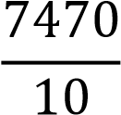 = 747

Mean = 747 seconds

Standard Deviation
Using the population standard deviation:
𝜎 ≈ 1102.87

Standard Deviation ≈ 1102.87 seconds

- Apply Z-Score Normalization
Formula:
𝑋 − 𝜇
𝑍 =
𝜎

Visit Duration Z-score
15 | -0.66
30 | -0.65
45 | -0.64
60 | -0.62
120 | -0.57
300 | -0.41
600 | -0.13
900 | 0.14
1800 | 0.95
3600 | 2.59

- Discussion
  - Z-score centers the data around 0.
  - Positive values are above the mean; negative values are below the mean.
  - Extreme values like 1800 and 3600 have higher positive Z-scores, making them easy to identify as unusually long visits.

C. Min-Max Normalization
- Formula
′ = 𝑋 − 𝑋𝑚𝑖𝑛
𝑋
𝑋𝑚𝑎𝑥 − 𝑋𝑚𝑖𝑛

Where:
  - Minimum = 15
  - Maximum = 3600
′ = 𝑋 − 15
𝑋
3585

- Transformed Values
Visit Duration Min-Max Normalized
15 | 0.000
30 | 0.004
45 | 0.008
60 | 0.013
120 | 0.029
300 | 0.080
600 | 0.163
900 | 0.247
1800 | 0.498
3600 1.000

iii. Comparison
Z-Score Normalization | Min-Max Normalization
Mean becomes 0 | Values scaled between 0 and 1
Can produce negative values | No negative values
Z-Score Normalization Min-Max Normalization
Helps identify outliers using large Sensitive to outliers because the largest positive/negative Z-scores value (3600) determines the scale
Commonly used in machine learning
Commonly used in statistical algorithms such as KNN and Neural
analysis
Networks

Final Answer Summary
- Equal-Frequency Binning
  - Bin 1: 15, 30, 45, 60
  - Bin 2: 120, 300, 600
  - Bin 3: 900, 1800, 3600
- Z-Score Normalization
  - Mean = 747 seconds
  - Standard Deviation ≈ 1102.87 seconds
  - Z-scores identify extreme values like 1800 and 3600 as above-average visit durations.
- Min-Max Normalization
  - Values are scaled to the range [0,1].
  - Smallest value (15) becomes 0.
  - Largest value (3600) becomes 1.
  - Compared to Z-score normalization, Min-Max is more sensitive to outliers because extreme values determine the scaling range.

