ASSIGNMENT – 1
THREAT INTELLIGENCE AND NETWORK SECURITY

Course Code: CSA6303
Course Name: Threat Intelligence and Network Security
Academic Session : November 2026
Maximum Marks : 50
Faculty: Dr. V. Parthipan SLOT A

Topics: Network Security Fundamentals | Security Goals (CIA Triad) | Types of Network Threats Introduction to Threat Intelligence Types of Threat Intelligence (Strategic, Tactical, perational) — Threat Intelligence Lifecycle — Applications in IT Industry
CO1: Interpret security principles, network threats, and the role of threat intelligence in
cybersecurity.

Total: 50

Student Name: V. Teja Sree Register number: 192411211

Code of Conduct:
I V. Teja Sree (192411211) (Name / Reg No) certify that this submission is my original work and that I have adhered to the guidelines specified for this assessment. I understand that any violation of academic integrity rules will result in disciplinary action.

Signature of the student:
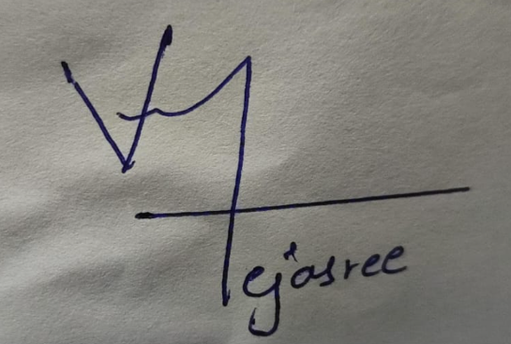

1 | A regional hospital network stores patient records, runs an online appointment portal and uses networked diagnostic machines. In one month the hospital faces four incidents: (i) an employee e-mails a spreadsheet of patient details to the wrong recipient, (ii) ransomware encrypts the records server, (iii) a technician alters a lab report without authorisation, and (iv) a flood of requests makes the appointment portal unreachable. Apply the fundamentals of network security to this case. Explain the three goals of the CIA triad and the related goals of authentication, non-repudiation and accountability; map each incident to the goal or goals that it violates with a reason; and prepare a table that gives, for each goal, two preventive controls and one detective control that the hospital should adopt. Discuss how the hospital should balance the three goals when they conflict (for example, tight access control versus emergency access to records). | (10) | (CO1) | (BL3)
2 | An online shopping company discovers that an attacker first sent a phishing e-mail to a customer-support agent, used the stolen password to log in to the internal network, moved across to the order database server, and copied customer data to an external server. Analyse the incident by classifying the types of network threats involved (malware, phishing, spoofing, sniffing, man-in-the-middle, denial of service, SQL injection and insider threats), stating which of them are passive and which are active, and identifying the likely threat actor (cybercriminal, hacktivist, nation-state or insider) with reasons. Prepare an attack-chain table that gives, for each stage, the threat, the weakness exploited, the impact on confidentiality, integrity or availability, and one control that would have stopped or detected the attack at that stage. Discuss which weaknesses were technical and which were human or procedural. | (10) | (CO1) | (BL4)
3 | A security analyst at a mid-size company notices that the firewall log shows 300 failed login attempts to the VPN gateway within ten minutes from one external IP address, and that the same address appears in a public threat-sharing report as part of a credential-stuffing campaign. Using this example, explain what threat intelligence is and how it differs from raw data and information, by showing how the log entry is converted step by step into actionable intelligence. Describe the characteristics of good threat intelligence (timely, accurate, relevant, contextual and actionable), explain how threat intelligence changes a security team from reactive to proactive, and discuss the benefits and the limitations (for example, false positives, information overload and stale indicators) of using threat intelligence in cybersecurity. | (10) | (CO1) | (BL3)
4 | A retail chain learns that a competitor has suffered a point-of-sale malware breach. The security manager must decide how to respond and wants to present suitable threat intelligence to three groups: the Chief Information Security Officer and the board, the SOC manager, and the incident handlers and network administrators. Analyse how strategic, tactical and operational threat intelligence apply to this situation. For each type, state the question that it answers, the audience, the time horizon and the sources, and give one deliverable that you would prepare for this case (for example, a risk briefing, a report of attacker techniques and tools, a warning about an expected campaign, and a list of technical indicators). Classify the following items as strategic, tactical or operational with a reason: an annual report on ransomware trends in retail, a description of how the attacker moves from stolen vendor credentials to the POS servers, an advance warning of a planned attack on the retailer's holiday sales, and a list of malicious domains. Discuss what the company would lose if it relied on only one type. | (10) | (CO1) | (BL4)
5 | A software-as-a-service company wants to set up a threat intelligence capability and begins with the requirement: "Are we likely to be targeted by credential-stuffing and ransomware groups in the next six months?" Evaluate how the threat intelligence lifecycle can be applied to answer this requirement. Describe the activities, tools and outputs of the planning and direction, collection, processing, analysis, dissemination and feedback phases, including how priority intelligence requirements are written and how information-sharing markings such as the Traffic Light Protocol are used. Then evaluate the applications of threat intelligence in the IT industry (for example, incident response, threat hunting, vulnerability and patch prioritisation, third-party risk assessment and executive risk reporting), and recommend four measures (for example, mean time to detect, mean time to respond, the percentage of alerts enriched with intelligence and the false-positive rate) to judge whether the programme is delivering value. | (10) | (CO1) | (BL5)

ANSWERS
Q1. Introduction
Network security protects information and systems from unauthorised access, misuse, modification and disruption. A hospital must protect patient records, its appointment portal and connected diagnostic machines because these systems support patient care and contain confidential medical information.
CIA Triad and Related Security Goals
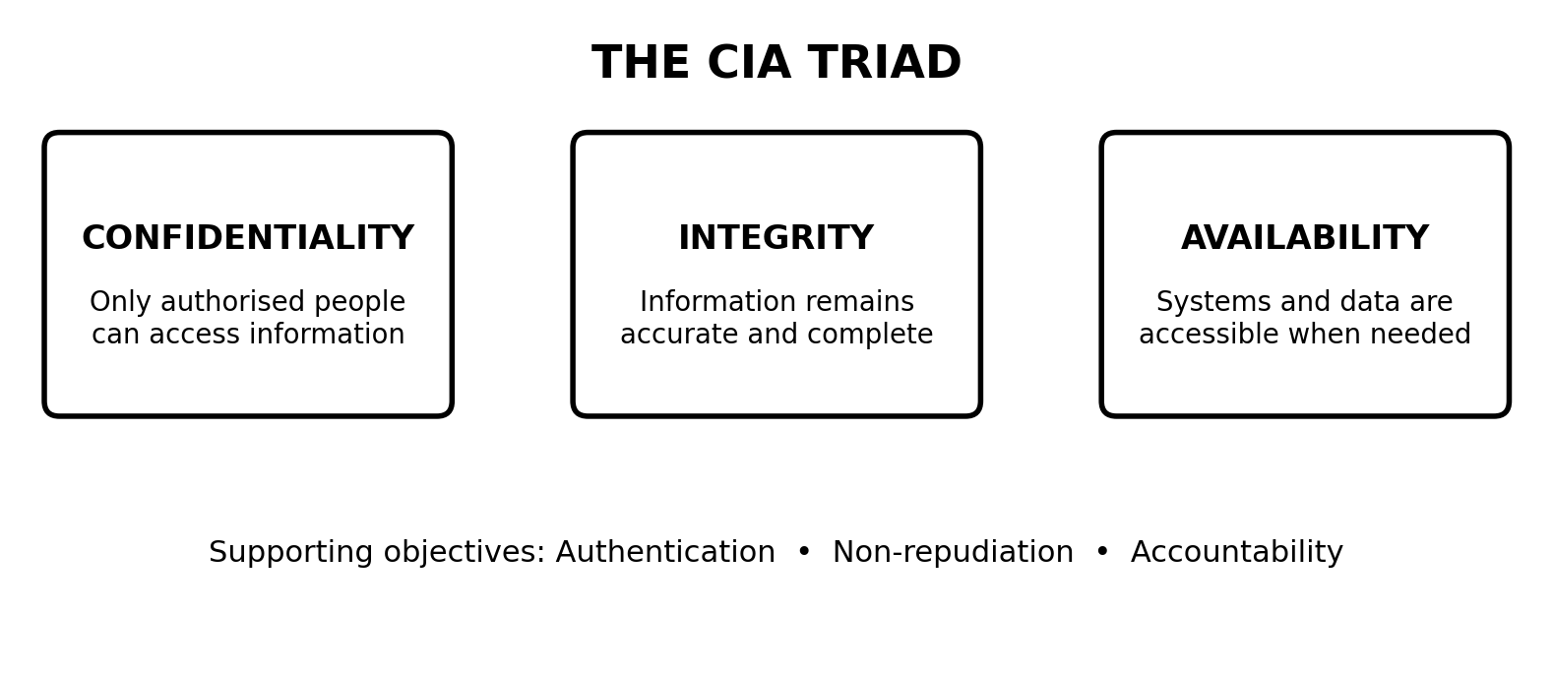
Figure 1: The CIA triad and its supporting security objectives.
1. Confidentiality: Ensures that information is viewed only by authorised users. Encryption, access permissions and strong authentication help protect patient details.
2. Integrity: Ensures that information remains accurate, complete and unchanged unless an authorised change is made. Audit trails and change controls help protect medical and laboratory records.
3. Availability: Ensures that information and services are accessible to authorised users whenever required. Backups, redundant systems and denial-of-service protection support availability.
Authentication verifies the identity of a user or system. Non-repudiation provides evidence that a person performed an action and cannot reasonably deny it. Accountability makes it possible to trace actions to the responsible user through logs and audit records.
Mapping the Hospital Incidents to Security Goals
Incident | Security goal violated | Reason
Patient spreadsheet sent to the wrong recipient | Confidentiality | Unauthorised person receives private patient information.
Ransomware encrypts the records server | Availability and integrity | Staff cannot access records; encrypted or altered files may no longer be trustworthy.
Technician changes a lab report without permission | Integrity; accountability | The report is modified without authorisation and the action must be traceable.
Flood of requests makes the appointment portal unreachable | Availability | Legitimate patients and staff cannot use the portal.

Preventive and Detective Controls
Security goal | Two preventive controls | One detective control
Confidentiality | Role-based access control (RBAC); encryption of stored and transmitted data | Monitor access logs for unusual downloads or access attempts.
Integrity | Digital signatures or hashes; restricted write permissions and approval for report changes | Audit logs and alerts for unauthorised record modifications.
Availability | Regular tested backups; redundant servers and DDoS protection | Availability monitoring and alerts for unusual traffic or service downtime.

Balancing the Security Goals
The hospital should apply the principle of least privilege while ensuring that doctors can obtain essential information during emergencies. Emergency or 'break-glass' access can be provided with strong user authentication, a reason for access, time limits and automatic logging. Such access should be reviewed after the emergency. Backups should be protected from ransomware, but recovery procedures must also allow authorised staff to restore services quickly. Security controls should protect privacy without delaying urgent patient care.
Conclusion: The hospital needs confidentiality, integrity and availability together. Strong access control, reliable recovery and continuous monitoring provide balanced protection.
Q2. Analysis of an Online Shopping Company Attack
Incident Overview
The attacker used a phishing email to steal a support agent's password, entered the internal network, moved to the order database and copied customer information to an external server. This is a multi-stage intrusion involving social engineering, credential misuse, lateral movement and data exfiltration.
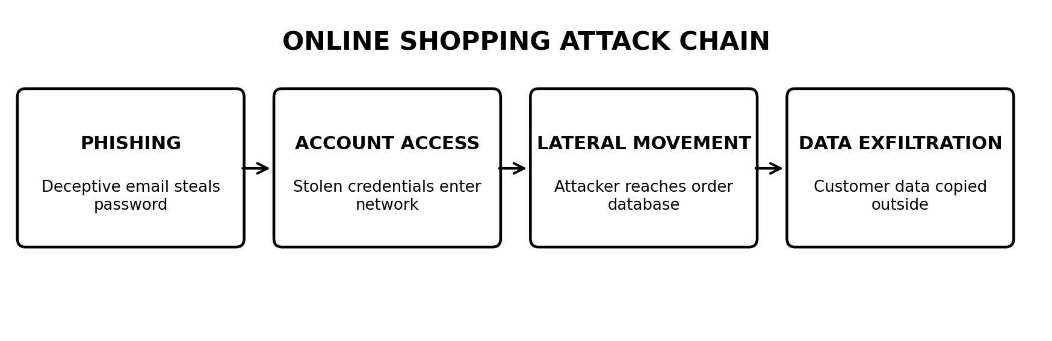
Figure 2: Stages of the online shopping company attack.
Classification of Network Threats
Threat | Passive or active | Relevance to this incident
Phishing | Active | The attacker sent a deceptive email to trick the support agent into revealing credentials.
Malware | Usually active | May be used to steal credentials, maintain access or transfer data; the case does not confirm malware was used.
Spoofing | Active | Could be used if the email sender or login identity was forged; not explicitly confirmed.
Sniffing | Passive | Could capture network traffic or credentials, but there is no evidence it occurred here.
Man-in-the-middle | Active | Could intercept or alter communications, but is not established by the facts given.
Denial of service | Active | Aims to disrupt availability; it is not part of the described attack.
SQL injection | Active | Could attack the database through unsafe queries; no evidence of it in this case.
Insider threat | Can be passive or active | An employee may misuse legitimate access, but the described attacker appears external.

Passive threats observe or collect information without directly changing system resources. Active threats attempt to alter, disrupt or gain unauthorised access to systems. Phishing and unauthorised login are active actions. Sniffing is generally passive. Some threat categories, such as malware and insider threats, can involve either type depending on the activity.
Likely Threat Actor
The most likely actor is a cybercriminal. Stealing credentials and copying customer data can support financial gain, identity theft, resale of personal information or extortion. The case does not provide evidence of a political motive associated with hacktivists or the strategic objectives commonly associated with nation-state groups. An insider is less likely because the initial access came from an external phishing attack.
Attack-Chain Analysis
Stage | Threat | Weakness exploited | CIA impact | Control
1. Phishing email | Social engineering / phishing | Low user awareness; convincing deceptive email | Confidentiality: credentials exposed | Email filtering, phishing-resistant MFA and staff awareness training.
2. Login to internal network | Credential theft and account compromise | Stolen password accepted without sufficient additional verification | Confidentiality and integrity risk | MFA, conditional access and monitoring for unusual logins.
3. Movement to database server | Lateral movement | Excessive permissions or weak network segmentation | Confidentiality and integrity risk | Least privilege, network segmentation and endpoint detection.
4. Copying customer data externally | Data exfiltration | Insufficient database monitoring or outbound data controls | Confidentiality | Data loss prevention, database activity monitoring and egress filtering.

Technical, Human and Procedural Weaknesses
Human weakness: the support agent was deceived by the phishing email. Procedural weakness: security awareness, credential-handling procedures or reporting processes may have been insufficient. Technical weaknesses may include lack of phishing-resistant MFA, excessive account permissions, weak network segmentation and inadequate monitoring of database access or outbound transfers. The organisation should investigate logs before concluding which of these weaknesses were definitely present.
Conclusion: A layered defence is required. Preventing phishing, protecting accounts, limiting lateral movement and detecting unusual data transfers can interrupt the attack at several stages.
Q3. Threat Intelligence and Conversion of Data into Actionable Intelligence
Meaning of Threat Intelligence
Threat intelligence is evidence-based, analysed information about existing or emerging threats that helps an organisation make security decisions. Raw data is an unprocessed observation. Information is data arranged or given context. Intelligence is analysed information that explains its significance and recommends an action.
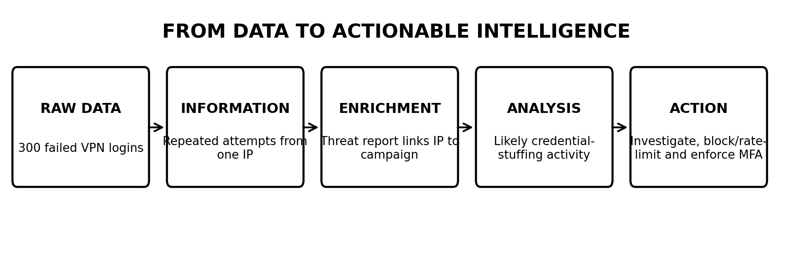
Figure 3: Converting raw observations into actionable threat intelligence.
From Raw Log Data to Actionable Intelligence
Step | Example in the VPN case | Result
1. Raw data | Firewall records 300 failed VPN logins from one external IP in ten minutes. | A log entry and count of failed attempts.
2. Information | The attempts occurred in a short period and came from the same source address. | A repeated login pattern is identified.
3. Enrichment | The IP address is checked against a public threat-sharing report that links it to credential stuffing. | External context connects the activity to a known campaign.
4. Analysis | The volume, timing and external report suggest an automated attempt to use stolen or reused passwords. | The activity is assessed as a likely credential-stuffing attempt.
5. Actionable intelligence | Prioritise the source for investigation, block or rate-limit it where appropriate, enforce MFA and check for successful logins. | The security team has specific actions to reduce risk.

Characteristics of Good Threat Intelligence
- Timely: Arrives early enough to support a useful response.
- Accurate: Is supported by reliable evidence and has a low error rate.
- Relevant: Applies to the organisation's systems, sector and likely threats.
- Contextual: Explains who may be involved, what is targeted and why the activity matters.
- Actionable: Leads to a practical decision, such as blocking an indicator or investigating an account.
Reactive to Proactive Security
A reactive team responds after an attack or alert. Threat intelligence helps a team identify likely attackers, monitor indicators, search for signs of compromise and strengthen vulnerable systems before an incident occurs. For example, learning that an IP address is linked to credential stuffing can lead the team to review VPN authentication, enable stronger MFA and search historical logs for related activity.
Benefits and Limitations
Benefits | Limitations
Earlier warning of campaigns and attacker activity. | False positives may cause legitimate activity to be blocked.
Better prioritisation of alerts and vulnerabilities. | Large volumes of feeds can create information overload.
Improved incident response and threat hunting. | Indicators can become stale or lose relevance quickly.
Better understanding of sector-specific risks. | Threat feeds may be incomplete, biased or unreliable.
More informed security planning and reporting. | Sharing sensitive information may create privacy or legal concerns.

Conclusion: Threat intelligence turns observations into decisions. It is most useful when information is reliable, relevant, current and connected to clear security actions.
Q4. Strategic, Tactical and Operational Threat Intelligence for a Retail Chain
Introduction
After a competitor experiences a point-of-sale (POS) malware breach, the retail chain should use different forms of threat intelligence for different audiences. Strategic intelligence supports long-term decisions, tactical intelligence explains attacker methods, and operational intelligence supports near-term action against specific threats.
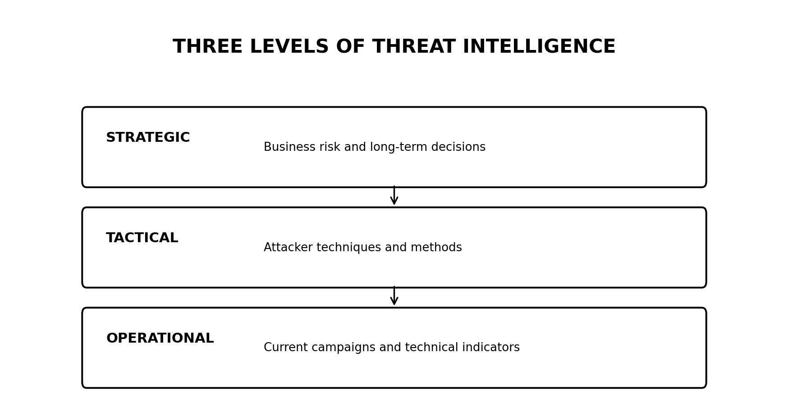
Figure 4: Strategic, tactical and operational threat intelligence.
Type | Question answered | Audience | Time horizon | Sources | Deliverable for this case
Strategic | What does the threat mean for the business and its risk? | CISO, board and senior leaders | Months to years | Industry reports, sector analysis, business risk assessments and government advisories | Board risk briefing on POS malware trends, possible financial loss and investment priorities.
Tactical | How do attackers operate and what techniques do they use? | SOC manager, security architects and defenders | Weeks to months | MITRE ATT&CK, malware analysis, incident reports and technical research | Report describing techniques such as credential theft, lateral movement and POS malware deployment.
Operational | What specific threat activity may affect us soon, and what should we do now? | Incident handlers, SOC analysts and network administrators | Hours to weeks | Threat-sharing groups, active campaign reporting, incident telemetry and indicator feeds | Urgent warning with malicious domains, IP addresses, hashes and recommended detection or blocking steps.

Classification of the Given Items
Item | Classification | Reason
Annual report on ransomware trends in retail | Strategic | It describes broad sector risk and supports long-term planning.
Description of movement from stolen vendor credentials to POS servers | Tactical | It explains attacker behaviour and techniques.
Advance warning of a planned attack during holiday sales | Operational | It concerns a specific expected campaign and requires near-term action.
List of malicious domains | Operational | These are technical indicators used for immediate detection, investigation or blocking.

Why All Three Types Are Needed
If the company relies only on strategic intelligence, leaders may understand the business risk but defenders may not know which techniques or indicators to monitor. If it relies only on tactical intelligence, the SOC may understand attacker methods but senior leaders may not receive the business context needed for investment decisions. If it relies only on operational intelligence, teams may block individual indicators but fail to understand broader trends or improve long-term defences. Combining all three creates a complete view of risk, attacker behaviour and immediate threats.
Conclusion: Strategic, tactical and operational intelligence complement one another and should be shared in formats suitable for each audience.
Q5. Threat Intelligence Lifecycle and Its Applications in the IT Industry
Requirement and Planning
The SaaS company's requirement is: 'Are we likely to be targeted by credential-stuffing and ransomware groups in the next six months?' This is a priority intelligence requirement (PIR). A useful PIR should be clear, focused, time-bound and answerable. Supporting questions may include: Which groups target SaaS providers? What indicators or techniques are associated with them? Are there signs of targeting against the company's industry, identity systems or cloud services?
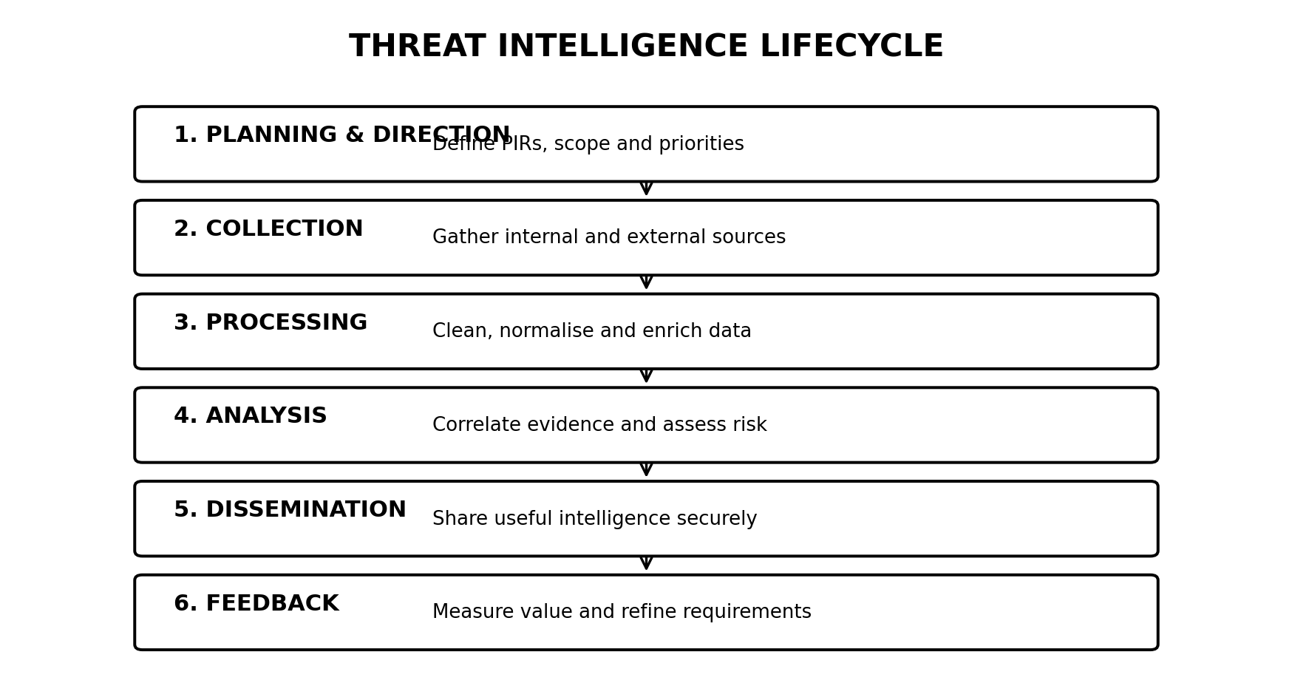
Figure 5: The six phases of the threat intelligence lifecycle.
Threat Intelligence Lifecycle
Phase | Activities and tools | Expected outputs
1. Planning and direction | Identify decision-makers, define the six-month requirement, set scope and write PIRs. Tools: risk workshops, asset inventories and intelligence requirements register. | Approved PIRs, collection plan, priorities and reporting schedule.
2. Collection | Gather relevant internal and external data. Sources: authentication logs, endpoint alerts, cloud audit logs, threat feeds, government advisories and trusted sharing communities. | Raw logs, indicators, reports and campaign information.
3. Processing | Normalise formats, remove duplicates, validate timestamps, extract indicators and add context. Tools: SIEM, TIP, parsers and enrichment services. | Structured, searchable and enriched data.
4. Analysis | Correlate evidence, assess source reliability, identify patterns and estimate likelihood and impact. Tools: SIEM queries, threat frameworks and analyst review. | Assessment of likely targeting, confidence level, key risks and recommended actions.
5. Dissemination | Share findings with the correct teams in a suitable format and within the required time. Use access controls and information-sharing markings. | Executive briefings, SOC alerts, technical indicators and response recommendations.
6. Feedback | Ask whether the intelligence answered the PIR, measure usefulness and update collection priorities. | Feedback, performance measures and revised PIRs.

Information-Sharing Markings: Traffic Light Protocol
The Traffic Light Protocol (TLP) communicates how shared information may be distributed. TLP:RED is restricted to the specific recipients; TLP:AMBER allows limited sharing within the recipient organisation and, where applicable, its clients; TLP:GREEN permits sharing within a community but not public release; and TLP:CLEAR permits public distribution. The company should follow the marking attached by the source and avoid sharing information more widely than permitted.
Applications of Threat Intelligence in the IT Industry
- Incident response: Provides indicators, attacker context and recommended containment steps.
- Threat hunting: Helps analysts search logs and endpoints for attacker techniques and signs of compromise.
- Vulnerability and patch prioritisation: Helps focus patching on weaknesses actively exploited by relevant threat actors.
- Third-party risk assessment: Identifies threats involving vendors, suppliers and external service providers.
- Executive risk reporting: Converts technical threats into business risks, possible impact and investment priorities.
Measures to Evaluate the Programme
Measure | Meaning and value
Mean Time to Detect (MTTD) | Average time taken to identify a security incident. A reduction can indicate faster detection.
Mean Time to Respond (MTTR) | Average time taken to contain or respond to an incident. A reduction can indicate more effective response.
Percentage of alerts enriched with intelligence | Shows how often security alerts receive useful threat context to support prioritisation.
False-positive rate | Shows the proportion of alerts incorrectly treated as malicious. A lower rate can reduce wasted analyst effort.

The company should compare these measures over time and review them alongside incident outcomes and analyst feedback. A metric should not be considered successful in isolation; for example, a lower alert count is not useful if important threats are missed.
Conclusion: The lifecycle provides a repeatable process for answering the six-month targeting requirement. Its value depends on clear priorities, reliable collection, careful analysis, secure dissemination and regular feedback.

