ASSIGNMENT – 2
THREAT INTELLIGENCE AND NETWORK SECURITY

Course Code: CSA6303
Course Name: Threat Intelligence and Network Security
Academic Session: November 2026
Maximum Marks: 50
Faculty: Dr. V. Parthipan SLOT A

Topics: Network Security Fundamentals | Security Goals (CIA Triad) | Types of Network Threats Introduction to Threat Intelligence Types of Threat Intelligence (Strategic, Tactical, perational) — Threat Intelligence Lifecycle — Applications in IT Industry
CO1: Interpret security principles, network threats, and the role of threat intelligence in
cybersecurity.

Total: 50

Student Name: V. Teja Sree Register number: 192411211

Code of Conduct:
I V. Teja Sree (192411211) (Name / Reg No) certify that this submission is my original work and that I have adhered to the guidelines specified for this assessment. I understand that any violation of academic integrity rules will result in disciplinary action.

Signature of the student:


1 | The finance office of a university receives an e-mail that appears to come from the vice-chancellor's office, asking the accounts officer to open an attached "budget revision" document and to approve an urgent payment. The attachment contains a macro that installs a trojan, and within hours the finance file server is encrypted. Apply your knowledge of malware and phishing to this case. Explain the types of malware (virus, worm, trojan, ransomware, spyware, rootkit and botnet agent) with their method of spreading, and identify which types are involved here. Explain the types of phishing (bulk, spear phishing, whaling, smishing, vishing and clone phishing) and classify this attack with reasons. Prepare a table of the warning signs in the e-mail (sender address, header mismatch, urgency, link and attachment) and describe the technical controls (SPF, DKIM, DMARC, attachment sandboxing, macro blocking) and the awareness measures that would have stopped the attack. | (10) | (CO2) | (BL3)
2 | An online ticket-booking website sells tickets for a popular cricket match. Within seconds of the sale opening, its web servers become unreachable. The monitoring graph shows a very large rise in incoming traffic, thousands of half-open TCP connections, and many repeated requests for the search page from addresses all over the world. Analyse the incident by explaining how DoS and DDoS attacks differ, and the working of volumetric attacks (UDP flood and DNS or NTP amplification), protocol attacks (SYN flood) and application-layer attacks (HTTP flood), with the structure of the botnet that launches them. Explain how the security team can distinguish a DDoS attack from a genuine rush of customers. Recommend a response and prevention plan using rate limiting, SYN cookies, content delivery networks, traffic scrubbing, anycast and black-holing, and discuss the cost and side effects of each measure. | (10) | (CO2) | (BL4)
3 | Sales staff of a company often work from a café that offers free public Wi-Fi. A security audit finds that an attacker sitting in the café could create a fake access point with the same name as the café network, redirect users to a copy of the company's web mail login page, and capture the data that passes over the network. Analyse the attacks that make this possible by explaining the working of man-in-the-middle attacks, the evil-twin access point, ARP spoofing, DNS spoofing, IP and e-mail spoofing, SSL stripping and packet sniffing, with a labelled sequence or network diagram of one attack. Differentiate passive from active attacks in this case. Describe how each attack is detected (for example, duplicate MAC addresses in the ARP table, certificate warnings and IDS alerts) and prevented (VPN, HTTPS with HSTS, WPA3, dynamic ARP inspection, port security and 802.1X), and discuss which measures the company can apply to staff laptops it does not control. | (10) | (CO2) | (BL4)
4 | A small private clinic has a reception computer, two doctors' laptops, a patient-records server, a network printer, a Wi-Fi router and a few IP cameras on one flat network. The clinic has never tested its network for weaknesses. Apply the vulnerability assessment process to this network. Explain the steps of asset discovery, scanning (for example, with Nmap, Nessus or OpenVAS), identification of vulnerabilities, scoring with CVSS, prioritisation, reporting, remediation and re-scanning; the difference between authenticated and unauthenticated scans and between network-based and host-based scans; and the difference between a vulnerability assessment and a penetration test. Prepare a sample findings table with at least five realistic vulnerabilities of this clinic (for example, default router password, outdated operating system, unpatched server software, open remote desktop port and unencrypted camera streams), giving for each the affected asset, CVSS severity rating, possible attack and recommended remediation. | (10) | (CO2) | (BL3)
5 | The Security Operations Centre of a bank receives threat data from three kinds of sources: its own firewall, proxy and e-mail logs; free OSINT sources such as community threat-sharing platforms, malware-analysis sites, vulnerability databases and internet-scanning services; and a paid commercial feed. A new batch contains these entries: an IP address that was reported as malicious fourteen months ago, a domain that imitates the bank's login page and was reported yesterday, and a file hash that also matches a legitimate Windows utility. Evaluate the threat data sources and the quality of these entries. Compare internal, OSINT, community and commercial sources, explain the types of Indicators of Compromise (hashes, IP addresses, domains, URLs, e-mail artefacts, registry keys and file names) with the Pyramid of Pain, and judge each entry on timeliness, accuracy, relevance, context and the risk of false positives. Explain how feed formats such as STIX and TAXII help sharing, and recommend how the bank should select, integrate and retire indicators in its SIEM, including aging of indicators and removal of duplicates. | (10) | (CO2) | (BL5)

ANSWERS
Q1. Malware and Phishing Attack in the University Finance Office
The incident is a targeted e-mail attack against the university finance office. The attacker impersonates the vice-chancellor's office and sends an urgent budget-revision document. When the accounts officer enables or runs its malicious macro, a trojan is installed. The malware then helps encrypt the finance file server, resulting in a ransomware incident.

1.1 Types of malware and their spreading methods
Malware type | Meaning and method of spreading
Virus | Attaches itself to a legitimate file or program. It spreads when the infected file is opened, copied or executed.
Worm | Self-replicating malware that spreads automatically across networks by exploiting vulnerabilities or weak credentials.
Trojan | Malicious software disguised as a genuine file or application. It relies on the user installing or opening it.
Ransomware | Encrypts files or locks systems and demands payment for restoration. It commonly enters through phishing, exposed services or compromised software.
Spyware | Secretly monitors user activity and collects information such as keystrokes, browsing data or credentials.
Rootkit | Hides malicious activity and provides stealthy, privileged access by modifying or interfering with operating-system components.
Botnet agent | Malware that makes a device part of a remotely controlled group of infected devices (a botnet). It may receive commands from an attacker.

Malware involved in this case: the attachment delivers a trojan because it is disguised as a budget document. The trojan installs or launches ransomware, which encrypts the finance server. A macro is the delivery mechanism; it is not itself a malware category. Other malware types are possible in general, but the scenario does not provide evidence that a virus, worm, spyware, rootkit or botnet agent was involved.
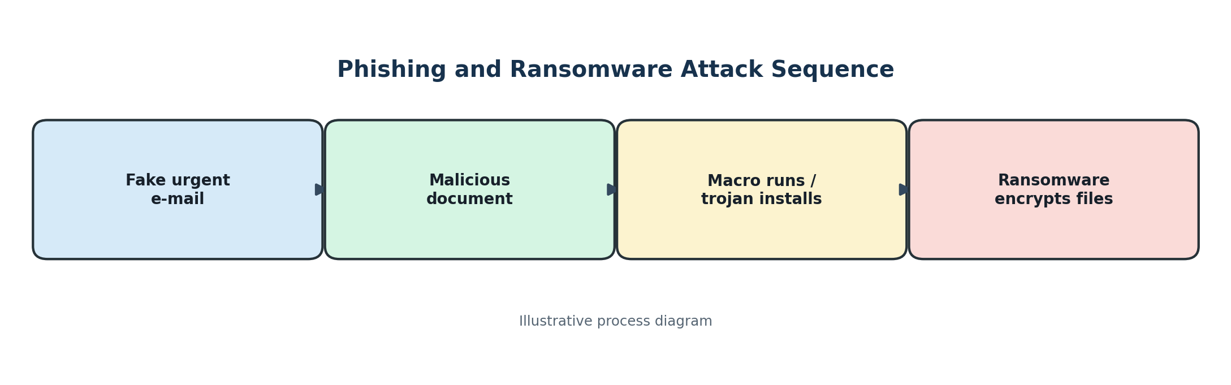
Figure 1: Phishing and ransomware attack sequence

1.2 Types of phishing
Phishing type | Description
Bulk phishing | Large numbers of similar deceptive messages are sent to many recipients.
Spear phishing | A tailored message targets a particular person or organisation using relevant names, roles or details.
Whaling | A highly targeted phishing attempt aimed at senior executives or other high-value leaders.
Smishing | Phishing carried out through SMS or text messages.
Vishing | Phishing through voice calls or recorded voice messages.
Clone phishing | A genuine earlier message is copied and modified to include a malicious link or attachment.

Classification: this is spear phishing because the message is directed at the university accounts officer and impersonates a specific internal authority. It may also resemble whaling if the message is designed around a senior executive's identity, but the direct target is the accounts officer. It is not smishing or vishing because it arrives by e-mail.

1.3 Warning signs in the e-mail
Warning sign | What the recipient should check
Sender address | Check the complete e-mail address and domain, not only the display name. Look for misspellings or look-alike domains.
Header mismatch | Compare the From, Reply-To and Return-Path fields. Unexpected differences may indicate spoofing.
Urgency | Pressure to approve an immediate payment or bypass normal authorisation is suspicious.
Link | Hover over links to inspect the real destination. Do not sign in through unexpected links.
Attachment | An unexpected document containing macros or asking the user to enable content should be treated as suspicious.

1.4 Technical controls and awareness measures
- SPF (Sender Policy Framework): identifies mail servers authorised to send mail for a domain. Receiving systems can use SPF results to detect unauthorised senders.
- DKIM (DomainKeys Identified Mail): adds a cryptographic signature so the receiving server can verify that the message was signed by an authorised domain and was not altered in transit.
- DMARC: tells receiving servers how to handle messages that fail domain authentication checks and provides reports to domain owners.
- Attachment sandboxing: opens suspicious attachments in an isolated environment to observe malicious behaviour before delivery.
- Macro blocking: disables macros from internet-originated Office documents by default and allows only approved, digitally signed macros where necessary.
- Awareness: train staff to verify urgent payment requests using a separate trusted channel, inspect sender details, report suspicious e-mails and never enable macros in unexpected files.
Conclusion: a combination of e-mail authentication, attachment isolation, macro restrictions, endpoint protection, backups and staff awareness could have prevented or limited the incident.

Q2. DoS and DDoS Attack on an Online Ticket-Booking Website
The sudden traffic increase, thousands of half-open TCP connections and repeated search-page requests from many countries indicate a possible distributed denial-of-service (DDoS) attack. The aim is to exhaust bandwidth, network devices or application resources so genuine customers cannot use the website.

2.1 Difference between DoS and DDoS
DoS | DDoS
Usually originates from one attacking system or a small number of sources. | Uses many distributed compromised devices, often controlled as a botnet.
Traffic or requests come from a limited source set. | Traffic comes from many IP addresses and networks.
May be easier to block by filtering the source. | Blocking individual sources is harder because sources are numerous and may be spoofed.

2.2 Main DDoS attack categories
Attack | Working
UDP flood (volumetric) | Large volumes of UDP packets are sent to consume network bandwidth and processing capacity.
DNS/NTP amplification (volumetric) | An attacker sends small requests with the victim's spoofed source IP to exposed DNS or NTP servers. The servers send larger replies to the victim, amplifying traffic.
SYN flood (protocol) | Many TCP SYN requests are sent without completing the handshake. The server keeps half-open connection state and may run out of resources.
HTTP flood (application layer) | A large number of apparently valid HTTP requests target expensive pages or functions, exhausting web-server, database or application resources.

2.3 Botnet structure
A botnet is a collection of compromised computers, routers, cameras or other connected devices. The attacker or bot herder controls them through command-and-control (C2) infrastructure. The controller issues an attack command; bots generate traffic towards the target. A layered or peer-to-peer design may make the controller harder to locate.
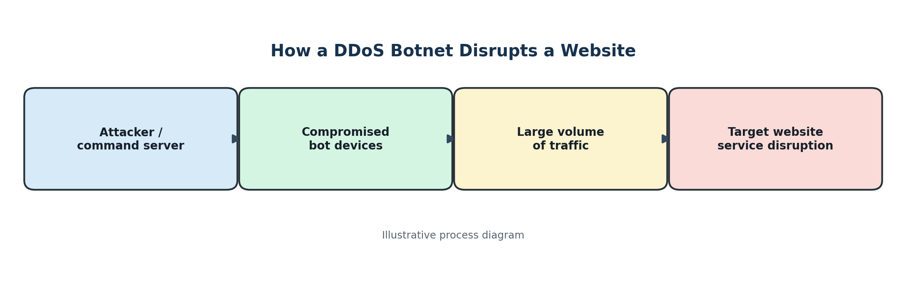
Figure 2: DDoS botnet structure

2.4 Distinguishing an attack from a genuine customer rush
- Compare traffic with historical sale-opening patterns, expected customer numbers and marketing activity.
- Look for abnormal geographic distribution, repeated identical requests, unusual user-agent strings and high request rates from related networks.
- Check whether sessions complete normal user journeys, such as loading pages, selecting seats and completing payment.
- Inspect TCP metrics: a high ratio of SYN packets to completed handshakes suggests a SYN flood.
- Monitor server CPU, memory, connection tables, database load, error rates and bandwidth together.
- Use bot detection, behavioural analytics and challenge mechanisms carefully; a genuine rush can also create high traffic.

2.5 Response and prevention plan
Measure | Use and benefit | Cost or side effect
Rate limiting | Limits requests per IP, account, token or endpoint; protects expensive functions. | May restrict genuine users behind shared networks if limits are too strict.
SYN cookies | Avoids allocating full connection state until the TCP handshake is completed. | May add processing overhead and does not stop bandwidth-saturating floods.
Content Delivery Network (CDN) | Distributes and caches content closer to users; absorbs some traffic and protects the origin server. | Service and configuration costs; dynamic or uncached content may still reach the origin.
Traffic scrubbing | Routes suspicious traffic through specialist filtering centres that remove attack packets. | Can be costly and may add latency or require traffic rerouting.
Anycast | Advertises the same service address from multiple network locations, distributing incoming traffic. | Requires provider and routing support; does not by itself filter malicious application requests.
Black-holing | Drops traffic to a targeted IP address or route during an extreme attack. | Can make the legitimate service completely unreachable while the route is black-holed.

Recommended response: activate the incident-response plan, contact the hosting provider and DDoS protection provider, preserve logs, enable upstream filtering and CDN protection, apply adaptive rate limits, and protect the origin server. Use SYN cookies for handshake exhaustion. Apply black-holing only as a last resort when keeping the wider network available is more important than keeping the affected service online. After the attack, review logs, update thresholds and test the mitigation plan.
Conclusion: layered protection is required because no single control stops every volumetric, protocol and application-layer attack.

Q3. Man-in-the-Middle Attacks on Public Café Wi-Fi
A man-in-the-middle (MITM) attack occurs when an attacker positions themselves between two communicating parties and secretly observes, relays or modifies their communication. In the café scenario, the attacker creates a fake access point with the same network name as the genuine café Wi-Fi and attempts to direct employees to a fake company webmail page.

3.1 Attacks that enable the incident
Attack | Working and effect
MITM | The attacker intercepts communication between the laptop and the intended service, and may read or alter data if protections are weak.
Evil-twin access point | A rogue Wi-Fi access point copies the legitimate network name (SSID). A device may connect to it because the name appears familiar.
ARP spoofing | The attacker sends forged ARP messages on a local network to associate the attacker's MAC address with another device's IP address, redirecting local traffic.
DNS spoofing | False DNS responses direct a user to an attacker-controlled IP address instead of the genuine website.
IP spoofing | The source IP address in packets is forged. It can disguise traffic origin but does not, by itself, allow an attacker to read an encrypted session.
E-mail spoofing | The sender address or display identity is forged to make a message appear to come from a trusted person or organisation.
SSL stripping | An attacker attempts to downgrade a connection from HTTPS to HTTP, exposing data if the user accepts the insecure connection and protections are absent.
Packet sniffing | A tool captures network packets for analysis. Unencrypted traffic may reveal information; properly encrypted HTTPS traffic should not expose its contents.

3.2 Labelled sequence of an evil-twin MITM attack
The following diagram shows the simplified traffic path. The attacker creates the fake access point and relays or manipulates traffic. A properly validated HTTPS connection and VPN reduce the attacker's ability to read the content.
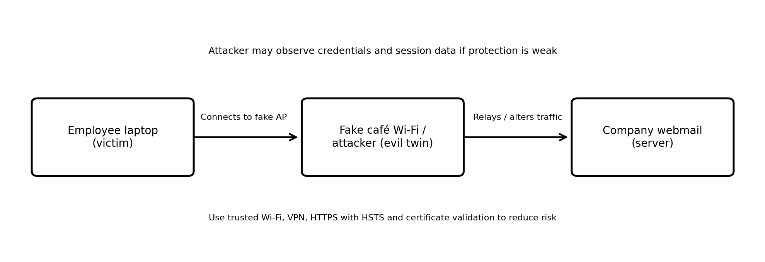

3.3 Passive and active attacks
Passive attack | Active attack
Observes or collects data without changing communication. | Changes, injects, redirects, blocks or replays communication.
Examples: packet sniffing of unencrypted traffic and traffic analysis. | Examples: evil-twin redirection, ARP/DNS spoofing and SSL stripping.
May be difficult to notice because data is only observed. | May create unusual network behaviour, certificate warnings or altered pages.

3.4 Detection methods
- Check for unexpected Wi-Fi networks with the same SSID, unusual signal behaviour or access points with unknown hardware addresses.
- Inspect ARP tables for duplicate or unexpected IP-to-MAC mappings; use network monitoring to identify frequent ARP changes.
- Never ignore browser certificate warnings. Confirm the webmail address and HTTPS lock/certificate details.
- Use DNS monitoring to detect unexpected DNS responses and compare them with trusted resolvers.
- Use wireless intrusion detection systems (WIDS), endpoint protection and IDS alerts to identify rogue access points and suspicious traffic.

3.5 Prevention measures
- VPN: encrypts traffic between the laptop and the VPN gateway, reducing the ability of a public Wi-Fi attacker to inspect it.
- HTTPS with HSTS: forces browsers to use HTTPS for supported sites and helps prevent downgrade attacks. Users must still validate certificate warnings.
- WPA3: provides stronger Wi-Fi security when supported and correctly configured; employees should avoid unknown open networks.
- Dynamic ARP Inspection: validates ARP messages against trusted DHCP snooping information and helps prevent ARP spoofing on managed switches.
- Port security: limits which MAC addresses can use a switch port and can restrict unauthorised devices on wired networks.
- 802.1X: provides port-based network access control, requiring authentication before a device receives network access.
Measures for laptops the company does not control: enforce VPN use, endpoint security, automatic operating-system and browser updates, full-disk encryption, secure DNS where supported, HTTPS-only browsing, strong multi-factor authentication and user training. Provide a managed configuration or virtual desktop where possible. Avoid relying only on switch controls because those controls may not apply to a personal or unmanaged laptop.
Conclusion: public Wi-Fi should be treated as untrusted. Encryption, identity verification, endpoint controls and staff awareness reduce the risk of MITM attacks.

Q4. Vulnerability Assessment of a Small Private Clinic
A vulnerability assessment is a structured process used to identify, evaluate and prioritise security weaknesses in systems and networks. For the clinic, the assessment should cover the reception computer, doctors' laptops, patient-records server, network printer, Wi-Fi router and IP cameras. Patient information and service availability must be protected throughout the assessment.
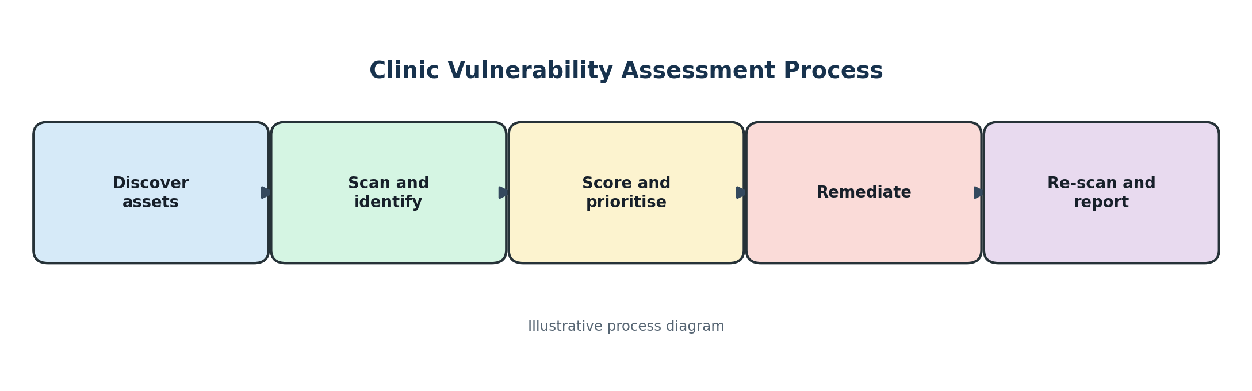
Figure 3: Vulnerability assessment process

4.1 Vulnerability assessment process
Step | Activity
1. Asset discovery | List all devices, IP addresses, operating systems, applications, owners and business importance. Confirm the inventory with clinic staff.
2. Scanning | Use approved tools such as Nmap for host and service discovery, and Nessus or OpenVAS for vulnerability checks. Schedule scans to avoid disrupting clinical work.
3. Identify vulnerabilities | Review scan results for missing patches, insecure services, weak passwords, exposed ports, default settings and insecure protocols.
4. CVSS scoring | Use the Common Vulnerability Scoring System (CVSS) to rate severity based on factors such as exploitability and impact. Validate scores against the actual clinic environment.
5. Prioritisation | Prioritise internet-exposed systems, patient-record systems, remotely exploitable issues and weaknesses that could affect patient care.
6. Reporting | Document affected assets, evidence, severity, business impact, recommended fixes, owners and target dates.
7. Remediation | Apply patches, change default passwords, close unnecessary ports, segment networks and enforce secure configurations.
8. Re-scanning | Scan again after fixes to confirm vulnerabilities are resolved and check that remediation has not introduced new issues.

4.2 Types of scans
Scan type | Description
Authenticated scan | Uses approved credentials to inspect the operating system, installed software, patches and local configuration. It generally provides more accurate detail.
Unauthenticated scan | Checks the system from an external or network perspective without logging in. It shows what an unauthorised attacker may see.
Network-based scan | Examines devices, ports, services and network-accessible weaknesses across the network.
Host-based scan | Runs an agent or local check on an individual computer or server to examine its configuration, software and security state.

4.3 Vulnerability assessment versus penetration test
Vulnerability assessment | Penetration test
Identifies and rates possible weaknesses across a defined scope. | Safely attempts to exploit selected weaknesses to demonstrate real-world impact.
Usually provides broad coverage and a prioritised list of findings. | Usually provides deeper evidence of exploitability and attack paths.
Does not normally require exploitation of each finding. | Requires controlled exploitation under written authorisation and agreed rules.

4.4 Sample vulnerability findings
Affected asset | Finding | Sample severity | Possible attack | Recommended remediation
Wi-Fi router | Default administrator password | High | Attacker changes DNS, Wi-Fi or firewall settings. | Change to a unique strong password; disable remote administration; update firmware.
Reception computer | Unsupported or outdated operating system | High | Known vulnerabilities may allow malware infection or unauthorised access. | Upgrade to a supported OS; apply security updates; enable endpoint protection.
Patient-records server | Unpatched server software | Critical / High* | Remote exploitation may expose or alter sensitive patient records. | Patch promptly after testing; restrict access; maintain verified backups.
Doctors' laptops | Remote Desktop exposed to untrusted networks | High | Credential attacks or exploitation may provide remote access. | Disable if not required; otherwise restrict through VPN, firewall allowlists and MFA.
IP cameras | Unencrypted video streams | Medium | A person on the network may view intercepted camera traffic. | Enable encrypted protocols; change default credentials; isolate cameras on a separate VLAN.

*The exact CVSS score depends on the product, version, configuration and vulnerability identifier. The ratings above are illustrative sample severities, not verified CVSS scores. A real report must record the CVE and the applicable CVSS version and score.

4.5 Safe assessment practices
- Obtain written permission and define the systems, time window and scan intensity before testing.
- Back up important configurations and coordinate with clinic staff to avoid affecting patient care.
- Keep patient-record systems and cameras in separate network segments where practical.
- Restrict access to assessment reports because they contain sensitive information about weaknesses.
Conclusion: regular vulnerability assessments, timely patching, secure configuration, network segmentation and re-scanning help the clinic reduce the risk of data theft and service disruption.

Q5. Threat Intelligence Sources and Indicator Evaluation in a Bank SOC
A Security Operations Centre (SOC) uses threat intelligence to identify malicious activity and improve detection. In this case, the bank receives information from internal logs, free OSINT and community sources, and a paid commercial feed. Each indicator must be checked for quality and relevance before it is used in security tools.
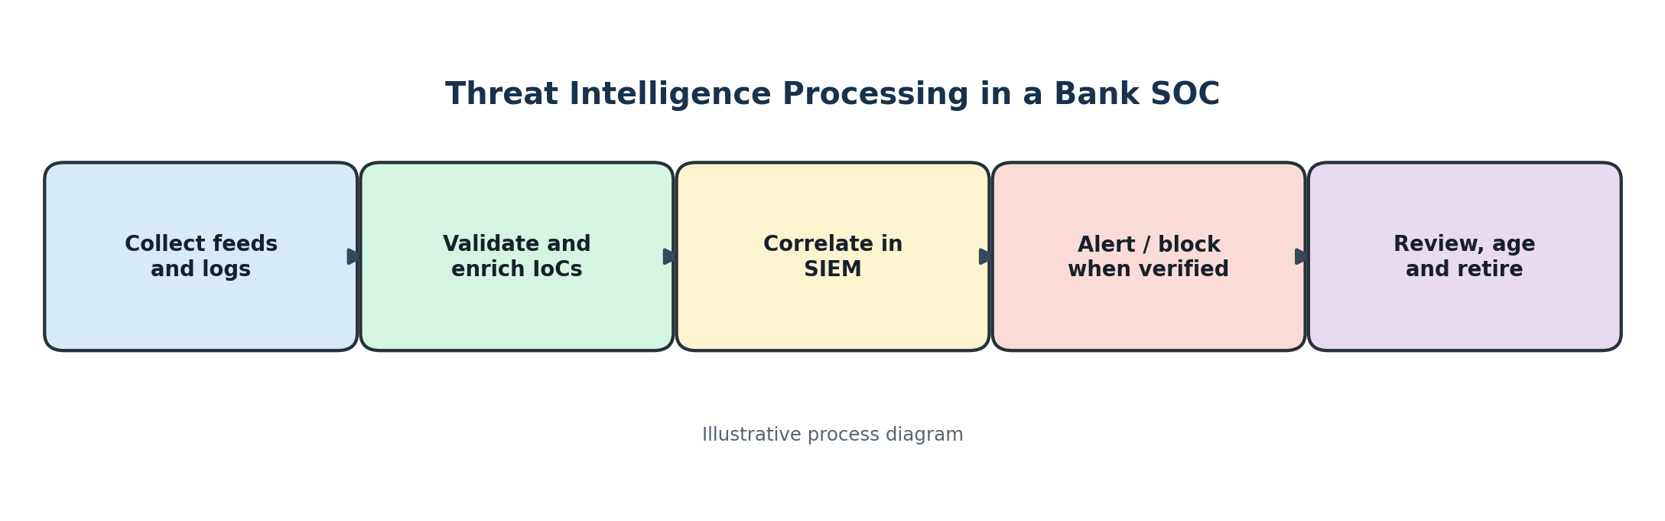
Figure 4: Threat intelligence processing

5.1 Comparison of threat intelligence sources
Source | Strengths | Limitations
Internal sources | Firewall, proxy and e-mail logs reflect the bank's own environment and provide direct evidence of activity. | May have limited visibility outside the organisation and can contain incomplete or noisy records.
OSINT sources | Public malware-analysis sites, vulnerability databases and internet-scanning services can provide broad and low-cost information. | Quality, freshness and context vary; some data may be unverified or duplicated.
Community sources | Threat-sharing groups can provide practical observations and early warnings from peers. | Trust and consistency vary; information may lack context or validation.
Commercial feeds | May provide curated, enriched and supported intelligence with service-level commitments. | Subscription costs apply; coverage and quality vary by provider, and feeds can still contain false positives.

5.2 Types of Indicators of Compromise (IoCs)
Indicator | Example / use
File hash | A cryptographic hash such as SHA-256 used to identify a particular file.
IP address | An address associated with command-and-control, scanning or malicious hosting.
Domain | A domain used for phishing, malware delivery or command-and-control.
URL | A complete web address that may point to a malicious page or download.
E-mail artefacts | Sender address, reply-to address, subject patterns, message IDs or attachment details associated with phishing.
Registry keys | Windows registry locations or values changed by malware to maintain persistence or alter system behaviour.
File names | Names or paths associated with known malicious files; these are useful but can be changed or imitated.

5.3 Pyramid of Pain
The Pyramid of Pain explains that some indicators are easier for attackers to change than others. Hash
harder to change. Higher-level indicators can therefore cause more disruption to an attacker when defenders detect and block them.
Level (lower to higher) | Indicator category | Typical attacker effort to change
1 | Hash values | Trivial: a small file change can produce a different hash.
2 | IP addresses | Easy to moderate: infrastructure can be moved or replaced.
3 | Domain names | Moderate: new domains can be registered, but reputation and setup take effort.
4 | Network / host artefacts | More difficult: tools and observable artefacts may need to be changed.
5 | Tools | Challenging: the attacker may need to replace or modify tools.
6 | TTPs | Most difficult: changing the overall methods and behaviour requires significant effort.

5.4 Evaluation of the three new entries
Entry | Timeliness and relevance | Accuracy / false-positive risk | Recommended decision
IP address reported malicious 14 months ago | Old intelligence may no longer describe current activity; the address may have been reassigned or cleaned. | Higher false-positive risk if used without fresh context. | Do not block automatically. Check recent sightings, ownership, reputation and internal logs; age or retire if unsupported.
Domain imitating bank login page, reported yesterday | Very recent and directly relevant to the bank's customers and credentials. | Likely important, but verify the domain, hosting, screenshots, DNS and independent reports. | Prioritise investigation; block through DNS, proxy and e-mail controls after validation, and notify the phishing-response team.
File hash also matches a legitimate Windows utility | The hash may identify a known legitimate file; context is essential. | High risk of false positive or incorrect attribution if the hash is shared or misreported. | Do not block solely on the indicator. Verify the exact hash, file signature, source, path and endpoint behaviour.

5.5 STIX and TAXII
- STIX (Structured Threat Information Expression) is a standard language for representing cyber threat intelligence, including indicators, threat actors, malware, campaigns and relationships.
- TAXII (Trusted Automated Exchange of Intelligence Information) is a protocol used to exchange threat intelligence, including STIX data, between systems.
- Together, STIX and TAXII make it easier for organisations and tools to share structured intelligence in a consistent and automated way.

5.6 Selecting, integrating and retiring indicators in the SIEM
- Select indicators based on source reliability, confidence, first-seen and last-seen dates, relevance to the bank, supporting evidence and expected impact.
- Enrich indicators with context such as associated malware, campaign, source, confidence, expiry date and related events.
- Validate indicators before enforcement. Use different actions for different confidence levels, such as alerting first and blocking only after verification.
- Integrate feeds into the SIEM using supported APIs or STIX/TAXII connectors. Normalise fields and map indicators to detection rules.
- Deduplicate records by normalised indicator value and type; retain source attribution and the strongest available context.
- Apply time-to-live (TTL) or expiry rules. Reassess indicators periodically using last-seen data and current threat information.
- Retire stale, invalid or disproven indicators. Keep an audit trail so analysts can understand why an indicator was added, changed or removed.
Conclusion: threat intelligence is valuable only when it is timely, accurate, contextual and relevant. The SOC should combine internal evidence with trusted external sources, validate indicators, manage false positives and regularly age out stale data.

