ASSIGNMENT – 3
THREAT INTELLIGENCE AND NETWORK SECURITY

Course Code: CSA6303
Course Name: Threat Intelligence and Network Security
Academic Session: November 2026
Maximum Marks: 50
Faculty: Dr. V. Parthipan SLOT A

Topics: Network Security Fundamentals | Security Goals (CIA Triad) | Types of Network Threats Introduction to Threat Intelligence Types of Threat Intelligence (Strategic, Tactical, perational) — Threat Intelligence Lifecycle — Applications in IT Industry
CO1: Interpret security principles, network threats, and the role of threat intelligence in
cybersecurity.

Total: 50

Student Name: V. Teja Sree Register number: 192411211

Code of Conduct:
I V. Teja Sree (192411211) (Name / Reg No) certify that this submission is my original work and that I have adhered to the guidelines specified for this assessment. I understand that any violation of academic integrity rules will result in disciplinary action.

Signature of the student:

1 | A small software company has an office network of about fifty users, a web server and a mail server that must be reachable from the Internet, an internal file server, and an administrator who manages the servers over SSH. The company has one Internet connection and wants to place a firewall at the edge. Apply the concepts of firewalls to this network. Explain the types of firewalls (stateless packet filtering, stateful inspection, application-level gateway or proxy, next-generation firewall and web application firewall) with their strengths and limits, and the role of a DMZ and of network address translation. Prepare an ordered firewall rule table of at least eight rules (action, source, destination, protocol and port, direction and reason) that allows only the required traffic, applies ingress and egress filtering and ends with a default-deny rule. Explain why the order of rules matters, and describe how the rules are tested, logged and reviewed. | (10) | (CO4) | (BL3)
2 | The SOC of a university receives about two thousand alerts a day from its intrusion detection system, and analysts estimate that more than ninety per cent are false positives, so a real intrusion in the student hostel network has gone unnoticed for two weeks. Analyse the situation using the concepts of IDS and IPS. Compare network-based and host-based systems, signature-based, anomaly-based and hybrid detection, and passive IDS (SPAN port or network tap) with inline IPS, and explain where sensors should be placed. Explain false positives and false negatives with examples and the cost of each. Interpret this Snort-style rule and say what it detects and how it could be tuned: alert tcp any any -> $HOME_NET 22 (msg:"SSH brute force"; flags:S; threshold:type both, track by_src, count 5, seconds 60; sid:1000001; rev:1;). Recommend a tuning and response process, and discuss how attackers try to evade detection (for example, fragmentation, encryption and slow scans). | (10) | (CO4) | (BL4)
3 | A retail company has a head office, ten branch stores and about two hundred staff who sometimes work from home. Branch stores send sales data to the head office, and remote staff need access to the internal inventory system. Apply VPN and secure communication techniques to this requirement. Explain site-to-site and remote-access VPNs, the working of IPsec (AH and ESP, transport and tunnel mode, security associations and IKE) and of SSL/TLS VPNs, and the difference between split tunnelling and full tunnelling. Draw a labelled diagram showing which VPN type is used for the branch stores and which for the remote staff, and justify the choice. Explain the role of TLS and SSH for secure communication of applications and administration, and discuss the security and operational issues of the design, such as multi-factor authentication, key and certificate management, logging, performance and the risk of a compromised home device. | (10) | (CO4) | (BL3)
4 | A manufacturing company runs its office computers, ERP servers, guest Wi-Fi, IP cameras and the production-line control systems on one flat network. Last month a ransomware infection on an office laptop spread to the ERP servers and stopped the production line for two days. Analyse how network segmentation and secure architecture design could have limited the damage. Explain VLANs, subnets, internal firewalls and access control lists, a DMZ and micro-segmentation, and design a zone-based architecture with at least five zones (for example, office, servers, DMZ, guest, camera and production) with a table of the traffic that is allowed between zones and the reason for each. Explain how administrators should reach the production zone (for example, through a jump host with multi-factor authentication). Discuss the principles of secure architecture design (least privilege, simplicity, fail-safe defaults, redundancy and separation of duties) and the costs and limits of segmentation. | (10) | (CO4) | (BL4)
5 | A financial services firm has moved most of its applications to the cloud and about half of its staff work remotely. A recent breach began with stolen VPN credentials, after which the attacker moved freely across the internal network because the firm trusted everything inside its perimeter. Evaluate the use of the Zero Trust model and the defense-in-depth strategy for this firm. Explain the principles of Zero Trust (never trust and always verify, least privilege, assume breach) and its components (identity provider, multi-factor authentication, device posture checks, policy decision and enforcement points, micro-segmentation and continuous monitoring). Explain the layers of defense in depth (physical, perimeter, network, host, application, data, people and policy) and map one control to each layer for this firm. Evaluate Zero Trust against the traditional perimeter model, explain how the two approaches complement each other, and recommend a phased roadmap with the difficulties the firm is likely to meet, such as legacy systems, user resistance and cost. | (10) | (CO4) | (BL5)

Q1. Firewall Design for a Small Software Company
A firewall should be installed between the Internet router and the company network. Use three security zones: outside (untrusted Internet), DMZ (public-facing web and mail servers), and inside (employees and file server). The administrator should manage servers through a secure VPN and SSH, not by exposing SSH to the Internet.
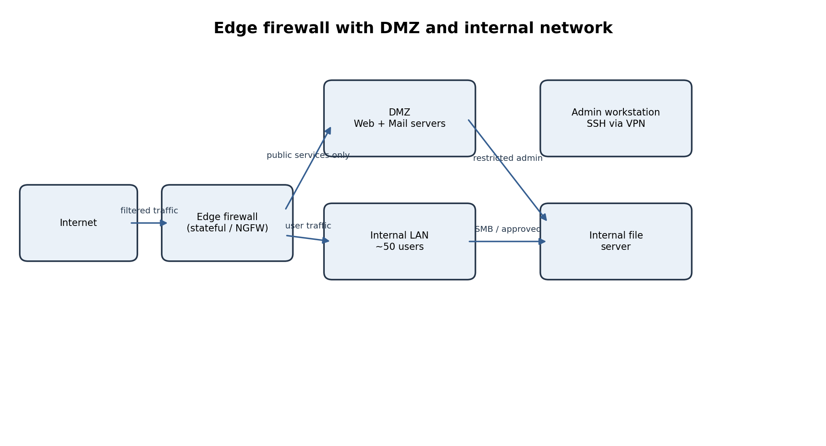

Types of firewalls – strengths and limits
Type | How it works | Strength | Limit
Stateless packet filter | Checks each packet’s source/destination IP, protocol and port independently. | Fast, simple, low resource use. | No session context; weak against spoofing or multi-step attacks.
Stateful inspection | Tracks connection state and permits packets belonging to valid sessions. | Blocks unsolicited packets; suitable edge control. | Limited application visibility; state table can be exhausted.
Application gateway / proxy | Terminates and inspects application sessions (e.g., HTTP proxy). | Deep protocol validation, user authentication and content control. | More latency and configuration; protocol support required.
Next-generation firewall (NGFW) | Stateful firewall plus application awareness, IPS, URL filtering and threat intelligence. | Can identify apps/users and block known threats. | Cost, tuning and encrypted-traffic visibility challenges.
Web application firewall (WAF) | Inspects HTTP/HTTPS requests to web applications. | Helps block SQL injection, XSS and malicious web requests. | Protects web layer only; cannot replace network firewall or secure coding.

DMZ and NAT
- DMZ: a separately firewalled network for the public web and mail servers. Internet users can reach only required DMZ services; DMZ systems cannot freely initiate connections to the internal LAN.
- NAT: translates private internal addresses to a public address for outbound Internet access (PAT) and maps selected public ports to DMZ servers. NAT hides private addressing but is not a substitute for firewall rules.

Ordered example firewall rules
Assumptions: public web server 203.0.113.10, mail server 203.0.113.20; DMZ addresses 10.0.10.10 and 10.0.10.20; LAN 10.0.20.0/24; file server 10.0.20.10; admin VPN pool 10.0.30.0/24. Rules are evaluated top to bottom; stateful return traffic is allowed only for established sessions.
# / Action | Source | Destination | Protocol / port | Direction | Reason
1 ALLOW | Internet | 203.0.113.10 | TCP 443 | Inbound | Public HTTPS website.
2 ALLOW | Internet | 203.0.113.10 | TCP 80 | Inbound | HTTP only to redirect to HTTPS; otherwise remove.
3 ALLOW | Internet mail servers | 203.0.113.20 | TCP 25 | Inbound | Receive SMTP mail.
4 ALLOW | Internet | 203.0.113.20 | TCP 587, 993 | Inbound | Authenticated mail submission / IMAPS only if required; restrict 587 to users where possible.
5 ALLOW | DMZ web server | Approved internal DB | TCP 5432 | Inbound to DB | Only required application-to-database connection; preferably database in server zone.
6 ALLOW | LAN users | Internet | TCP 80,443; DNS 53 to approved resolver | Outbound | Normal web access and name resolution.
7 ALLOW | LAN mail clients | DMZ mail server | TCP 587,993 | Outbound | Send and retrieve company mail.
8 ALLOW | LAN users | File server 10.0.20.10 | TCP 445 | Internal | File sharing for authorized users only.
9 ALLOW | Admin VPN pool | DMZ/LAN servers | TCP 22 | VPN-to-inside | SSH administration only from authenticated VPN and approved admin devices.
10 ALLOW | Any | Any | Established/related sessions | Both | Permit valid response packets for allowed sessions.
11 DENY + LOG | Internet | LAN and DMZ | Any | Inbound | Block all other unsolicited inbound traffic.
12 DENY + LOG | Any | Any | Any | Both | Default deny; log and alert on repeated violations.

Ingress filtering rejects spoofed or unauthorized inbound traffic. Egress filtering limits outbound traffic to approved destinations and ports, blocks unexpected server-initiated connections, and helps contain malware or data exfiltration. In practice, place explicit egress-deny rules before the final default deny.

Why order, testing, logging and review matter
- Specific allow rules must appear before broader deny rules; otherwise legitimate traffic is blocked. A broad allow placed early can bypass later restrictions. First-match firewalls require especially careful ordering.
- Test in a staging environment and use rule-hit counters, packet captures and port/service tests. Verify both permitted and prohibited paths, including IPv4/IPv6 and return traffic.
- Log denied inbound/outbound attempts, administrative access, rule changes and security alerts; send logs to a central SIEM with synchronized time.
- Review rules at least quarterly and after changes or incidents. Remove unused/duplicate rules, confirm business owners, expiry dates and least-privilege scope.

Q2. IDS and IPS Analysis for a University SOC (CO4 – BL4)
The SOC’s 2,000 daily alerts with over 90% false positives indicate poor detection tuning, weak asset context or noisy signatures. The two-week unnoticed hostel intrusion shows a detection gap. The SOC should validate coverage, prioritize high-risk assets and correlate network and endpoint evidence.
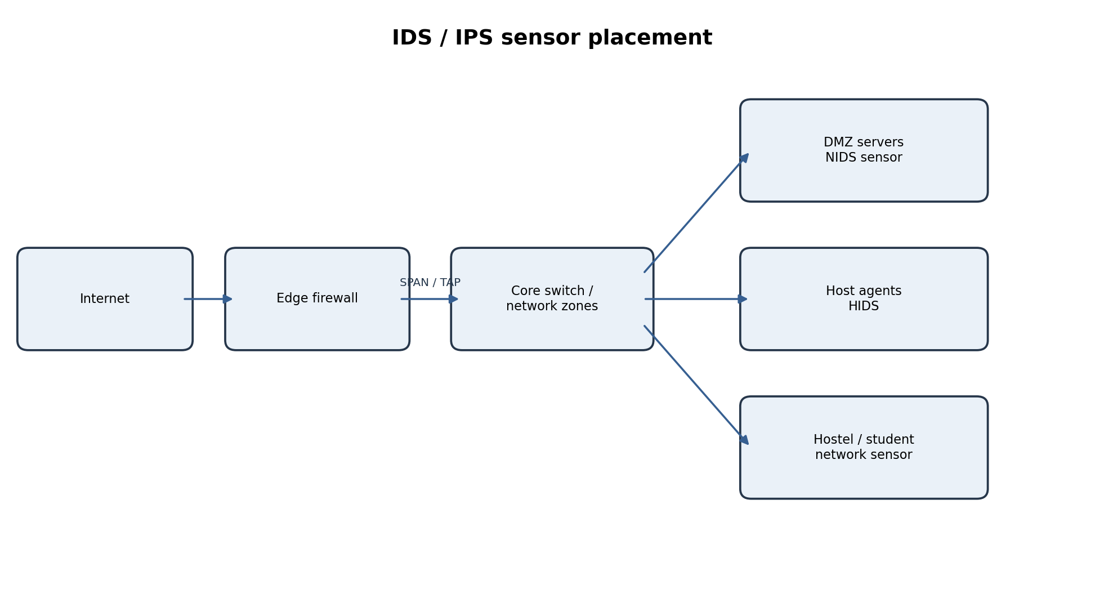

IDS/IPS types and deployment
Category | Types / operation | Best use and limitation
Network-based (NIDS/NIPS) | Monitors traffic on a network segment. | Sees scans and lateral movement; encrypted payloads and switched traffic can hide activity.
Host-based (HIDS/HIPS) | Agent monitors files, processes, logs and system calls on a host. | Sees local changes and activity after decryption; needs agent management and host resources.
Signature-based | Matches known attack patterns or rules. | Accurate for known threats; misses new or modified attacks.
Anomaly-based | Flags deviations from learned normal behaviour. | Can detect novel activity; baseline drift and false alarms are common.
Hybrid | Combines signatures, anomaly and contextual correlation. | Broader coverage; needs tuning and skilled analysts.
Passive IDS | Receives copied traffic via SPAN/mirror port or network TAP; alerts but does not block. | Low disruption and safe observation; cannot stop an attack directly.
Inline IPS | Sits in the traffic path and can drop/reset malicious packets. | Can block immediately; false blocks, latency and bypass/fail-open design must be managed.

- Place NIDS sensors at the Internet edge, between DMZ and internal network, at the core/distribution switch, and at hostel/student VLAN gateways. Use SPAN or TAP feeds that include both directions.
- Deploy HIDS/EDR on critical servers, domain/identity systems, mail servers, lab machines and representative hostel endpoints. Monitor authentication, process creation and critical file changes.
- Ensure east-west traffic between VLANs is visible; a single perimeter sensor will not detect lateral movement inside a flat network.

False positives and false negatives
Error | Meaning and example | Cost
False positive (FP) | Benign activity is labelled malicious; e.g., a legitimate student login burst triggers brute-force alert. | Analyst fatigue, wasted time, alert overload and possible blocking of valid users.
False negative (FN) | Real attack is missed; e.g., slow SSH password guessing or stolen valid credentials are not flagged. | Potential account takeover, data theft, ransomware and prolonged attacker presence; usually higher impact.

Interpretation of the Snort-style rule
alert tcp any any -> $HOME_NET 22 (msg:"SSH brute force"; flags:S; threshold:type both, track by_src, count 5, seconds 60; sid:1000001; rev:1;)
- alert: generate an alert; tcp: inspect TCP; any any: any source IP and source port; ->: traffic direction; $HOME_NET 22: destination is the protected network on TCP port 22 (SSH).
- flags:S: match TCP SYN packets, commonly the start of connection attempts. threshold type both, track by_src, count 5, seconds 60: apply a per-source threshold of five matching events in 60 seconds (exact alert/suppression behaviour depends on the IDS version and threshold implementation).
- sid identifies the local rule and rev is its revision. The rule is a heuristic for repeated SSH connection attempts, not proof of successful password guesses; SYN attempts alone do not establish authentication failure.
Tuning: restrict $HOME_NET to actual SSH servers; exclude approved scanners and management hosts; correlate with SSH authentication-failure logs; alert at a lower severity for five SYNs and escalate when failures or distributed sources are observed. Use rate windows and suppression carefully so a distributed or slow attack is not hidden.

Tuning and response process
- Inventory critical assets and define normal baselines by VLAN, time and user role. Update signatures and sensor software; check packet loss and clock synchronization.
- Classify alerts by severity, asset criticality, confidence and threat intelligence. Deduplicate and correlate NIDS, HIDS, firewall, VPN and identity logs.
- Validate alerts with packet metadata, endpoint process evidence and authentication logs. Record true/false positive labels and feed them into rule tuning.
- Response: contain affected host or account, block malicious source where appropriate, preserve evidence, reset credentials, eradicate persistence, recover and conduct lessons learned.
Evasion: fragmentation can split signatures across packets; normalize/reassemble traffic and inspect at the destination. Encryption hides payloads; use TLS metadata, endpoint telemetry and approved decryption where lawful. Slow scans evade simple rate thresholds; use longer behavioural windows, distributed-source correlation and flow analytics.

Q3. VPN and Secure Communication for a Retail Company (CO4 – BL3)
Use site-to-site IPsec VPN tunnels between each branch gateway and the head-office VPN gateway. Use remote-access VPN for staff working from home, with MFA and device posture checks before allowing access to the inventory application.
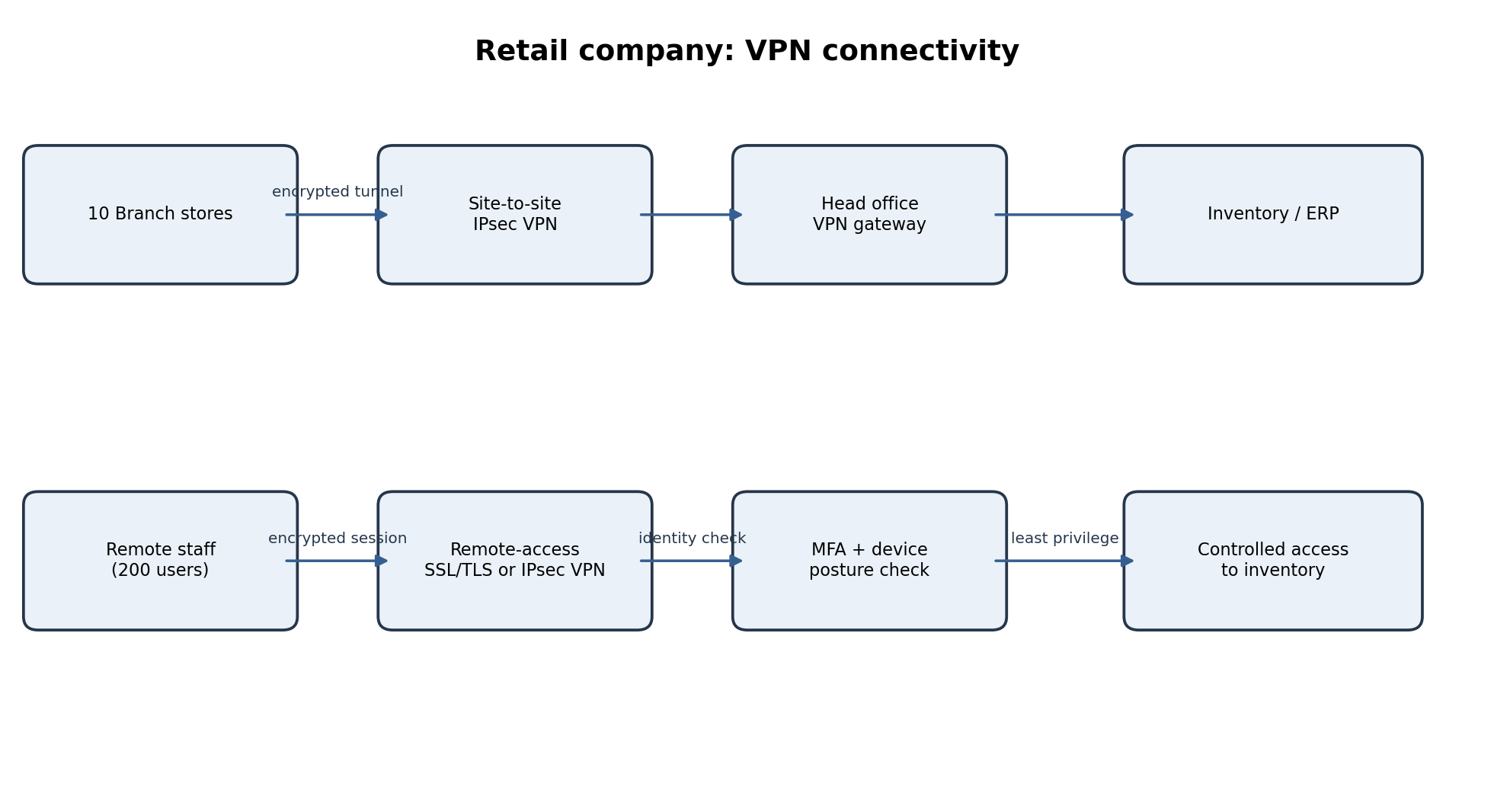

VPN types and IPsec operation
Concept | Explanation
Site-to-site VPN | Connects whole branch networks through gateway-to-gateway encrypted tunnels; suitable for ten stores sending sales data continuously.
Remote-access VPN | Connects an individual user/device to the corporate network or a specific application; suitable for about 200 remote workers.
IPsec AH | Provides packet integrity, origin authentication and anti-replay; does not encrypt payloads and is uncommon with NAT.
IPsec ESP | Provides confidentiality (encryption), integrity/authentication and anti-replay; commonly used for secure VPNs.
Transport mode | Protects the IP payload while retaining the original IP header; often host-to-host.
Tunnel mode | Encapsulates and protects the complete original IP packet inside a new packet; common for gateway site-to-site VPNs.
Security Association (SA) | Defines algorithms, keys, lifetime and parameters for one-way IPsec protection; a pair is normally used for two-way traffic.
IKE / IKEv2 | Authenticates peers, negotiates algorithms and establishes/rekeys SAs and keys.

SSL/TLS VPN, split and full tunnelling
- An SSL/TLS VPN uses TLS to create an encrypted connection through a client or browser portal. It can provide application-level access without exposing the whole internal network.
- Split tunnelling sends only corporate traffic through the VPN; ordinary Internet traffic goes directly to the Internet. It can improve performance but increases exposure to local-network threats.
- Full tunnelling sends both corporate and Internet traffic through the corporate gateway. It improves centralized inspection and policy enforcement but consumes more bandwidth and gateway capacity.

TLS and SSH
- TLS protects application sessions such as HTTPS inventory access and API communication. Use current TLS versions, valid certificates, strong cipher suites and certificate renewal monitoring.
- SSH provides encrypted remote administration, host authentication and command integrity. Disable password-based root login where possible; use managed keys, MFA/bastion access, restricted source IPs and audit logs.

Security and operational considerations
- Require MFA for every remote user and privileged administrator; use role-based access so store staff see only their branch data.
- Use a managed certificate authority, certificate inventory, automated renewal and secure key storage/rotation. Rotate/revoke keys when devices or staff leave.
- Log VPN logins, source device, assigned user, tunnel status, data flows and privileged commands centrally; alert on impossible travel and unusual access.
- Plan gateway capacity, encryption overhead, redundancy and failover. Monitor latency and throughput for point-of-sale and sales synchronization.
- Treat home devices as untrusted: require supported OS, disk encryption, endpoint protection, patch level and screen lock. Quarantine non-compliant devices and limit access to the inventory app.
- Prefer full tunnel for unmanaged/high-risk endpoints; split tunnel only for managed devices under a documented policy. Consider application-specific zero-trust access instead of broad network access.

Q4. Network Segmentation for a Manufacturing Company (CO4 – BL4)
The flat network allowed ransomware on an office laptop to reach ERP and operational technology (OT). Segmentation limits lateral movement by dividing systems into zones and enforcing explicit communication between them.
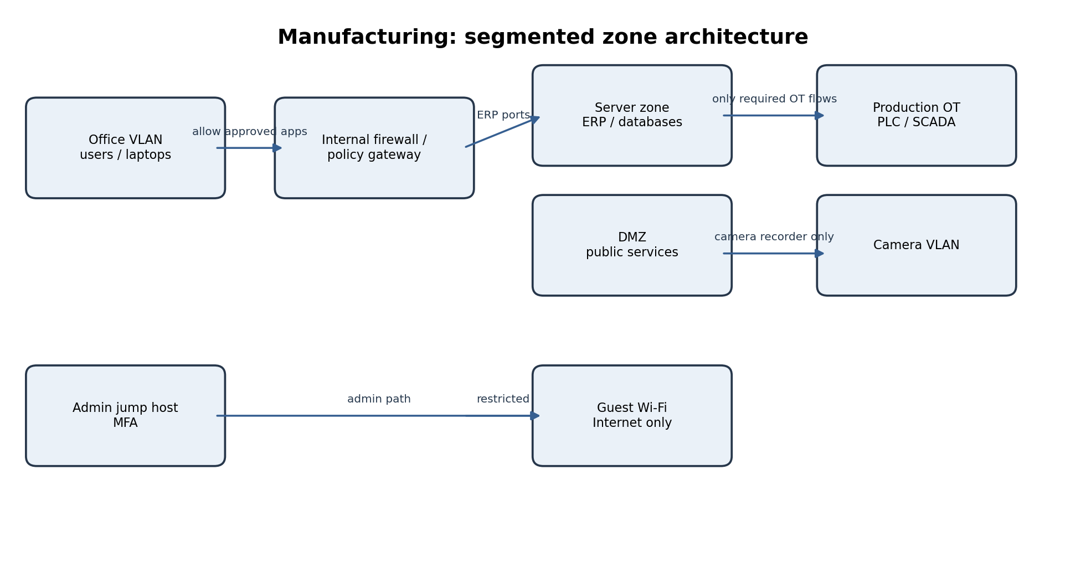

Segmentation technologies
- VLAN: creates separate Layer-2 broadcast domains on switches (e.g., office, guest, camera and OT VLANs).
- Subnet: assigns each zone a separate IP network and routing boundary; inter-subnet traffic can be inspected and controlled.
- Internal firewall / ACL: permits only specified source, destination, protocol and port combinations between zones. Deny by default.
- DMZ: isolates services that must communicate with external or less-trusted networks; use controlled relays rather than direct Internet-to-OT access.
- Micro-segmentation: applies fine-grained workload or host-level policy within a zone, reducing east-west movement even between servers.

Zone-to-zone traffic policy
Source zone | Destination zone | Allowed traffic | Reason / control
Office | Server zone | ERP client to ERP service ports only (e.g., HTTPS 443) | Business use; user authentication and role authorization.
Office | DMZ | HTTPS 443 to approved portals | Access public-facing business services.
Guest Wi-Fi | Internet | DNS and web via guest gateway | Internet-only; deny all corporate subnets.
Camera VLAN | Video recorder / management server | Camera streams to recorder on documented ports | No camera-to-office or camera-to-OT access.
Server zone | Production OT | Only approved historian/industrial gateway flows | Necessary operational data exchange; inspect and allowlist.
Production OT | Server zone | Telemetry to historian; tightly scoped | Prevent OT devices initiating general office connections.
Admin jump host | Production OT | Approved management protocols during authorized window | Privileged access with MFA, session recording and approval.
Office laptop | Production OT | DENY | Prevent direct user endpoint access to critical control systems.
Any zone | Any other zone | DENY + LOG unless explicitly allowed | Default-deny boundary.

Administrator access to production
Administrators connect to a hardened jump host in a management zone using MFA and a managed device. Access requires a ticket/approval, time-limited privilege and role-based authorization. The jump host then connects only to approved OT assets and ports. Record sessions and commands; do not permit direct SSH/RDP from office laptops to PLCs or SCADA.

Secure architecture principles
Principle | Application
Least privilege | Only required users, services and ports cross zone boundaries.
Simplicity | Use a small, documented set of zones and standard rules to reduce mistakes.
Fail-safe defaults | Unknown traffic is denied; management interfaces are not exposed by default.
Redundancy | Use resilient firewalls, switches, power and backups so a single failure does not stop production.
Separation of duties | Different people approve OT access, administer controls and review logs.

Costs and limits: extra firewalls, switches, licenses and skilled staff increase cost. Incorrect rules can interrupt production or legacy protocols; troubleshooting becomes harder. Some OT devices cannot run agents or tolerate active scans. Segmentation is not complete protection—patching, backups, endpoint security, monitoring and incident response remain necessary. Test changes with OT engineers and use maintenance windows.

Q5. Zero Trust and Defense in Depth for a Financial Firm (CO4 – BL5)
The breach shows that VPN authentication alone is insufficient. A stolen credential should not grant broad trust to the internal network. Adopt Zero Trust access controls while retaining perimeter firewalls and other traditional controls as complementary layers.
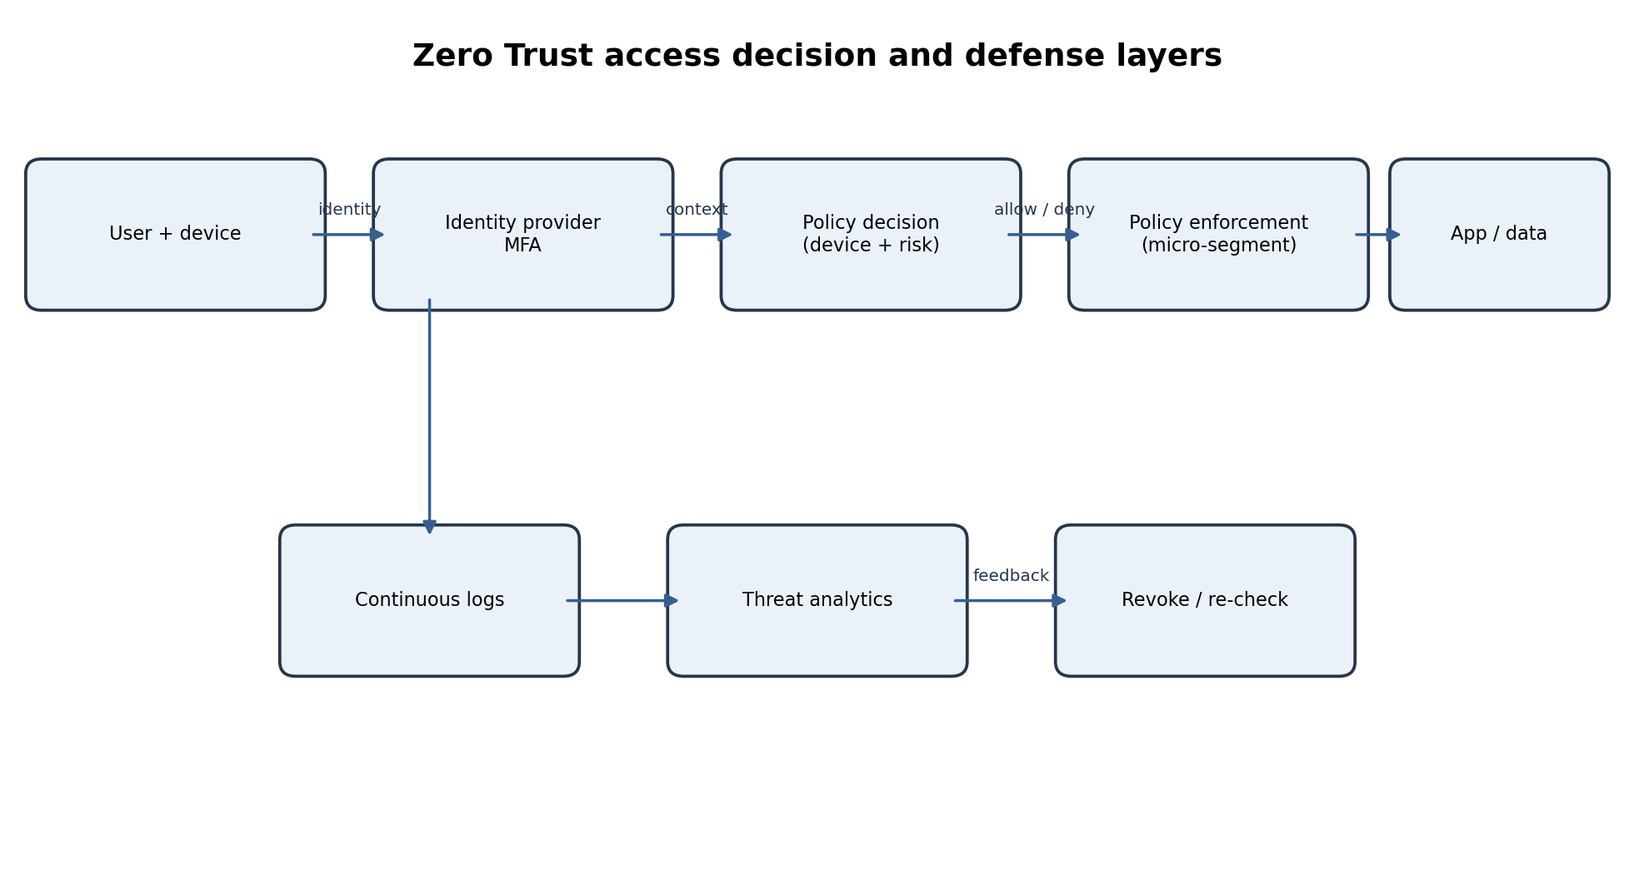

Zero Trust principles and components
- Never trust, always verify: authenticate and authorize each access request based on identity, device, resource and context—not network location.
- Least privilege: grant only the minimum application, data and time-limited access needed; use just-in-time privilege for administrators.
- Assume breach: design as if an attacker may already be inside; segment systems, monitor continuously and make containment fast.
- Identity provider (IdP) provides centralized identity and single sign-on; MFA makes stolen passwords less useful.
- Device posture checks evaluate patch level, encryption, endpoint detection, compliance and device identity before access.
- Policy decision point evaluates user, device, risk, location and requested resource; policy enforcement point allows, limits or denies the session.
- Micro-segmentation restricts lateral movement between applications and workloads. Continuous monitoring detects unusual behaviour and can revoke sessions.

Defense-in-depth layers and controls
Layer | Example control for the firm
Physical | Badge access, CCTV, locked server racks and visitor logs.
Perimeter | Redundant NGFWs, DDoS protection and secure email/web gateways.
Network | VLANs, internal firewalls, micro-segmentation and egress filtering.
Host | EDR, secure configuration, patching, disk encryption and application allowlisting.
Application | SSO, MFA, secure coding, API gateway, WAF and regular penetration testing.
Data | Encryption at rest/in transit, tokenization, data-loss prevention and tested immutable backups.
People | Security awareness, phishing simulations and clear incident-reporting channels.
Policy | Access reviews, vendor risk management, incident response plan and change control.

Zero Trust versus traditional perimeter security
Traditional perimeter model | Zero Trust model
Trust is largely based on being inside the corporate network or VPN. | No implicit trust based on network location; each request is evaluated.
VPN may provide broad network access after login. | Access is limited to specific apps/resources and user roles.
Strong at controlling north-south traffic at the edge. | Strong at identity-aware access and east-west/lateral movement control.
Can be simpler for legacy systems but creates a trusted internal zone. | Improves containment but needs identity, device and application integration.

They complement each other: retain perimeter firewalls, secure gateways and DDoS controls, but treat the internal network as untrusted. Use Zero Trust policies behind the perimeter so a VPN connection is only a transport path, not proof of authorization.

Phased implementation roadmap
Phase | Actions and outcome
1. Discover (0–2 months) | Inventory users, devices, cloud apps, data, service accounts and legacy dependencies; map access flows and classify critical assets.
2. Strengthen identity (2–4 months) | Centralize SSO/IdP, enforce phishing-resistant MFA for admins and remote access, remove stale accounts and deploy privileged access management.
3. Device and application controls (4–6 months) | Introduce device posture checks, conditional access and application-specific access; pilot with a low-risk business unit.
4. Segment and monitor (6–9 months) | Micro-segment high-value cloud workloads, isolate admin paths, centralize logs/SIEM and automate high-confidence containment.
5. Expand and optimize (ongoing) | Migrate legacy access gradually, review policies quarterly, test recovery and measure coverage, risky access and incident response time.

Likely difficulties and mitigation
- Legacy systems may not support modern identity or agents: place them behind controlled gateways, use compensating network controls and plan upgrades.
- User resistance and productivity impact: pilot, communicate benefits, provide training and make MFA methods usable.
- Cost and complexity: prioritize high-value data and privileged access first; use phased licensing and measure risk reduction.
- Policy mistakes can block business processes: monitor in report-only mode, test with owners, maintain rollback plans and review exceptions with expiry dates.
- Cloud and third-party environments create visibility gaps: standardize identity federation, logging, vendor access and configuration baselines.
Success measures include MFA coverage, percentage of managed/compliant devices, privileged accounts reviewed, critical workloads segmented, policy exceptions, mean time to detect/respond and successful recovery-test results.

Illustrative Network Security Diagrams
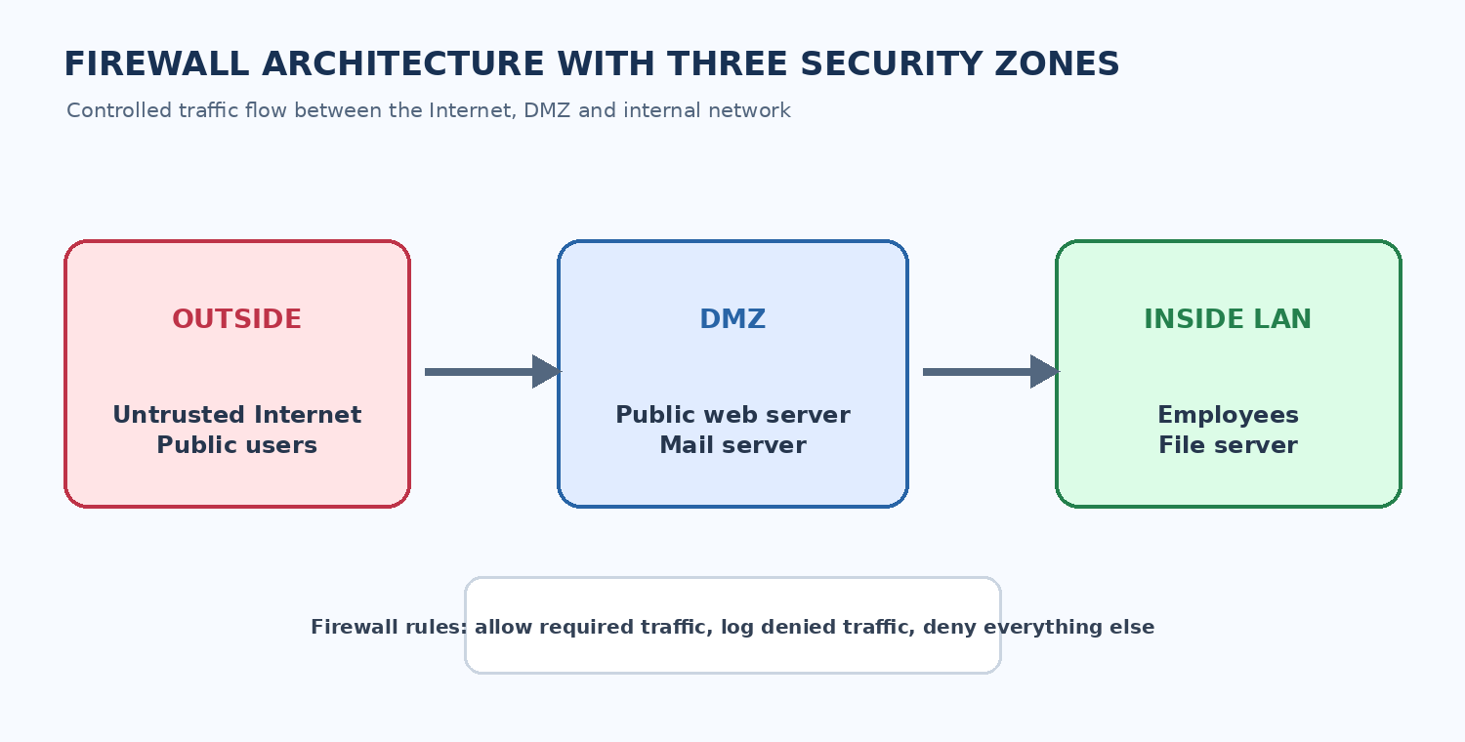
Figure 1: Firewall architecture showing outside, DMZ and inside security zones.
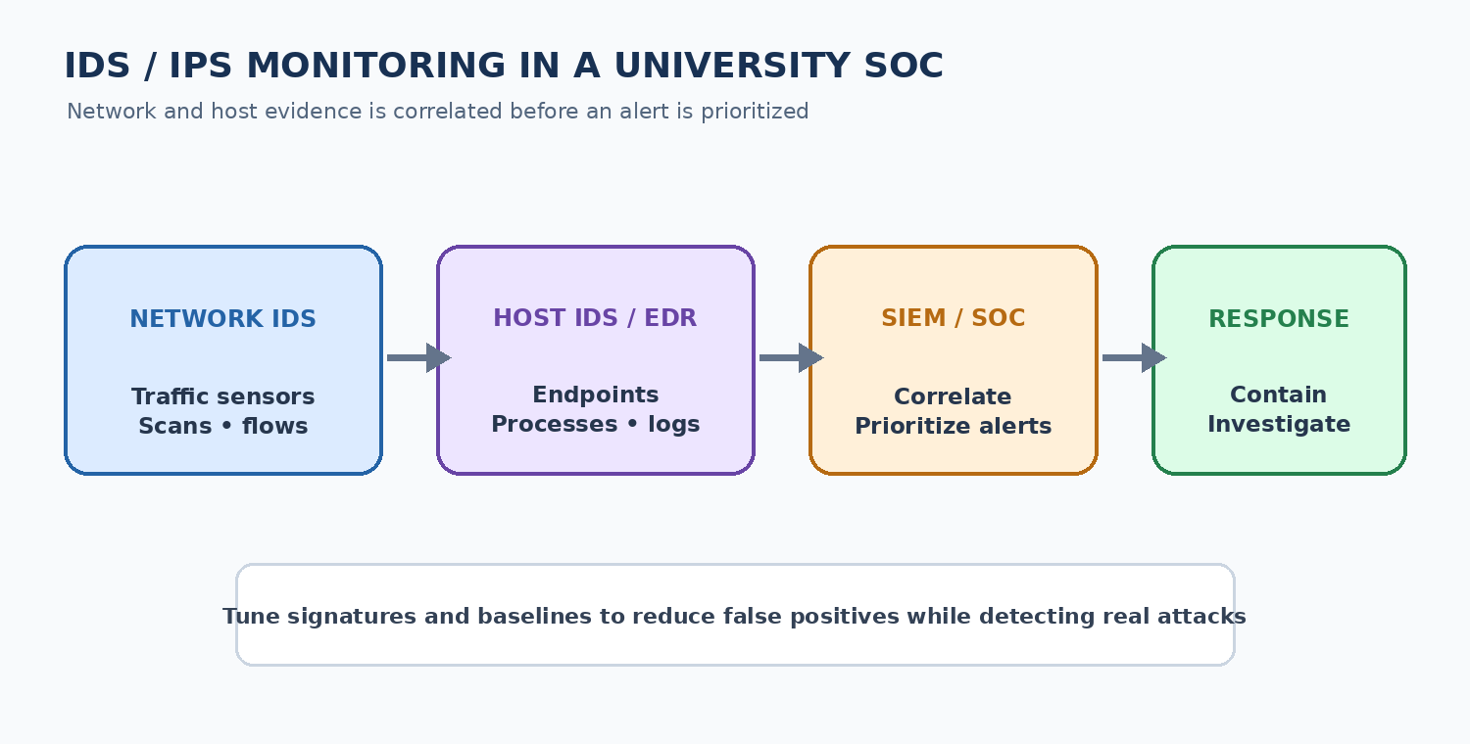
Figure 2: IDS/IPS and SIEM workflow for security monitoring and response.
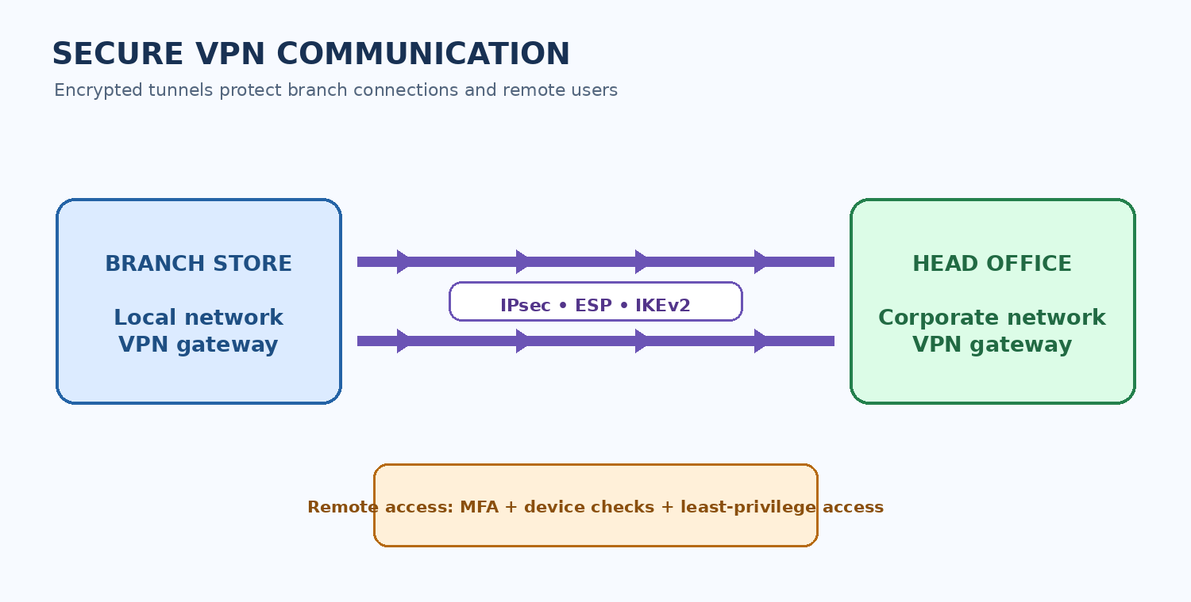
Figure 3: Encrypted site-to-site VPN communication between branch and head office.
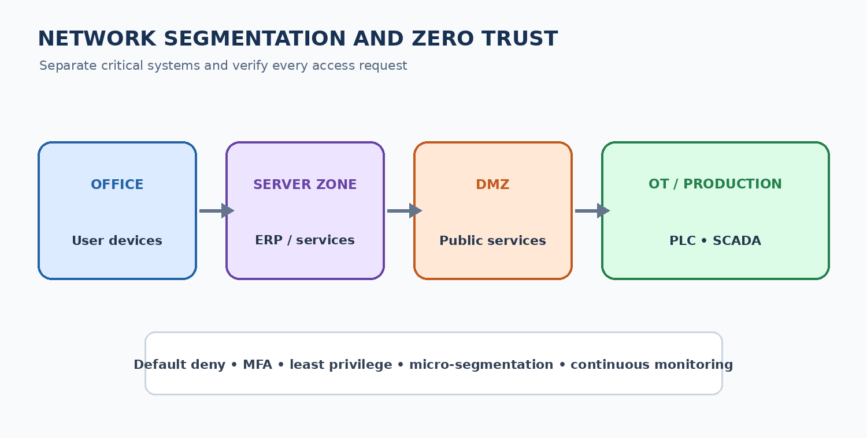
Figure 4: Segmented network zones with Zero Trust security controls.
Quick Revision – Key Points
Question | Core points to remember
1. Firewall | Zones: Internet / DMZ / LAN; firewall types; NAT is not security; ordered least-privilege rules; ingress + egress; default deny; test/log/review.
2. IDS/IPS | NIDS + HIDS; signature + anomaly + hybrid; passive IDS vs inline IPS; sensor placement; FP vs FN; tune Snort threshold; detect evasion.
3. VPN | Branch stores: site-to-site IPsec tunnel mode; remote users: remote-access VPN with MFA; ESP, AH, SA, IKE; TLS and SSH; split vs full tunnel.
4. Segmentation | Separate office, server, DMZ, guest, camera and OT zones; ACL/internal firewall; jump host + MFA; least privilege and default deny.
5. Zero Trust | Verify every request; least privilege; assume breach; IdP + MFA + posture + policy enforcement + micro-segmentation + monitoring; phased roadmap.

.

