\SIMATS ENGINEERING
CSA6303 – Threat Intelligence and Network Security
CO2-A1 – Threat Intelligence Report

Particulars | Details
Subject | Threat Intelligence
Total Marks | 50
Questions | 10
Reg. No. | 192411211
Name | V Teja Sree
Faculty | Dr. V. Parthipan
Slot | A

Code of Conduct:
I V. Teja Sree (192411211) (Name / Reg No) certify that this submission is my original work and that I have adhered to the guidelines specified for this assessment. I understand that any violation of academic integrity rules will result in disciplinary action.

Signature of the student


Q1. Malware
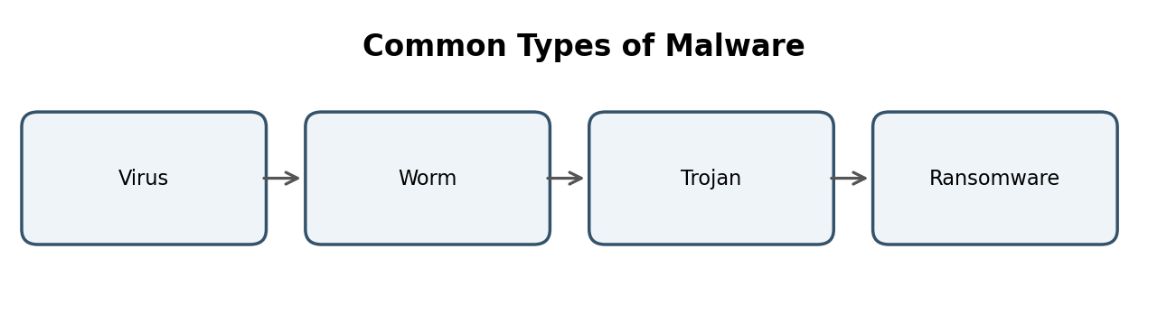
Definition
Malware (malicious software) is any program, script or code that is deliberately designed to infiltrate, damage, disrupt or gain unauthorised access to a computer system, network or data without the knowledge or consent of the owner.
Types of Malware
Type | Description | How it spreads | Impact on the victim
Virus | Malicious code that attaches itself to a legitimate program or file and runs when the host is executed. | Infected files, email attachments, USB drives and downloaded software shared by users. | Corrupts or deletes files and slows down or crashes the system.
Worm | Self-replicating malware that is a standalone program and needs no host file or user action. | Exploits network vulnerabilities and open ports; also spreads through email and shared folders (e.g. WannaCry, Conficker). | Consumes bandwidth and resources, causing network congestion and service outages.
Trojan | Malware disguised as genuine or useful software that tricks the user into installing it. It does not self-replicate. | Fake software downloads, cracked applications and malicious email attachments. | Opens a backdoor, giving the attacker remote control and enabling data theft.
Ransomware | Malware that encrypts the victim's files or locks the system and demands a ransom for the decryption key. | Phishing emails, malicious links, exposed Remote Desktop (RDP) and unpatched software. | Loss of access to data, business downtime and financial loss (e.g. WannaCry, LockBit).

Q2. Phishing
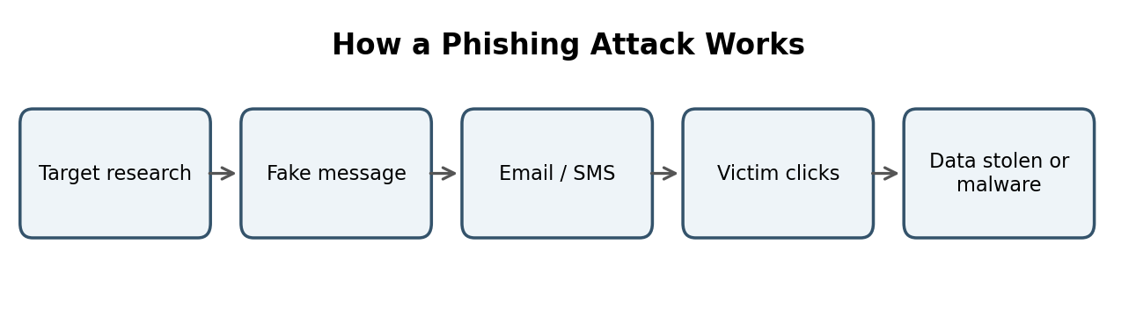
How a Phishing Attack is Carried Out
Phishing is a social-engineering attack in which the attacker impersonates a trusted entity (a bank, employer or service provider) to trick the victim into revealing sensitive information or installing malware. The attack proceeds as follows:
Target research | → | Craft fake message | → | Deliver by email / SMS | → | Victim clicks or replies | → | Data stolen or malware installed

- Reconnaissance: the attacker selects targets and collects details such as email addresses and organisation names.
- Crafting the lure: a convincing email, SMS or website is created with a spoofed sender address, logo and an urgent message (e.g. “Your account will be blocked”).
- Delivery: the message is sent with a malicious link to a fake login page or an infected attachment.
- Victim action: the user enters credentials or card details on the fake page, or opens the attachment.
- Exploitation: the attacker harvests credentials, installs malware or commits fraud using the stolen data.
Spear Phishing vs Whaling vs Vishing
Feature | Spear Phishing | Whaling | Vishing
Target | A specific individual or small group in an organisation. | Senior executives such as the CEO, CFO or directors. | Any individual, using a phone call.
Medium | Personalised email or message. | Highly polished email, often fake legal or business notices. | Voice call or voicemail (voice phishing).
Method | Uses researched personal details to look genuine. | Targets high-value approvals such as wire transfers. | Caller poses as a bank or tech support and asks for OTP or PIN.
Example | Fake email from the HR manager to an employee about payroll. | Fake CEO-to-finance request for an urgent fund transfer. | Call claiming “your account is compromised, share the OTP”.

Measures to Reduce Phishing Risk
- Security awareness training and simulated phishing exercises so that employees can recognise and report suspicious messages.
- Email security controls: spam and phishing filters with SPF, DKIM and DMARC to block spoofed senders, plus attachment sandboxing.
- Multi-factor authentication (MFA) so that stolen passwords alone cannot be used, together with endpoint protection and a clear reporting procedure.

Q3. DoS and DDoS
DoS vs DDoS
Basis | DoS Attack | DDoS Attack
Full form | Denial of Service | Distributed Denial of Service
Attack source | A single computer or connection. | Many compromised systems (a botnet) attacking together.
Scale / impact | Limited traffic volume; less powerful. | Very large volume; can overwhelm even strong servers.
Detection and blocking | Easy: block the single source IP. | Difficult: traffic comes from thousands of genuine-looking IPs.
Example | Ping flood from one machine. | Mirai botnet attack on Dyn DNS (2016).

Working of a SYN Flood
A SYN flood exploits the TCP three-way handshake (SYN, SYN-ACK, ACK). In a normal connection the client sends SYN, the server replies with SYN-ACK and keeps the connection in its half-open queue, and the client completes it with ACK. In a SYN flood the attacker sends a very large number of SYN packets, usually with spoofed source IP addresses, and never sends the final ACK.
Normal handshake | SYN flood
1. Client → Server: SYN  2. Server → Client: SYN-ACK  3. Client → Server: ACK  Connection established | 1. Attacker → Server: SYN (spoofed IPs, thousands per second)  2. Server → Fake IPs: SYN-ACK, waits for ACK  3. ACK never arrives; half-open entries pile up  Backlog queue becomes full, so genuine users are refused

Mitigation Techniques
- SYN cookies: the server does not store state for a half-open connection. It encodes the connection details in the initial sequence number of its SYN-ACK and allocates resources only when a valid ACK returns.
- Rate limiting and filtering: limit the number of SYN packets accepted per source or per second, and use firewalls or IPS. For large DDoS attacks, use CDN/scrubbing services or blackhole routing to drop attack traffic upstream.

Q4. Man-in-the-Middle Attacks
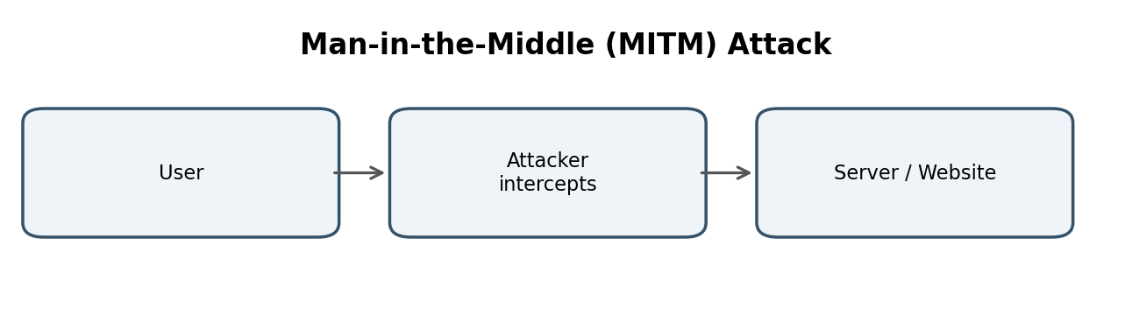
Definition and Interception Concept
A Man-in-the-Middle (MITM) attack occurs when an attacker secretly positions themselves between two communicating parties (for example a user and a website), intercepts the traffic, and may read, modify or inject data while both parties believe they are talking directly to each other.
User | → | Attacker (intercepts / alters) | → | Server / Website

Techniques Used
- ARP poisoning: on a local network, the attacker sends forged ARP replies that map the attacker's MAC address to the IP address of the default gateway. The victim's traffic is then sent to the attacker, who reads it and forwards it to the real gateway so that the victim notices nothing.
- Rogue Wi-Fi access point (evil twin): the attacker sets up a fake hotspot with a trusted name (e.g. “Free_Airport_WiFi”). Users connect to it and all their traffic passes through the attacker's device, exposing logins and session cookies. (SSL stripping is a related technique that downgrades HTTPS to HTTP.)
How Encryption and Other Defences Help
- TLS/HTTPS encrypts data in transit, so intercepted traffic is unreadable and cannot be altered without detection.
- Certificate validation lets the browser detect a fake server through an invalid or untrusted certificate, and HSTS forces HTTPS and prevents SSL stripping.
- A VPN encrypts all traffic on untrusted networks, and Dynamic ARP Inspection protects the local network from ARP poisoning.

Q5. Spoofing and Sniffing
Comparison
Basis | Spoofing | Sniffing
Meaning | Forging identity (IP, MAC, email) to impersonate a trusted device or user. | Capturing and inspecting network packets passing through a network.
Nature | Active: the attacker sends fake packets. | Mostly passive: the attacker only listens.
Goal | Bypass authentication, hide the source or redirect traffic. | Steal passwords, data and learn about the network.
Examples | IP spoofing, ARP spoofing, email spoofing. | Wireshark, tcpdump.

IP Spoofing
The attacker alters the source IP field in packet headers to pretend to be another host. Example: in a SYN flood or a reflection DDoS attack, packets carry fake or the victim's source IPs so that the attacker stays hidden and replies are directed at the victim.
ARP Spoofing
The attacker sends false ARP replies that link their own MAC address to a legitimate IP address (such as the gateway) so that traffic is redirected through the attacker. Example: on a college LAN, the attacker poisons the ARP cache of a student's PC to capture its traffic (a MITM attack).
Dual Use of Packet Sniffers such as Wireshark
- Malicious use: capturing unencrypted passwords, session cookies and emails on open Wi-Fi or a compromised network, and mapping the network before an attack.
- Legitimate use: network troubleshooting, performance analysis, detecting malware or suspicious traffic, forensic investigation and security testing with authorisation.
Countermeasure: use encrypted protocols (HTTPS, SSH, VPN) so that sniffed data is unreadable; Dynamic ARP Inspection and ingress/egress filtering reduce ARP and IP spoofing.

Q6. Vulnerability Assessment
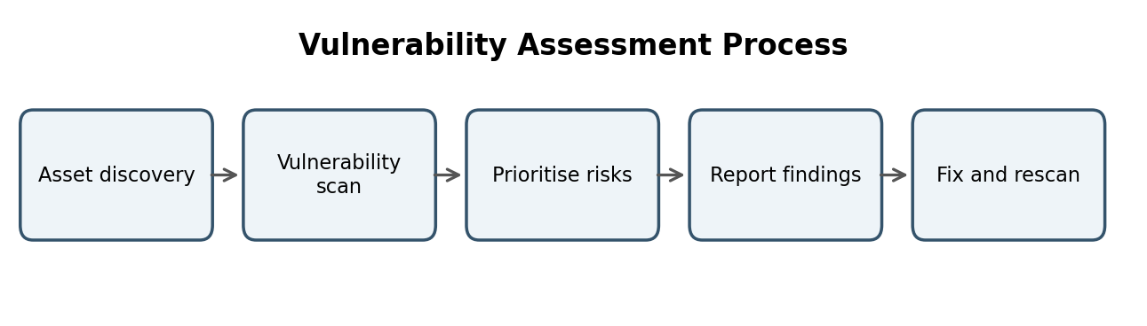
Vulnerability Assessment Process
Vulnerability assessment (VA) is the systematic process of identifying, classifying and prioritising security weaknesses in systems, networks and applications so that they can be fixed before attackers exploit them.
Main Phases
Asset discovery | → | Vulnerability scanning | → | Analysis and prioritisation | → | Reporting | → | Remediation

- Asset discovery: identify and list all hosts, devices, applications and services in scope.
- Scanning: run automated tools to detect missing patches, misconfigurations, weak passwords and known vulnerabilities.
- Analysis and prioritisation: remove false positives and rank findings by severity (CVSS), exploitability and asset importance.
- Reporting: document the findings, risk ratings and recommended fixes for management and technical teams.
- Remediation: patch, reconfigure or apply compensating controls, then rescan to verify the fix.
Vulnerability Assessment vs Penetration Testing
Basis | Vulnerability Assessment | Penetration Testing
Purpose | Find and list as many weaknesses as possible. | Exploit weaknesses to prove real impact.
Approach | Mostly automated scanning. | Manual, simulated attack by skilled testers.
Depth | Broad coverage, does not exploit. | Deep, focused on attack paths and chaining.
Output | Prioritised list of vulnerabilities. | Proof of compromise and attack narrative.
Frequency | Regular and continuous (monthly or quarterly). | Periodic (annually or after major changes).

Commonly Used Scanning Tools
- Nessus (Tenable): a widely used commercial scanner with a large plugin database.
- OpenVAS: an open-source vulnerability scanner. Qualys is another popular cloud-based option.

Q7. Vulnerability Scoring
CVE
CVE (Common Vulnerabilities and Exposures) is a public catalogue that gives each publicly known vulnerability a unique identifier in the format CVE-YEAR-NUMBER (e.g. CVE-2021-44228, Log4Shell). It provides a common name so that tools, vendors and security teams refer to the same flaw.
CVSS
CVSS (Common Vulnerability Scoring System) is an open standard that rates the severity of a vulnerability on a scale of 0.0 to 10.0, based on factors such as attack vector, complexity, privileges required, user interaction and impact on confidentiality, integrity and availability.
Score | Severity
0.0 | None
0.1 – 3.9 | Low
4.0 – 6.9 | Medium
7.0 – 8.9 | High
9.0 – 10.0 | Critical

Role in Prioritisation
CVSS gives a standard, objective number so that teams can sort thousands of vulnerabilities and fix the Critical and High ones first, set patch deadlines (SLAs) and communicate risk consistently.
Why a High CVSS Score Alone Does Not Decide Patching Order
CVSS measures technical severity, not the risk to a particular organisation. Other context factors must be considered:
- Exploitability: whether a working exploit exists or the flaw is being exploited in the wild. A Medium flaw under active attack may be fixed before a High one with no known exploit.
- Asset criticality: a vulnerability on an internet-facing payment server matters more than the same flaw on an isolated test machine.
- Exposure and compensating controls: network reachability, firewalls or other mitigations, and the availability of a patch also affect urgency.

Q8. Threat Data Sources and OSINT
Main Sources of Threat Data
Source | Description | Examples
Internal | Data generated inside the organisation; most relevant to its own environment. | Firewall, IDS/IPS, proxy and DNS logs, SIEM alerts, endpoint (EDR) telemetry, past incident reports.
External | Data obtained from outside parties such as sharing communities and government agencies. | ISACs, CERT-In and CERT advisories, vendor security bulletins, partner sharing.
Open-source | Freely and publicly available information. | Public blogs, social media, forums, WHOIS records, abuse.ch, AlienVault OTX.
Commercial | Paid, curated feeds and reports from security vendors with analysis and support. | CrowdStrike, Recorded Future, Mandiant and Anomali subscriptions.

Open-Source Intelligence (OSINT)
OSINT is intelligence produced from information that is publicly and legally available, such as websites, social media, public records, search engines and technical databases. In threat intelligence it is used to profile attacker infrastructure, find exposed assets and enrich indicators at low cost.
Three OSINT Sources / Tools
- Shodan: a search engine for internet-connected devices that shows open ports, services and exposed systems, helping to find vulnerable assets.
- VirusTotal: analyses files, URLs, domains and IPs using many antivirus engines and gives reputation, hash and behaviour information for malware.
- WHOIS (with passive DNS): reveals domain registration details, name servers and creation dates, helping to link malicious domains to the same attacker. Social-media and dark-web monitoring are other useful sources.

Q9. Indicators of Compromise (IoCs)
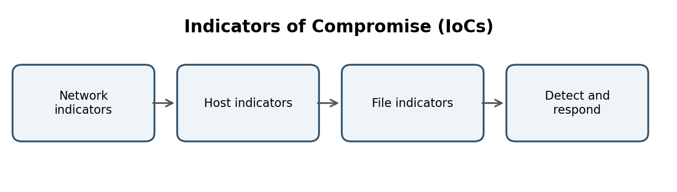
Definition
Indicators of Compromise (IoCs) are pieces of forensic evidence, such as artefacts, data or behaviours observed on a network or system, which show that a system has been, or is being, compromised by a malicious actor.
Classification of IoCs
Type | Meaning | Examples
Network-based | Evidence seen in network traffic and communication. | 1. Connections to known malicious IP addresses or command-and-control (C2) domains.  2. Unusual outbound traffic volume or abnormal DNS requests (e.g. beaconing).
Host-based | Evidence found on an individual computer or server. | 1. New or modified registry run keys and scheduled tasks created for persistence.  2. Unexpected processes or unauthorised new user accounts.
File-based | Evidence tied to specific files. | 1. Hash values (MD5, SHA-256) of known malware samples.  2. Suspicious file names or paths and YARA-matched strings in files.

Use of IoCs in Incident Response
- Detection: IoCs are loaded into SIEM, IDS/IPS, firewalls and EDR to raise alerts and to hunt for the same indicators across the environment.
- Scoping and containment: matching IoCs identifies which systems are affected, so infected hosts can be isolated and malicious IPs and domains blocked.
- Eradication, recovery and sharing: IoCs guide the removal of malware and persistence mechanisms, confirm clean-up, and are shared with peers to help others defend.

Q10. Threat Feeds
Definition
A threat intelligence feed is a continuously updated stream of machine-readable threat data, such as malicious IPs, domains, URLs, file hashes and malware signatures, supplied by a provider so that security tools can detect and block known threats automatically.
Common Feed Formats and Sharing Standards
- STIX (Structured Threat Information eXpression): a standard JSON-based language used to describe threat information such as indicators, malware, threat actors and campaigns.
- TAXII (Trusted Automated eXchange of Intelligence Information): a protocol that transports STIX data between systems over HTTPS (for example through a collection or a publish-subscribe channel).
- Other formats: CSV and plain-text lists, JSON, OpenIOC and MISP format, and detection rules such as Snort/Suricata and YARA.
Advantages and Limitations
Advantages | Limitations
1. Provides timely, automated updates that can be fed directly into SIEM and firewalls.  2. Gives wider visibility of global threats than an organisation can gather alone. | 1. Can produce false positives and noise, and indicators quickly become outdated.  2. Often lacks context and may not be relevant to the organisation, so analysts are overloaded.

Example Feeds
- AlienVault OTX (Open Threat Exchange): a community-driven platform for sharing threat indicators.
- abuse.ch (URLhaus, MalwareBazaar, Feodo Tracker) and MISP are other well-known feeds and sharing platforms.

