SIMATS ENGINEERING
CSA6303 – Threat Intelligence and Network Security
CO2-AT2 – Threat Intelligence Report

Particulars | Details
Subject | Threat Intelligence
Total Marks | 50
Questions | 10
Reg. No. | 192411211
Name | V Teja Sree
Faculty | Dr. V. Parthipan
Slot | A

Code of Conduct:
I V. Teja Sree (192411211) (Name / Reg No) certify that this submission is my original work and that I have adhered to the guidelines specified for this assessment. I understand that any violation of academic integrity rules will result in disciplinary action.

Signature of the student


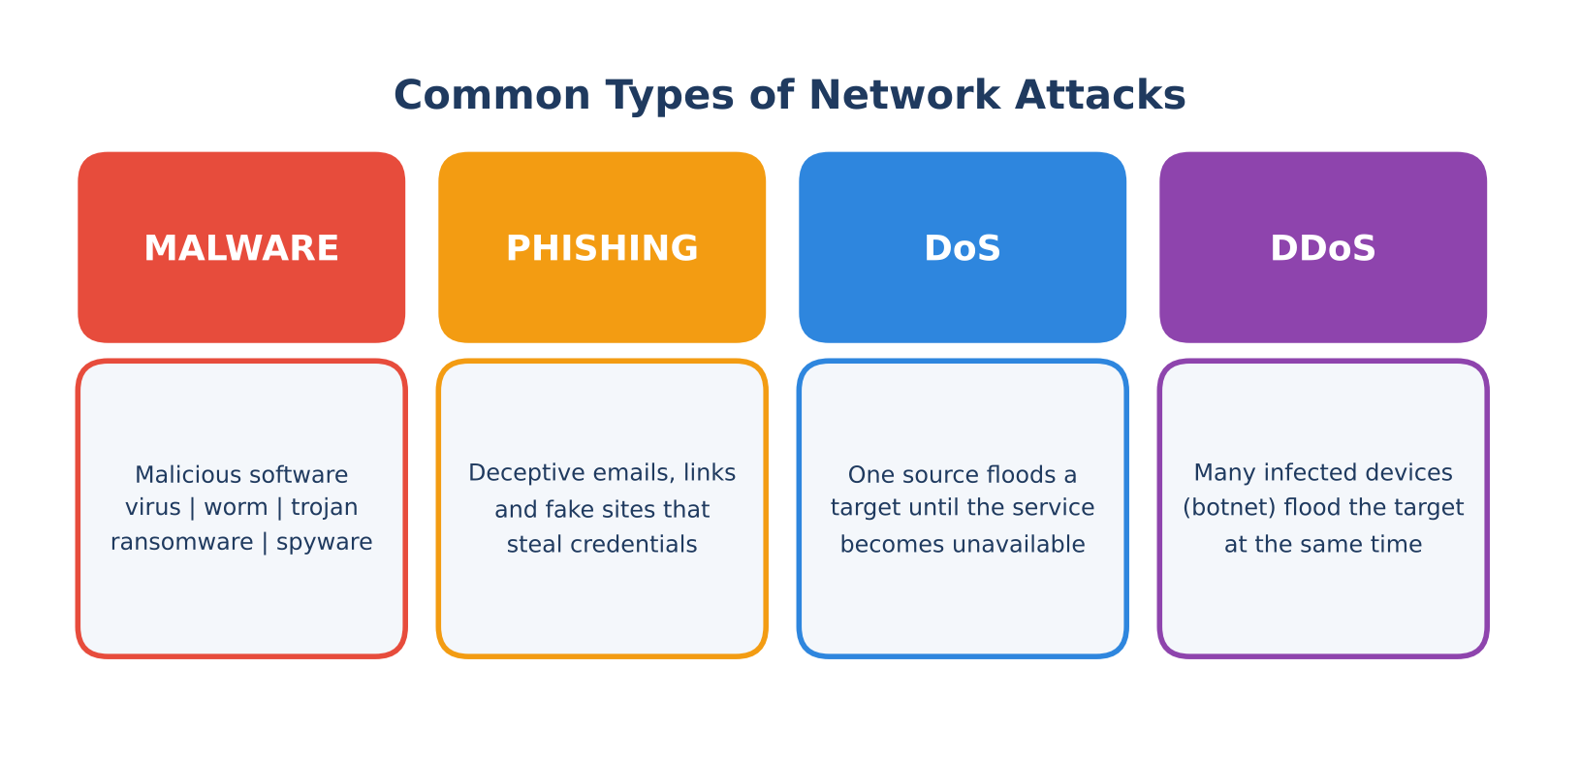
Figure 1: Overview of common network attacks
Q1. Common types of network attacks: malware, phishing, DoS and DDoS

Definition
A network attack is any deliberate attempt to gain unauthorized access to, disrupt, or steal data from a computer network. Attacks target one or more parts of the CIA triad: Confidentiality, Integrity and Availability. The four most common categories are explained below, each with an example and a preventive measure.

1.1 Malware
Malware (malicious software) is any program designed to damage, disrupt or gain unauthorized access to a system. The main types are:
- Virus: attaches itself to a legitimate file and spreads when the infected file is executed.
- Worm: self-replicating malware that spreads across networks without user action.
- Trojan: disguised as useful software but performs hidden malicious actions, often opening a backdoor.
- Ransomware: encrypts the victim's files and demands payment for the decryption key.
- Spyware: secretly monitors the user and steals information such as keystrokes and passwords.
Example: The WannaCry ransomware (2017) spread like a worm through unpatched Windows SMB services and encrypted files on hundreds of thousands of computers worldwide.
Preventive measure: Install and update antivirus/EDR software, apply security patches promptly, restrict administrator privileges and keep offline backups.

1.2 Phishing
Phishing is a social engineering attack in which the attacker impersonates a trusted entity using deceptive emails, links, messages or fake websites to trick victims into revealing credentials, financial data or installing malware. Variants include spear phishing (targeted at a person), whaling (aimed at executives), smishing (SMS) and vishing (voice calls).
Example: An email that appears to come from a bank warns of account suspension and links to a cloned login page that captures the user's username and password.
Preventive measure: Conduct regular user awareness training, enable email filtering with SPF/DKIM/DMARC and use multi-factor authentication so that stolen passwords alone are not enough.

1.3 Denial of Service (DoS) and 1.4 Distributed Denial of Service (DDoS)
A DoS attack floods a server, service or network with excessive traffic or malformed requests from a single source so that legitimate users cannot access it. A DDoS attack does the same using many compromised devices (a botnet) at the same time, which makes it far larger and much harder to block by filtering a single IP address.
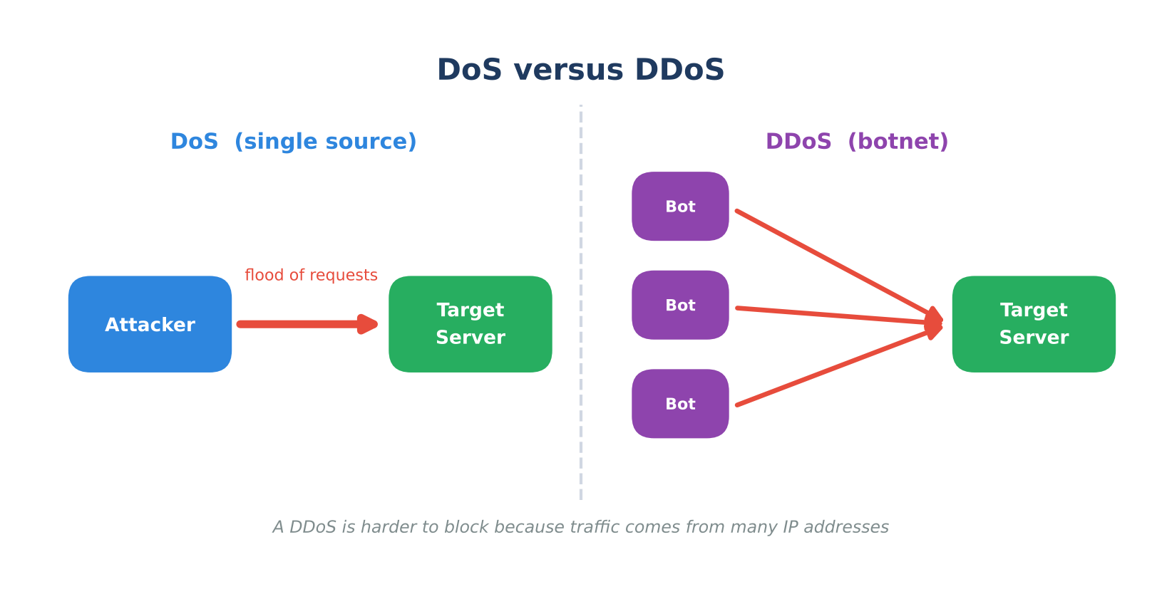
Figure 2: Single-source DoS compared with botnet-driven DDoS
DoS example: A SYN flood, in which the attacker sends a large number of TCP connection requests and never completes the handshake, exhausting the server's connection table.
DDoS example: The Mirai botnet attack on the DNS provider Dyn (October 2016), which used hijacked IoT devices such as cameras and routers to disrupt many popular websites.
Preventive measures: Rate limiting, firewalls and IPS, SYN cookies, and using a CDN or traffic scrubbing service to absorb and filter large volumes of attack traffic.

Summary
Attack | Key idea | Example | Preventive measure
Malware | Malicious software | WannaCry ransomware | Antivirus/EDR, patching
Phishing | Deception to steal credentials | Fake bank login page | User training, MFA, email filtering
DoS | Flood from one source | SYN flood | Rate limiting, firewall
DDoS | Flood from a botnet | Mirai attack on Dyn | CDN, traffic scrubbing

Q2. Man-in-the-Middle (MitM) attack

Definition
A Man-in-the-Middle attack occurs when an attacker secretly positions themselves between two communicating parties, such as a user and a website, so that all traffic passes through the attacker. The attacker can eavesdrop on the conversation and may also alter the messages, while both parties believe they are talking directly to each other.

How it works
- Interception: the attacker inserts themselves into the communication path (for example by joining the same Wi-Fi network or poisoning the ARP cache).
- Decryption / relaying: traffic is captured; if it is unencrypted it is read directly, otherwise the attacker may present a forged certificate or downgrade the connection.
- Manipulation: the attacker steals credentials, session cookies or financial data, or injects malicious content into the traffic.
- Forwarding: messages are passed on so the victim notices nothing unusual.
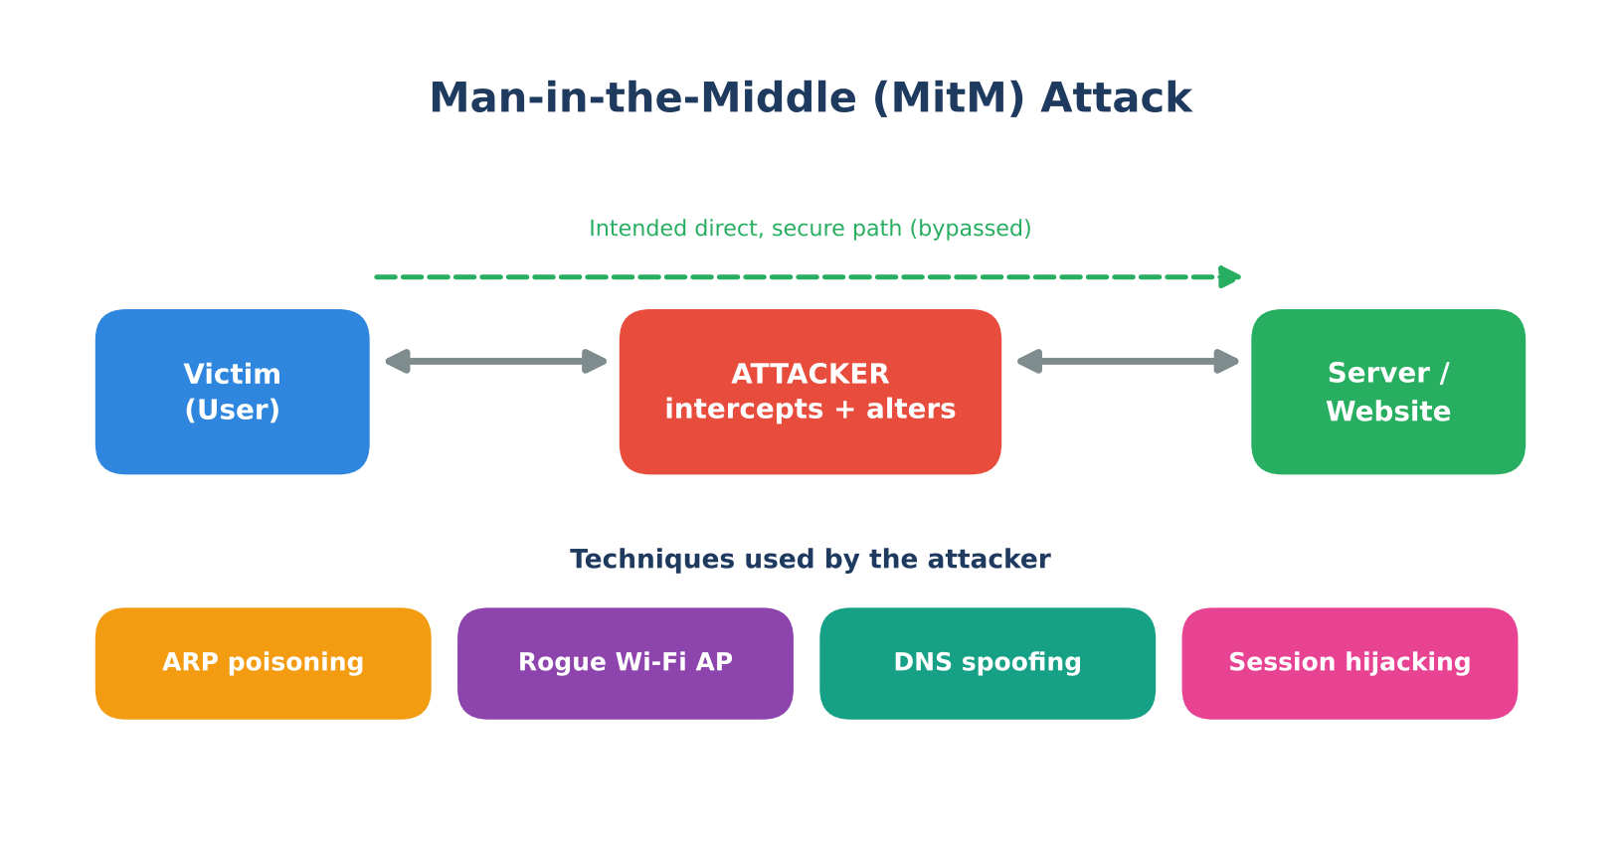
Figure 3: Man-in-the-Middle attack and common techniques

Techniques used
Technique | Description
ARP poisoning | The attacker sends forged ARP replies so devices on the LAN map the gateway's IP address to the attacker's MAC address, redirecting traffic through the attacker.
Rogue Wi-Fi access point | A fake or 'evil twin' hotspot with a familiar name lures users to connect; all of their traffic is then visible to the attacker.
DNS spoofing | Forged DNS responses send the victim to a malicious website instead of the genuine one.
Session hijacking | The attacker steals or predicts a valid session ID or cookie and takes over the authenticated session.

Countermeasures
- Use HTTPS/TLS everywhere and validate server certificates; never ignore certificate warnings.
- Enable HSTS so browsers refuse to connect over plain HTTP and prevent SSL-stripping.
- Use a VPN on untrusted networks such as public Wi-Fi.
- Deploy Dynamic ARP Inspection (DAI) and DHCP snooping on switches to block forged ARP replies.
- Use DNSSEC, secure session cookies (Secure and HttpOnly flags) and multi-factor authentication.
- Avoid unknown Wi-Fi networks and use certificate pinning in sensitive applications.

Q3. Spoofing versus sniffing

Difference between spoofing and sniffing
Basis | Spoofing | Sniffing
Meaning | Forging an identity (IP, MAC, email, DNS) to appear as a trusted source | Capturing and inspecting packets travelling over a network
Nature | Active: the attacker sends falsified data | Mostly passive: the attacker only listens
Goal | Impersonation, bypassing trust, redirecting traffic | Information gathering, such as passwords and session data
Typical tools | Scapy, Ettercap, hping3 | Wireshark, tcpdump
Main data at risk | Trust relationships and authentication | Unencrypted data (HTTP, FTP, Telnet)
Detectability | Often visible through mismatched addresses and logs | Hard to detect because it generates no traffic

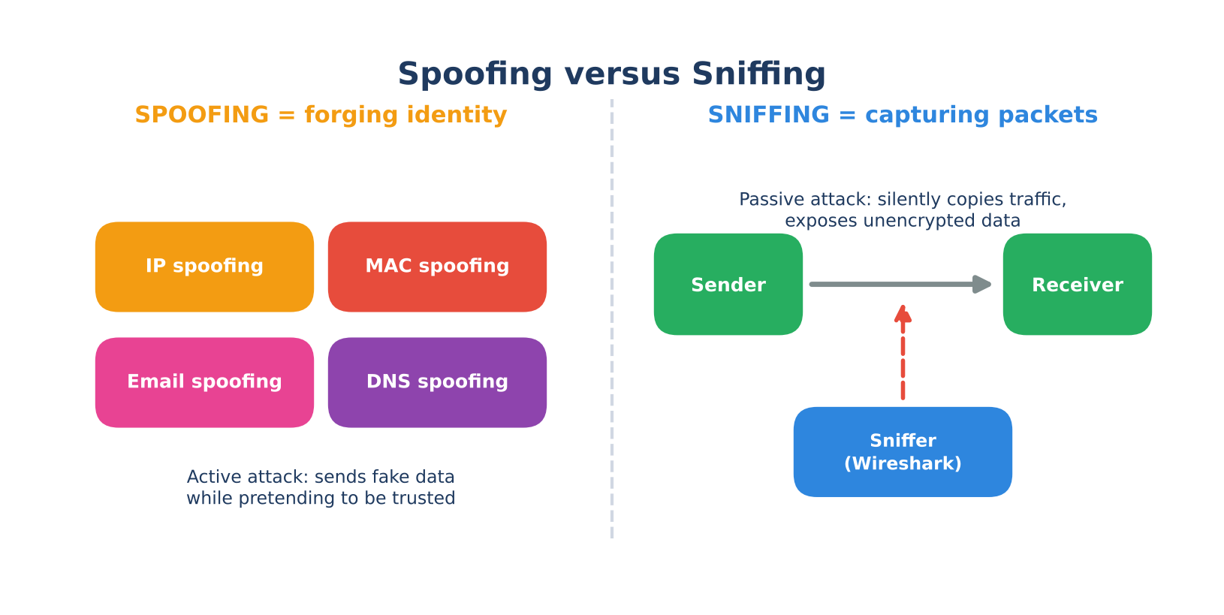
Figure 4: Spoofing (forging identity) compared with sniffing (capturing packets)

Types of spoofing
- IP spoofing: the source IP address of packets is forged to hide the attacker or impersonate another host; common in DDoS reflection attacks.
- MAC spoofing: the attacker changes their NIC's MAC address to bypass MAC filtering or impersonate a device.
- ARP spoofing: false ARP messages link the attacker's MAC address with a legitimate IP address.
- Email spoofing: the sender address is forged so that a message looks like it comes from a trusted person or organization, as in phishing.
- DNS spoofing (cache poisoning): false DNS records redirect users to malicious sites.

Detecting sniffing
- Look for network interfaces running in promiscuous mode on hosts.
- Monitor for ARP anomalies, duplicate MAC/IP mappings and unexpected MAC table changes (tools such as arpwatch).
- Use an IDS/IPS to flag ARP poisoning, rogue devices and unusual traffic redirection.
- Watch for unexplained network latency and unauthorized devices plugged into switch ports.

Preventing sniffing and spoofing
- Encryption: TLS, SSH, IPsec and VPNs make captured packets unreadable.
- Switched networks instead of hubs, so traffic is sent only to the intended port.
- Port security limits the MAC addresses per switch port; combine with DHCP snooping and Dynamic ARP Inspection.
- Anti-spoofing filters: ingress/egress filtering (BCP 38) and unicast reverse path forwarding (uRPF); SPF, DKIM and DMARC for email; DNSSEC for DNS.
- Network segmentation with VLANs and strong authentication such as 802.1X.

Q4. Vulnerability assessment and report contents

Definition
A vulnerability assessment (VA) is a systematic process of identifying, classifying and prioritizing security weaknesses in systems, networks and applications so that they can be fixed before an attacker exploits them.

Steps of a vulnerability assessment
- Asset identification: list all hosts, devices, applications and data in scope, and decide their criticality to the business.
- Vulnerability scanning: run automated scanners such as Nessus, OpenVAS or Qualys (and Nmap for discovery) to detect missing patches, misconfigurations and weak services.
- Analysis: verify results, remove false positives and identify root causes.
- Risk rating: score each finding using CVSS and the asset's business importance, then rank by priority.
- Reporting and remediation: document the findings and recommend fixes; re-scan afterwards to confirm closure.
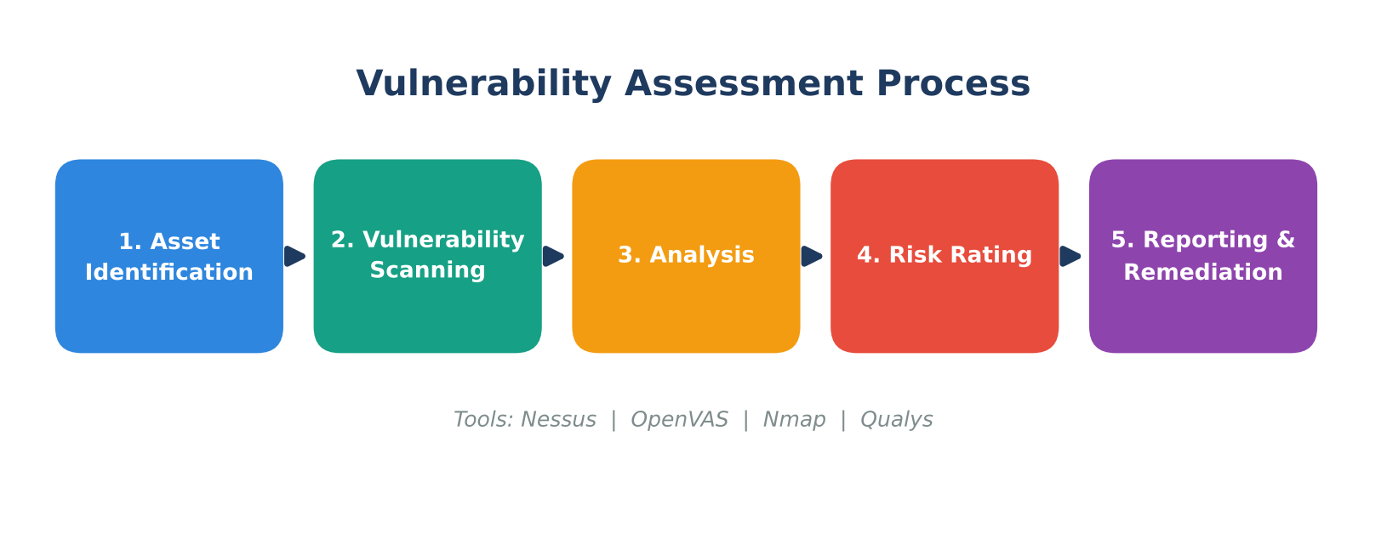
Figure 5: Vulnerability assessment process

Severity rating (CVSS)
The Common Vulnerability Scoring System (CVSS) assigns each vulnerability a base score from 0.0 to 10.0, which is mapped to a qualitative severity band.
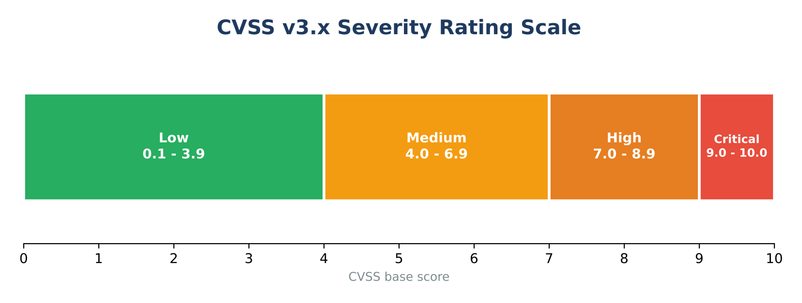
Figure 6: CVSS v3.x severity bands

Contents of a good vulnerability assessment report
Section | What it contains
Executive summary | A non-technical overview of overall risk, key findings and the main actions required, written for management.
Scope and methodology | Systems and IP ranges assessed, dates, tools used (Nessus, OpenVAS), scan type and any limitations.
Findings | Each vulnerability with a unique ID, its CVE ID, title, description and affected asset.
CVSS severity scores | Base score and severity rating (Low, Medium, High, Critical) for every finding.
Evidence | Scanner output, screenshots, version banners or logs proving the finding exists.
Risk and impact | The business and technical consequences if the vulnerability is exploited.
Prioritized remediation | Recommended fixes in priority order, such as patches, configuration changes or workarounds, with suggested timelines.

Illustrative findings table:
CVE ID | Description | CVSS | Severity | Remediation
CVE-2021-44228 | Log4Shell remote code execution in Apache Log4j | 10.0 | Critical | Upgrade Log4j to a patched release
CVE-2017-0144 | EternalBlue flaw in SMBv1 | 8.1 | High | Apply MS17-010 patch; disable SMBv1
CVE-2014-0160 | Heartbleed information leak in OpenSSL | 7.5 | High | Upgrade OpenSSL; reissue certificates

Vulnerability assessment versus penetration testing
Aspect | Vulnerability assessment | Penetration testing
Purpose | Find and list as many weaknesses as possible; run regularly | Exploit weaknesses to prove real-world impact; run periodically
Approach | Mostly automated scanning | Manual, goal-driven attack simulation
Output | Prioritized list of vulnerabilities | Proof of compromise and attack paths

Q5. Open-Source Intelligence (OSINT), threat data sources and collection techniques

What is OSINT?
Open-Source Intelligence (OSINT) is intelligence produced from information that is publicly and legally available. In cybersecurity it is used to understand attacker infrastructure, discover an organization's exposed assets, and track new vulnerabilities and campaigns, without needing privileged access.
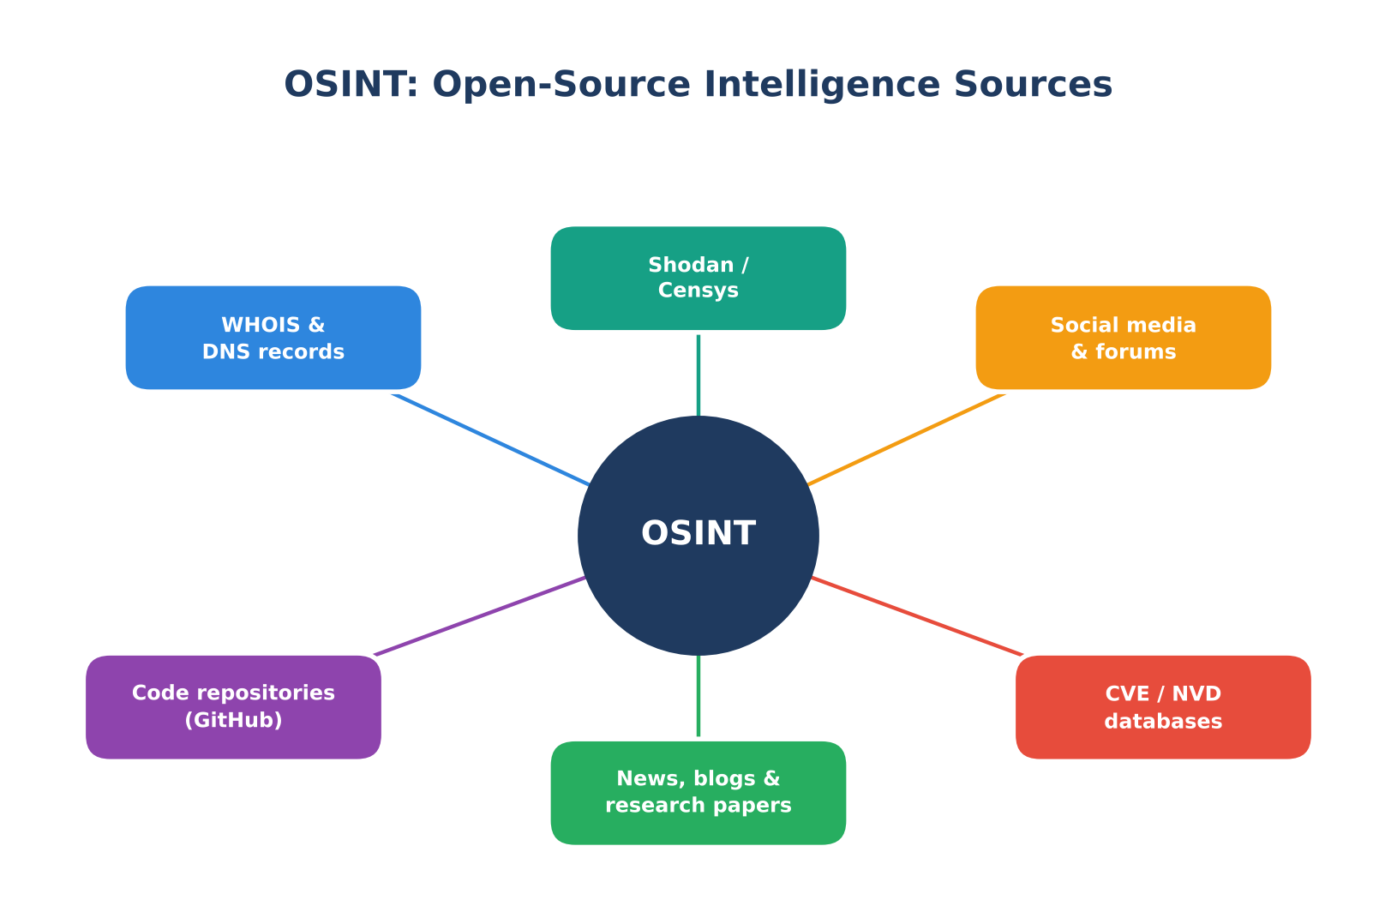
Figure 7: Common OSINT sources

Common threat data sources
Category | Sources | Use
Public (OSINT) | WHOIS and DNS records, Shodan and Censys, social media, news and blogs, hacker forums, paste sites, code repositories (GitHub), CVE and NVD databases | Domain ownership, exposed services, leaked credentials, new vulnerabilities and attacker discussion
Commercial | Paid threat intelligence platforms and vendor reports (for example Recorded Future, Mandiant, CrowdStrike) | Curated, enriched and context-rich intelligence with support
Internal | Firewall, DNS, proxy and server logs, SIEM alerts, honeypots, incident records | Organization-specific activity, direct evidence of attacks against the network
Community / sharing | MISP, AlienVault OTX, abuse.ch, ISACs | Shared indicators and campaign information

Techniques used to collect threat data
- Passive collection: gathering from existing public records and archives without interacting with the target, so the target is not alerted.
- Active collection: querying the target or its services directly (port scans, banner grabbing), which can be noticed.
- Web scraping and crawling: automated tools extract data from websites, forums and paste sites at scale.
- DNS and domain lookups: WHOIS, passive DNS, subdomain enumeration and certificate transparency logs reveal infrastructure.
- Search-engine techniques: advanced operators (Google dorking) uncover exposed files and misconfigured systems.
- Social media and dark web monitoring: tracking mentions of the organization, leaked data and attacker chatter.
- Honeypots and sensors: decoy systems capture attacker tools, IP addresses and techniques firsthand.
Common tools include Maltego, theHarvester, Recon-ng, SpiderFoot and Shodan. Collected data is then processed, analyzed and shared following the intelligence cycle: planning, collection, processing, analysis and dissemination.

Legal and ethical considerations
- Collect only publicly available data and never bypass authentication or access protected systems without permission.
- Respect privacy and data protection laws (such as GDPR) and website terms of service.
- Verify the reliability of sources, since open data can be false, outdated or deliberately planted.
- Handle personal data carefully and use the intelligence only for defensive and authorized purposes.

Q6. Indicators of Compromise (IoCs) and threat feeds

What are IoCs?
Indicators of Compromise (IoCs) are pieces of forensic evidence or artifacts that suggest a system or network has been breached or is under attack. They allow defenders to detect known malicious activity and to investigate incidents.

Types of IoCs
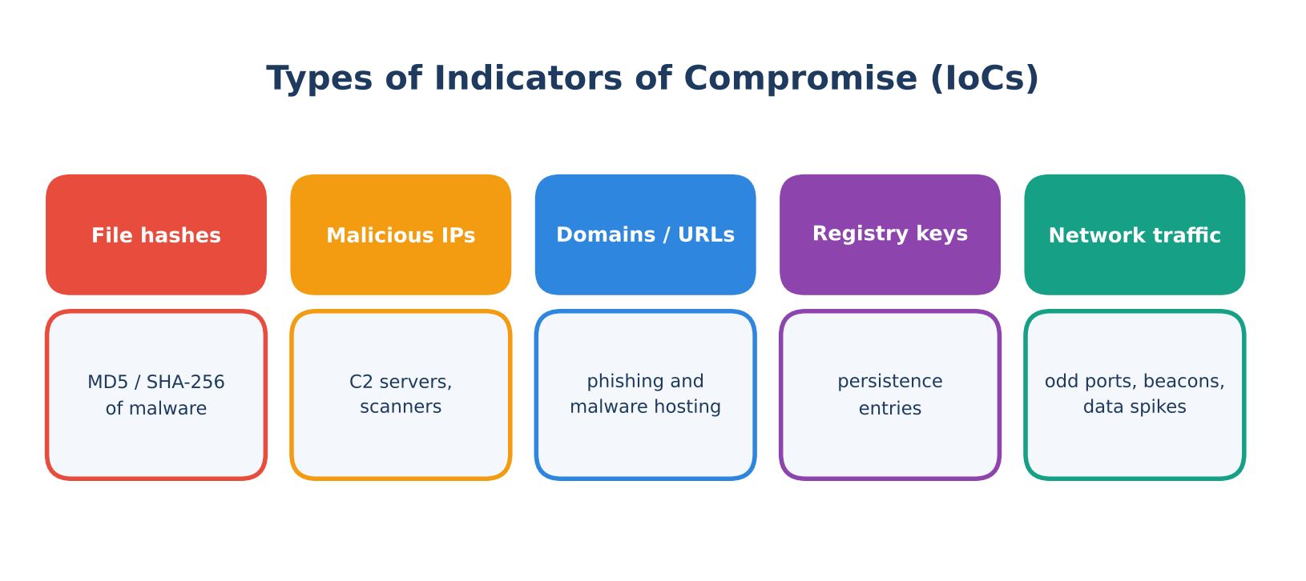
Figure 8: Main types of IoCs
IoC type | Example | Use in defense
File hashes | MD5 or SHA-256 hash of a known malware sample | Antivirus and EDR matching of known malicious files
IP addresses | Command-and-control server or scanner address | Block or alert at firewall and IPS
Domains and URLs | Phishing site or malware download URL | DNS and proxy blocking
Registry keys / file paths | Run keys used for persistence | Host-based detection and forensics
Network traffic patterns | Beaconing at fixed intervals, unusual ports, sudden large data transfers | Anomaly detection in SIEM and network monitoring
Email artifacts | Malicious sender address, subject or attachment name | Mail gateway filtering

How threat feeds help organizations
A threat feed is a continuously updated stream of IoCs and threat information. Feeds can be open-source (AlienVault OTX, abuse.ch, MISP communities) or commercial (Recorded Future, Mandiant, CrowdStrike). They are commonly delivered in standard formats such as STIX (structured description of threat information) over TAXII (the protocol for exchanging it), so that tools can consume them automatically.
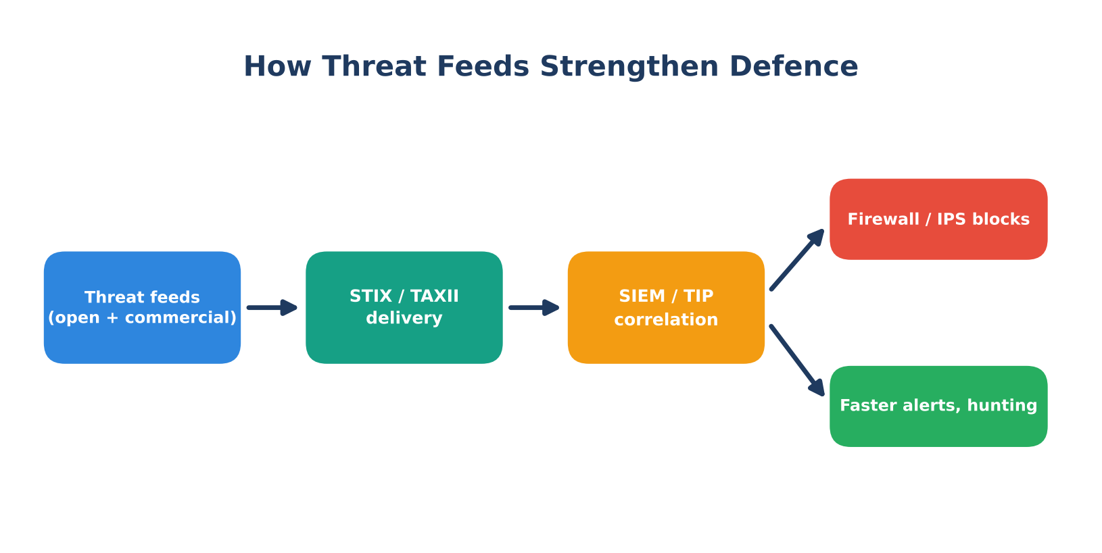
Figure 9: Flow of threat feed data into defensive tools
- Automatic blocking: malicious IPs, domains and URLs are pushed to firewalls, proxies and email gateways.
- Faster detection: SIEM and EDR tools correlate feed IoCs with internal logs and raise alerts quickly.
- Proactive defense: teams learn about new campaigns and threat actors before they are affected.
- Incident response and threat hunting: analysts search historical data for known indicators to find hidden compromises.
- Prioritization: intelligence helps focus patching and monitoring on threats relevant to the organization.

Limitations
- False positives: shared hosting or recycled IP addresses can cause legitimate services to be blocked.
- Stale data: IoCs expire quickly because attackers change infrastructure; old indicators must be aged out.
- Lack of context: a raw indicator does not explain who is behind it or whether it is relevant, so enrichment and confidence scoring are needed.
- Easily changed indicators: file hashes and IP addresses are trivial for attackers to alter, so behavior-based detection is also required.
- Volume: too many feeds can overwhelm analysts without filtering and automation.

References
- NIST SP 800-115, Technical Guide to Information Security Testing and Assessment.
- FIRST, Common Vulnerability Scoring System (CVSS) specification.
- NIST National Vulnerability Database (NVD) and MITRE CVE program.
- OASIS, STIX and TAXII specifications.

