CSA6303 - THREAT INTELLIGENCE AND NETWORK SECURITY

Assessment Tool 1: CONCEPT MAPPING

Faculty : Dr. V. Parthipan SLOT A

Topics: Network Security Fundamentals | Security Goals (CIA Triad) | Types of Network Threats Introduction to Threat Intelligence Types of Threat Intelligence (Strategic, Tactical, perational) — Threat Intelligence Lifecycle — Applications in IT Industry
CO1: Interpret security principles, network threats, and the role of threat intelligence in
cybersecurity.

Total: 50

Student Name : V. Teja Sree Register number: 192411211

Code of Conduct:
I V. Teja Sree (192411211) (Name / Reg No) certify that this submission is my original work and that I have adhered to the guidelines specified for this assessment. I understand that any violation of academic integrity rules will result in disciplinary action.

Signature of the student:
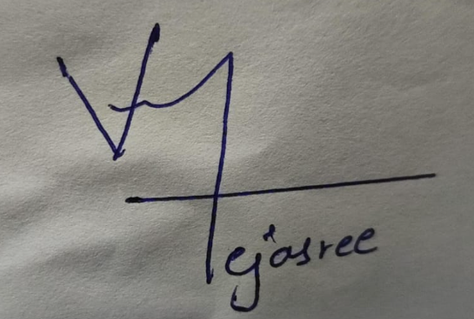

Q1.Construct a comprehensive concept map explaining the foundations of Network Security. Connect network security fundamentals with security objectives, the CIA Triad (Confidentiality, Integrity, and Availability), network assets, vulnerabilities, threats, and protective measures, and explain how these concepts collectively support secure network operations.
Foundations of Network Security
Central concept: Network Security
Hierarchy (concept → linking phrase → concept)
- Network Security → aims to achieve → Security Objectives
- Security Objectives → are expressed through → CIA Triad
  - CIA Triad → includes → Confidentiality (only authorized parties access data)
  - CIA Triad → includes → Integrity (data stays accurate and unaltered)
  - CIA Triad → includes → Availability (services are accessible when needed)
- Network Security → protects → Network Assets
  - Network Assets → include → Hardware (routers, switches, servers), Software and applications, Data and information, Users and credentials, Services (DNS, web, email)
- Network Assets → contain → Vulnerabilities (weak passwords, unpatched software, misconfigurations, open ports)
- Threats (malware, phishing, DoS, spoofing, eavesdropping, insiders) → exploit → Vulnerabilities
- Vulnerabilities exploited by threats → create → Risk → compromises → CIA Triad
- Protective Measures → reduce → Vulnerabilities and Risk
  - Preventive: firewalls, encryption, access control, patching
  - Detective: IDS/IPS, logging, SIEM, monitoring
  - Corrective: incident response, backups, recovery
- Protective Measures → enforce → CIA Triad, which leads to Secure Network Operations
Cross-links
- Encryption → enforces → Confidentiality
- Hashing and digital signatures → enforce → Integrity
- Redundancy and backups → enforce → Availability
- Asset value → determines → Priority of protective measures
Explanation
Network security starts by identifying the assets worth protecting. Every asset has vulnerabilities, and threats exploit them, creating risk to confidentiality, integrity and availability. Protective measures (preventive, detective, corrective) lower that risk. Together, these concepts form a continuous cycle of identify, protect, detect and respond that keeps network operations secure and reliable.
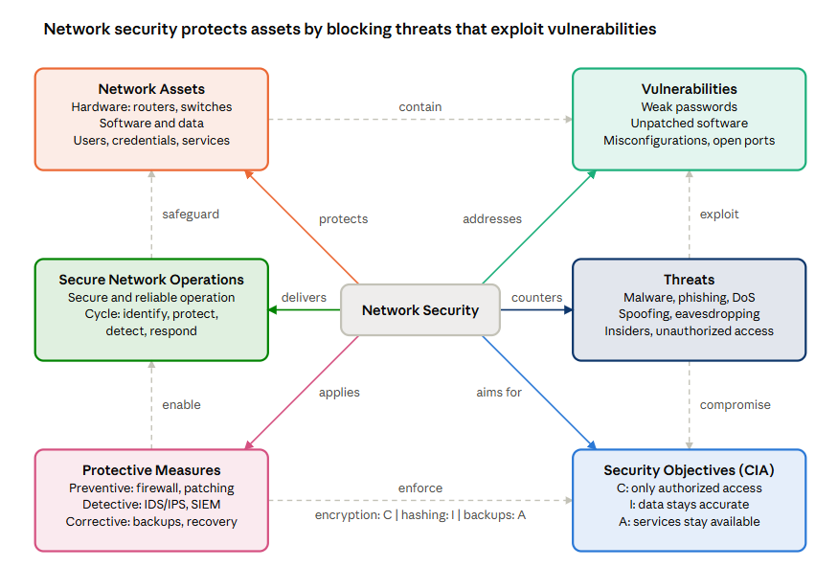Solid arrows run from Network Security to its six branches; dashed arrows show how the branches act on each other, from assets through vulnerabilities and threats to the CIA goals and the measures that enforce them.
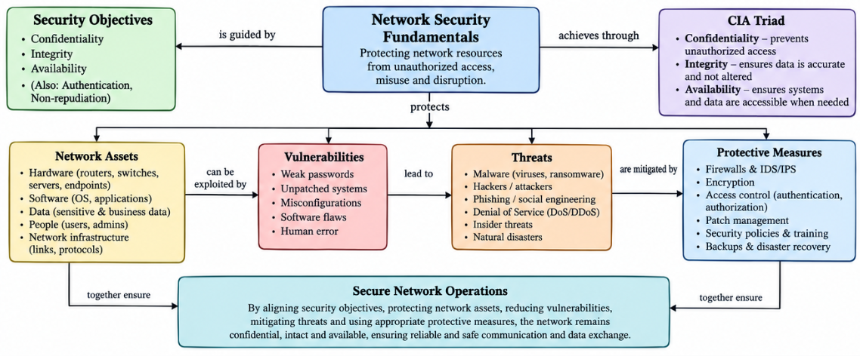
Q2.Develop a concept map illustrating the CIA Triad as the foundation of network security. Relate Confidentiality, Integrity, and Availability to different types of network threats and demonstrate how a single threat can affect one or more security goals.
CIA Triad and Network Threats Central concept:
CIA Triad (foundation of network security)
Hierarchy
- CIA Triad → is the foundation of → Network Security
- Confidentiality → is threatened by → Eavesdropping/sniffing, Phishing, Unauthorized access, Man-in-the-Middle, Malware (spyware)
- Integrity → is threatened by → Man-in-the-Middle (modification), Spoofing, Malware (viruses, trojans), SQL injection, Unauthorized access
- Availability → is threatened by → DoS/DDoS, Ransomware, Malware (worms), Hardware failure or sabotage
Multi-goal threats (the key analysis)
Threat | Confidentiality | Integrity | Availability | Explanation
Ransomware | Yes (data exfiltration) | Yes (files altered by encryption) | Yes (systems locked) | One attack hits all three goals
Man-in-the-Middle | Yes (traffic read) | Yes (packets altered) | No | Reads and modifies data in transit
Malware (trojan/worm) | Yes (steals data) | Yes (corrupts files) | Yes (consumes resources) | Impact depends on payload
Unauthorized access | Yes | Yes | Possible | Attacker can read, change or delete
Phishing | Yes (credentials stolen) | Possible (later account misuse) | Possible | Entry point for later attacks
DoS/DDoS | No | No | Yes | Targets availability only
Spoofing | Possible | Yes (false identity or source) | No | Undermines trust in data origin

Crosslinks
- Phishing → leads to → Unauthorized access → enables → Ransomware, showing how threats chain across the triad
- Controls map back to goals: Encryption and MFA → Confidentiality; Hashing, checksums, digital signatures → Integrity; Load balancing, DDoS mitigation, backups → Availability
Explanation
The triad gives a way to classify the impact of any threat. A threat is rarely limited to one goal. Ransomware affects all three, a man-in-the-middle attack affects confidentiality and integrity, and DDoS affects availability alone. Mapping threats to the triad lets an organization prioritize defenses by which goal matters most for each asset.
[embed: node/1e3470dc-80f1]
Each goal lists the threats that hit it; dashed arrows from Man-in-the-Middle and Ransomware show one threat reaching several goals.
