CSA6303 - THREAT INTELLIGENCE AND NETWORK SECURITY

Assessment Tool 3: MCQ Test

Faculty : Dr.V.Parthipan SLOT A
Total: 50

Student Name : V. Teja Sree Register number: 192411211

Code of Conduct:
I V. Teja Sree (192411211) (Name / Reg No) certify that this submission is my original work and that I have adhered to the guidelines specified for this assessment. I understand that any violation of academic integrity rules will result in disciplinary action.

Signature of the student:
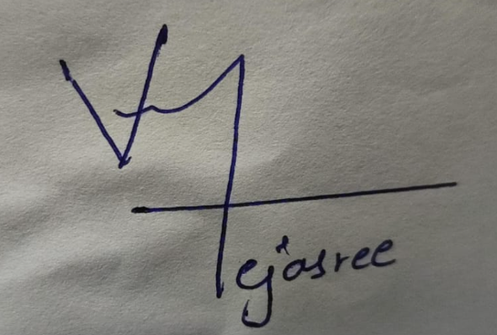

Google Form Link: https://forms.gle/mJHQH4UXYnxzRM9w9

