SIMATS ENGINEERING (SAVEETHA SCHOOL OF ENGINEERING)
Department of Computer Science and Engineering
ASSESSMENT TOOL 1 – ANALYTICAL PROBLEM SOLVING

Course Code: | CSA0608 | Course Title: | Design and Analysis of Algorithms
CO Assessed: | CO2 – Manipulation (BL1, BL2, BL3) | Assessment: | Assessment Tool 1 – Analytical Problem Solving
Weightage: | 40% of CIA | Total Marks: | 100
CO2 Statement: | Apply Brute Force technique to solve sorting, searching, Closest-Pair and Convex-Hull problems (BL1, BL2, BL3)
Student Name: | V. Teja Sree | Reg. No.: | 192411211
Section / Batch: | 2024 | Date: | 23/07/2026

Instructions to Students
• Answer ALL questions. Total Marks: 100.
• Analyze each problem carefully before applying the appropriate Brute Force technique.
• Clearly show all intermediate steps, comparisons, iterations, and logical reasoning used in solving the problems.
• Apply suitable algorithms for sorting, searching, Closest-Pair, and Convex-Hull problems wherever required.
• Justify the correctness and efficiency of the proposed solution using appropriate complexity analysis.
• Use diagrams, tables, or stepwise illustrations wherever necessary for better explanation.
• Maintain neat presentation, proper algorithmic notation, and structured analytical reasoning throughout the answers.

Question Type | Focus Area | Questions | Marks
Application-Based Questions | Apply Brute Force techniques for sorting, searching, Closest-Pair and Convex-Hull problem analysis | Q1  Q2,Q3 | 40  60 (2X30)
GRAND TOTAL: |  | 100 Marks

SECTION A – APPLICATION BASED QUESTIONS
Q133. Linear Search – Target Appearing Multiple Times
Given the unsorted dataset [23, 45, 23, 67, 89, 23, 12], apply Linear Search to find the first occurrence of the element 23. Clearly interpret the problem and explain the sequential search process step-by-step. Count the number of comparisons required before locating the first match. Analyze the best-case, average-case, and worst-case time complexity. Verify the correctness of the result. Interpret the efficiency of Linear Search when the target appears multiple times.

Q86. Binary Search – Exact Center Value Search
Given the sorted dataset [8, 16, 24, 32, 40, 48, 56], apply Binary Search to find the element 32. Clearly interpret the problem and justify why Binary Search is ideal for this ordered list. Show the step-by-step reduction of the search interval. Count the total number of comparisons made before locating the target. Analyze the time complexity of the method. Verify the correctness of the result and interpret the performance of Binary Search when the target is exactly at the center.

Q79. Linear Search – Target Immediately After First Element
Given the unsorted dataset [60, 25, 33, 41, 52, 77, 89], apply Linear Search to find the element 25. Clearly interpret the problem and explain the search process step-by-step. Count the number of comparisons made before finding the target. Analyze the best-case, average-case, and worst-case time complexity. Verify the correctness of the result. Interpret the efficiency of Linear Search when the target appears near the beginning of the list.

Code of Conduct
I __________________________ (Name / Reg No) certify that this submission is my original work and that I have adhered to the guidelines specified for this assessment. I understand that any violation of academic integrity rules will result in disciplinary action.
Signature of the Student: _________________________
RUBRICS FOR CALCULATION
Criteria | Wt. | Level 4 – Exemplary | Level 3 – Proficient | Level 2 – Developing | Level 1 – Beginning
Understanding of Problem Context | 20% | Clearly understands the problem and accurately identifies all requirements | Good understanding with minor gaps | Basic understanding; some requirements unclear | Poor understanding or misinterpretation of the problem
Application of Concepts | 30% | Accurately applies appropriate concepts to solve complex problems | Applies relevant concepts correctly with minor errors | Applies basic concepts with limited accuracy | Fails to apply appropriate concepts
Problem-Solving Approach | 20% | Logical, well-structured, and efficient approach | Mostly logical approach with minor gaps | Basic approach with some inconsistencies | Illogical or unclear approach
Accuracy of Solution | 20% | Completely correct solution with proper justification | Mostly correct with minor errors | Partially correct solution | Incorrect or incomplete solution
Clarity | 10% | Clear, well-organized, and properly explained solution | Understandable with minor clarity issues | Limited clarity and explanation | Poorly presented and difficult to understand

Marks Evaluation:
Question No. | Understanding of Problem Context (20%) | Application of Concepts (30%) | Problem-Solving Approach (20%) | Accuracy of Solution (20%) | Clarity (10%) | Total Marks
Q1
(40 Marks)
Q2
(30 Marks)
Q3
(30 Marks)
Overall Total (100)

Faculty In-charge | Course Coordinator | Head of Department
Signature: _______________ | Signature: _______________ | Signature: _______________
Date: ___________________ | Date: ___________________ | Date: ___________________

SOLUTIONS:
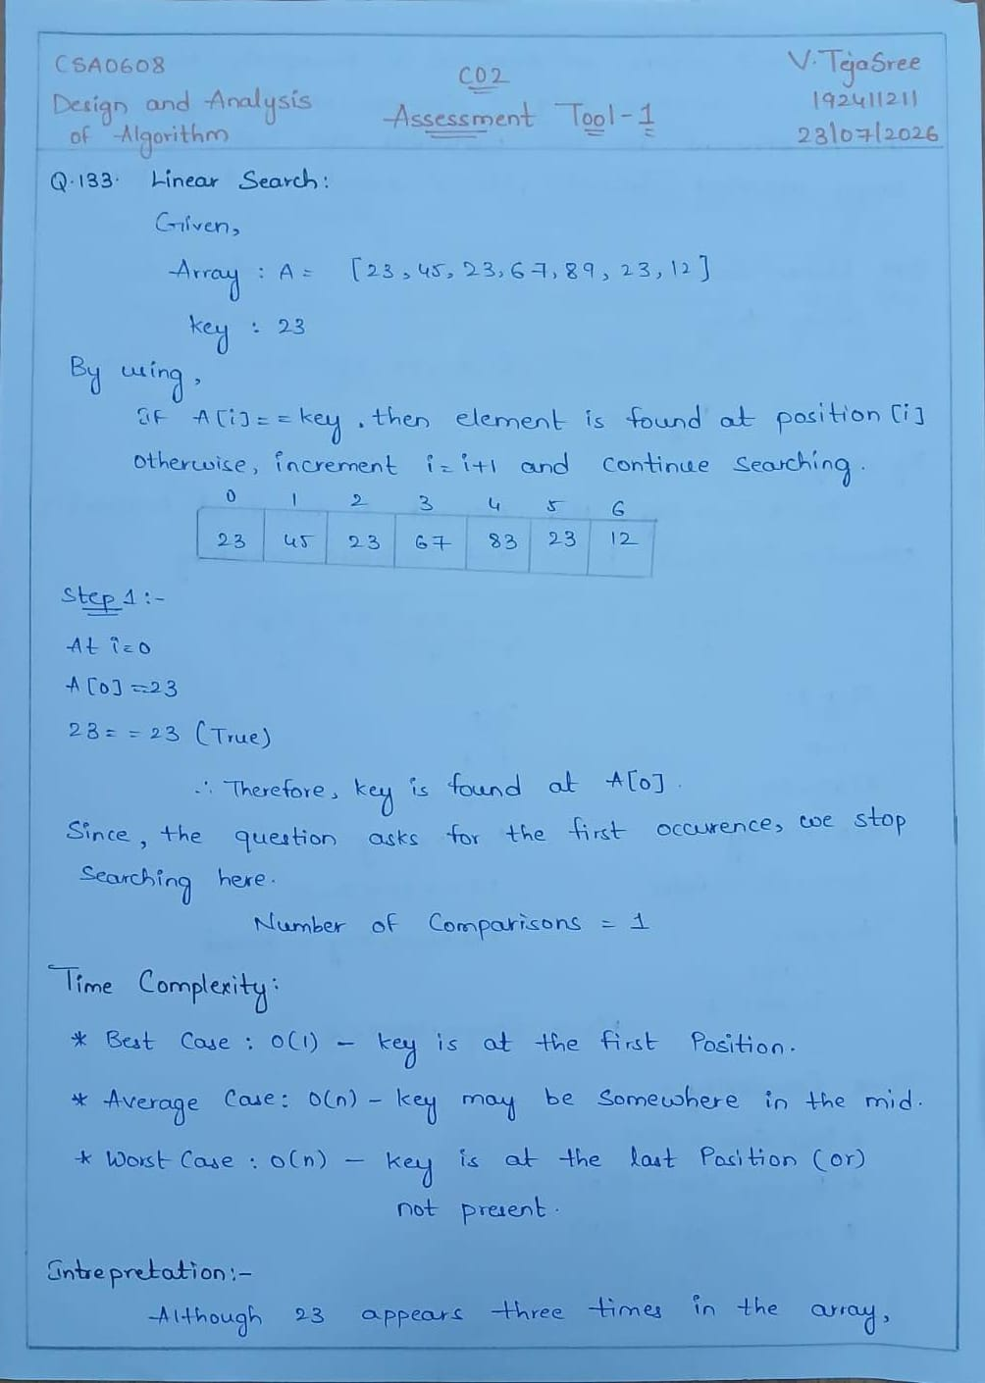
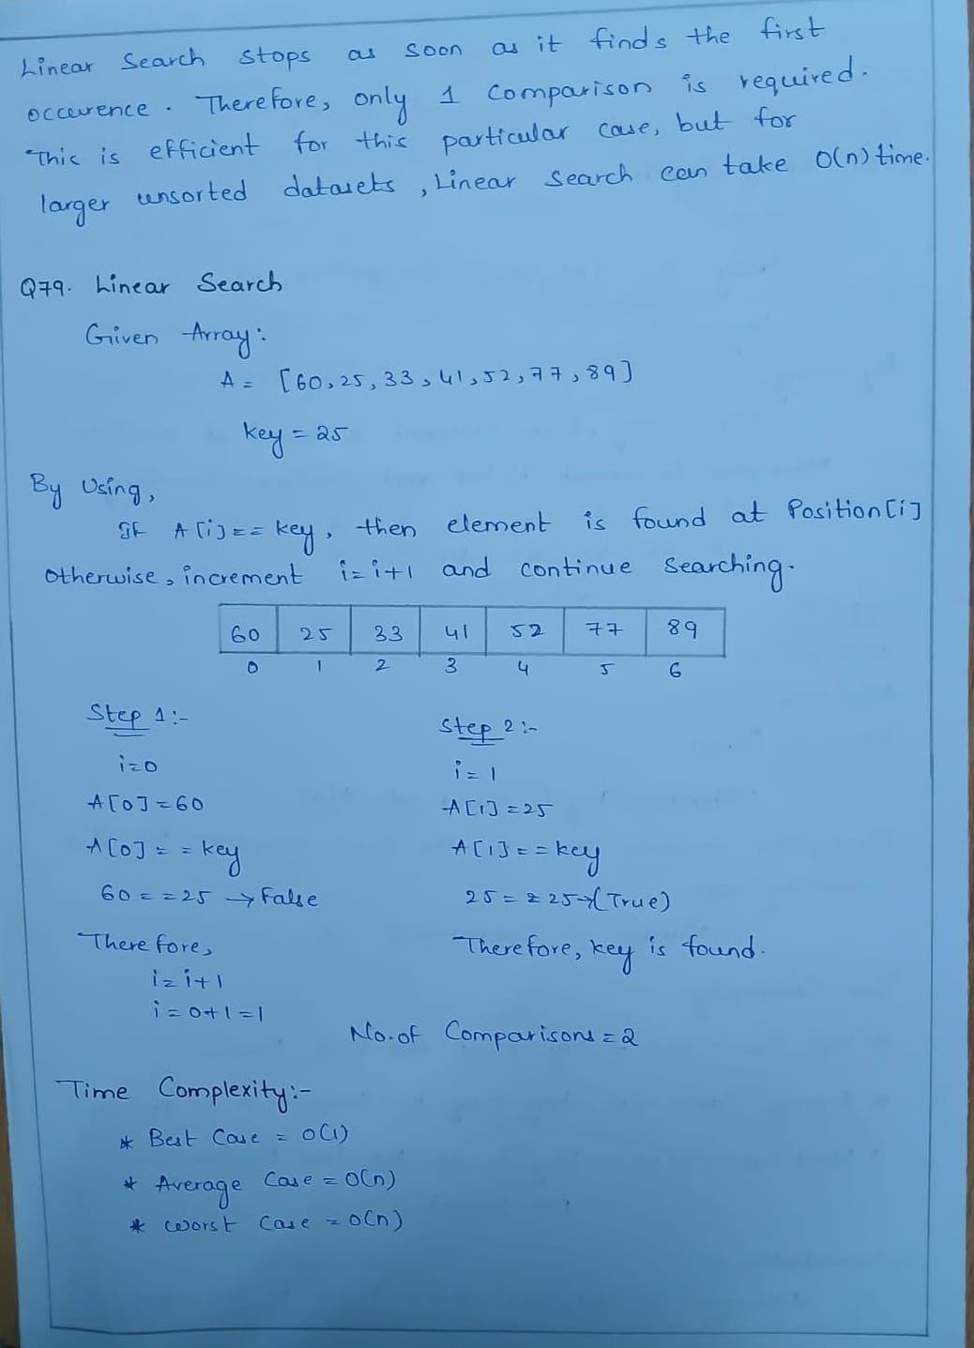
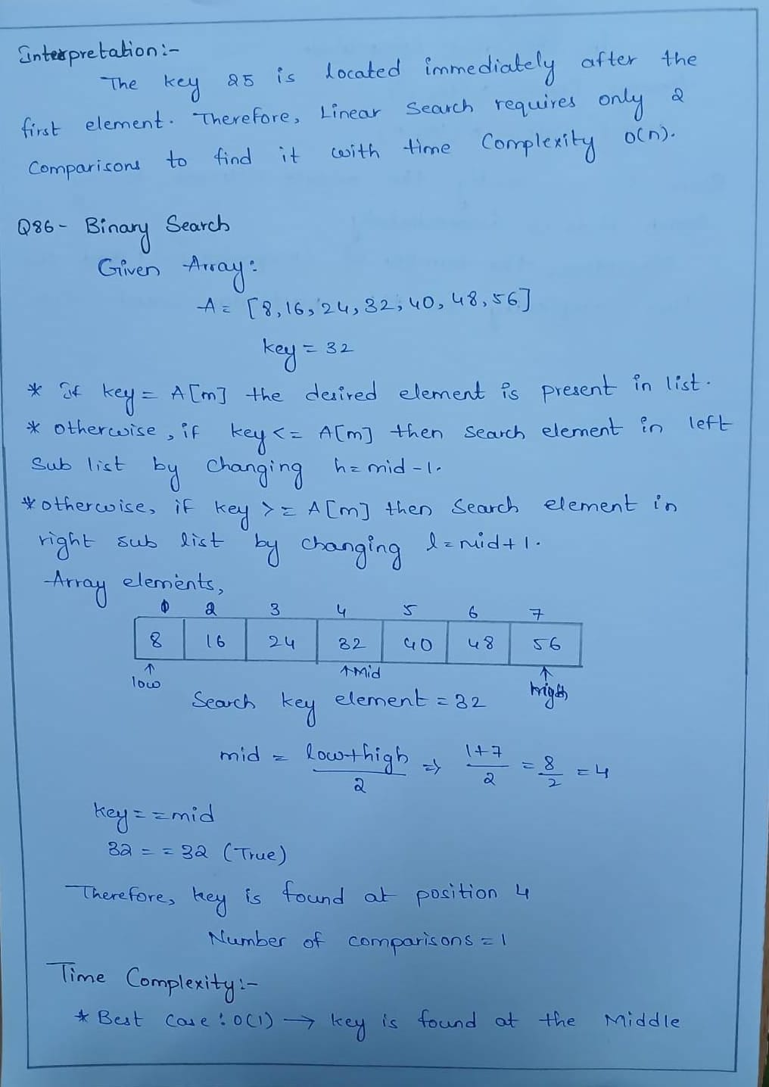
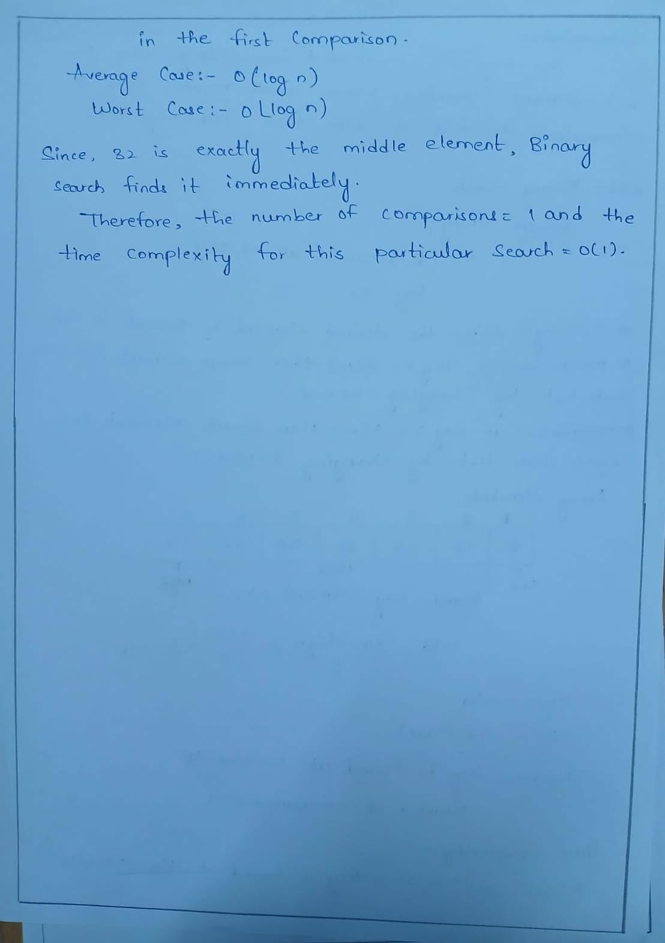
OUTPUTS:
Q133.
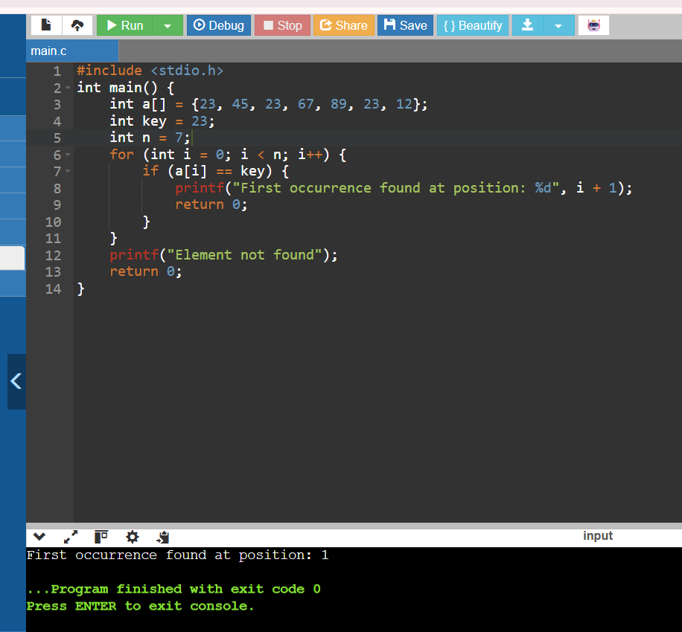

Q79.
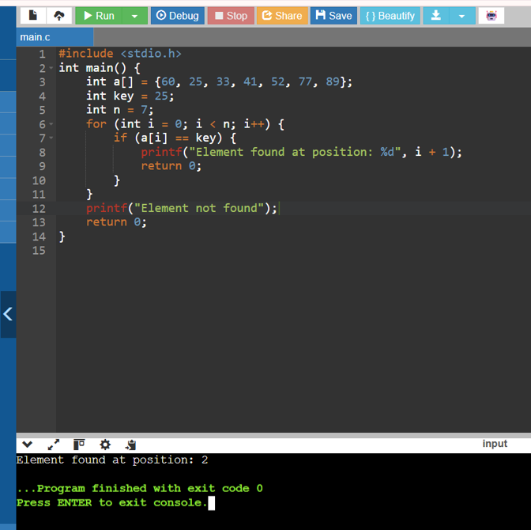

Q86.
