UNIT – II
Teja Sree (192411211)
CSA1006 – SOFTWARE ENGINEERING
Problem 4
API-First Development for a Hotel Booking Platform

Scenario
A software company is developing a Hotel Booking Platform where customers can search hotels, check room availability, book rooms, make online payments, and receive booking confirmations. The project consists of three development teams: Frontend Team, Backend Team, and Mobile Application Team. Since all teams need to work simultaneously, the Project Manager decides to adopt an API-First Development approach using OpenAPI (Swagger).
In API-First Development, APIs are designed and documented before writing the application code. Every development team follows the same API specification, reducing misunderstandings and enabling faster software development.

Task 1: API-First Development Approach
Recommended Approach
API-First Development using OpenAPI (Swagger)
What is API-First Development?
API-First Development is a software development methodology in which APIs are designed, documented, and approved before implementation begins.
Instead of writing backend code first, developers create API specifications using OpenAPI (Swagger). These specifications define request methods, endpoints, parameters, responses, and error codes.
Once the API documentation is finalized, all development teams can start working independently.

Why API-First is Suitable
The Hotel Booking Platform contains multiple modules such as:
- User Registration
- Hotel Search
- Room Availability
- Booking
- Payment
- Notifications
Each module communicates through APIs.
Using API-First ensures that all teams use the same communication standard.
This results in:
- Faster development
- Better collaboration
- Fewer integration issues
- Improved software quality

Task 2: Advantages of API-First Development
1. Parallel Development
After API documentation is completed:
- Backend developers build APIs.
- Frontend developers design web pages.
- Mobile developers create Android and iOS applications.
All teams work simultaneously without waiting for each other.
Example
The backend team develops the Room Availability API, while the frontend team designs the hotel search page using mock API responses.
Benefits
- Faster project completion
- Better productivity
- Reduced waiting time

2. Clear API Documentation
Swagger automatically generates API documentation.
Documentation includes:
- API URLs
- Request methods
- Input parameters
- Response format
- Status codes
- Authentication details
Developers can easily understand how each API works.
Benefits
- Easy learning
- Better maintenance
- Reduced communication errors

3. Easy Testing
APIs can be tested using:
- Swagger UI
- Postman
- REST Client
Developers verify API functionality before integrating with frontend applications.
Benefits
- Early bug detection
- Improved reliability
- Better software quality

4. Reusability
The same API can be used by:
- Website
- Android App
- iOS App
- Third-party applications
Example
The Room Availability API can serve both the website and mobile application.
Benefits
- Less duplicate code
- Easier maintenance
- Lower development cost

Task 3: Swagger API Outline
Room Availability API
Endpoint
GET /api/v1/rooms/availability
Request Parameters
Parameter | Type | Description
checkIn | Date | Customer check-in date
checkOut | Date | Customer check-out date
roomType | String | Standard, Deluxe, Suite
guests | Integer | Number of guests

Sample Request
GET /api/v1/rooms/availability?
checkIn=2026-08-01&
checkOut=2026-08-03&
roomType=Deluxe&
guests=2

Sample Response
{
"hotelName":"ABC Grand Hotel",
"roomType":"Deluxe",
"available":true,
"price":4500,
"currency":"INR"
}

Status Codes
Code | Meaning
200 | Success
400 | Invalid Request
401 | Unauthorized
404 | Room Not Found
500 | Internal Server Error

Task 4: API Versioning Strategy
Why API Versioning?
- As software evolves, APIs require new features.
- Changing the existing API directly may break old applications.
- API Versioning solves this problem.

Version 1
/api/v1/rooms/availability
Supports:
- Room Search
- Price Details

Version 2
/api/v2/rooms/availability
Supports:
- Room Search
- Dynamic Pricing
- Hotel Rating
- Discount Information
- Nearby Attractions
Older applications continue using Version 1 without interruption.

Benefits
- Backward compatibility
- Easy upgrades
- Reduced maintenance issues
- Smooth migration

Task 5: Docker Containerization
What is Docker?
Docker packages an application together with all required libraries and dependencies into a container.
The same container works on:
- Developer computer
- Testing server
- Production server
- Cloud platform

Benefit 1 – Easy Deployment
- Developers build the application once.
- The same Docker image runs everywhere.
Example
The booking API developed on Windows works perfectly on Linux Cloud servers.

Benefit 2 – Better Scalability
- During holidays and weekends booking traffic increases.
- Instead of purchasing new servers, Docker launches multiple containers.
- Traffic is distributed automatically.
Example
Holiday Season
Normal Days
Booking API
Holiday
Booking API
Booking API
Booking API
Booking API
Benefits
- Faster response
- High availability
- Better performance

Proposed System Architecture
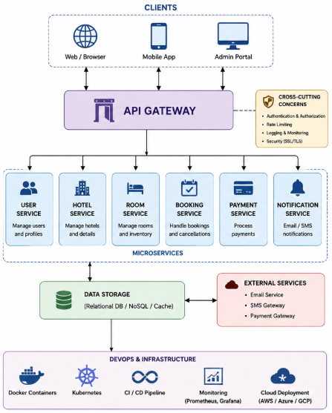
Hotel Booking Workflow

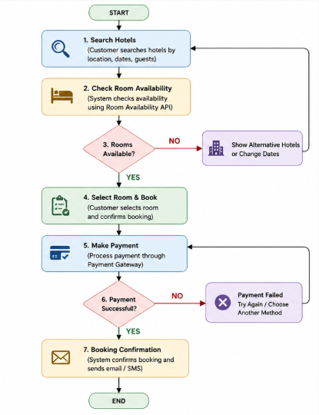
Functional Requirements
- User Registration
- User Login
- Search Hotels
- Check Room Availability
- Book Rooms
- Online Payment
- Booking Cancellation
- Booking History
- Send Confirmation Email
- Generate Reports

Non-Functional Requirements
Requirement | Description
Performance | API response within 2 seconds
Availability | 99.9% uptime
Security | JWT Authentication
Scalability | Support 50,000 users
Reliability | Automatic backup
Maintainability | Modular APIs

Innovative Implementation
To improve user experience, the system includes an AI-Based Hotel Recommendation Engine.
Features
- Recommends hotels based on previous bookings.
- Suggests hotels within the user's budget.
- Displays nearby attractions.
- Provides seasonal discount recommendations.
- Predicts room demand using historical booking data.
This innovative feature helps customers find suitable hotels quickly while increasing hotel bookings.

Advantages of API-First Development
- Faster software development
- Parallel team collaboration
- Clear API documentation
- Improved communication
- Easier API testing
- Better scalability
- API reusability
- Supports cloud deployment
- Simplifies maintenance
- Better software quality

Conclusion
For a modern Hotel Booking Platform, API-First Development using OpenAPI (Swagger) is the most suitable approach because it allows frontend, backend, and mobile teams to work simultaneously using a shared API specification. Swagger documentation ensures consistent communication, while API versioning supports future enhancements without affecting existing users. Docker containerization provides scalability, portability, and reliable deployment across different environments. The addition of an AI-based hotel recommendation system further enhances the platform by delivering personalized suggestions and improving the overall customer experience. This architecture results in a scalable, maintainable, and high-quality hotel booking system suitable for real-world application.

IMPLIMENTATION
