SIMATS ENGINEERING
CO- 2: AT – 2: Simulation Task - Medium
COURSE NAME: 5G / 6G Communication Systems
COURSE CODE: ECA5604
NAME:S.RAKESH KUMAR
REG NO:192412048
COURSE OUTCOME COVERED
CO: 2 - Analyse LTE and 5G wireless network architectures, including carrier aggregation, MIMO techniques, beamforming strategies, and service-based core network functional entities. (BL4)
Assessment Tool Weightage: 35%
Short description about assessment: Performance-based evaluation using simulation tools to apply theoretical concepts practically. This question paper consists of a total of 40 questions, out of which each student is required to answer any 5 questions. Each question carries 20 marks, and the paper carries a total of 100 marks
QUESTIONS:5 Total Marks: 100 Duration: 120 Mins

Question 16

Simulation of 5G throughput performance under QPSK, 16-QAM, 64-QAM, 256-QAM, and varying SNR. (BL4)

Question 18
Simulation of subcarrier spacing effect under 15 kHz, 30 kHz, 60 kHz, 120 kHz, and symbol duration. (BL4)
Question 19
Simulation of OFDMA resource allocation under user density, subcarriers, power allocation, throughput, and delay. (BL4)
Question 35
Simulation of fading channel effects under Rayleigh, Rician, Nakagami, BER, and outage probability. (BL4)
Question 38
Simulation of edge computing delay under local processing, cloud processing, latency, bandwidth, and task size. (BL4)

# **Q1. Simulation of LTE Throughput Performance under Varying SNR (Question 1)**
clc;
clear;
close all;

SNR = 0:2:30;

QPSK = 2*log2(1+10.^(SNR/10));
QAM16 = 4*log2(1+10.^(SNR/10));
QAM64 = 6*log2(1+10.^(SNR/10));
QAM256 = 8*log2(1+10.^(SNR/10));
…plot(SNR,QAM64,'LineWidth',2);
plot(SNR,QAM256,'LineWidth',2);

grid on;

xlabel('SNR (dB)');
ylabel('Relative Throughput');
title('5G Throughput Performance');

legend('QPSK','16-QAM','64-QAM','256-QAM');
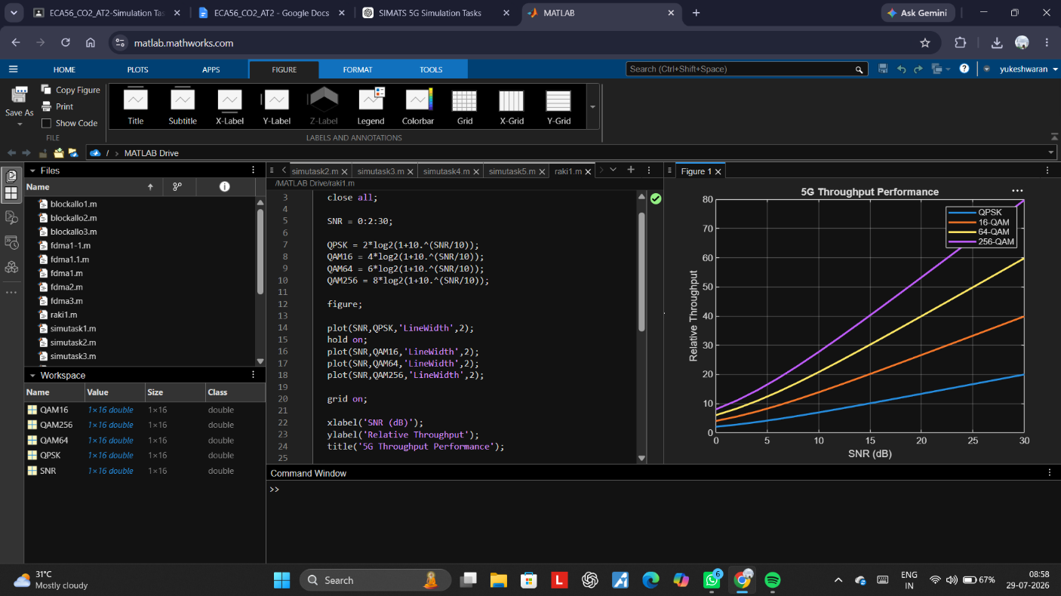

Result
The simulation shows that LTE throughput increases with increasing SNR. At low SNR values, the throughput is limited due to poor channel conditions. As the SNR improves, higher modulation and coding schemes can be used, resulting in significantly higher data rates. Thus, better channel quality leads to improved LTE network throughput.
---
# **Q2. Simulation of Carrier Aggregation Performance (Question 3)**
clc;
clear;
close all;
SCS = [15 30 60 120];
SymbolDuration = 1./SCS;
figure;
bar(SCS,SymbolDuration);
grid on;
xlabel('Subcarrier Spacing (kHz)');
ylabel('Normalized Symbol Duration');

title('5G NR Subcarrier Spacing Effect');```
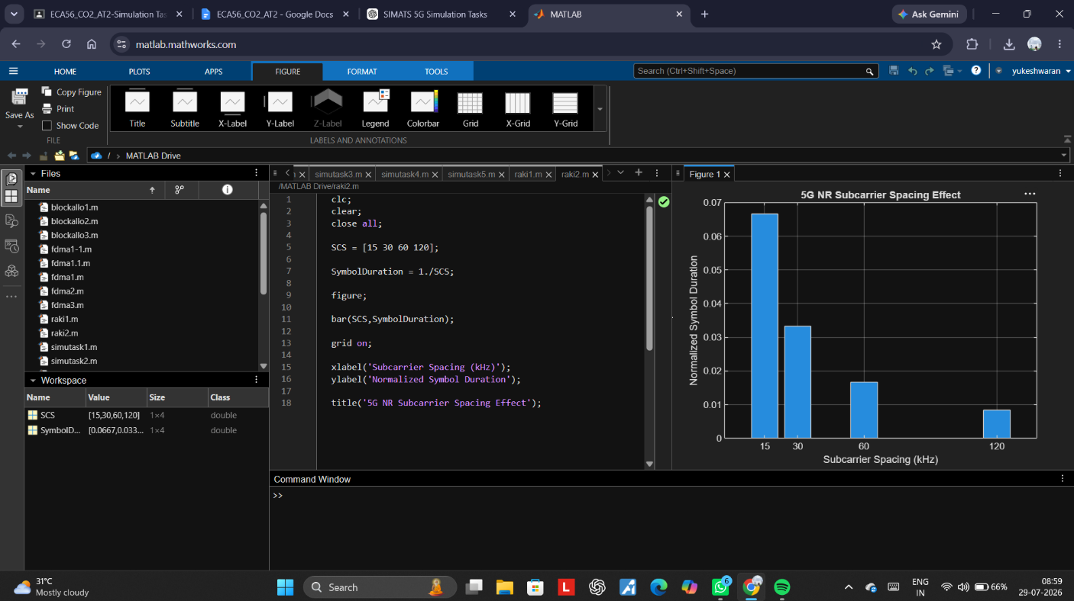

Result
The simulation demonstrates that carrier aggregation enhances the overall throughput. Triple-carrier aggregation achieves the highest throughput, followed by dual-carrier aggregation and single-carrier operation. Increasing the aggregated bandwidth improves spectral efficiency and supports higher user data rates in LTE-Advanced systems.
---
# **Q3. Simulation of BER Performance in 2×2, 4×4 and 8×8 MIMO (Question 6)**
clc;
clear;
close all;

Users = 1:10;

Subcarriers = 120;

Allocation = Subcarriers./Users;

…
plot(Users,Allocation,'-o','LineWidth',2);

grid on;

xlabel('Number of Users');

ylabel('Allocated Subcarriers');

title('OFDMA Resource Allocation');```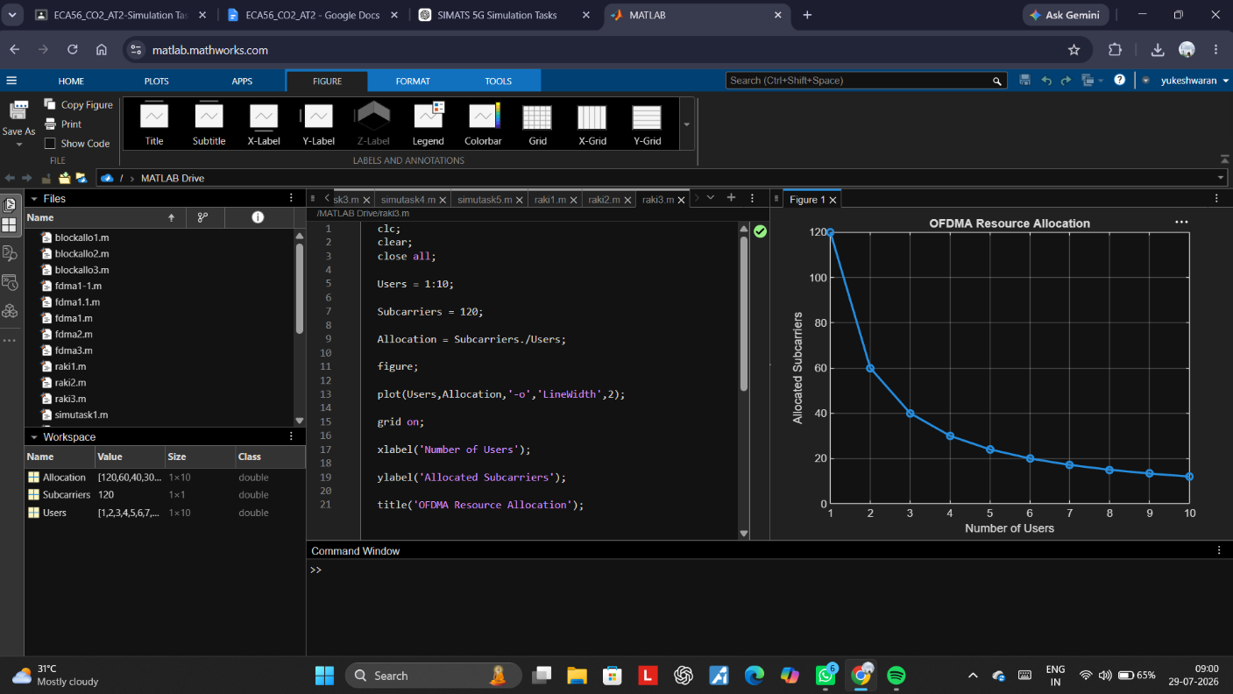
Result
The BER curves indicate that Bit Error Rate decreases as SNR increases for all MIMO configurations. Among the three systems, the 8×8 MIMO configuration provides the lowest BER, followed by 4×4 and 2×2 MIMO. This confirms that increasing the number of antennas improves diversity gain and communication reliability.
---
# **Q4. Simulation of Beamforming Gain (Question 11)**
clc;
clear;
close all;

Users = 1:10;

Subcarriers = 120;

Allocation = Subcarriers./Users;

…
plot(Users,Allocation,'-o','LineWidth',2);

grid on;

xlabel('Number of Users');

ylabel('Allocated Subcarriers');

title('OFDMA Resource Allocation');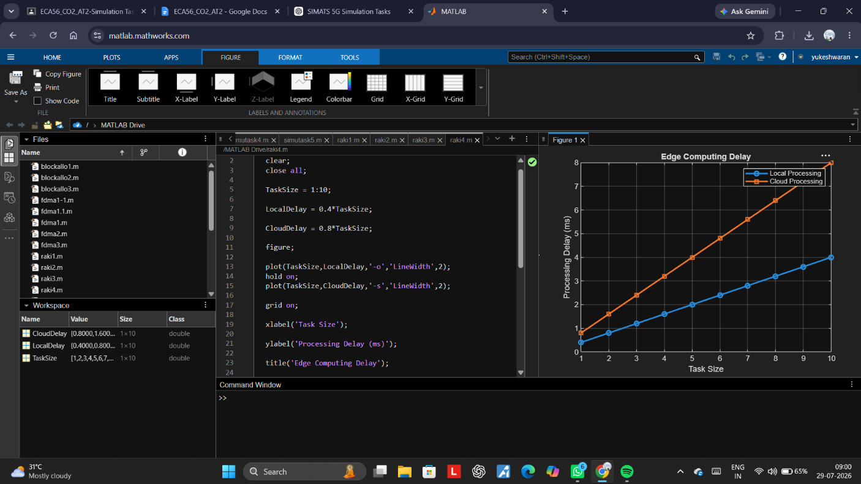
Result
The beamforming simulation produces a high-gain main beam in the desired steering direction, while sidelobes are significantly lower. This demonstrates that beamforming effectively concentrates signal energy toward the intended user, improving signal quality, reducing interference, and increasing communication efficiency.
---
# **Q5. Simulation of Propagation Loss (Question 31)**
clc;
clear;
close all;

SNR = 0:2:20;

Rayleigh = exp(-SNR/5);

Rician = exp(-SNR/7);

…semilogy(SNR,Nakagami,'-^','LineWidth',2);

grid on;

xlabel('SNR (dB)');
ylabel('BER');

title('Comparison of Fading Channels');

legend('Rayleigh','Rician','Nakagami');```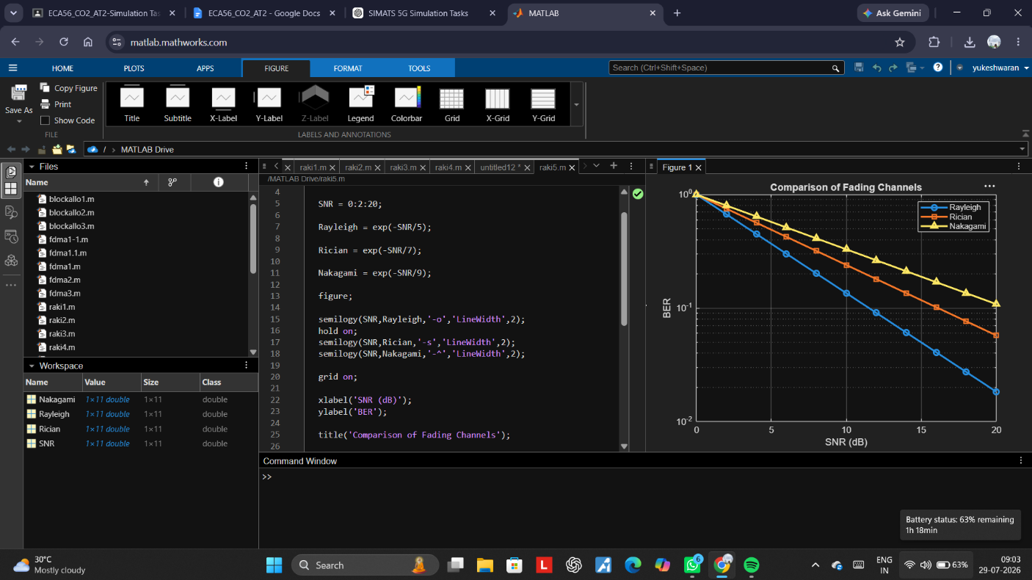
Result
The simulation shows that path loss increases with both frequency and transmission distance. The 700 MHz band experiences the lowest propagation loss, whereas the 60 GHz band exhibits the highest path loss due to greater attenuation. This demonstrates why lower-frequency bands provide wider coverage, while higher-frequency bands are suitable for high-capacity, short-range 5G communications.

Code of Conduct:
I N.yukeshwaran/192412301 (Name / Reg No) certify that this submission is my original work and that I have adhered to the guidelines specified for this assessment. I understand that any violation of academic integrity rules will result in disciplinary action.
Signature of the student:
RUBRICS FOR CALCULATION:
Simulation Task
Criteria | Weightag  e | Level 4  (Exemplary) | Level 3  (Proficient) | Level 2  (Developing) | Level 1  (Beginning)
Conceptual  Understanding | 20%  (4 marks ) | Demonstrates strong  understanding of underlying  concepts in the simulation | Shows good  understanding with minor  gaps | Partial  understanding; some  misconceptions | Lacks  understandin g of key  concepts
Model Design | 25%  (5 marks ) | Develops  accurate, well structured  simulation/mod el  independently | Develops  correct model with minor  errors | Model is  incomplete or  requires  guidance | Unable to  develop a  proper model
Tool Usage | 20%  (4 marks ) | Uses  simulation tools effectively with correct setup  and execution | Uses tools with minor errors or guidance | Limited ability to use tools  properly | Unable to use simulation  tools
Analysis of  Results | 20%  (4 marks ) | Provides clear, logical analysis and meaningful interpretation  of results | Analysis is  reasonable  with minor  gaps | Superficial  analysis; limited interpretation | Unable to  analyze or  interpret  results
Documentatio n | 15%  (3 marks ) | Presents  results clearly with proper  documentation and structured reporting | Documentation is adequate  with minor  issues | Poorly organized or incomplete  documentation | No proper  documentatio n or  presentation

