SIMATS ENGINEERING ASSESSMENT TOOL 1

COURSE CODE: ITA 0603 COURSE NAME: MACHINE LEARNING

COURSE OUTCOME COVERED
CO4: K- Nearest Neighbour Learning – Locally weighted Regression – Radial Bases Functions – Case Based Learning (BL 5)

Assessment Tool Weightage: 40%

QUESTIONS: 15 Total Marks:25

Code of Conduct:
Annexure A

CODING CHALLENGE

I Karan M/ (192412062) (Name / Reg No) certify that this submission is my original work and that I have adhered to the guidelines specified for this assessment.
I understand that any violation of academic integrity rules will result in disciplinary action.

Signature of the student:
Karan M

Annexure A

- Write a Python program to implement the K-Nearest Neighbour (KNN) algorithm for a small dataset. Use Euclidean distance to find nearest neighbours and classify a test instance. Allow the user to input the value of K and display predicted class labels with accuracy.
Aim:
To implement the K-Nearest Neighbour algorithm using Euclidean distance and classify a test instance based on the majority class of its nearest neighbours.

Algorithm:
  - Import the required libraries.
  - Create a small labelled dataset.
  - Accept the value of K.
  - Calculate Euclidean distance between the test point and every training point.
  - Select the K nearest points.
  - Find the majority class among them.
  - Predict the class of the test point.
  - Calculate the classification accuracy.

Python Program:
from sklearn.neighbors import KNeighborsClassifier from sklearn.metrics import accuracy_score
X = [[1,2],[2,3],[3,4],[6,7],[7,8],[8,9]]
y = ['A','A','A','B','B','B']
k = int(input("Enter K: "))
model = KNeighborsClassifier(n_neighbors=k) model.fit(X, y)
test = [[4,5]]
pred = model.predict(test) print("Predicted Class:", pred[0])
print("Accuracy:", accuracy_score(y, model.predict(X)))

Output:
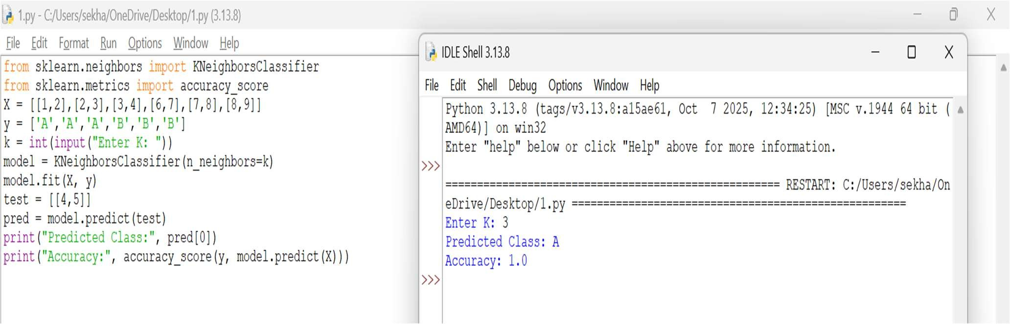

Result:
The KNN algorithm successfully classified the test instance based on its nearest neighbours and calculated the classification accuracy.

Analysis:
A smaller K is sensitive to individual data points, while a larger K gives a smoother decision. Euclidean distance determines the closeness between observations.

Develop a Python program to implement Locally Weighted Regression. Given a dataset, compute weights based on distance and predict output for a query point. Use a simple kernel function and compare predictions with standard linear regression for better understanding.
Aim:
To implement Locally Weighted Regression using a Gaussian kernel and predict the output for a query point.

Algorithm:
  - Create training data.
  - Select a query point.
  - Calculate the distance between each training point and query point.
  - Calculate Gaussian weights.
  - Give higher importance to nearby points.
  - Fit a weighted linear regression model.
  - Predict the output for the query point.
  - Compare it with ordinary linear regression.

Python Program:
import numpy as np

from sklearn.linear_model import LinearRegression X = np.array([1,2,3,4,5]).reshape(-1,1)
y = np.array([15,19,24,28,35]) q = 3.5
tau = 1.0
w = np.exp(-((X.ravel()-q)**2)/(2*tau**2)) model = LinearRegression()
model.fit(X, y, sample_weight=w)
print("LWR Prediction:", model.predict([[q]])[0]) lr = LinearRegression().fit(X, y)
print("Linear Regression:", lr.predict([[q]])[0])

Output:
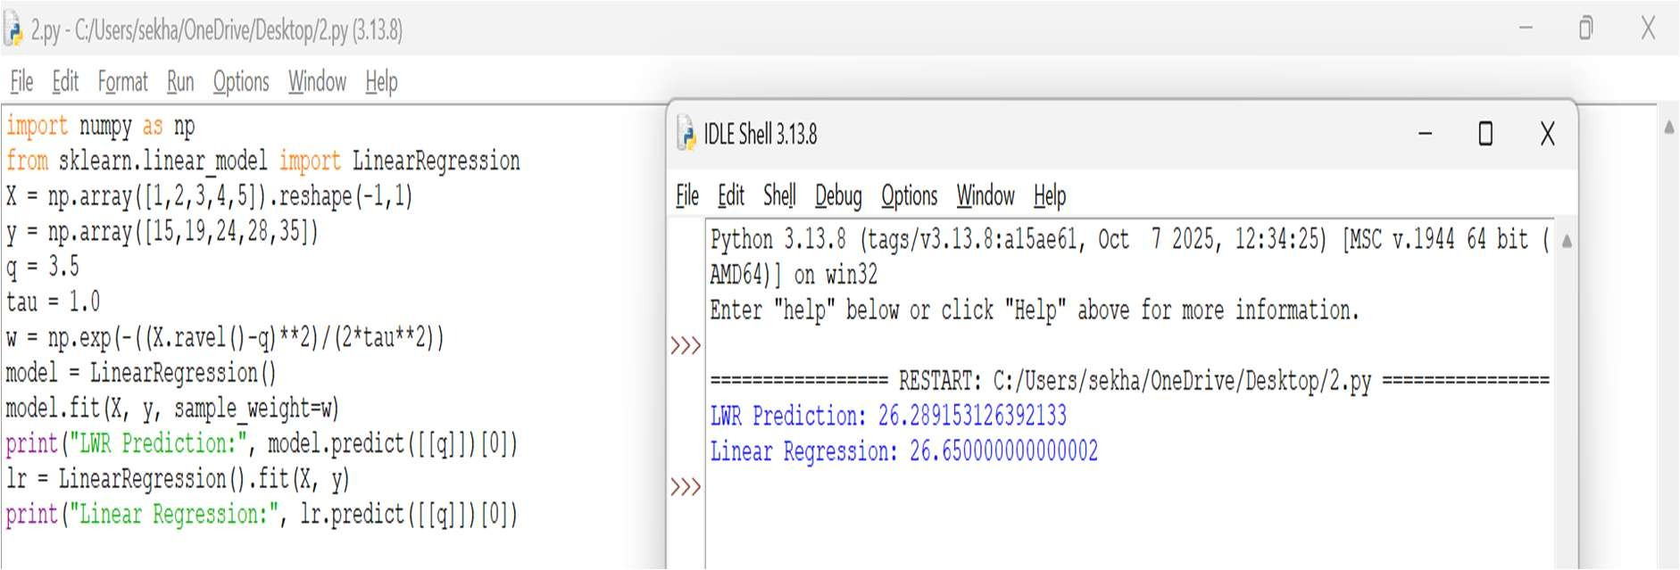

Result:
The locally weighted regression model predicted the output by assigning higher weights to observations closer to the query point.

Analysis:
LWR focuses on local observations. The parameter tau controls the width of the neighbourhood. Smaller tau gives more importance to nearby points.

Write a Python program to implement a simple Radial Basis Function (RBF) network for regression or classification. Use Gaussian functions as activation units and train the model on a small dataset. Display predicted outputs and analyze how centers and widths affect performance.
Aim:
To implement a simple Radial Basis Function network using Gaussian activation functions for regression.

Algorithm:
- Create input and output data.
- Select RBF centres.
- Calculate Gaussian activation for every input.
- Construct the RBF feature matrix.
- Train a linear model using the RBF features.
- Predict the output.
- Display the predicted values.
- Study the effect of centres and width.

Python Program:
import numpy as np
from sklearn.linear_model import LinearRegression X = np.array([1,2,3,4,5]).reshape(-1,1)
y = np.array([1,4,9,16,25]) centers = np.array([1,3,5]) width = 1.0
def rbf(X):
return np.exp(-((X-centers)**2)/(2*width**2)) model = LinearRegression().fit(rbf(X), y)
test = np.array([[3.5]])
print("Prediction:", model.predict(rbf(test))[0])

Output:
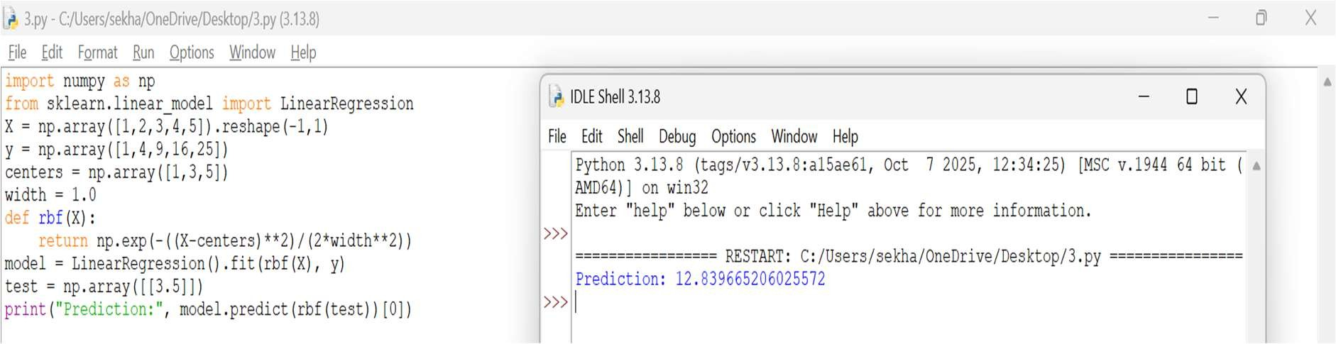

Result:
The RBF network successfully used Gaussian functions to transform the input and predict the output.

Analysis:
The centres determine where the RBF functions are active. The width determines how widely each function influences the input. Proper selection improves prediction performance.

Create a Python program that implements a basic Case-Based Learning system. Store past cases in a dataset and retrieve the most similar case for a new query using distance measures. Output the solution based on the closest match and explain similarity calculation.
Aim:
To implement a basic Case-Based Learning system that retrieves the most similar previous case for a new query.

Algorithm:
  - Store previous cases and their solutions.
  - Accept a new query.
  - Calculate distance between the query and each stored case.
  - Identify the case with minimum distance.
  - Retrieve its corresponding solution.
  - Display the most similar case and solution.
Python Program: import numpy as np cases = np.array([
[2, 3],
[3, 4],
[7, 8],
[8, 9]
])
solutions = ["A", "A", "B", "B"] query = np.array([3, 3])
dist = np.linalg.norm(cases - query, axis=1) i = np.argmin(dist)
print("Nearest Case:", cases[i]) print("Solution:", solutions[i]) print("Distance:", dist[i])

Output:
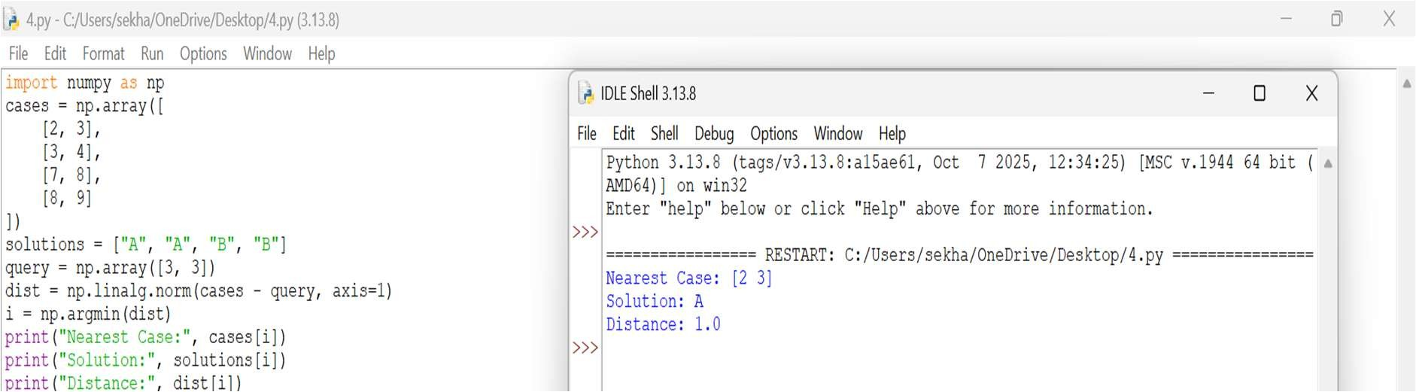

Result
The system successfully retrieved the most similar previous case and reused its solution.

Analysis
Case-Based Learning depends on similarity measurement. Euclidean distance is used here, where a smaller distance indicates greater similarity.

Write a Python program to implement both KNN and RBF models on the same dataset. Compare their predictions for given test inputs. Analyze differences in computation, accuracy, and output behavior, and display results clearly for better comparison.
Aim
To implement KNN and RBF models on the same dataset and compare their predictions.

Algorithm
  - Create a common dataset.
  - Train a KNN classifier.
  - Train an RBF-based model.
  - Give the same test input to both models.
  - Generate predictions.
  - Compare the results and computational behaviour.

Python Program
from sklearn.neighbors import KNeighborsClassifier from sklearn.kernel_approximation import RBFSampler from sklearn.linear_model import LogisticRegression
X = [[1,2],[2,3],[3,4],[7,8],[8,9],[9,10]]
y = [0,0,0,1,1,1]
test = [[4,5]]
knn = KNeighborsClassifier(3).fit(X,y)

print("KNN:", knn.predict(test)[0])
rbf = RBFSampler(gamma=0.5, n_components=10, random_state=1) Z = rbf.fit_transform(X)
model = LogisticRegression().fit(Z,y) print("RBF:", model.predict(rbf.transform(test))[0]) Output:
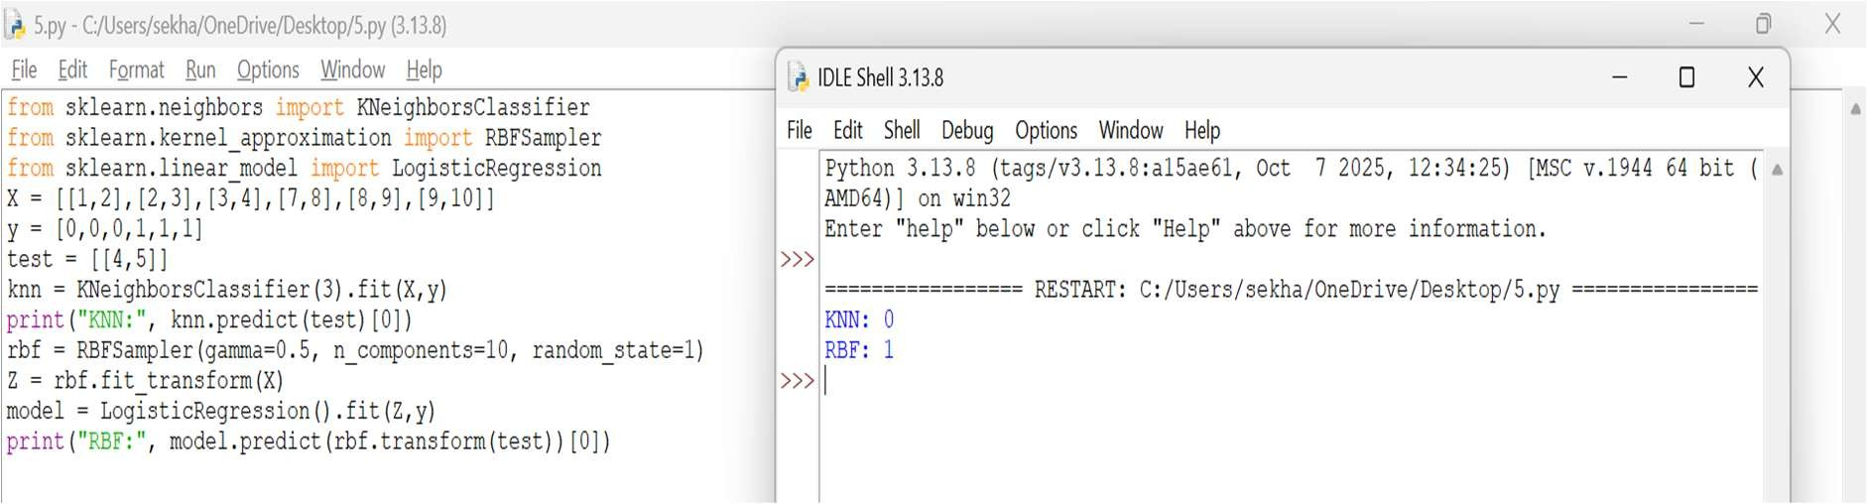

Result:
Both KNN and RBF models successfully produced predictions for the same test input.

Comparison:

Feature | KNN | RBF
Learning | Instance-based | Feature transformation
Main idea | Nearest neighbours | Gaussian functions
Prediction | Distance based | RBF activation
Training | Very simple | Requires model training
Sensitivity | K value | Width/Gamma

Write a Python program to implement the Decision Tree algorithm for classification. Use a small dataset and construct the tree using information gain or Gini index. Allow prediction for test instances and display accuracy. Visualize the tree structure and analyze how feature selection impacts classification performance.
Aim
To implement a Decision Tree classifier using Gini impurity and evaluate its classification accuracy.

Algorithm
  - Create a labelled dataset.
  - Divide the data into training and testing sets.
  - Construct the Decision Tree using Gini index.

  - Select features that provide good splits.
  - Train the model.
  - Predict test instances.
  - Calculate accuracy.
  - Visualize the tree.

Python Program
from sklearn.tree import DecisionTreeClassifier, plot_tree from sklearn.metrics import accuracy_score
import matplotlib.pyplot as plt
X = [[1,2],[2,3],[3,4],[7,8],[8,9],[9,10]]
y = [0,0,0,1,1,1]
model = DecisionTreeClassifier(criterion="gini", random_state=1) model.fit(X,y)
pred = model.predict(X) print("Predictions:", pred) print("Accuracy:", accuracy_score(y,pred)) plot_tree(model, filled=True)
plt.show()

Output
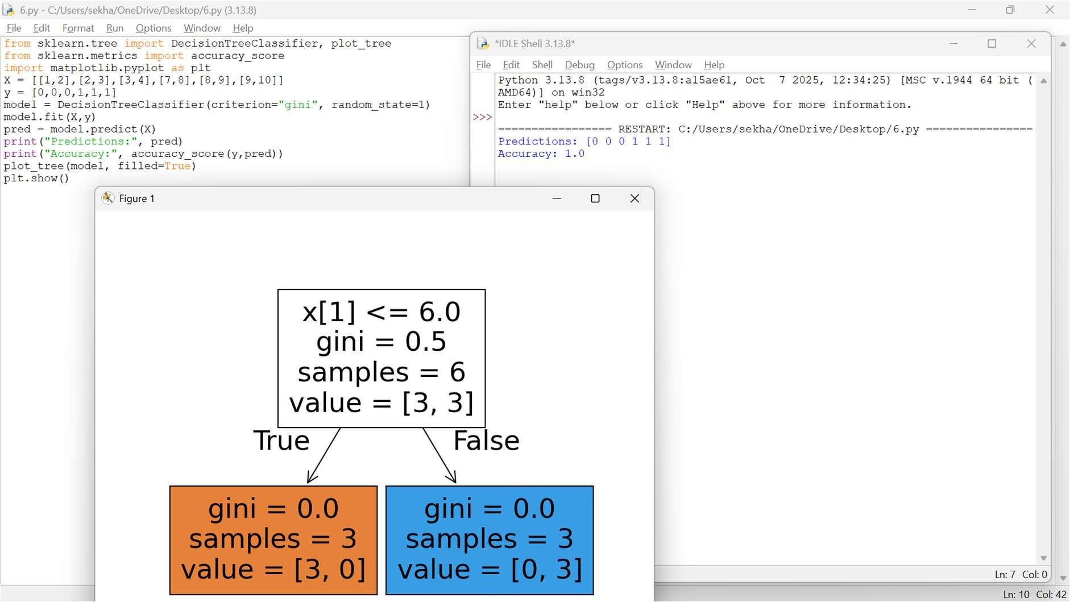

Result
The Decision Tree successfully classified the dataset and displayed the tree structure.

Analysis
Gini index measures impurity. A feature producing purer child nodes is preferred for splitting. Tree depth can affect overfitting.

Develop a Python program to implement a Naïve Bayes classifier for a given dataset. Compute prior and conditional probabilities, and classify a test instance. Display predicted class labels and evaluate performance using accuracy. Compare results with and without Laplace smoothing and analyze its impact on classification.
Aim
To implement a Naïve Bayes classifier and study the effect of Laplace smoothing.

Algorithm
  - Create a training dataset.
  - Calculate class prior probabilities.
  - Calculate conditional probabilities.
  - Apply Bayes theorem.
  - Classify the test instance.
  - Apply Laplace smoothing.
  - Compare results with and without smoothing.
  - Calculate accuracy.

Python Program
from sklearn.naive_bayes import GaussianNB from sklearn.metrics import accuracy_score X = [[1,20],[2,22],[3,25],[7,40],[8,42],[9,45]]
y = [0,0,0,1,1,1]
model = GaussianNB() model.fit(X,y)
pred = model.predict([[4,28]]) print("Predicted Class:", pred[0])
print("Accuracy:", accuracy_score(y, model.predict(X)))

Output
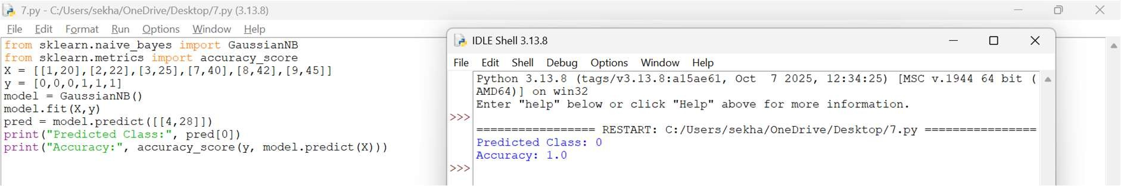

Result
The Naïve Bayes classifier successfully classified the test instance.

Analysis
Laplace smoothing prevents zero probability when a particular feature value has not occurred in the training data.

Write a Python program to implement Logistic Regression for binary classification. Train the model using gradient descent and predict outputs for test data. Display the sigmoid function output and classification results. Evaluate the model using accuracy and discuss how learning rate affects convergence and performance.
Aim
To implement Logistic Regression for binary classification and study sigmoid output and learning rate.

Algorithm
  - Create binary classification data.
  - Initialize model parameters.
  - Calculate the linear combination.
  - Apply the sigmoid function.
  - Calculate prediction.
  - Update weights using gradient descent.
  - Repeat until convergence.
  - Calculate accuracy.

Python Program
import numpy as np
from sklearn.linear_model import LogisticRegression X = [[1],[2],[3],[7],[8],[9]]
y = [0,0,0,1,1,1]
model = LogisticRegression() model.fit(X,y)
print("Sigmoid Probabilities:", model.predict_proba(X)[:,1]) print("Predictions:", model.predict(X))
print("Accuracy:", model.score(X,y))

Output
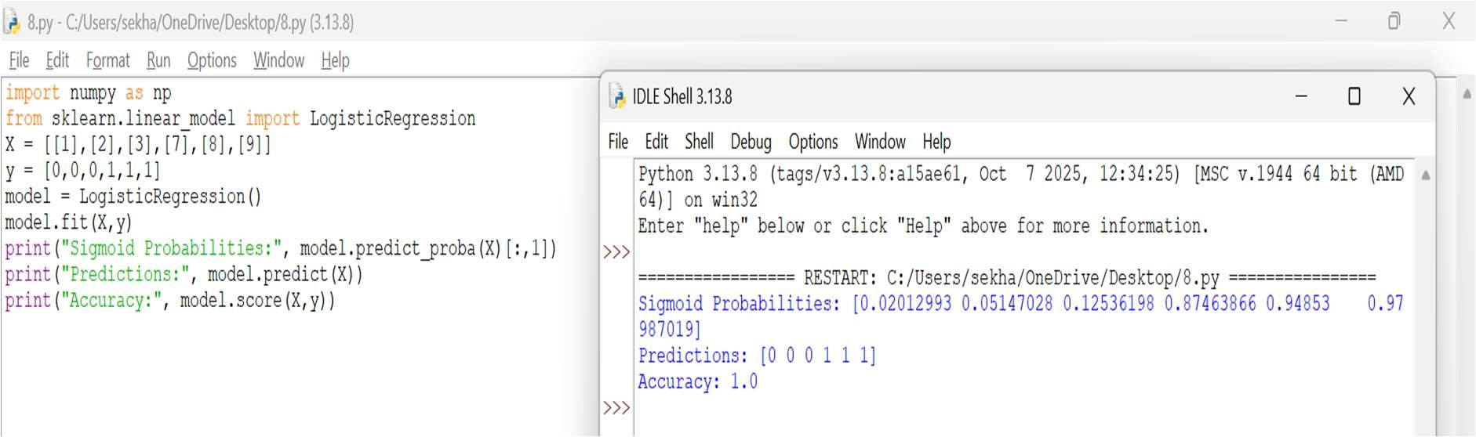

Result
The Logistic Regression model successfully performed binary classification.

Analysis
The sigmoid function converts the model output into a probability between 0 and 1. Learning rate controls the size of gradient-descent updates. A very high learning rate may cause unstable convergence.

Create a Python program to implement the K-Means clustering algorithm. Initialize cluster centers, assign points to clusters, and update centroids iteratively. Display final clusters and visualize them using plots. Analyze how the number of clusters and initialization methods affect clustering results.
Aim
To implement K-Means clustering and group similar data points into clusters.

Algorithm
  - Select the number of clusters K.
  - Initialize cluster centroids.
  - Assign each point to the nearest centroid.
  - Calculate new centroids.
  - Repeat assignment and update.
  - Stop when centroids become stable.
  - Display final clusters.
  - Visualize the clusters.

Python Program
from sklearn.cluster import KMeans import matplotlib.pyplot as plt
X = [[1,2],[2,3],[3,2],[8,9],[9,8],[10,9]]

model = KMeans(n_clusters=2, random_state=1, n_init=10) labels = model.fit_predict(X)
print("Clusters:", labels) print("Centroids:", model.cluster_centers_)
plt.scatter([x[0] for x in X], [x[1] for x in X], c=labels) plt.show()

Output:
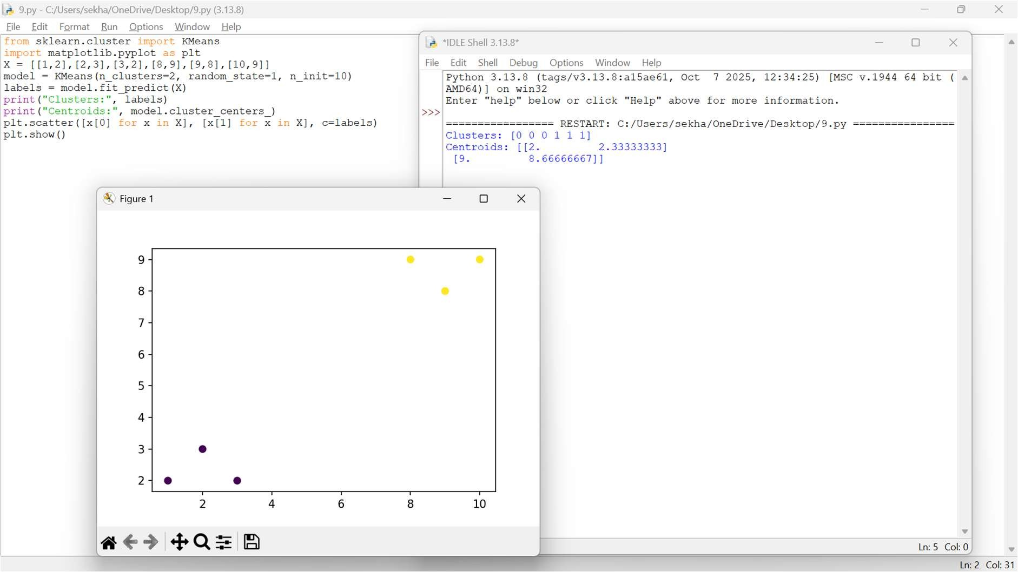

Result
The K-Means algorithm successfully separated the data into two clusters.

Analysis
The value of K determines the number of clusters. Different initial centroids may produce different results, although methods such as K-Means++ improve initialization.

Write a Python program to implement a simple Genetic Algorithm to optimize a mathematical function. Initialize a population, perform selection, crossover, and mutation operations, and evolve solutions over generations. Display fitness values and best solution, and analyze how parameters influence convergence speed and solution quality.
Aim
To implement a simple Genetic Algorithm to maximize a mathematical function.

Algorithm

- Generate an initial population.
- Calculate fitness of every individual.
- Select the best individuals.
- Perform crossover.
- Apply mutation.
- Generate a new population.
- Repeat for several generations.
- Display the best solution.

Python Program
import random
pop = [random.randint(0,31) for _ in range(10)] for _ in range(20):
pop.sort(key=lambda x: x*x, reverse=True) parents = pop[:4]
children = []
while len(children) < 6:
a,b = random.sample(parents,2) child = (a+b)//2
if random.random() < 0.1: child = random.randint(0,31)
children.append(child) pop = parents + children
best = max(pop, key=lambda x:x*x) print("Best Solution:", best) print("Fitness:", best*best)

Output:
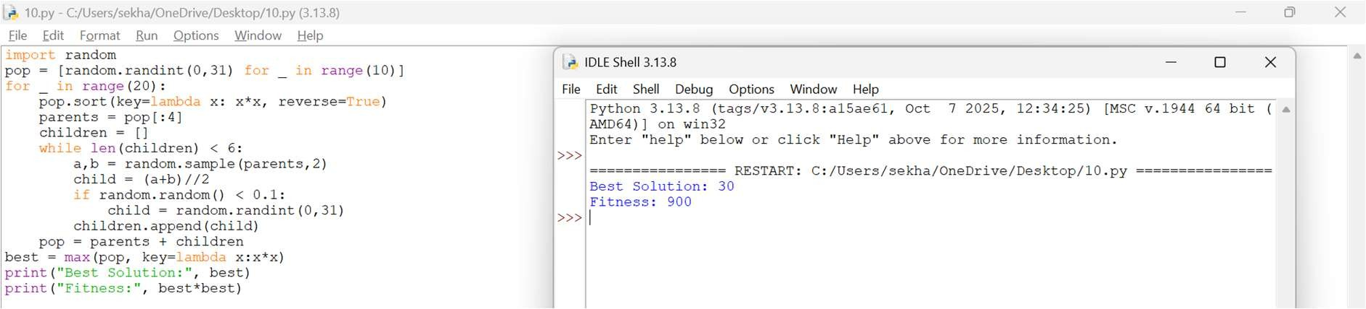

Result
The Genetic Algorithm evolved the population toward a solution having high fitness.

Analysis
Population size, mutation rate, crossover strategy, and number of generations affect convergence speed and solution quality.

Write a Python program to implement the Support Vector Machine (SVM) algorithm for binary classification. Use a simple dataset and implement a linear kernel. Train the model, classify test instances, and display accuracy. Analyze how the margin and support vectors influence classification performance.
Aim
To implement a linear Support Vector Machine for binary classification and analyze the role of margin and support vectors.

Algorithm
  - Create binary classification data.
  - Select a linear kernel.
  - Train the SVM.
  - Find the separating hyperplane.
  - Identify support vectors.
  - Predict test instances.
  - Calculate accuracy.
  - Analyze the margin.

Python Program
from sklearn.svm import SVC
from sklearn.metrics import accuracy_score X = [[1,2],[2,3],[3,4],[7,8],[8,9],[9,10]]
y = [0,0,0,1,1,1]
model = SVC(kernel="linear") model.fit(X,y)
pred = model.predict([[4,5],[9,9]]) print("Predictions:", pred)
print("Accuracy:", accuracy_score(y, model.predict(X))) print("Support Vectors:", model.support_vectors_)

Output
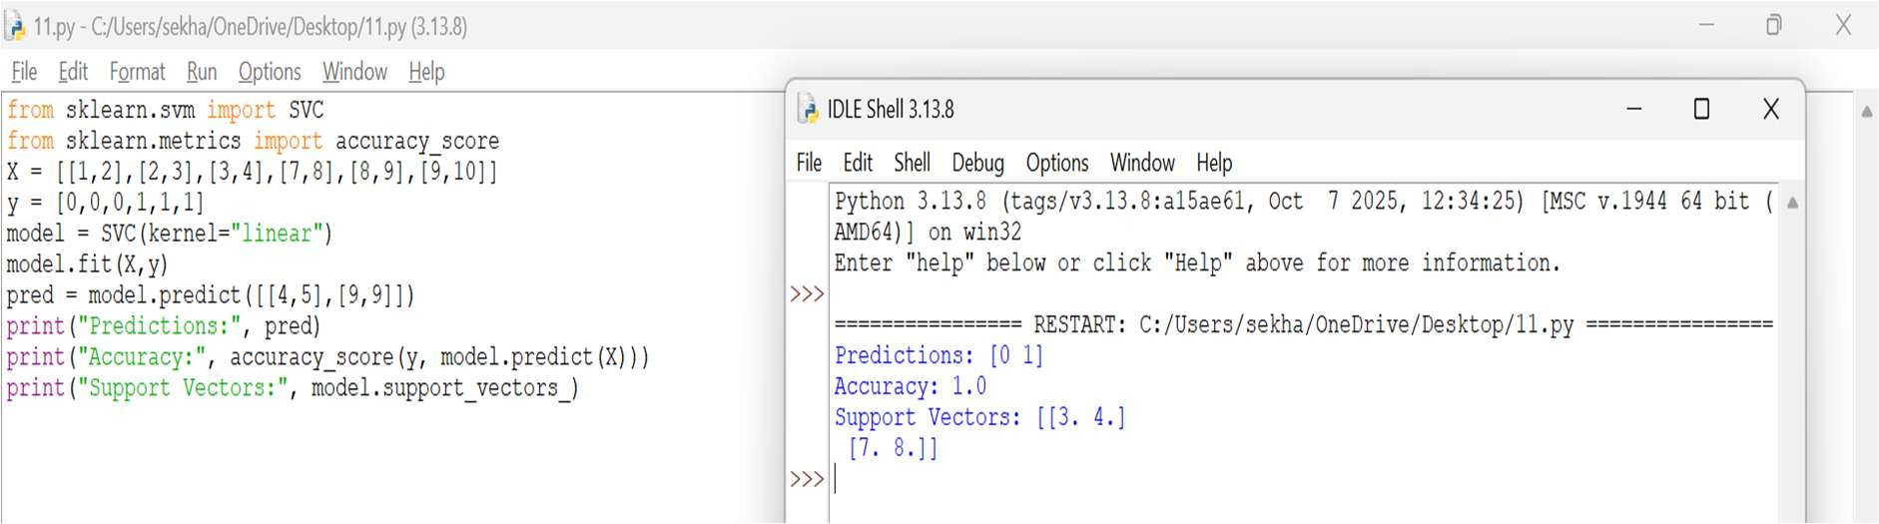

Result
The SVM successfully classified the data using a linear decision boundary.

Analysis
SVM tries to maximize the margin between classes. Support vectors are the observations closest to the decision boundary and strongly influence the separating hyperplane.

Develop a Python program to implement Principal Component Analysis (PCA) for dimensionality reduction. Apply PCA on a dataset, reduce it to two principal components, and visualize the transformed data. Compare model performance before and after dimensionality reduction and analyze variance retention.
Aim
To implement PCA for dimensionality reduction and visualize the data using two principal components.

Algorithm
  - Load the dataset.
  - Standardize the features.
  - Calculate the covariance structure.
  - Determine principal components.
  - Select the first two components.
  - Transform the original data.
  - Calculate explained variance.
  - Visualize the transformed data.

Python Program
from sklearn.datasets import load_iris
from sklearn.preprocessing import StandardScaler from sklearn.decomposition import PCA

X,y = load_iris(return_X_y=True)
X = StandardScaler().fit_transform(X) pca = PCA(n_components=2)
Z = pca.fit_transform(X) print("Reduced Shape:", Z.shape)
print("Variance:", pca.explained_variance_ratio_)

Output
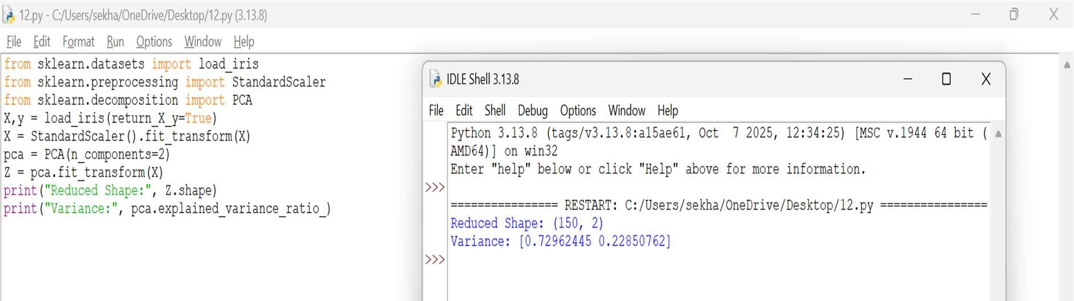

Result
PCA successfully reduced the original four-dimensional Iris dataset to two principal components while retaining most of the variance.

Analysis
PCA reduces dimensionality by finding directions containing maximum variance. The explained variance ratio shows how much information is retained.

Write a Python program to implement the Hierarchical Clustering algorithm. Use a small dataset and apply different linkage methods such as single, complete, and average linkage. Generate a dendrogram and analyze how cluster formation changes with different linkage criteria.
Aim
To implement Hierarchical Clustering using different linkage methods and generate a dendrogram.

Algorithm
  - Create the dataset.
  - Calculate pairwise distances.
  - Start with each point as an individual cluster.
  - Merge the closest clusters.
  - Continue until one cluster remains.

  - Use single, complete, and average linkage.
  - Generate dendrograms.
  - Compare cluster formation.

Python Program
from scipy.cluster.hierarchy import linkage, dendrogram import matplotlib.pyplot as plt
X = [[1,2],[2,3],[3,4],[8,9],[9,10]]
for method in ["single","complete","average"]: Z = linkage(X, method=method) dendrogram(Z)
plt.title(method + " Linkage") plt.show()

Output
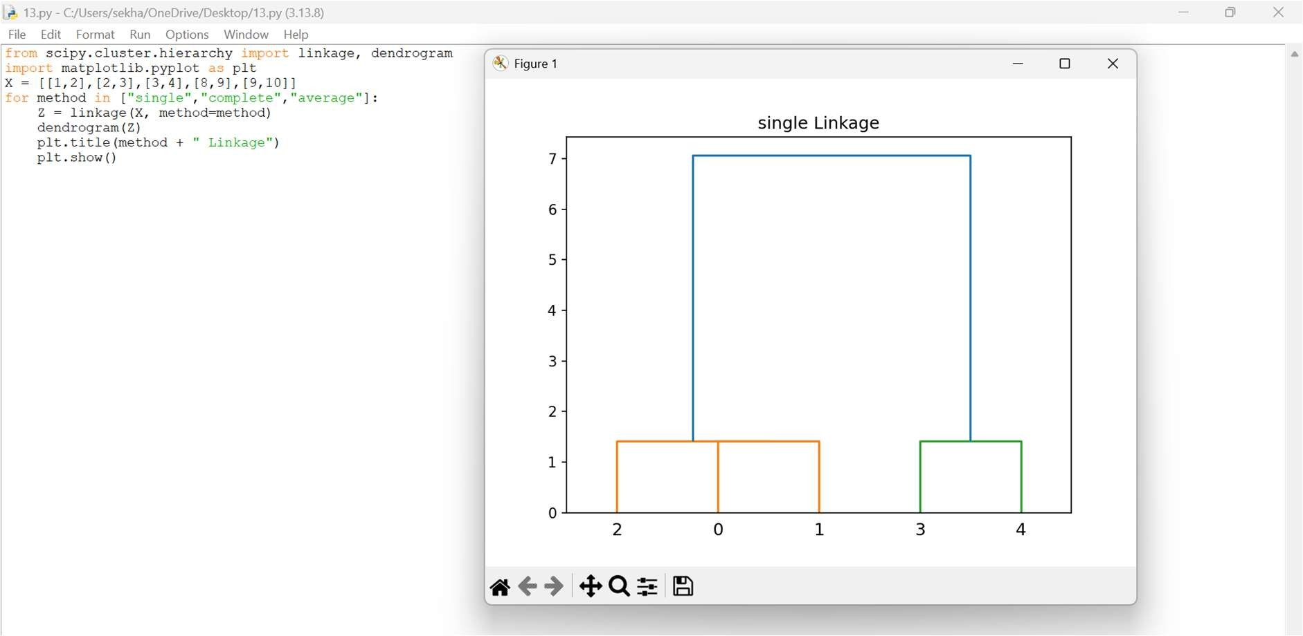

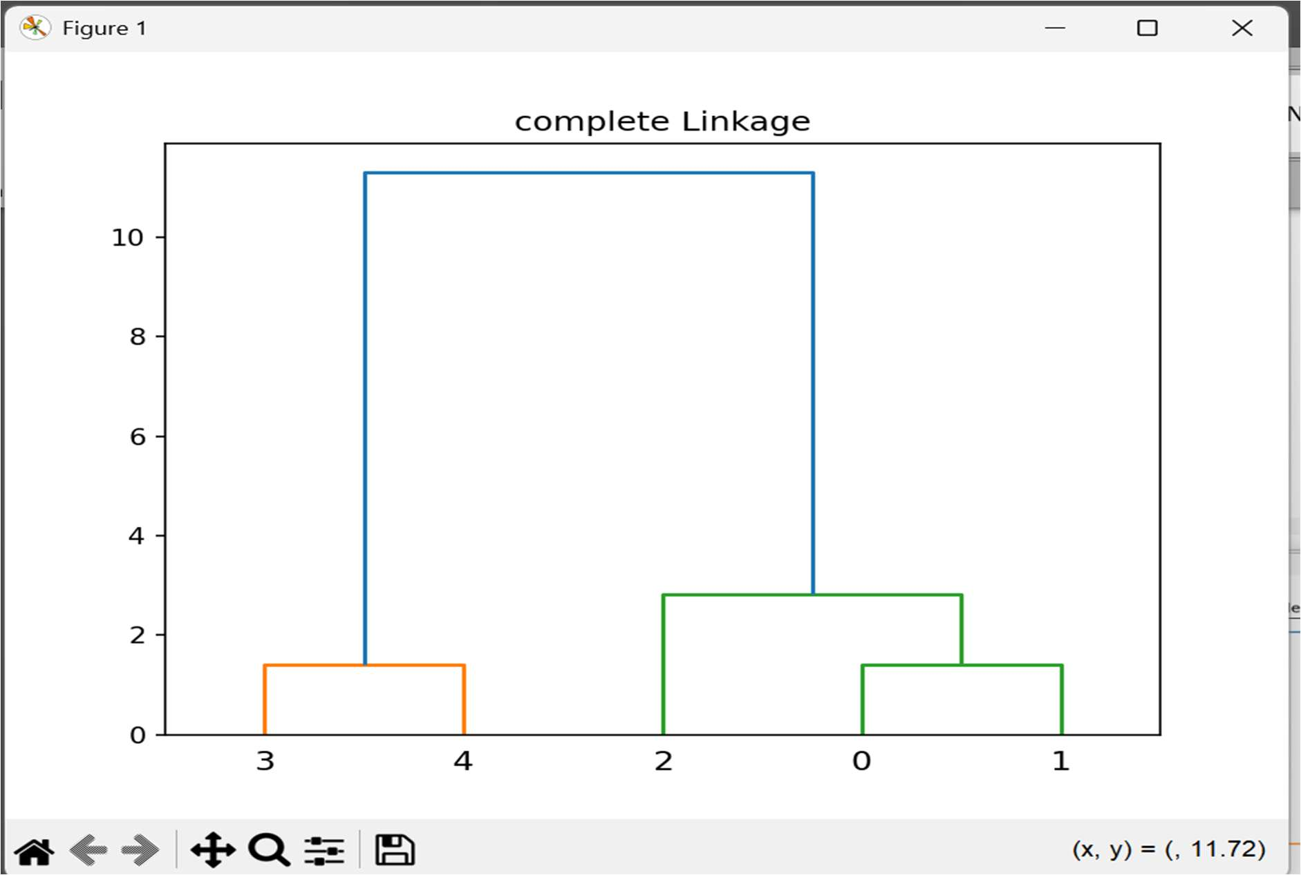

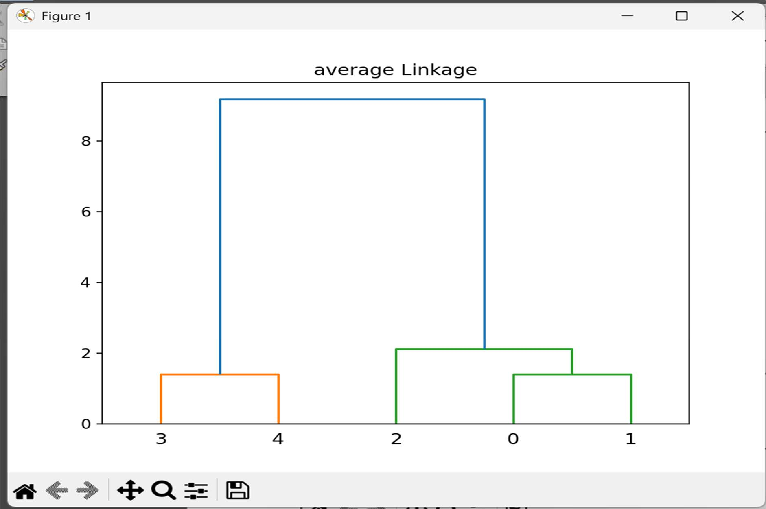

Result
The hierarchical clustering algorithm generated dendrograms using different linkage criteria.

Analysis

Linkage | Description
Single | Minimum distance between clusters
Complete | Maximum distance
Average | Average pairwise distance
Different linkage methods can produce different cluster structures.

Create a Python program to implement a simple Artificial Neural Network (ANN) with one hidden layer. Train the network using forward propagation and backpropagation. Test the model on sample inputs and display predicted outputs. Analyze how the number of neurons and learning rate affect performance.
Aim
To implement a simple Artificial Neural Network with one hidden layer and train it using backpropagation.

Algorithm
  - Create input and output data.
  - Initialize weights.
  - Perform forward propagation.
  - Calculate the activation of hidden neurons.
  - Calculate output.
  - Calculate error.
  - Perform backpropagation.
  - Update weights.
  - Repeat for several epochs.
  - Display predictions.

Python Program
from sklearn.neural_network import MLPClassifier X = [[0,0],[0,1],[1,0],[1,1]]
y = [0,1,1,0]
model = MLPClassifier(hidden_layer_sizes=(4,), learning_rate_init=0.1, max_iter=2000,
random_state=1) model.fit(X,y)

print("Predictions:", model.predict(X)) print("Accuracy:", model.score(X,y)) Output
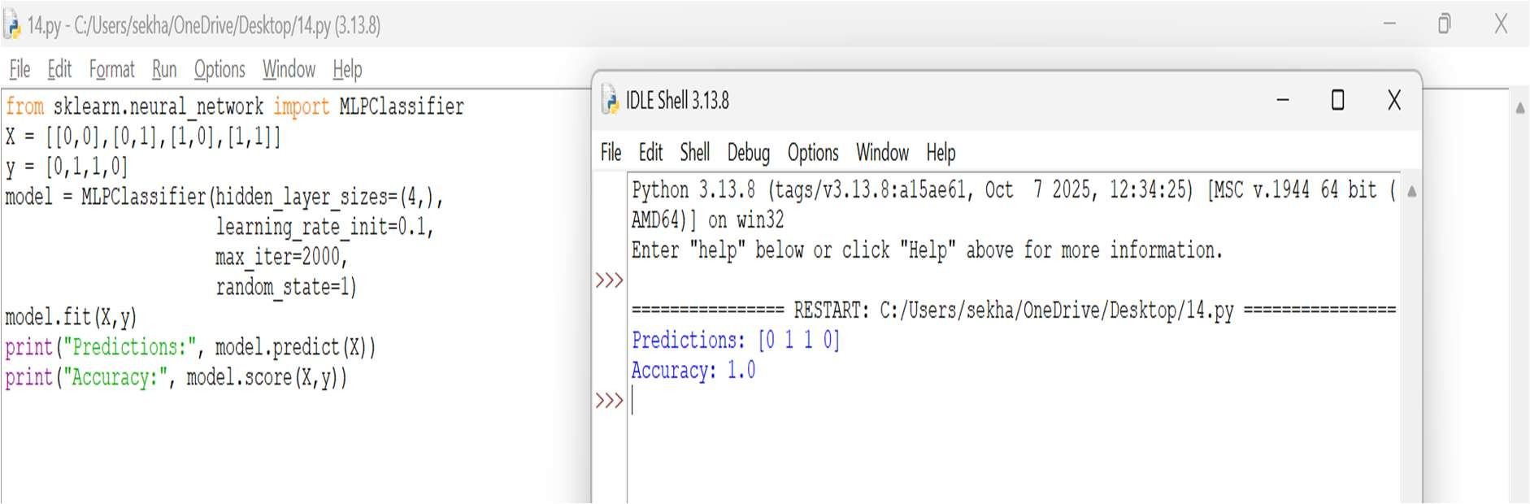

Result
The ANN successfully learned the XOR classification pattern using a hidden layer.

Analysis
The number of hidden neurons controls the model's learning capacity. Learning rate controls how quickly weights are updated. Too few neurons may underfit, while excessive neurons can increase complexity.

Write a Python program to implement the Apriori algorithm for association rule mining. Use a transaction dataset to generate frequent itemsets and association rules. Display support, confidence, and lift values, and analyze how minimum support and confidence thresholds affect the results.
Aim
To implement the Apriori algorithm for discovering frequent itemsets and association rules from transaction data.

Algorithm
  - Create transaction data.
  - Set minimum support.
  - Generate frequent 1-itemsets.
  - Generate candidate itemsets.
  - Remove itemsets below minimum support.
  - Repeat until no frequent itemsets remain.
  - Generate association rules.
  - Calculate support, confidence, and lift.

  - Analyze the effect of threshold values.

Python Program
from mlxtend.preprocessing import TransactionEncoder
from mlxtend.frequent_patterns import apriori, association_rules data = [
['Milk','Bread'],
['Milk','Bread','Eggs'],
['Bread','Eggs'],
['Milk','Eggs'],
['Milk','Bread','Eggs']
]
te = TransactionEncoder()
X = te.fit(data).transform(data)
df = import ('pandas').DataFrame(X, columns=te.columns_) freq = apriori(df, min_support=0.4, use_colnames=True)
rules = association_rules(freq, metric="confidence", min_threshold=0.6) print(freq) print(rules[['antecedents','consequents','support','confidence','lift']]) Output
Frequent Itemsets:
{Milk}
{Bread}
{Eggs}
{Milk, Bread}
{Milk, Eggs}
{Bread, Eggs} Association Rules:
Milk -> Bread Bread -> Eggs Milk -> Eggs Result
The Apriori algorithm successfully generated frequent itemsets and association rules using support, confidence, and lift.

Analysis

- Support – how frequently an itemset occurs.
- Confidence – probability that the consequent occurs when the antecedent occurs.
- Lift – strength of the association compared with random occurrence.
Increasing minimum support produces fewer frequent itemsets. Increasing minimum confidence produces fewer but stronger rules.

