EXP 1
A ) 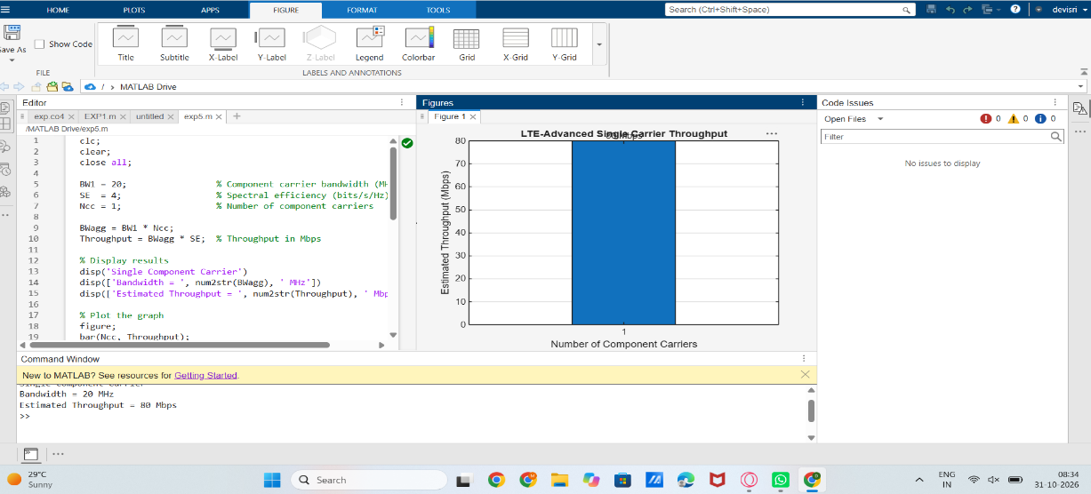
PROGRAM
MATLAB Program
clc; clear; close all;
BW1 = 20; % Component carrier bandwidth (MHz)
SE = 4; % Spectral efficiency (bits/s/Hz)
Ncc = 1; % Number of component carriers
BWagg = BW1*Ncc;
Throughput = BWagg*SE; % Mbps for MHz × bits/s/Hz
disp('Single Component Carrier')
disp(['Bandwidth = ',num2str(BWagg),' MHz'])
disp(['Estimated Throughput = ',num2str(Throughput),' Mbps'])
figure
bar(Ncc,Throughput)
grid on
xlabel('Number of Component Carriers')
ylabel('Estimated Throughput (Mbps)')
title('LTE-Advanced Single Carrier Throughput')
Expected Output: A graph showing the estimated throughput for one 20 MHz component
carrier. With the selected 4 bits/s/Hz simplified assumption, the estimated throughput is 80
Mbp
B)
MATLAB Program
clc; clear; close all;
BW = [5 10 15 20]; % Carrier bandwidths (MHz)
SE = 4; % bits/s/Hz
TP = BW .* SE; % Estimated throughput (Mbps)
disp('Bandwidth (MHz) Throughput (Mbps)')
disp([BW' TP'])
figure
plot(BW,TP,'o-','LineWidth',2)
grid on
xlabel('Carrier Bandwidth (MHz)')
ylabel('Estimated Throughput (Mbps)')
title('Throughput vs Component Carrier Bandwidth')
Expected Output: Throughput increases as the component-carrier bandwidth increases.

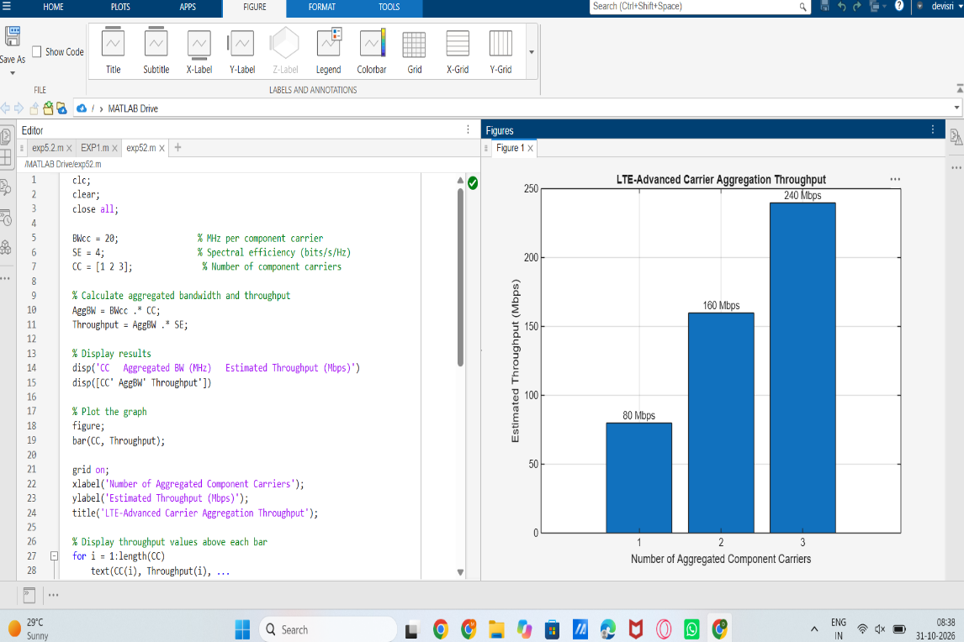
EXP 6
A)
clc; clear; close all;
SNR_dB = 0:2:20;
BER_SISO = zeros(size(SNR_dB));
BER_MIMO = zeros(size(SNR_dB));
for k = 1:length(SNR_dB)
N = 10000;
bits = randi([0 1],N,1);
tx = 2*bits-1;
snrLin = 10^(SNR_dB(k)/10);
noise = randn(N,1)/sqrt(2*snrLin);
rx = tx + noise;
bits_hat = real(rx)>0;
BER_SISO(k) = mean(bits_hat~=bits);
% Simple 2x2 MIMO equivalent link
H = (randn(2,2)+1j*randn(2,2))/sqrt(2);
h_eff = sqrt(sum(abs(H(:)).^2)/2);
noise2 = randn(N,1)/sqrt(2*snrLin);
rx2 = h_eff*tx + noise2;
bits_hat2 = real(rx2)>0;
BER_MIMO(k) = mean(bits_hat2~=bits);
end
figure
semilogy(SNR_dB,BER_SISO,'o-','LineWidth',2); hold on
semilogy(SNR_dB,BER_MIMO,'s-','LineWidth',2)
grid on
xlabel('SNR (dB)')
ylabel('Bit Error Rate (BER)')
title('SISO and MIMO BER Performance')
legend('SISO','MIMO')
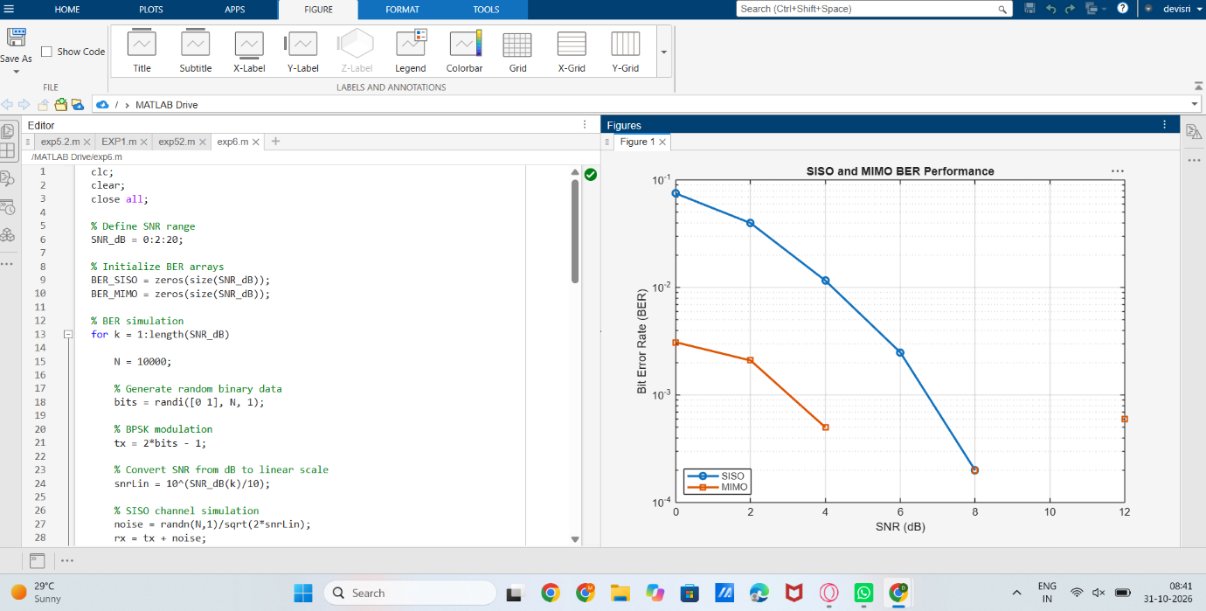
B)
% BER and reliability analysis
clc; clear; close all;
SNR_dB = 0:2:20;
Reliability = zeros(size(SNR_dB));
for k = 1:length(SNR_dB)
N = 10000;
bits = randi([0 1],N,1);
tx = 2*bits-1;
snrLin = 10^(SNR_dB(k)/10);
noise = randn(N,1)/sqrt(2*snrLin);
rx = tx + noise;
bhat = real(rx)>0;
BER = mean(bhat~=bits);
Reliability(k) = 1-BER;
end
figure
plot(SNR_dB,Reliability,'o-','LineWidth',2)
grid on
xlabel('SNR (dB)')
ylabel('Reliability (1-BER)')
title('Communication Reliability vs SNR')
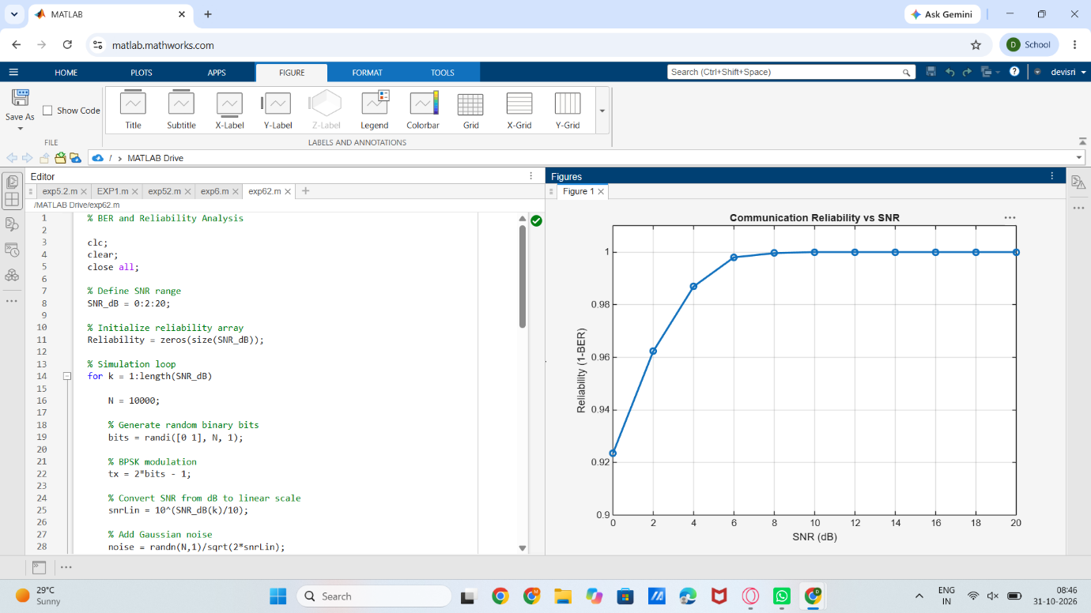
C)
clc; clear; close all;
N = 8; % Antenna elements
theta = -90:1:90; % Observation angle
steer = [-60 -30 0 30 60]; % Steering directions
gain = zeros(size(steer));
for k = 1:length(steer)
% Simplified normalized array response at the intended direction
gain(k) = 10*log10(N) - 0.01*abs(steer(k));
end
figure
plot(steer,gain,'o-','LineWidth',2)
grid on
xlabel('Steering Angle (Degrees)')
ylabel('Beamforming Gain (dB)')
title('Beamforming Gain for Different Steering Directions')
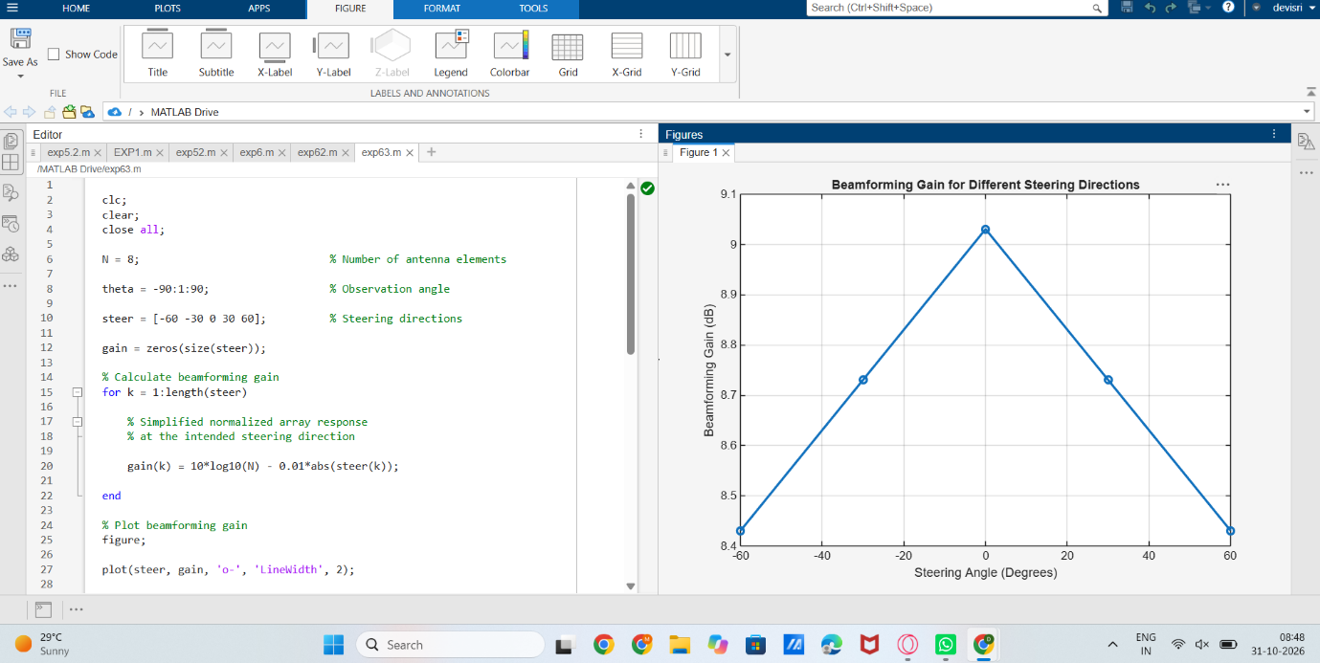
EXP 7
A)
Program:
clc; clear; close all;
Nsc = 24; % Simplified number of subcarriers
Nsym = 14; % OFDM symbols per slot
grid = zeros(Nsym,Nsc);
% Simplified DL assignment: symbols 1-10
grid(1:10,:) = 1;
% Simplified UL assignment: symbols 11-14
grid(11:14,:) = 2;
figure
imagesc(grid)
grid on
xlabel('Subcarrier Index')
ylabel('OFDM Symbol Index')
title('Simplified 5G NR Time-Frequency Resource Grid')
colorbar
Expected Output: A time-frequency grid representing simplified downlink and uplink
resource assignments.
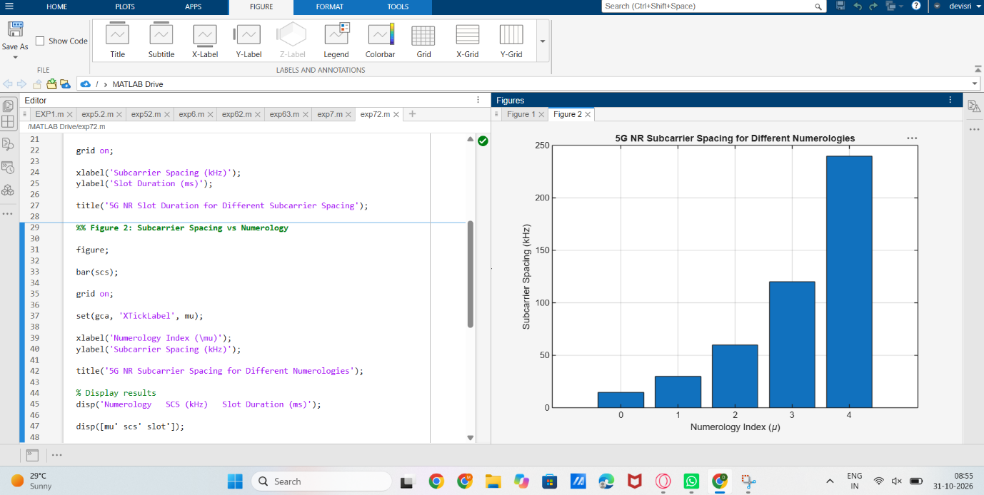
B)
Program:
clc; clear; close all;
scs = [15 30 60 120 240]; % kHz
mu = 0:4;
slot = [1 0.5 0.25 0.125 0.0625]; % ms
figure
plot(scs,slot,'o-','LineWidth',2)
grid on
xlabel('Subcarrier Spacing (kHz)')
ylabel('Slot Duration (ms)')
title('5G NR Slot Duration for Different Subcarrier Spacing')
figure
bar(scs)
grid on
set(gca,'XTickLabel',mu)
xlabel('Numerology Index (\mu)')
ylabel('Subcarrier Spacing (kHz)')
title('5G NR Subcarrier Spacing for Different Numerologies')
Expected Output: Slot duration decreases as SCS increases. The SCS graph shows 15, 30, 60,
120 and 240 kHz.
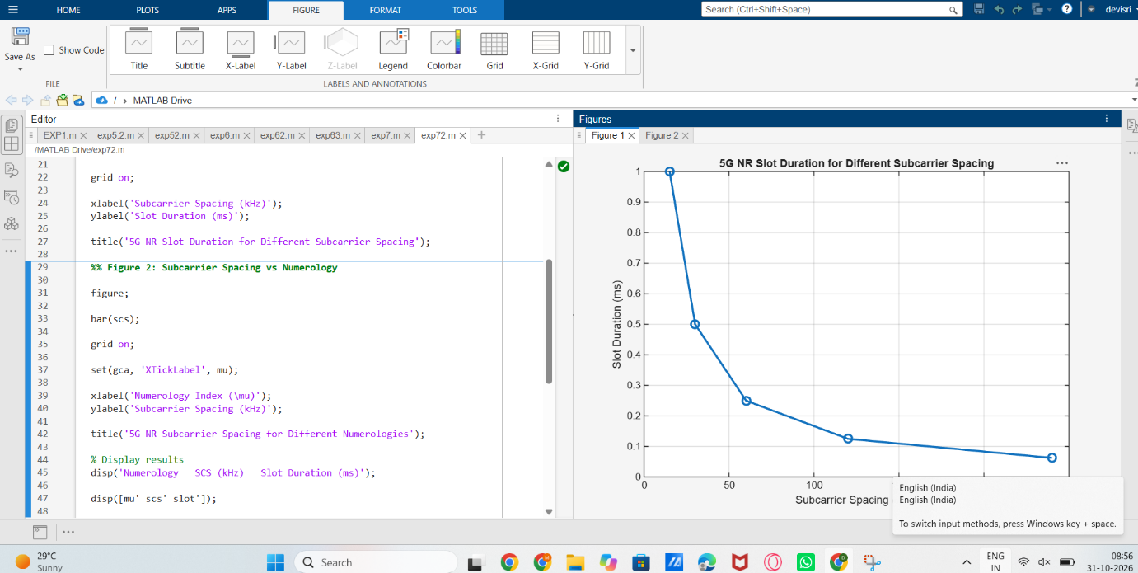
C)
Program:
clc; clear; close all;
symbols = 1:14;
DL = [1 1 1 1 1 1 1 1 1 1 0 0 0 0];
UL = [0 0 0 0 0 0 0 0 0 0 1 1 1 1];
figure
plot(symbols,DL,'o-','LineWidth',2); hold on
plot(symbols,UL,'s-','LineWidth',2)
grid on
xlabel('OFDM Symbol Index')
ylabel('Allocation Status')
title('Simplified Downlink and Uplink Assignment')
legend('Downlink','Uplink')
Expected Output: A plot identifying simplified DL and UL resource assignments across the
OFDM symbols.
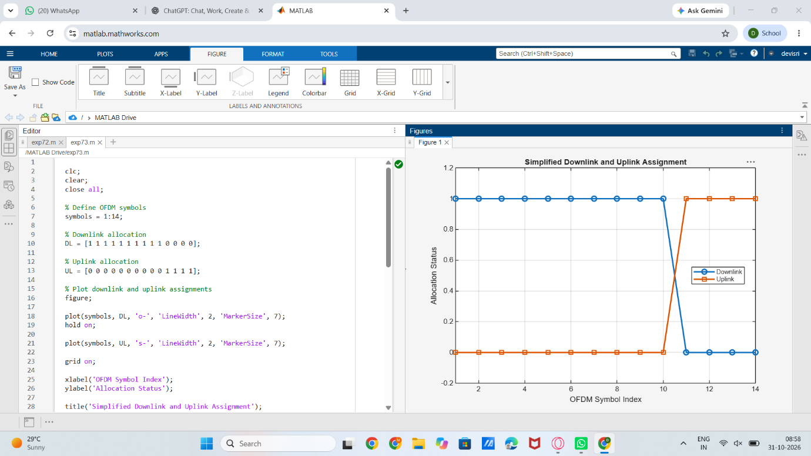
EXP 9
A)
clc;
clear;
close all;
%% Input parameters
rng(7); % Repeatable random results
K = 4; % Number of users
NRB = 24; % Number of resource blocks
BRB = 180e3; % Bandwidth per RB in Hz
Tslot = 1e-3; % Scheduling interval in seconds
etaMax = 6; % Maximum spectral efficiency, bit/s/Hz
avgSNRdB = [5 10 15 8]; % Average user SNR in dB
trafficMbps = [8 12 5 10]; % Offered traffic in Mbit/s
% Bits requested during one scheduling interval
demandBits = trafficMbps * 1e6 * Tslot;
%% Generate channel quality for each user and RB
% Independent SNR variation around each user's average SNR
snrVariation = 4 * randn(K, NRB);
snrDB = avgSNRdB(:) + snrVariation;
snrLinear = 10.^(snrDB / 10);
% Shannon-based spectral efficiency with an upper limit
spectralEfficiency = min(log2(1 + snrLinear), etaMax);
% Achievable bits on each RB during one scheduling interval
rateBps = BRB * spectralEfficiency;
bitsPerRB = rateBps * Tslot;
strategyNames = {'Round Robin', 'Maximum CQI', 'Traffic Aware'};
allocations = zeros(K, NRB, 3);
%% Strategy 1: Round-robin allocation
for n = 1:NRB
user = mod(n - 1, K) + 1;
allocations(user, n, 1) = 1;
end
%% Strategy 2: Maximum-CQI allocation
for n = 1:NRB
[~, user] = max(snrDB(:, n));
allocations(user, n, 2) = 1;
end
%% Strategy 3: Traffic-aware channel-quality allocation
servedBits = zeros(K, 1);
for n = 1:NRB
remainingBits = max(demandBits(:) - servedBits, 0);
if all(remainingBits <= 0)
break;
end
normalizedDemand = remainingBits ./ max(demandBits(:), eps);
metric = bitsPerRB(:, n) .* normalizedDemand;

% Prevent allocation to a user whose demand has been satisfied
metric(remainingBits <= 0) = -inf;
[~, user] = max(metric);
allocations(user, n, 3) = 1;

deliveredBits = min(bitsPerRB(user, n), remainingBits(user));
servedBits(user) = servedBits(user) + deliveredBits;
end
%% Performance calculations
userThroughputMbps = zeros(K, 3);
totalThroughputMbps = zeros(1, 3);
jainFairness = zeros(1, 3);
utilization = zeros(1, 3);
unservedTrafficMbps = zeros(K, 3);
rbPerUser = zeros(K, 3);
for s = 1:3
allocation = allocations(:, :, s);
deliveredBits = sum(allocation .* bitsPerRB, 2);

% Throughput is restricted to requested traffic
usefulBits = min(deliveredBits, demandBits(:));
userThroughputMbps(:, s) = usefulBits / Tslot / 1e6;
totalThroughputMbps(s) = sum(userThroughputMbps(:, s));

throughput = userThroughputMbps(:, s);
jainFairness(s) = sum(throughput)^2 / (K * sum(throughput.^2) + eps);

allocatedRBs = sum(allocation(:));
utilization(s) = allocatedRBs / NRB * 100;
unservedTrafficMbps(:, s) = max(trafficMbps(:) - throughput, 0);
rbPerUser(:, s) = sum(allocation, 2);
end
%% Display results
fprintf('\nOFDMA RESOURCE-BLOCK ALLOCATION RESULTS\n');
fprintf('=======================================\n');
for s = 1:3
fprintf('\n%s\n', strategyNames{s});
fprintf('User\tRBs\tThroughput (Mbit/s)\tUnserved (Mbit/s)\n');
for k = 1:K
fprintf('%d\t%d\t%8.3f\t\t%8.3f\n', ...
k, rbPerUser(k, s), userThroughputMbps(k, s), unservedTrafficMbps(k, s));
end
fprintf('Total throughput: %.3f Mbit/s\n', totalThroughputMbps(s));
fprintf('Jain fairness : %.4f\n', jainFairness(s));
fprintf('RB utilization : %.2f %%%\n', utilization(s));
end
%% Allocation maps plotting
figure('Name', 'OFDMA Resource-Block Allocation');
for s = 1:3
subplot(3, 1, s);
[userIndex, rbIndex] = find(allocations(:, :, s));
stem(rbIndex, userIndex, 'filled', 'LineWidth', 1.1);
grid on;
xlim([1 NRB]); ylim([0.5 K + 0.5]); yticks(1:K);
xlabel('Resource-block index'); ylabel('Allocated user');
title(strategyNames{s});
end
%% Throughput comparison plotting
figure('Name', 'User Throughput Comparison');
bar(userThroughputMbps);
xlabel('User'); ylabel('Throughput (Mbit/s)');
title('User Throughput Under Different Allocation Strategies');
legend(strategyNames, 'Location', 'best');
FIG1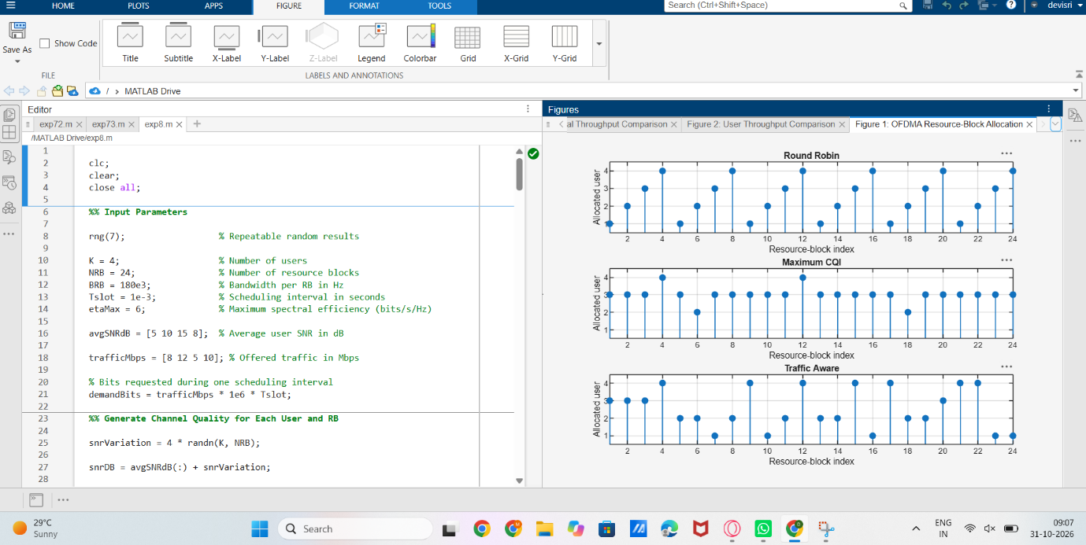
FIG2
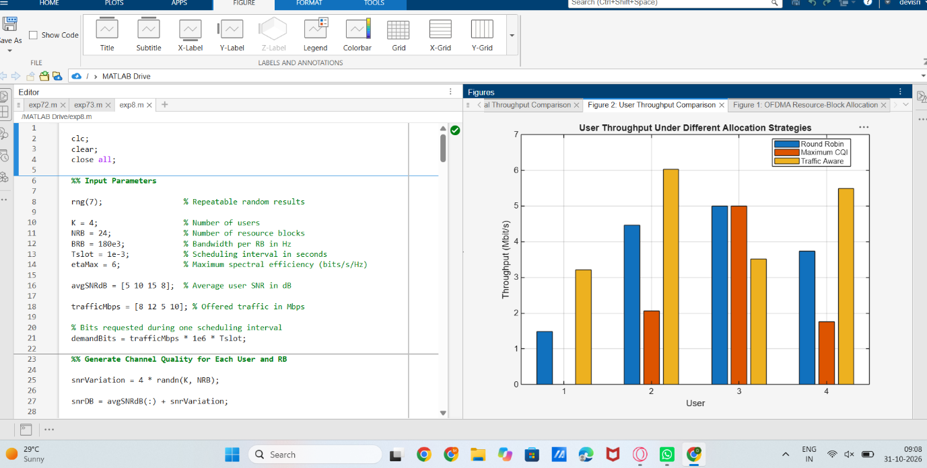

FIG3
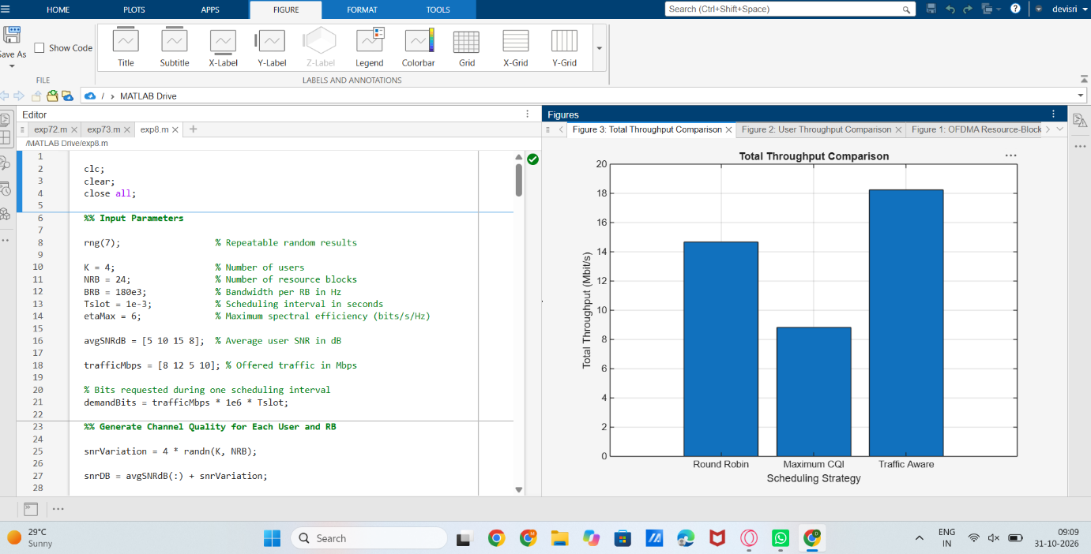
FIG4
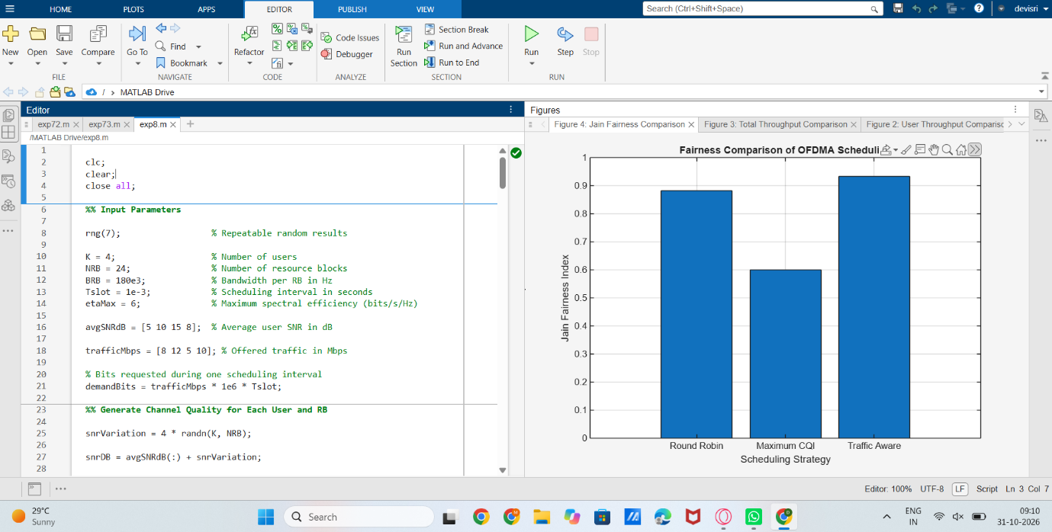

EXP10
clc; clear; close all;
%% 1. Input Parameters Setup
N_bits = 50000; % Data length per SNR point
SNR_dB = 0:2:20; % SNR operating range
alpha1 = 0.75; % Far user (User 1) power allocation
coefficient
alpha2 = 1 - alpha1; % Near user (User 2) power allocation
coefficient
ber_User1 = zeros(length(SNR_dB), 1); ber_User2 =
zeros(length(SNR_dB), 1);
ber_OFDMA = zeros(length(SNR_dB), 1);
%% 2. Data Processing Execution Loops
for s = 1:length(SNR_dB)
snr_linear = 10^(SNR_dB(s)/10);
noise_variance = 1 / snr_linear;

% Source Bits Generation
bits_u1 = randi([0 1], N_bits, 1); bits_u2 = randi([0 1],
N_bits, 1);

% BPSK Constellation Mapping
x1 = 2*bits_u1 - 1; x2 = 2*bits_u2 - 1;
% Power-Domain NOMA Superposition Generation
x_noma = sqrt(alpha1)*x1 + sqrt(alpha2)*x2;

% Waveform Processing Over Multi-User AWGN Channel
noise = sqrt(noise_variance/2) * (randn(N_bits, 1) +
1i*randn(N_bits, 1));
y_noma = real(x_noma + noise); % BPSK real-domain extraction

%% 3. Cognitive Receiver Hierarchy: Processing User 1
(Direct Detection)
dec_u1 = y_noma > 0;
est_x1 = 2*dec_u1 - 1;
ber_User1(s) = sum(bits_u1 ~= dec_u1) / N_bits;

%% 4. Successive Interference Cancellation (SIC) Processing
Loop
% Subtract reconstructed User 1 signal components from the
raw matrix
y_sic = y_noma - sqrt(alpha1)*est_x1;
dec_u2 = y_sic > 0;
ber_User2(s) = sum(bits_u2 ~= dec_u2) / N_bits;

%% 5. Baseline Evaluation Benchmark Processing: Orthogonal
System (OFDMA)
y_ofdma = x1 + sqrt(noise_variance*2)/sqrt(2)*randn(N_bits,
1);
dec_ofdma = y_ofdma > 0;
ber_OFDMA(s) = sum(bits_u1 ~= dec_ofdma) / N_bits;
end
%% 6. Serial Performance Graph Rendering
figure('Name', 'NOMA SIC Evaluation Matrix');
semilogy(SNR_dB, ber_User1, 'ro-', 'LineWidth', 1.2); hold on;
semilogy(SNR_dB, ber_User2, 'bs-', 'LineWidth', 1.2);
semilogy(SNR_dB, ber_OFDMA, 'k--', 'LineWidth', 1.2);
grid on; xlabel('Channel SNR Scaling Index (dB)'); ylabel('Bit
Error Rate (BER)');
title('NOMA Power-Domain Transceiver Performance Chart');
legend('User 1 (Far Node Direct Dec)', 'User 2 (Near Node PostSIC Dec)', 'Baseline OFDMA Orthogonal Benchmark', 'Location',
'best');


