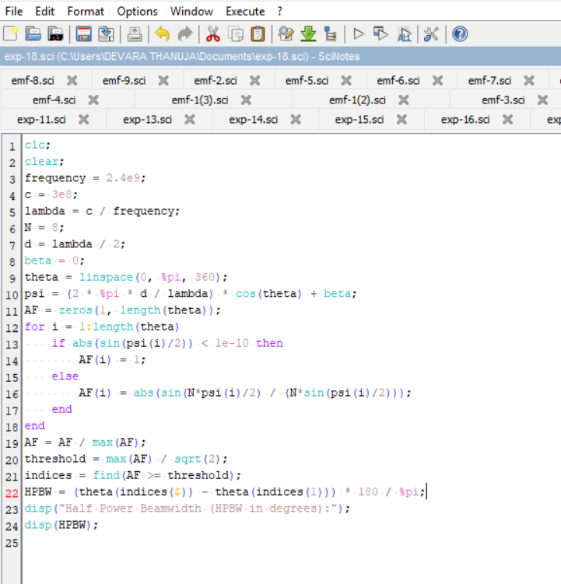
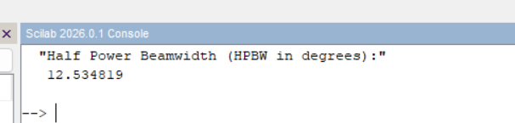
Exp No 18: Determination and plotting of Antenna Half power beamwidth.

Program:

