EXPERIMENT 2: AM Sideband Power & Frequencies
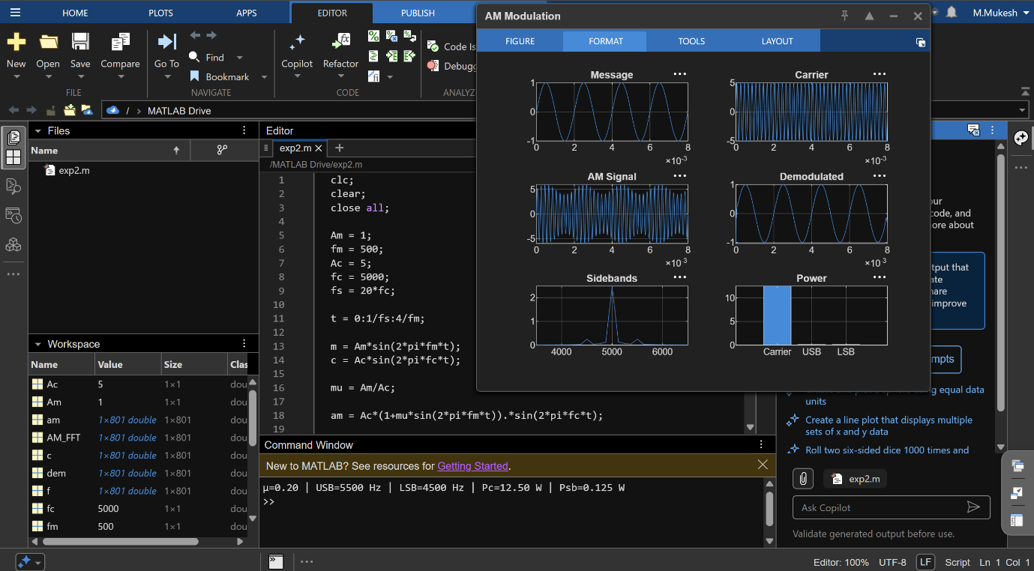

EXPERIMENT 3: VSB Modulator & Demodulator
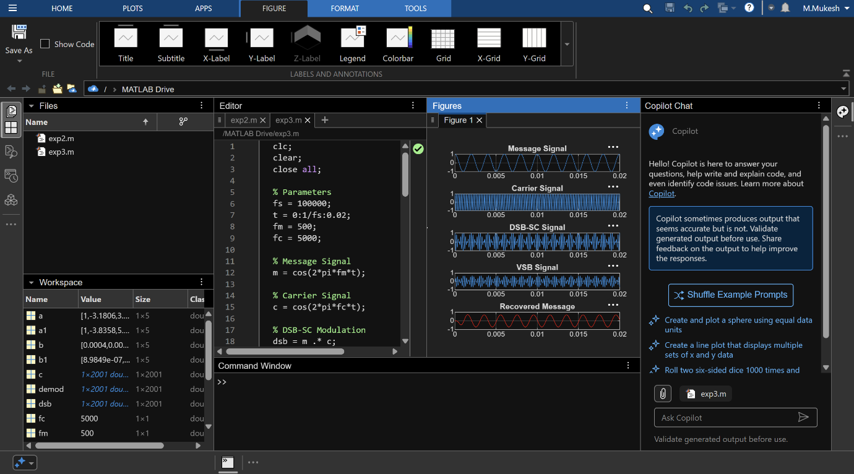

EXPERIMENT 4: Superheterodyne Receiver
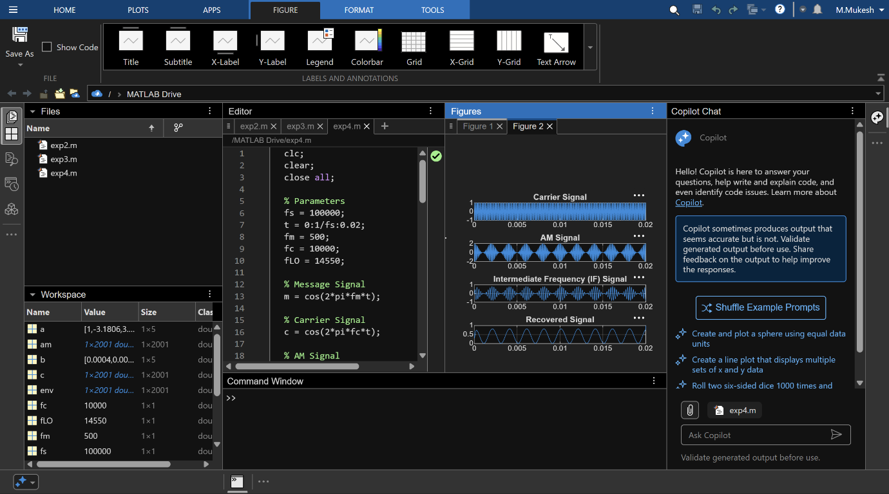

EXPERIMENT 6: FM & PM Signals
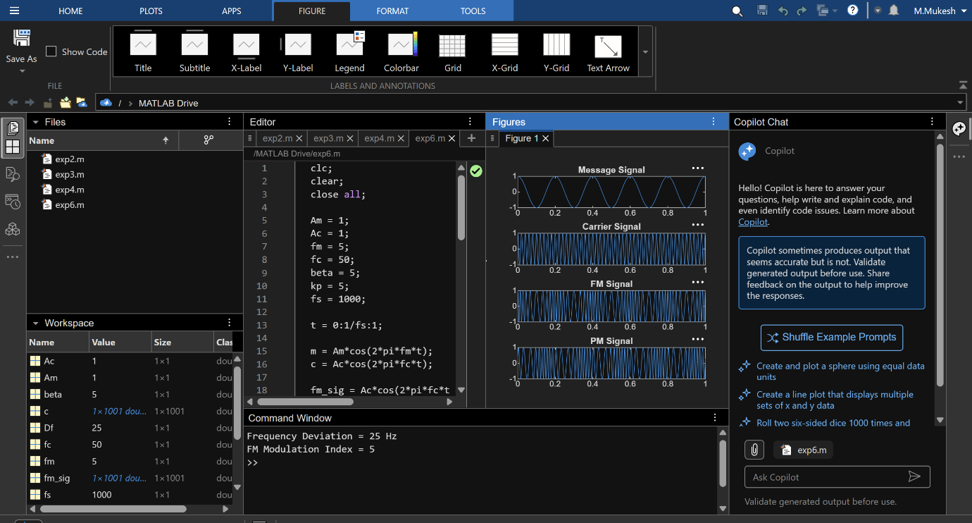

EXPERIMENT 7: FM Frequency Deviation & Modulation Index
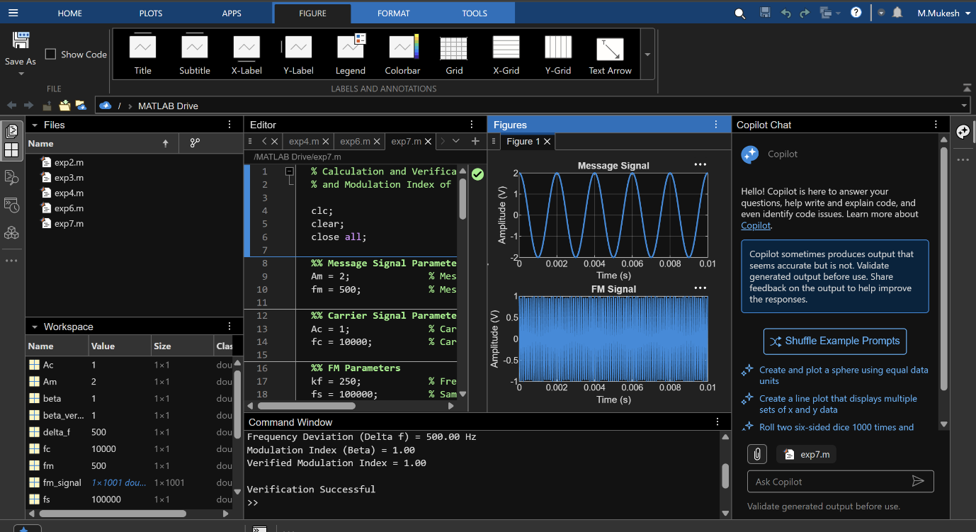

EXPERIMENT 8: PM Power Spectral Density
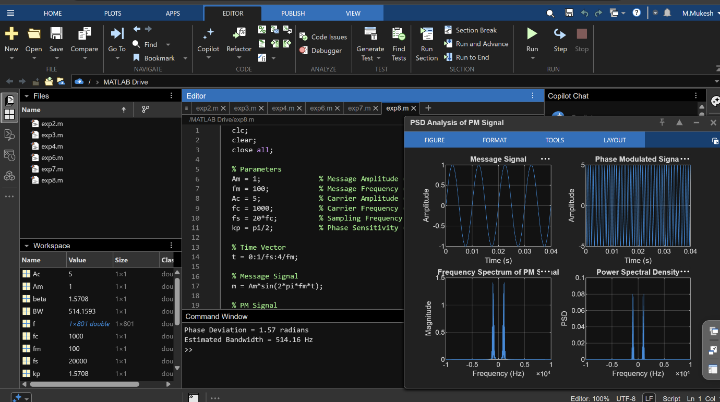

EXPERIMENT 9: AM under AWGN
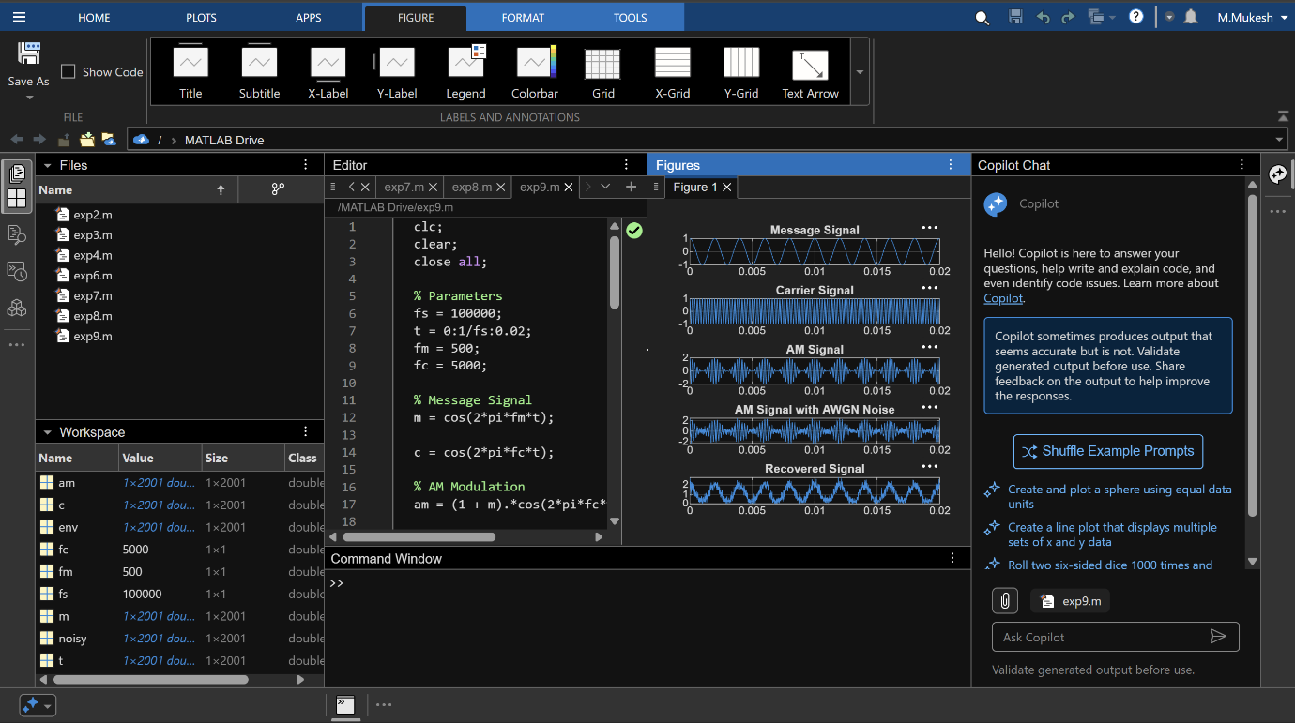

EXPERIMENT 10: FM under Gaussian White Noise
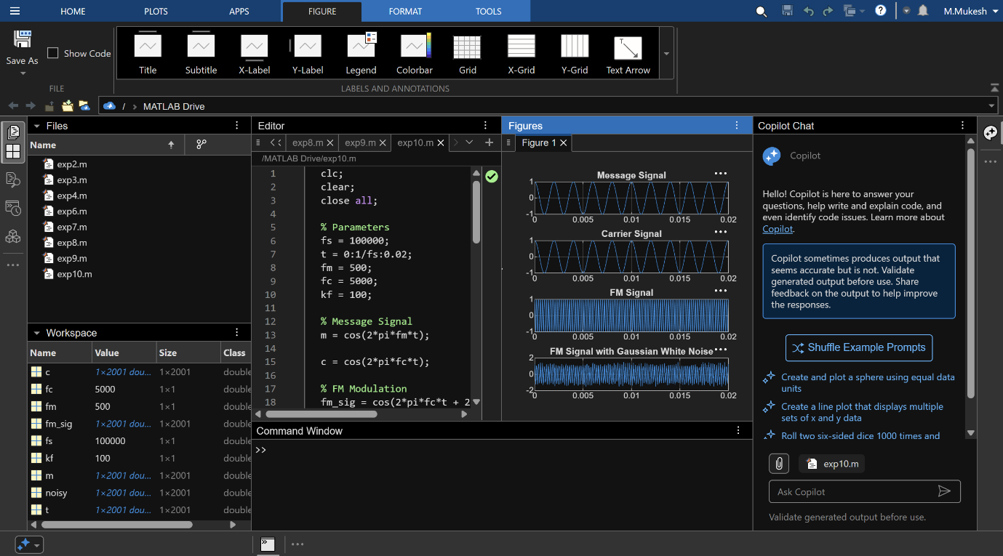

EXPERIMENT 16: Uniform & Non-Uniform Quantization
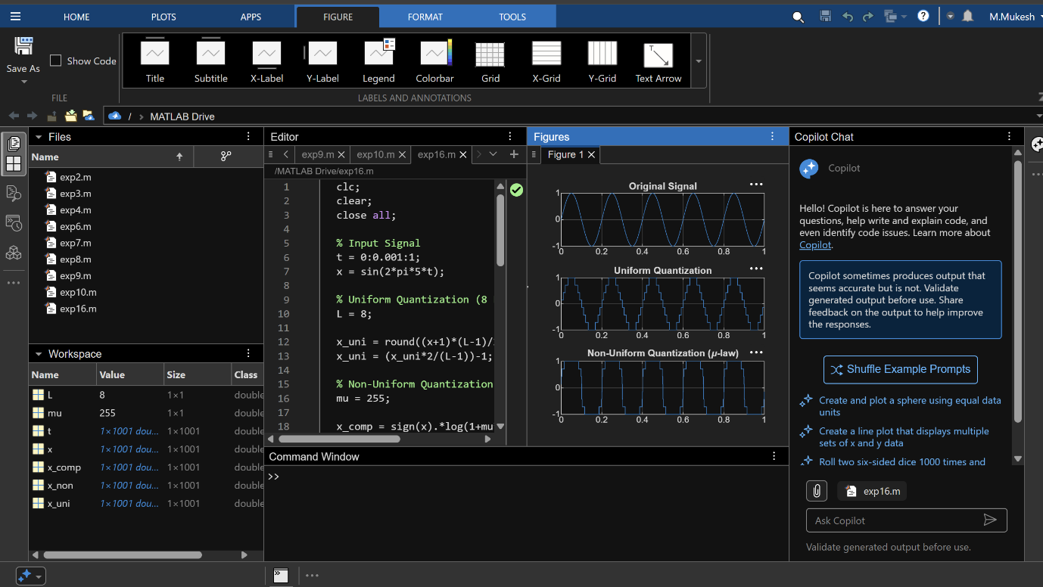

EXPERIMENT 17: Eye Diagram under AWGN
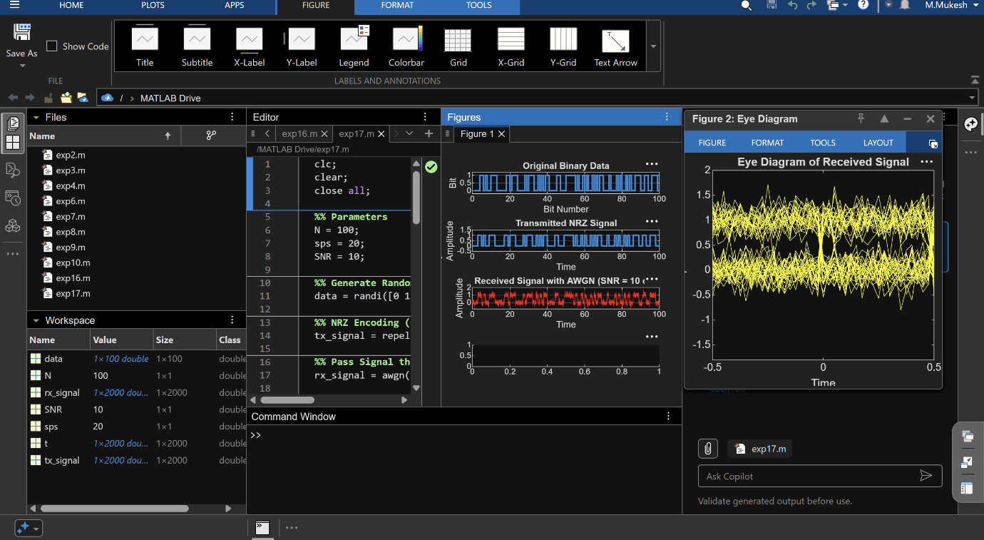

EXPERIMENT 18: Eye Diagram under ISI
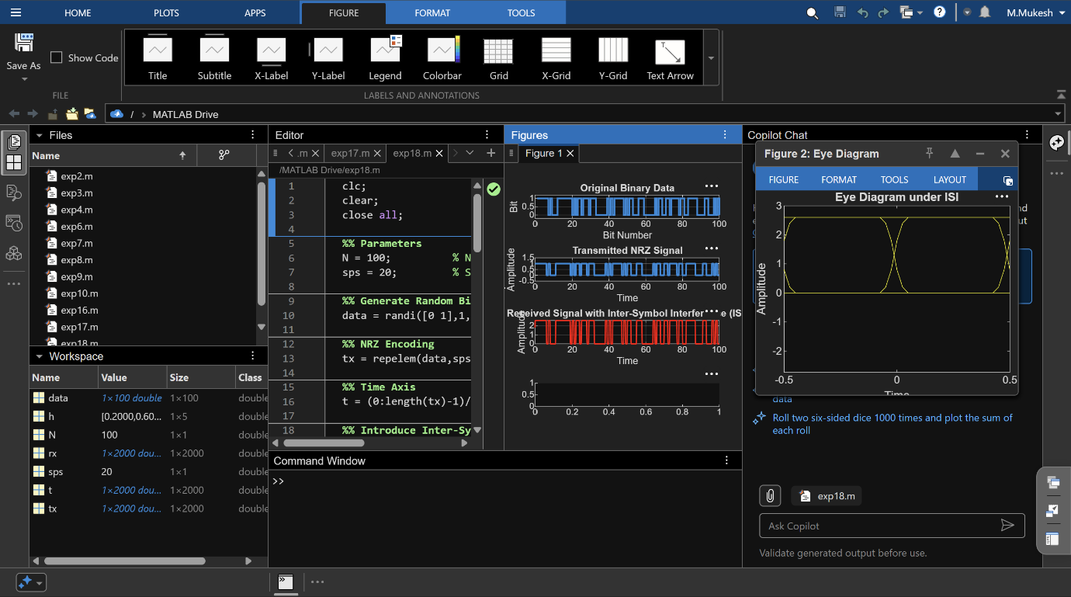

EXPERIMENT 22: BPSK Constellation
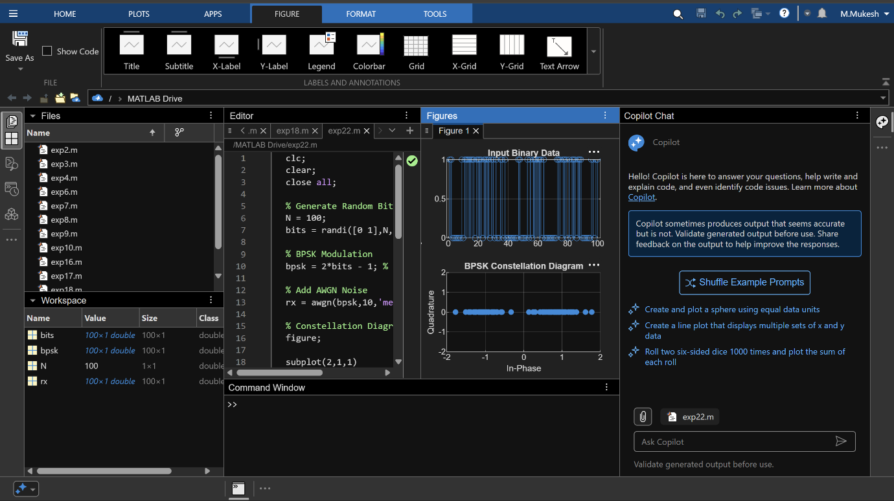

EXPERIMENT 23: 8-QAM & 16-QAM
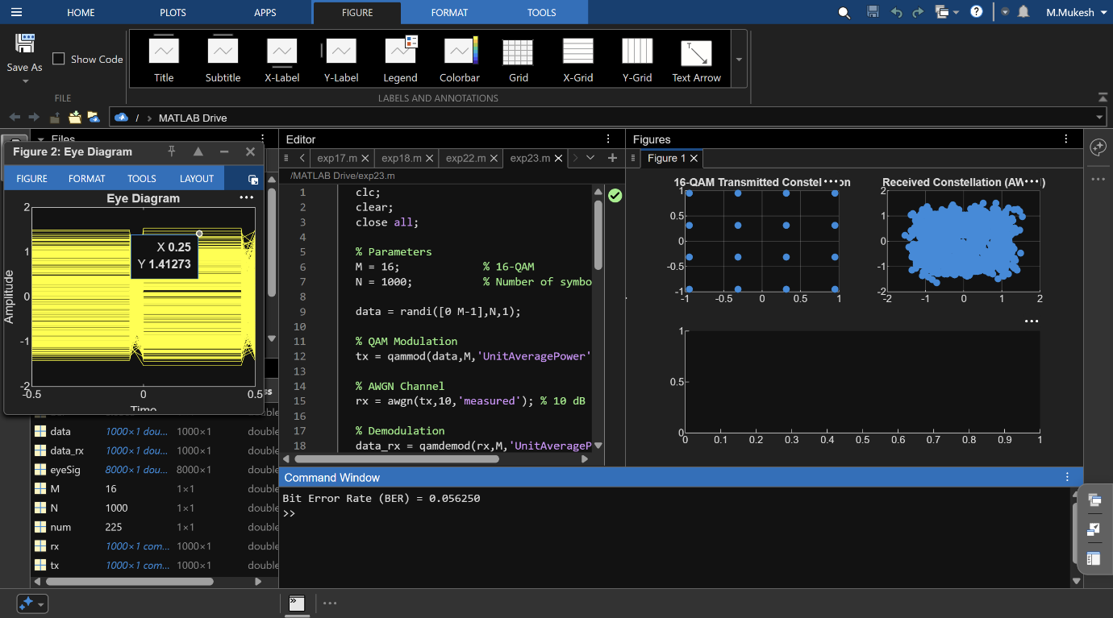

EXPERIMENT 24: Passband Transmission + Multipath BER
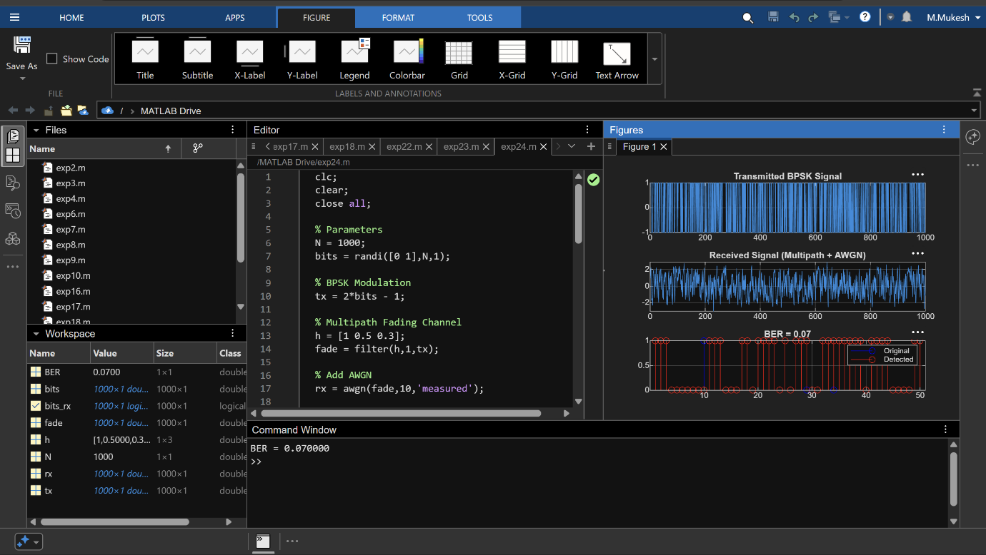

EXPERIMENT 25: Convolutional Codes
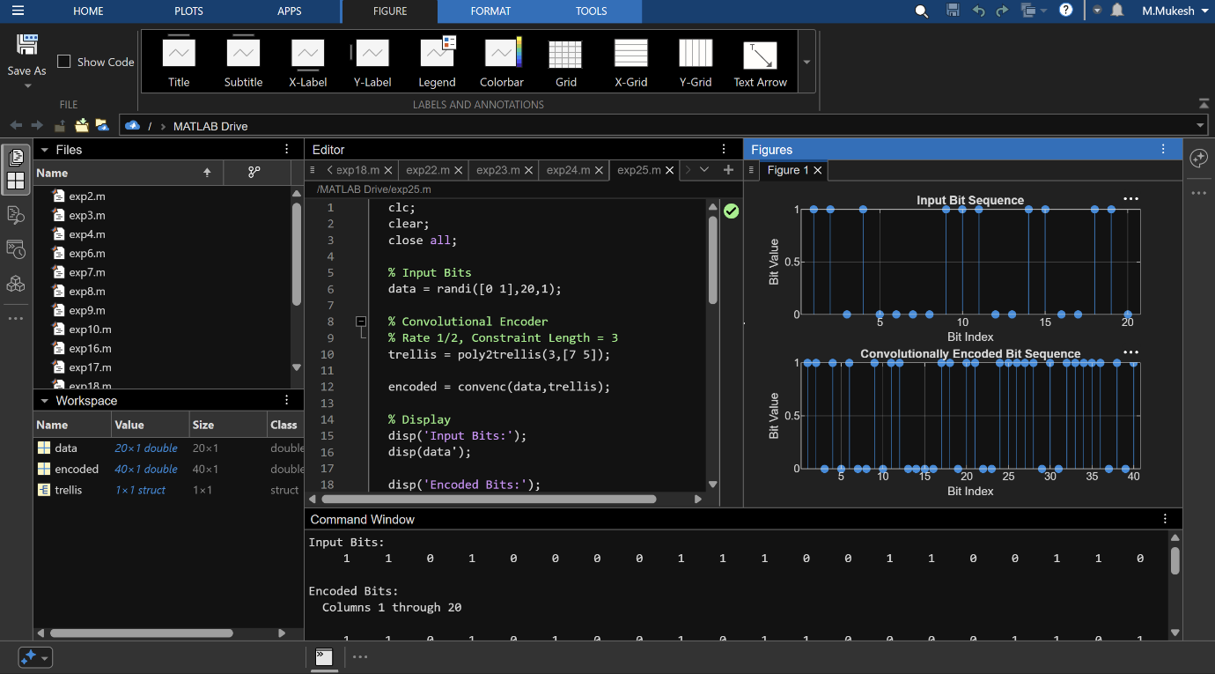

EXPERIMENT 26: Single-Bit Error Correction
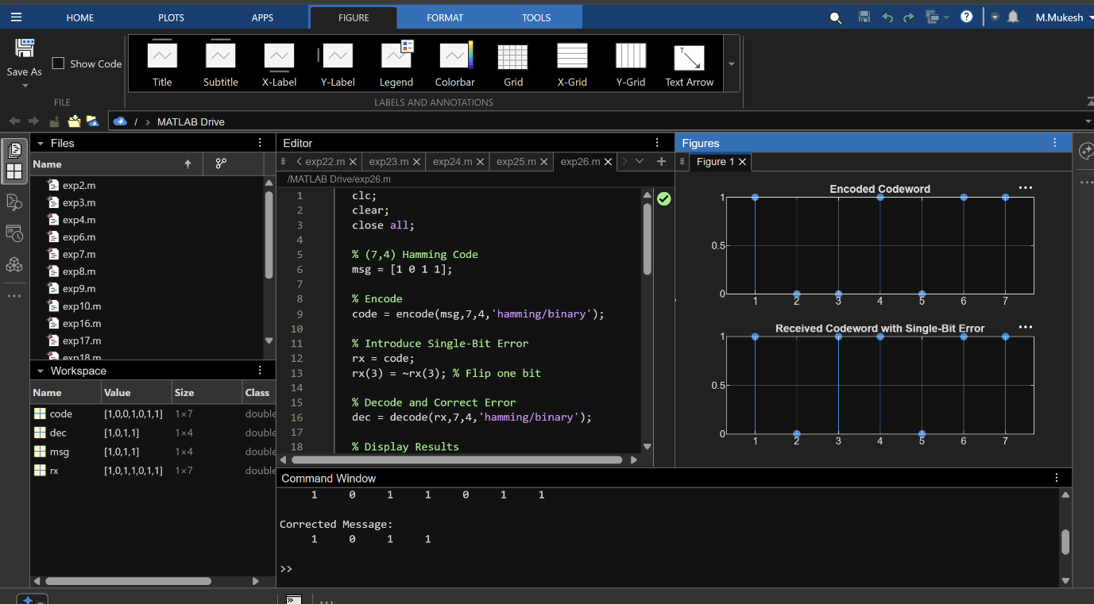

EXPERIMENT 27: PN Sequence & Processing Gain
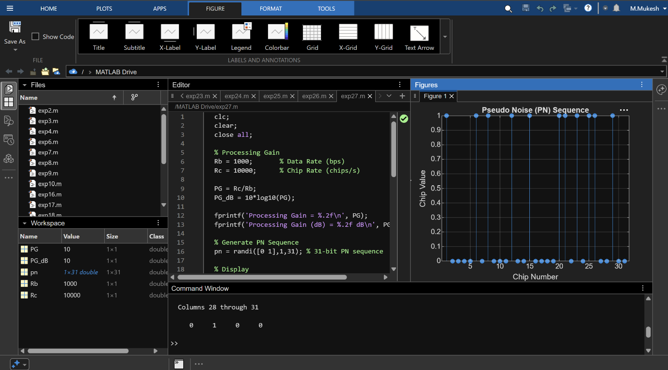

EXPERIMENT 28: DSSS
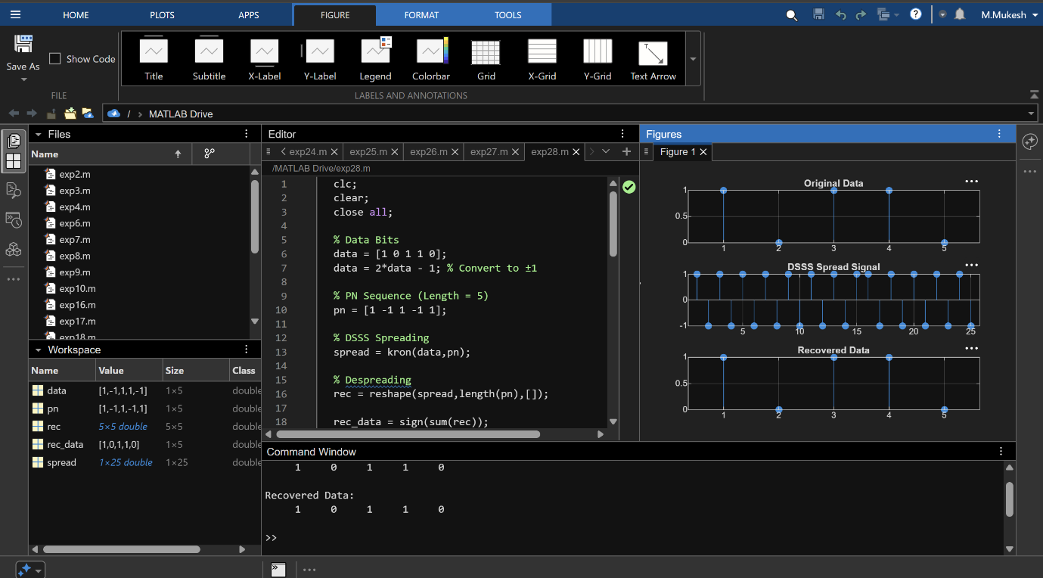

EXPERIMENT 29: GSM/TDMA
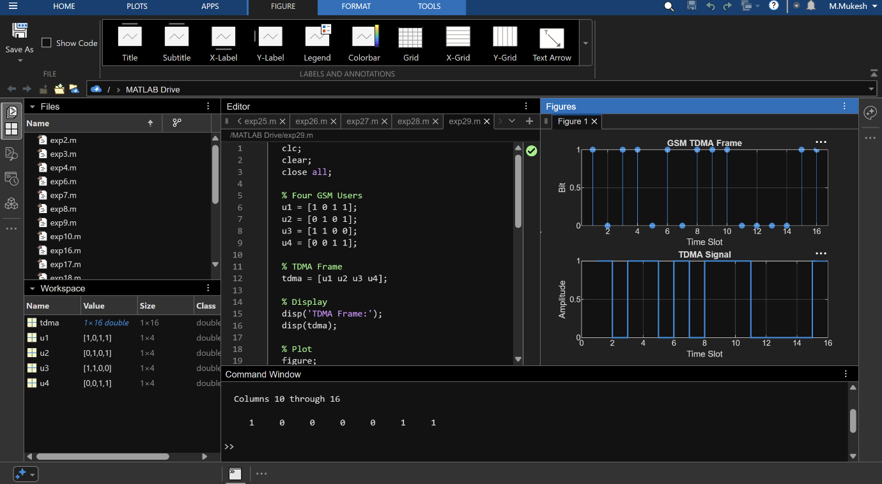

EXPERIMENT 30: Cellular Frequency Planning & Handover
