TRANSMISSION LINES & WAVEGUIDES – ECA1501

EXPERIMENT – 2

REG NO: 192412204
NAME: S. ARSHAD ALI

TEST CASE:1
AIM:
Analysis of SWR (Standing Wave Ratio) pattern in High Frequency Transmission Lines by varying
a) load impedance
b) Characteristic impedance

SOFTWARE REQUIRED:
SCILAB Version 6.1.1

PROCEDURE:
● Open SCILAB software
● Open file-new
● Put the input values
● Type the program
● Execute the program
● End the program

SCAILAB CODE:

clc;clear;close;
Zo=200;ZR=650-(%i*475);
K=(ZR-Zo)/(ZR+Zo);
EXNO: 2

Analysis of SWR (Standing Wave Ratio)Transmission Lines by varying

a)load impedance b) characteristic impedance DATE:

ampK=sqrt((real(K)^2)+(imag(K)^2));S=(1+ampK)/(1-ampK);
printf("(c)Standing wave ratio = %f",round(S*1000)/1000);

OUT PUT:
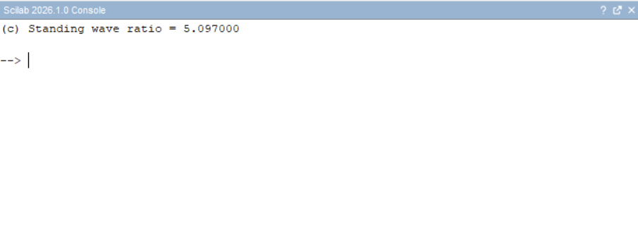

TEST CASE 2:

Analyze the SWR for a fixed load impedance (ZL) of 50 ohms while varying the
characteristic impedance (Z0) of the transmission line to 250 ohms to 400 ohms. Verify how
the SWR changes with each value Z0 including Z0=ZL.

OUT PUT :
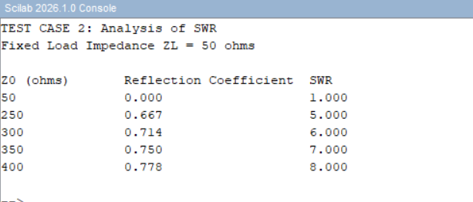

RESULT:
SWR for a fixed load impedance (ZL) of 50 ohms is analyzed while varying the characteristic
impedance (Z0) of the transmission line to 250 ohms to 400 ohms. Impact of the condition Z0=ZL
on SWR is also examined for various values of Z0 .

