SIMATS ENGINEERING
ASSESSMENT TOOL 3
COURSE CODE: ITA 06 COURSE NAME: MACHINE LEARNING

COURSE OUTCOME COVERED
CO4: K- Nearest Neighbour Learning – Locally weighted Regression – Radial Bases
Functions – Case Based Learning  Assessment Tool Weightage: 10% | (BL 5)
QUESTIONS: 15 | Total Marks:20
Annexure A Comparative Analysis
Code of Conduct:
I P.Sree Vaishnavi(192412219) (Name / Reg No) certify that this submission is my original work and that I have adhered to the guidelines specified for this assessment.
I understand that any violation of academic integrity rules will result in disciplinary action.
Criteria | Conceptual  Understanding | Accuracy  of  Answers | Application of  Knowledge | Completeness of Response | Clarity &  Presentation | Total
Weightage | 30% | 15% | 20% | 20% | 15%
Q1
Q2
Q3
P.Sree Vaishnavi
Signature of the student: Total Marks :
Annexure A

Short Answer Test
- Compare Linear Regression and Polynomial Regression for predicting housing prices. Analyze differences in model complexity, ability to capture non-linear relationships, risk of overfitting, and interpretability. Discuss scenarios where each model performs better.
- Compare Recurrent Neural Networks (RNNs) and Long Short-Term Memory (LSTM) networks for time-series prediction tasks such as stock price forecasting. Analyze differences in handling long-term dependencies, vanishing gradient problem, computational complexity, and prediction accuracy.
- Compare Naïve Bayes and Support Vector Machines (SVM) for classification problems such as sentiment analysis. Analyze differences in assumptions, decision boundaries, computational efficiency, and performance on high-dimensional data. Discuss scenarios where each method is preferable.

2. RNN vs LSTM for Time-Series Prediction
For time-series tasks such as stock price forecasting, both RNN and LSTM process data sequentially and use previous observations to predict future values.
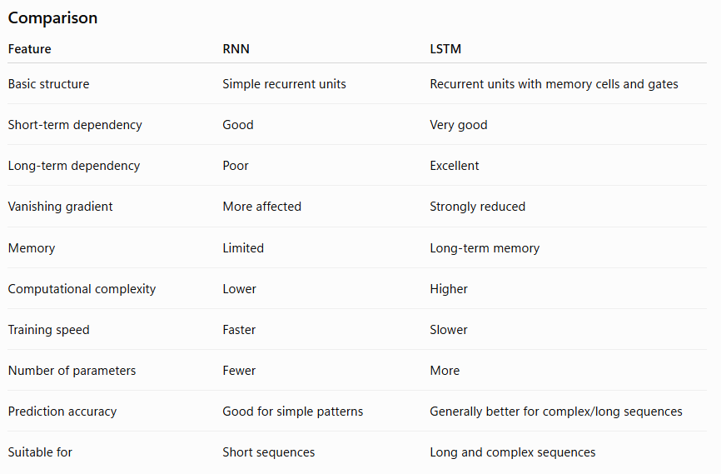
Handling Long-Term Dependencies
A standard RNN updates its hidden state as:
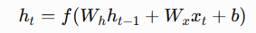
The current output depends on the previous hidden state. However, information from very early time steps can gradually disappear.
LSTM introduces a cell state and three gates:
- Forget gate
- Input gate
- Output gate
The cell state allows important information to be carried over many time steps.
Vanishing Gradient Problem
During RNN training, gradients are repeatedly multiplied through time. If these values become very small, the gradient approaches zero:
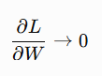
This is called the vanishing gradient problem.
LSTM reduces this problem through its gated memory mechanism, allowing important information to remain available for longer periods.
Computational Complexity
RNNs have a simpler architecture, so they generally require:
- Less memory
- Fewer parameters
- Less computation
- Faster training
LSTMs contain multiple gates and additional parameters, so they require more computational resources.
Prediction Accuracy
For a stock-price sequence where recent and older market information may influence predictions:
Past prices → Market indicators → Current price → Future price
An RNN may lose important information from older observations.
An LSTM can preserve relevant historical information for longer periods, so it often provides better performance on long and complex sequences. However, neither architecture guarantees accurate stock-price prediction because financial markets are highly noisy and difficult to predict.
When to Use Each
Use RNN when:
- The sequence is relatively short.
- Dependencies are mainly recent.
- Computational resources are limited.
- A simple baseline model is required.
Use LSTM when:
- Long-term dependencies are important.
- The sequence is long.
- Historical information influences future predictions.
- Higher prediction performance justifies additional computation.
Conclusion
LSTM is generally preferred for complex stock-price time-series prediction because its memory cells and gates handle long-term dependencies better and substantially reduce the vanishing-gradient problem. Standard RNNs remain useful when the problem is simpler and computational efficiency is more important.

3. Naïve Bayes vs SVM for Sentiment Analysis
For sentiment analysis, the input can be a text document represented using features such as word counts, TF-IDF values, or n-grams.
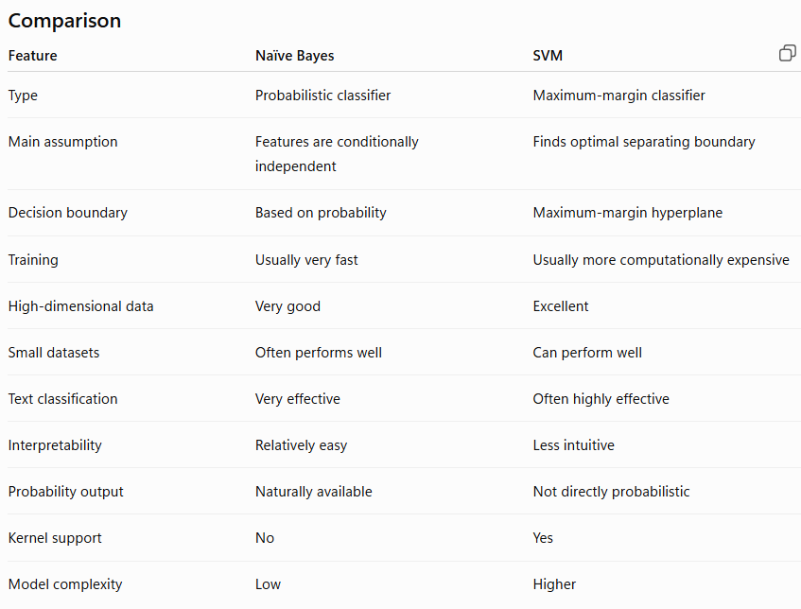
1. Assumptions
Naïve Bayes
Naïve Bayes assumes that features are conditionally independent given the class.
For a document :
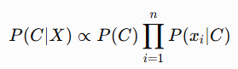
For example, the words:
excellent
good
amazing
are treated as separate features when calculating the probability of the positive class.
The independence assumption is often unrealistic for natural language, but Naïve Bayes can still perform surprisingly well.
SVM
SVM does not make the same feature-independence assumption. It tries to find a decision boundary that maximizes the separation between classes.
For a linear SVM:
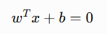
The classifier predicts one class on one side of the hyperplane and another class on the other side.
2. Decision Boundaries
Naïve Bayes:
Text Features
↓
Calculate class probabilities
↓
Highest probability
↓
Positive / Negative
SVM:
Text Features
↓
Find maximum-margin hyperplane
↓
┌───────────────┐
│ Decision │
│ Boundary │
└───────────────┘
↓
Positive / Negative
SVM can also use nonlinear kernels when the data cannot be effectively separated by a straight boundary.
3. Computational Efficiency
Naïve Bayes is generally very fast to train and predict, making it useful for large collections of text documents.
SVM training can be more computationally expensive, particularly with large datasets or nonlinear kernels. However, linear SVMs are highly practical for large, sparse text datasets.
4. High-Dimensional Data
Sentiment-analysis datasets may contain thousands or millions of possible words.
For example:
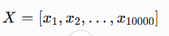
where each feature represents a word or n-gram.
Both methods can work well with high-dimensional sparse text data.
- Naïve Bayes: Efficient and simple.
- Linear SVM: Often very strong for text classification because it can find an effective separating boundary in a high-dimensional feature space.
Naïve Bayes calculates:
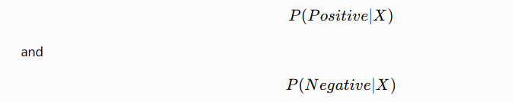
and selects the class with the higher probability.
SVM maps the sentence into the feature space and determines which side of the learned decision boundary it falls on.
When Naïve Bayes is Preferable
Choose Naïve Bayes when:
- Training speed is important.
- The dataset is very large.
- A simple baseline is required.
- Text contains many sparse features.
- Probabilistic predictions are useful.
- Computational resources are limited.
When SVM is Preferable
Choose SVM when:
- Classification accuracy is a high priority.
- The dataset contains high-dimensional features.
- A strong linear classifier is required.
- The classes have a reasonably separable boundary.
- More computational resources are available.

RUBRICS FOR CALCULATION
Criteria | Weightage | Level 4 –  Exemplary (5  Marks) | Level 3 –  Proficient (4  Marks) | Level 2 –  Developing (2–3 Marks) | Level 1 –  Beginning (0–1  Mark)
Conceptual  Understanding | 30 | Demonstrates clear and complete understanding of  the concept | Good  understanding  with minor gaps | Basic understanding with some  misconceptions | Poor or incorrect  understanding
Accuracy of  Answer | 15 | Completely correct answer with no  errors | Mostly correct with minor errors | Partially correct with noticeable errors | Incorrect or  irrelevant answer
Application of  Knowledge | 20 | Correctly applies concepts to solve  the  question/problem | Applies concepts  with minor  mistakes | Limited or partially  correct application | No or incorrect application
Completeness of Response | 20 | Covers all required parts of the  question | Covers most parts with minor  omissions | Covers only some  parts | Incomplete or missing response
Clarity &  Presentation | 15 | Clear, concise, and well-organized answer | Understandable  with minor  issues | Somewhat unclear  or poorly structured | Difficult to understand

