Exp. 5. Band Structure Simulation for Graphene and CNTs using NanoHub
Case Study 1: Simulate the band-structure of InAs circular nanowire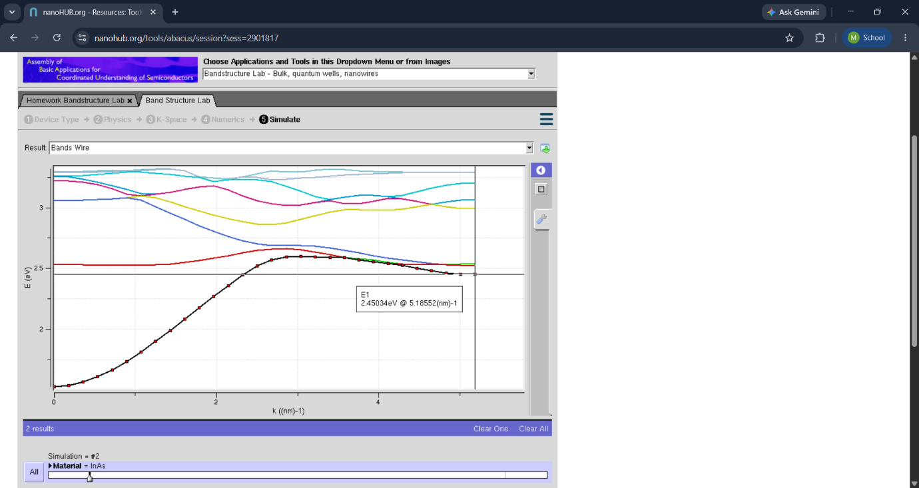
Case Study 2: Simulate the band-structure of AlGaAs circular nanowire

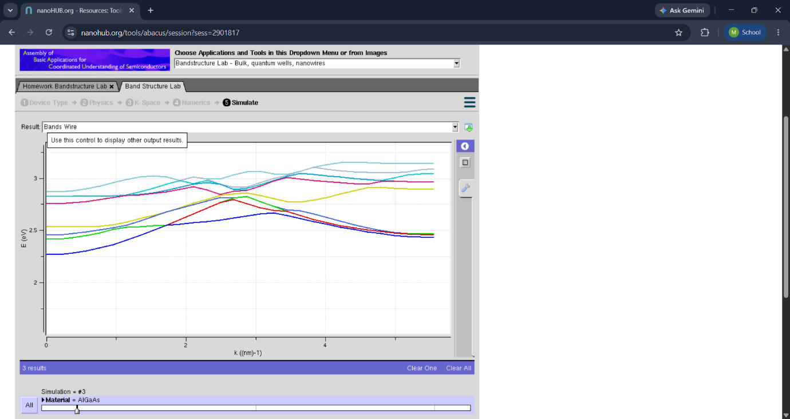
Exp-6 Demonstration of quantum tunnelling
Case study 1 : Analysis the transmission co-efficient Vs Energy characteristics on refined grid
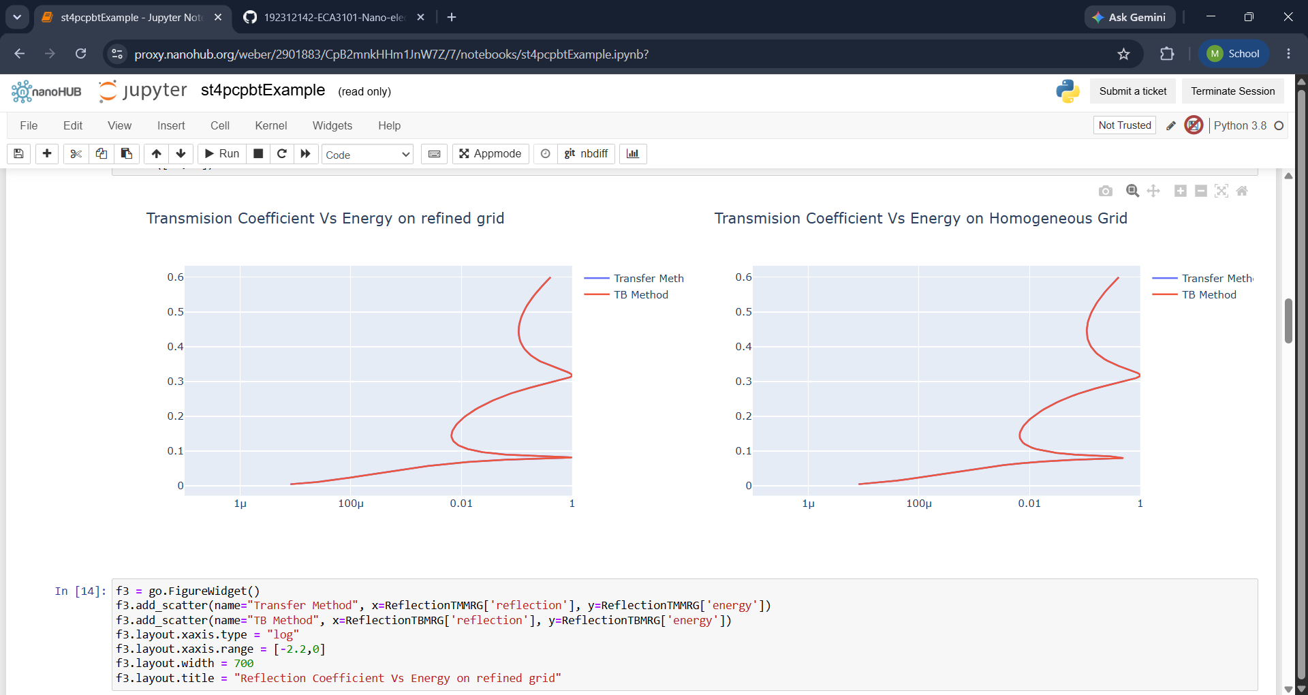
Case study 2 : Analysis the Reflection co-efficient Vs Energy on Homogeneous Grid
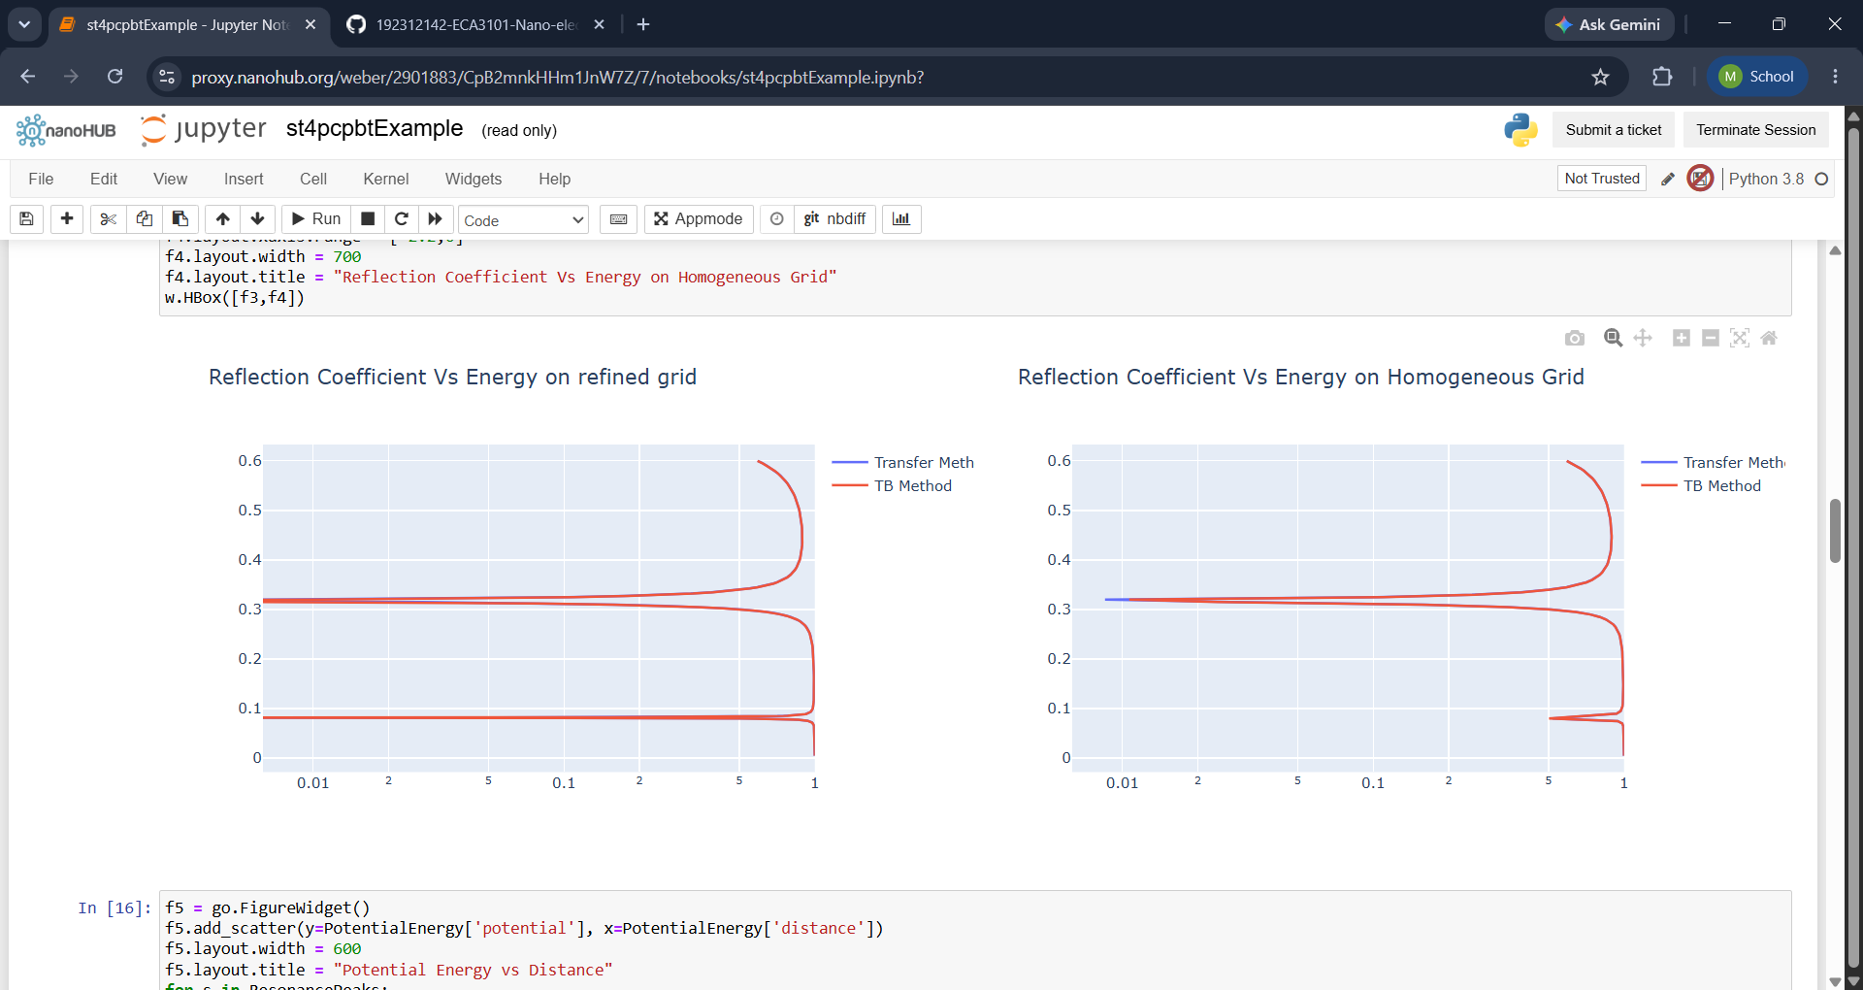
Exp. 7. MOSFET Scaling Analysis and Subthreshold Swing Calculation using NanoHub
Case 1: Increase in VG :
● Observation: As VG increases, the drain current (ID ) also increases exponentiallydue to the MOSFET entering the saturation region earlier.
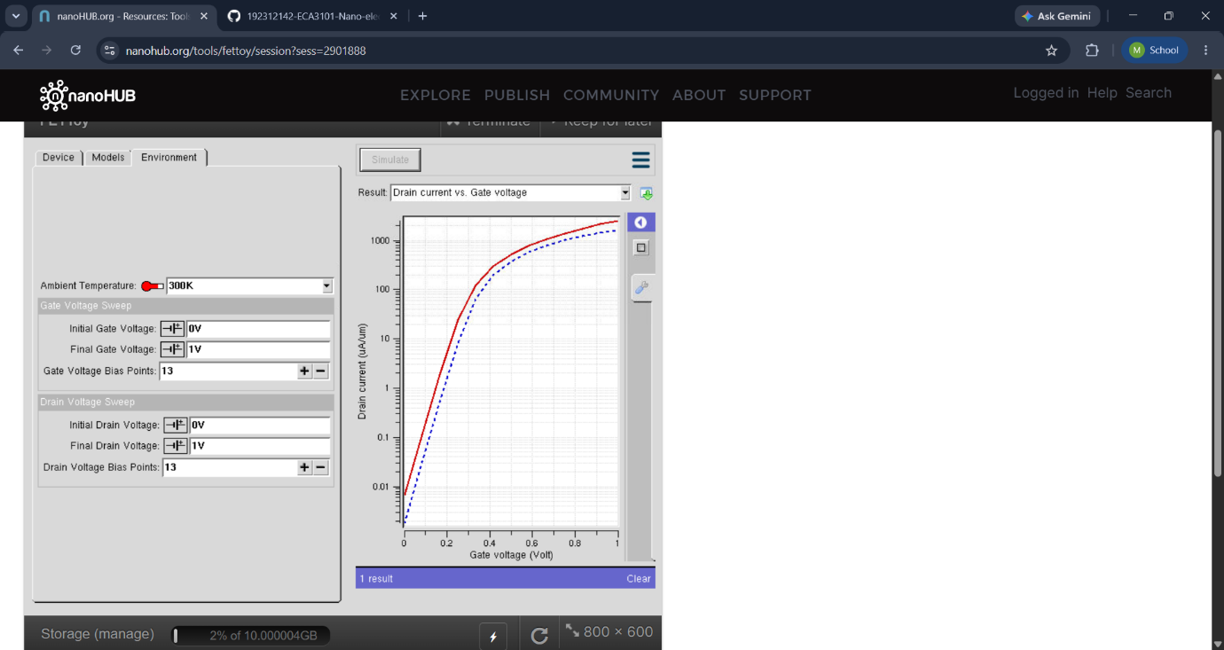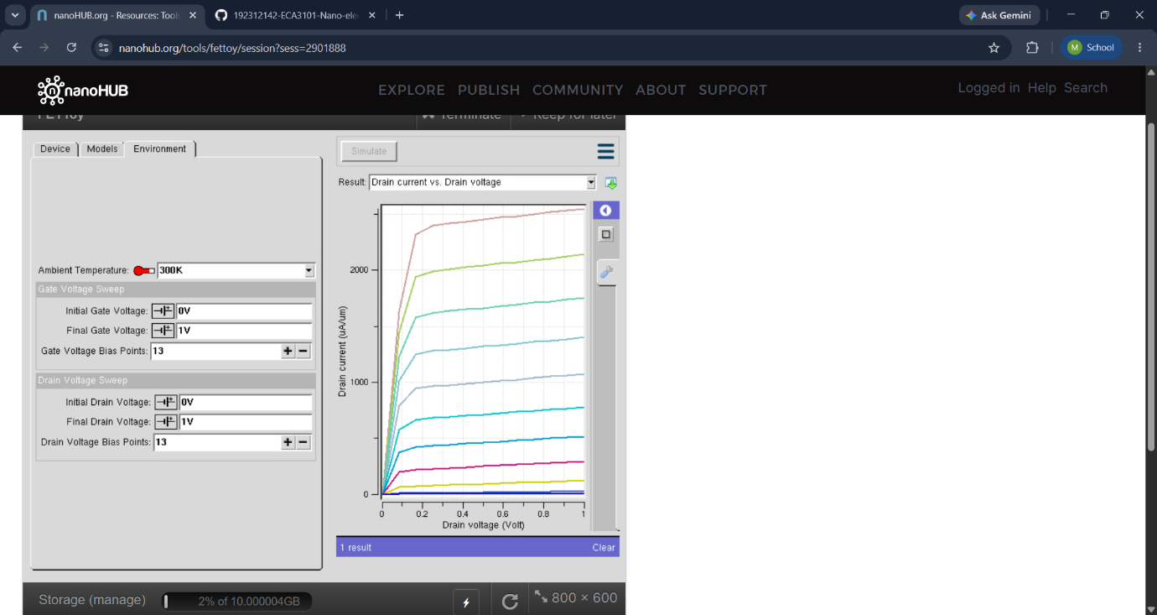
Case 2: Variation in VD :
● Observation: Drain current (ID ) saturates for higher VD at a fixed VG
