Exp:7-Determination and plotting of Capacitance of isolated and concentric sphere with different inner and outer radius and dielectric constant of the dielectric mediums.
Aim:
To write program for Capacitance of an isolated sphere and two concentric sphere using SCILAB.

Software required:
•SCILAB version 6.0.1

Program:
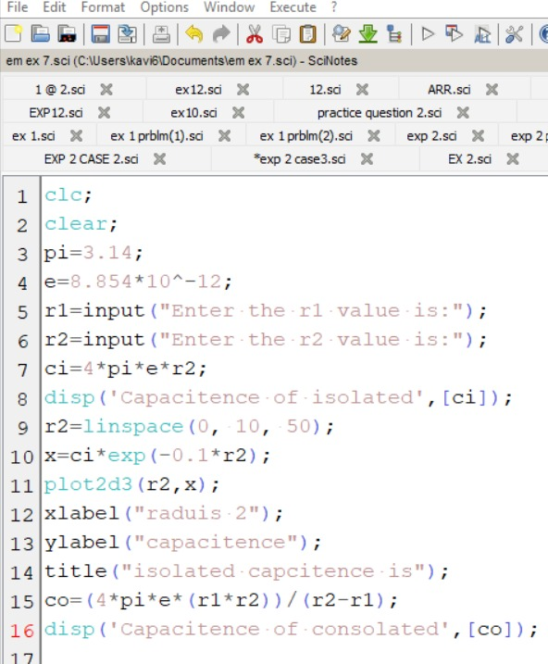
Output:-
Enter the r1 value is:3*10^3
Enter the r2 value is:7*10^3

"Capacitence of isolated"

7.784D-13

"Capacitence of consolated"

3.338D-13

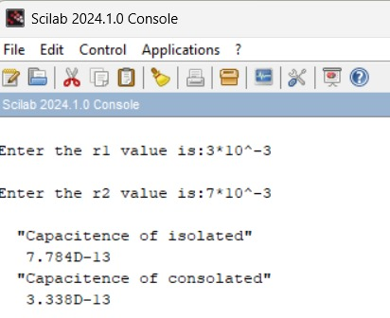

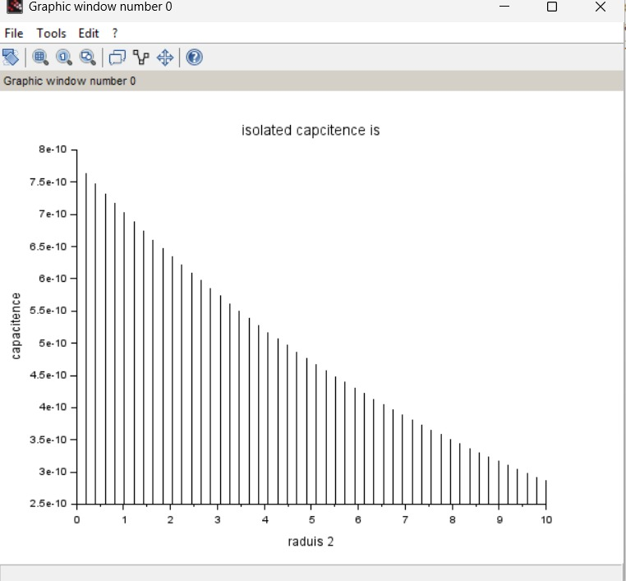
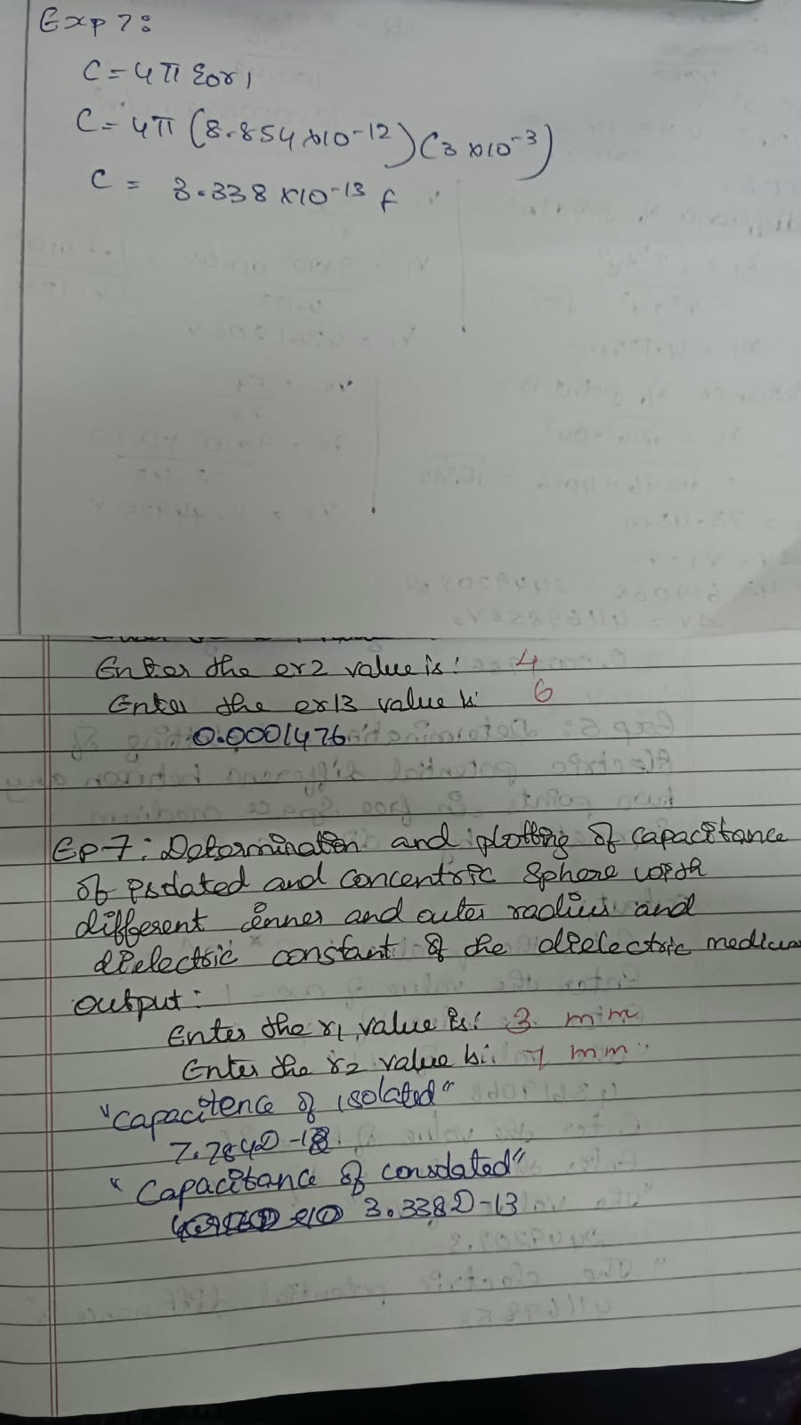
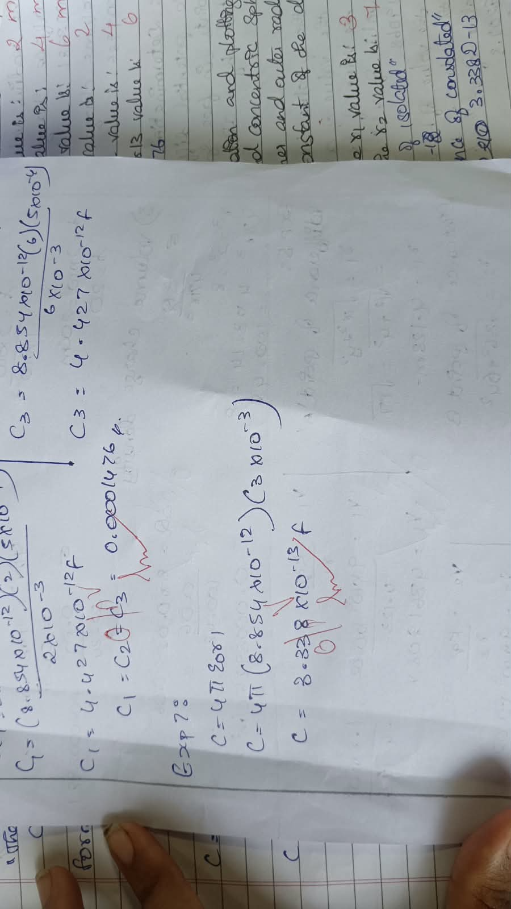

CASE 1:-CONCENTRIC SPHERICAL CAPACITOR WITH DIFFERENT DIELECTRIC MEDIUMS
CODE:-
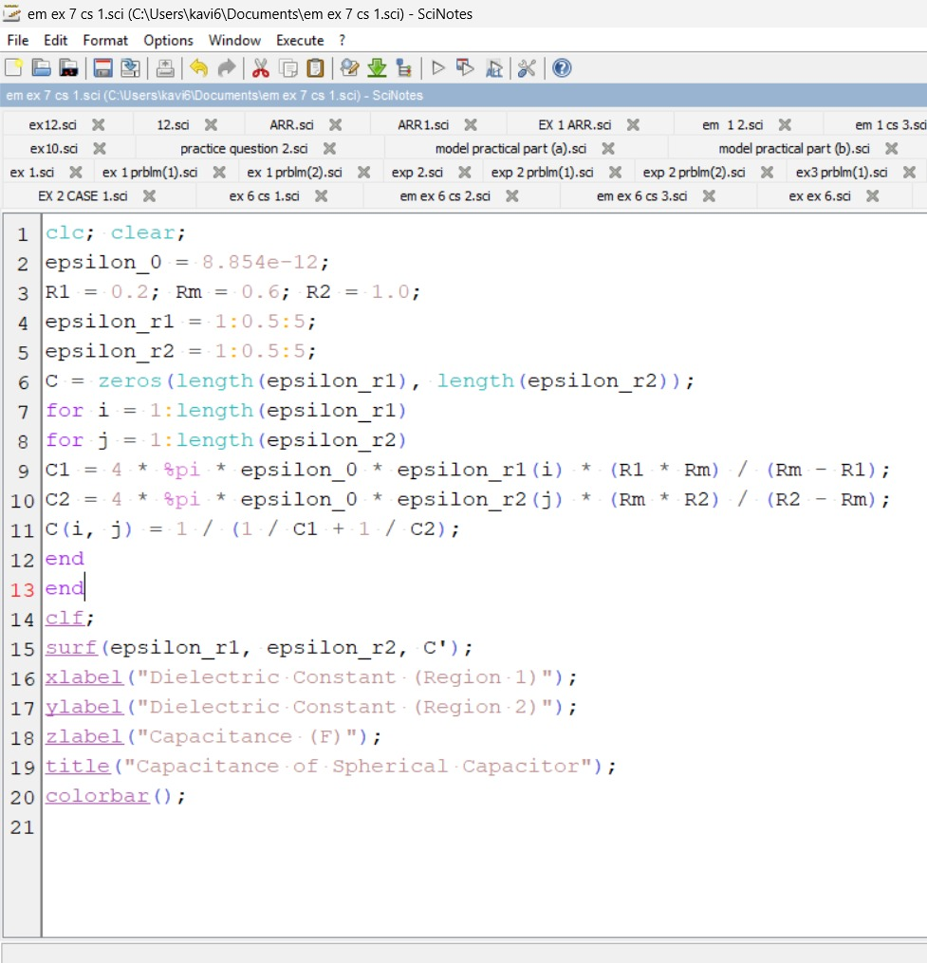
OUTPUT:
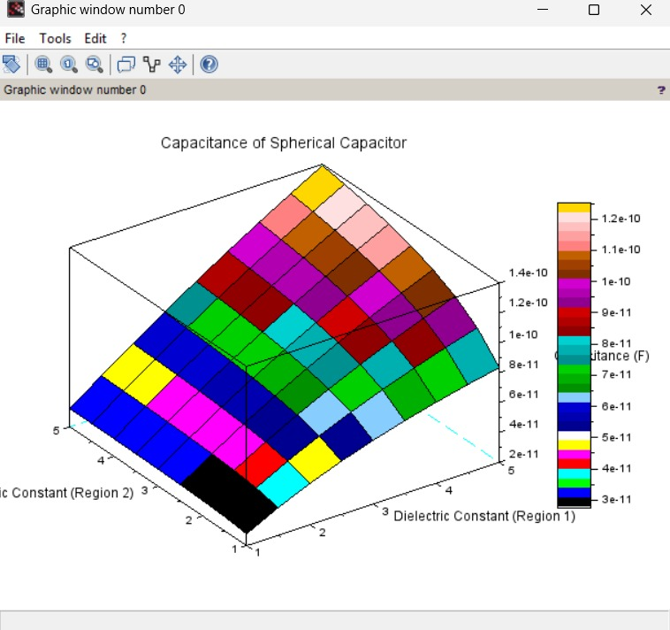

CASE 2: ISOLATED SPHERE
CODE:- 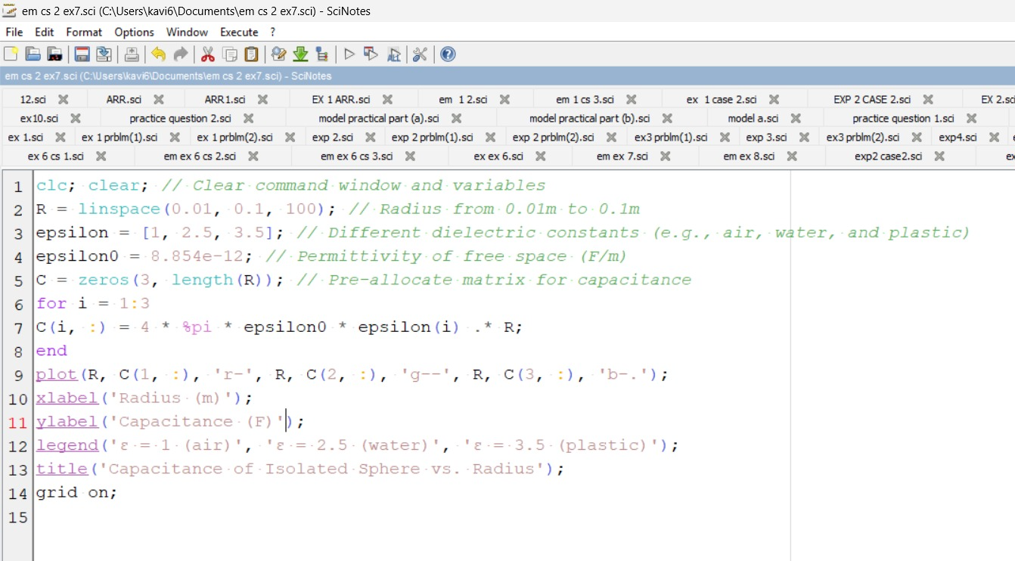

OUTPUT:

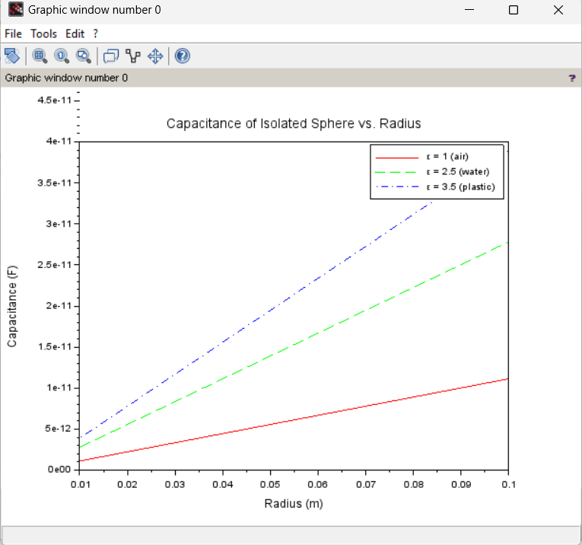

CASE 3: CONCENTRIC SPHERICAL CAPACITOR
CODE:-
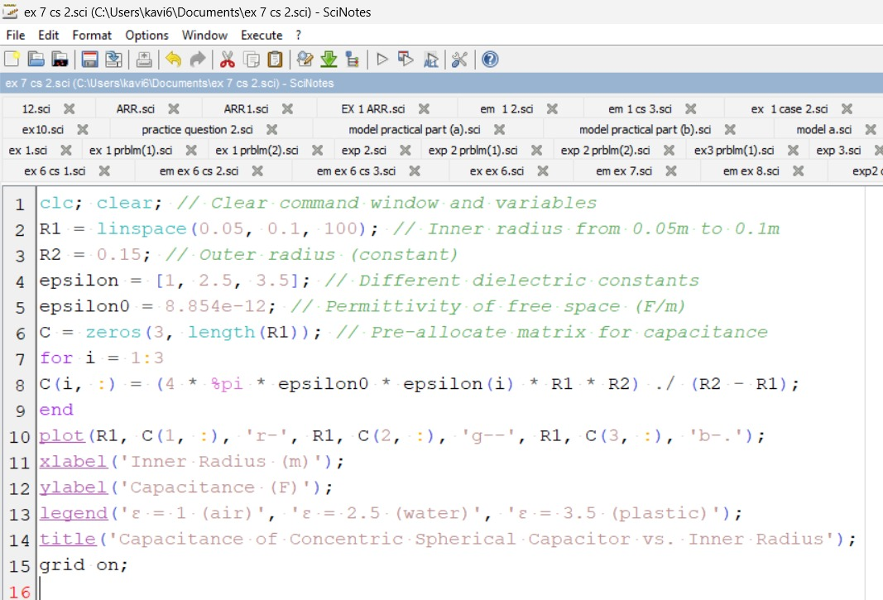

OUTPUT:
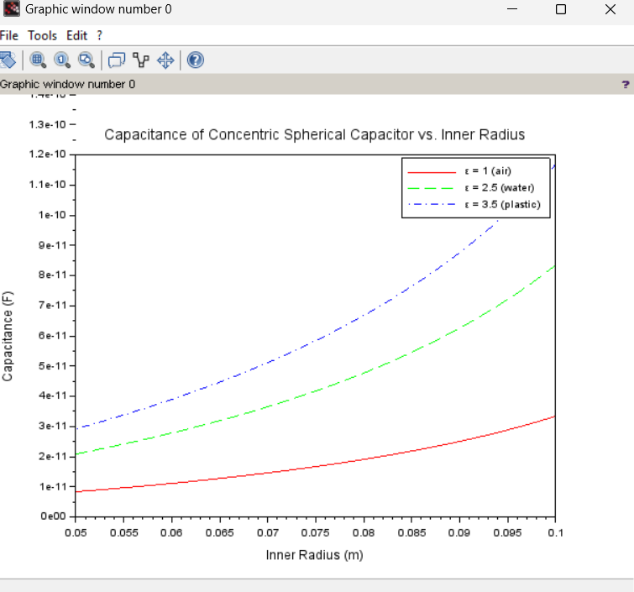

Result :
Thus the program was verified for Capacitance of an isolated sphere and two concentric sphere using SCILAB was successfully.

