Exp no:8 -Determination and plotting of Capacitance of Co-axial cable per unit length with different (i) inner radius, (ii) outer radius and (iii) relative permittivity of the dielectric medium.

Aim:
To write program for Capacitance of co-axial cable per unit length using SCILAB.

Software required:
•SCILAB version 6.0.1

Program:
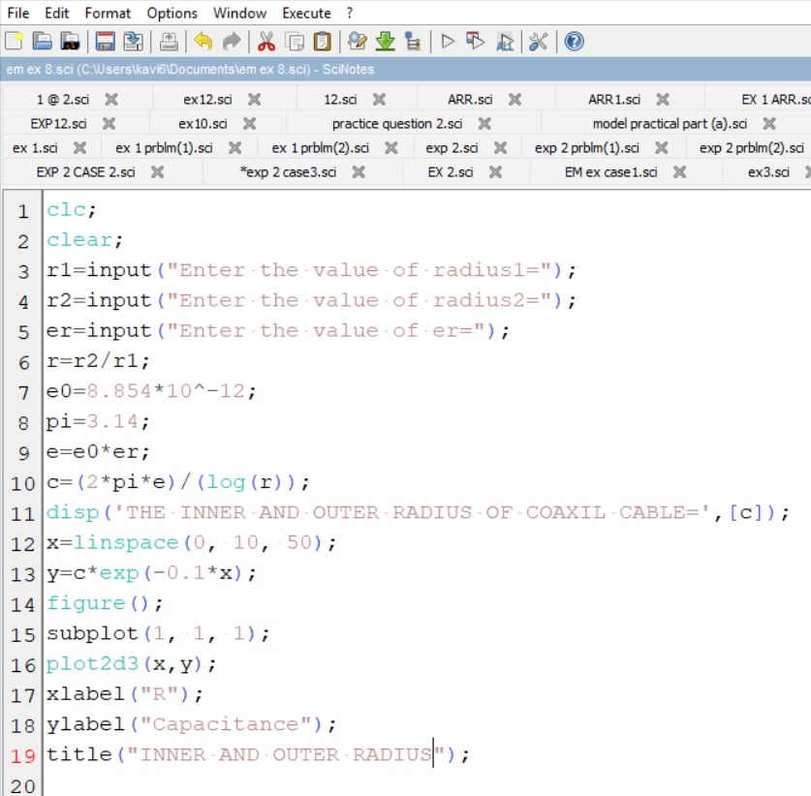

Output:-
Enter the value of radius1=2*10^-2
Enter the value of radius2=3*10^-2
Enter the value of er=1.77*10^-11

"THE INNER AND OUTER RADIUS OF COAXIL CABLE="
2.427D-21
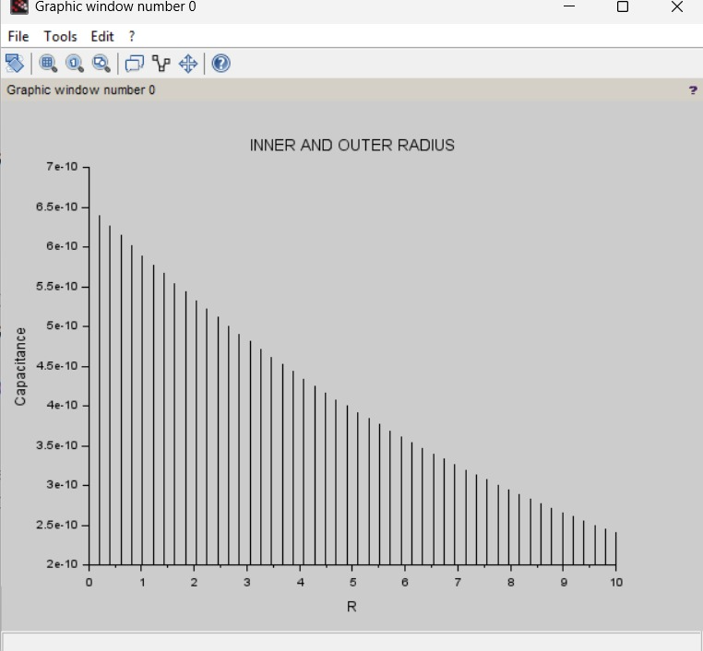
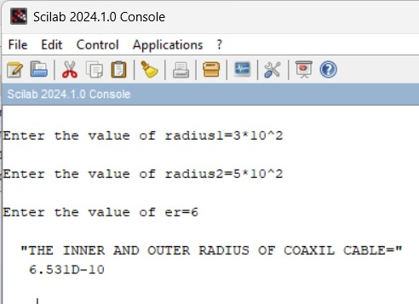
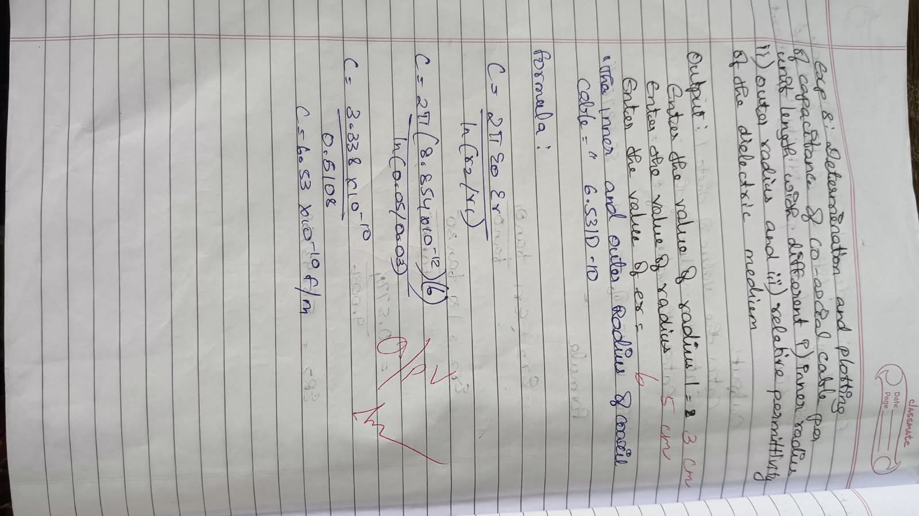
CASE STUDY 1: Variation with Inner Radius
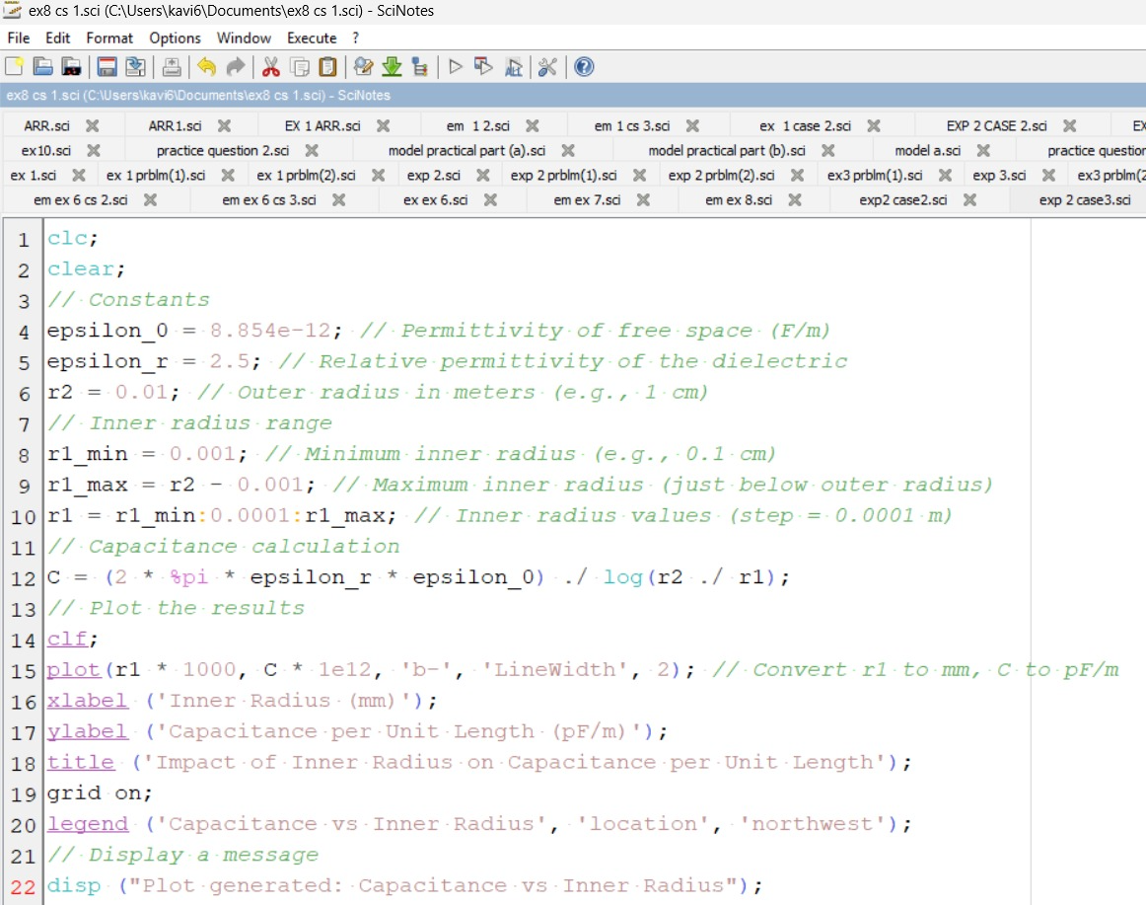
OUTPUT:
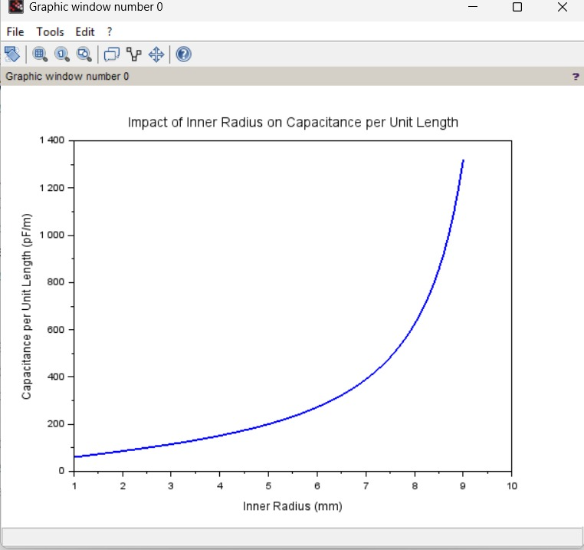

CASE STUDY 2: Variation with Outer Radius
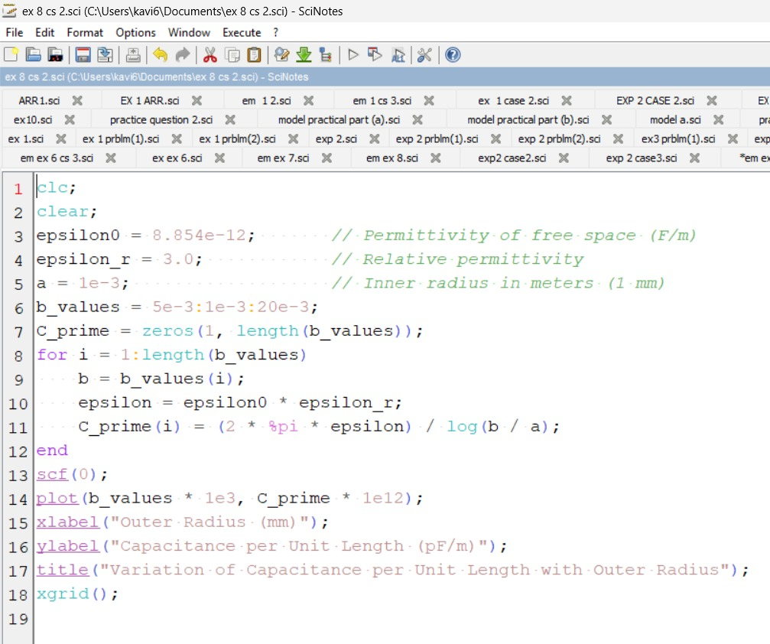
OUTPUT:

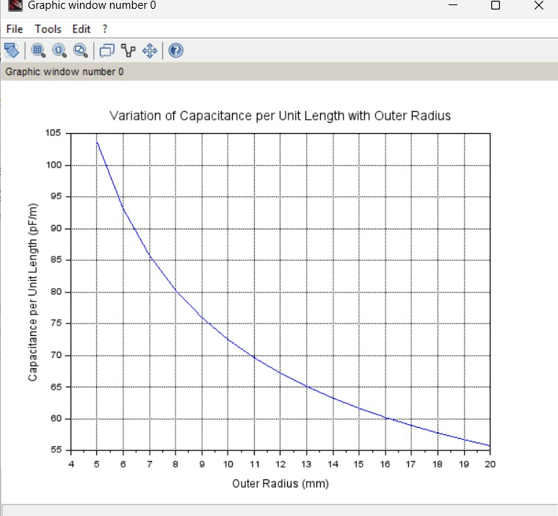
CASE STUDY 3: Variation with Relative Permittivity
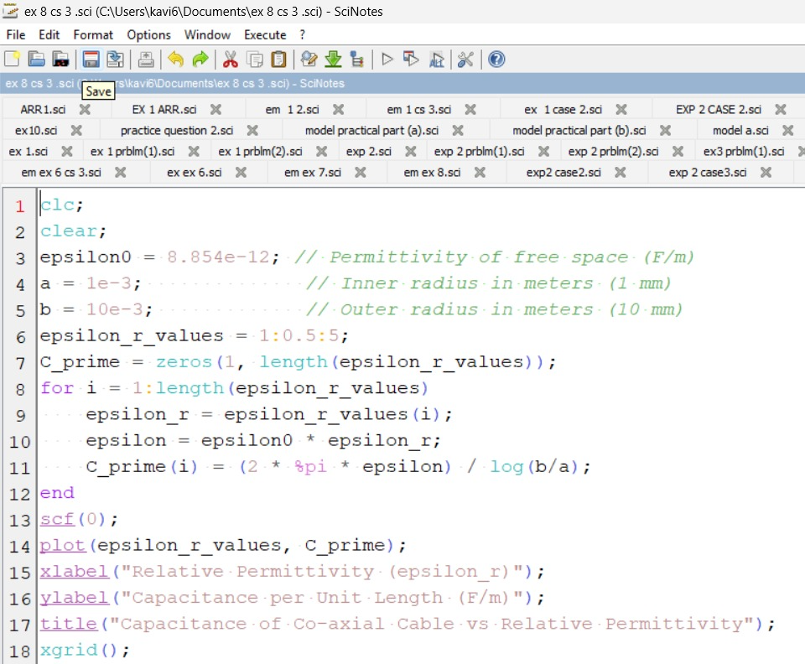
OUTPUT:
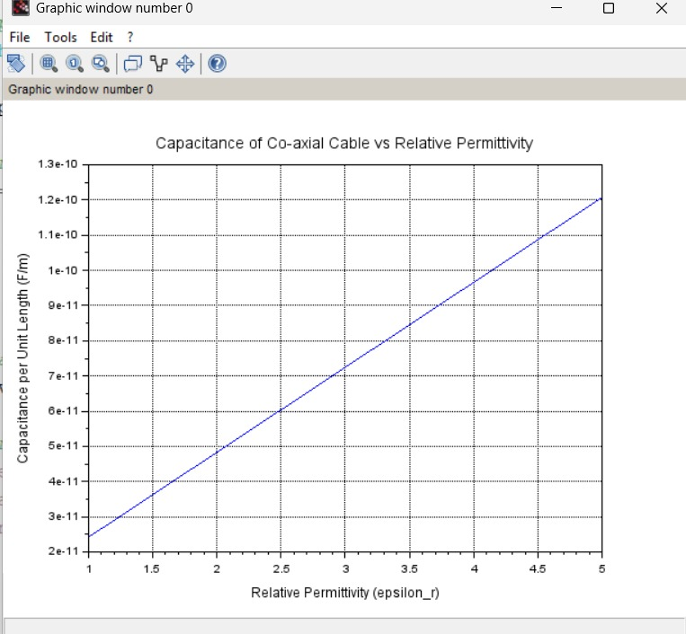

Result :
Thus the program was verified for Capacitance of co-axial cable per unit length using SCILAB was successfully.

