Exp. No: 1
Transformation between Cartesian, Cylindrical and spherical coordinate system
Aim:
To write program for Transformation between Cartesian, Cylindrical and spherical coordinate system using SCILAB.
Software required:
•SCILAB version 6.0.1
Program: 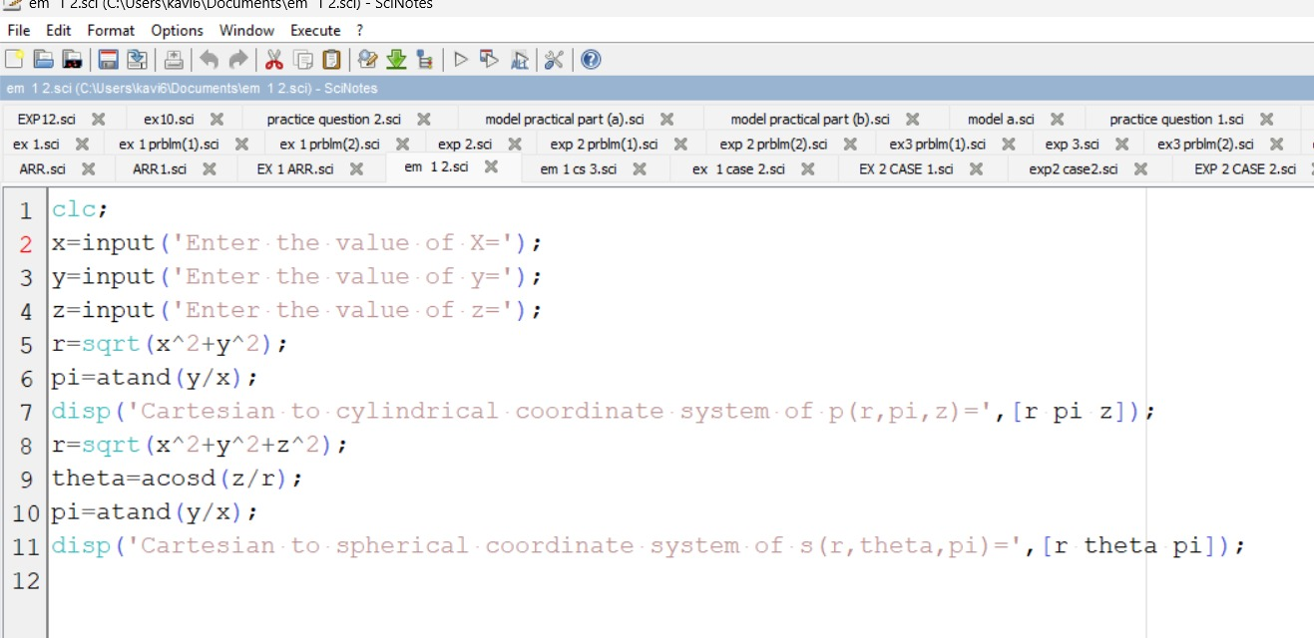
Test case (i) Transformation of Cartesian coordinate points in to Cylindrical and spherical coordinate system
Output:-
Enter the value of X=13
Enter the value of y=4
Enter the value of z=-2
"cartesain to cylinderical coordinate system of p(r,pi,z)="
13.601471 17.102729 -2.
"cartesain to spherical coordinate system of s(r,theta,pi)="
13.747727 98.364994 17.102729
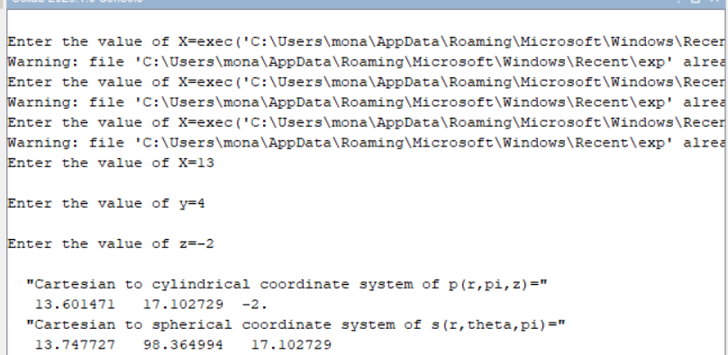

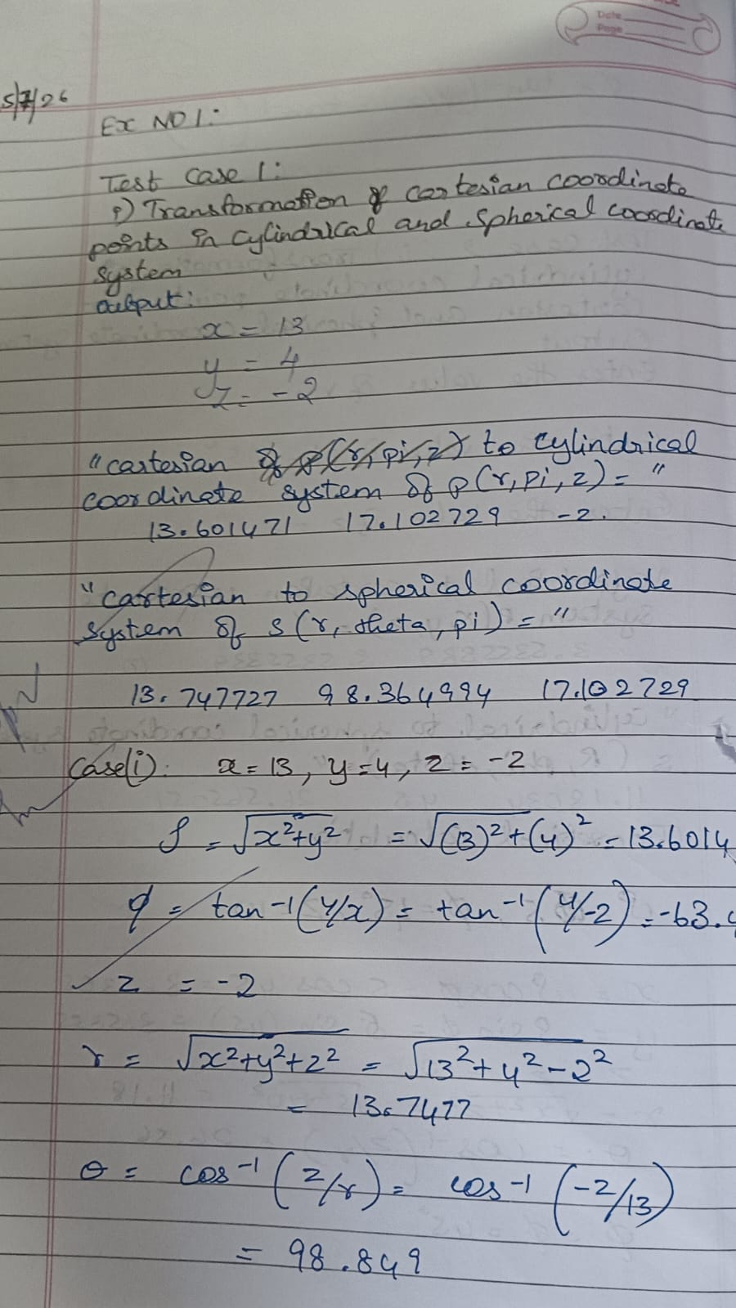
Test case (ii) Transformation of Cylindrical coordinate points into Cartesian and spherical coordinate system

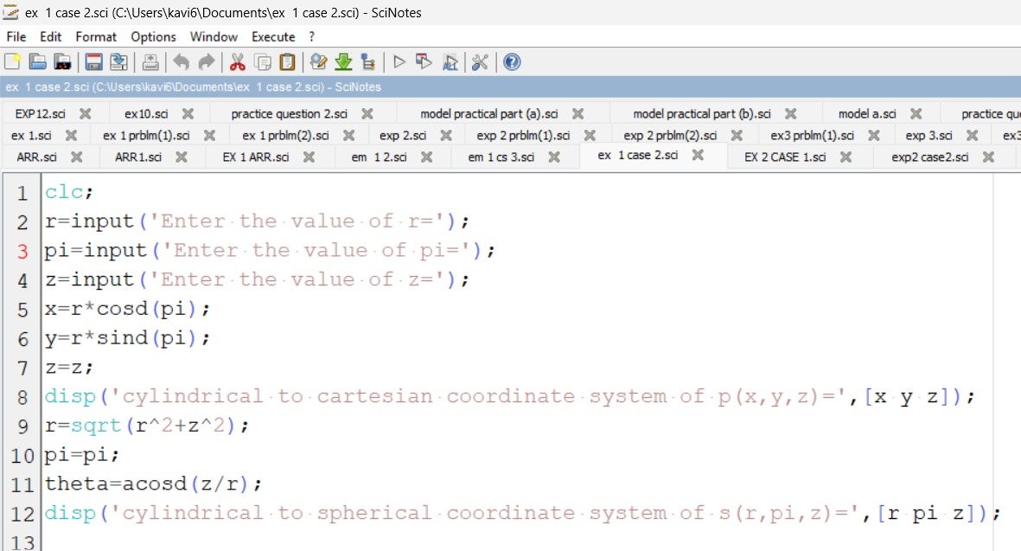Output:-
Enter the value of r=5
Enter the value of pi=45
Enter the value of z=-10
"cylinderical to cartesian coordinate system of p(x,y,z)="
3.5355339 3.5355339 10
"cylinderical to spherical coordinate system of s(r,pi,theta)="
11.18034 45. 26.565051
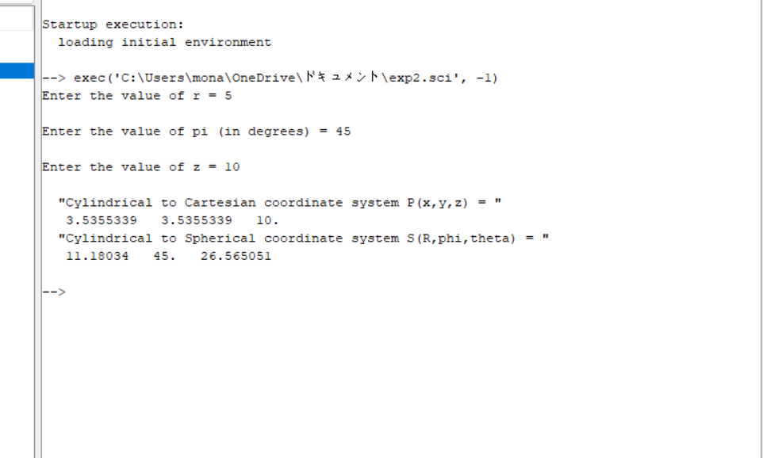
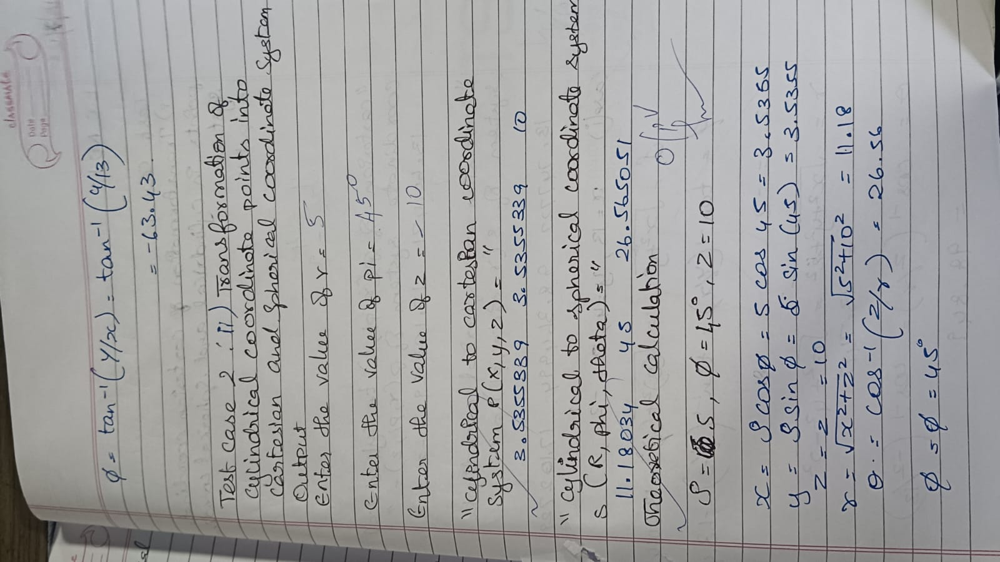

Test case (iii) Transformation of spherical coordinate points into Cylindrical and Cartesian coordinate system
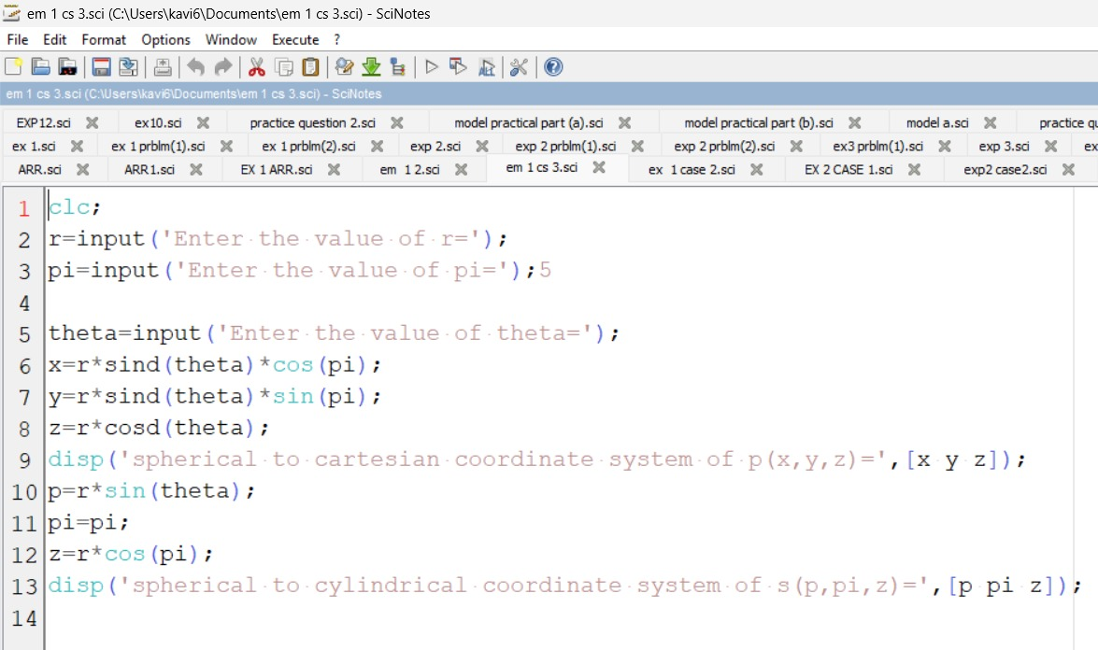Output:-
Enter the value of r=5
Enter the value of pi=30
Enter the value of theta=120

"spherical to cartesian coordinate system of p(x,y,z)="
0.667984 -4.2783024 -2.5
"spherical to cylinderical coordinate system of s(p,pi,z)="
2.9030559 30 0.7712572
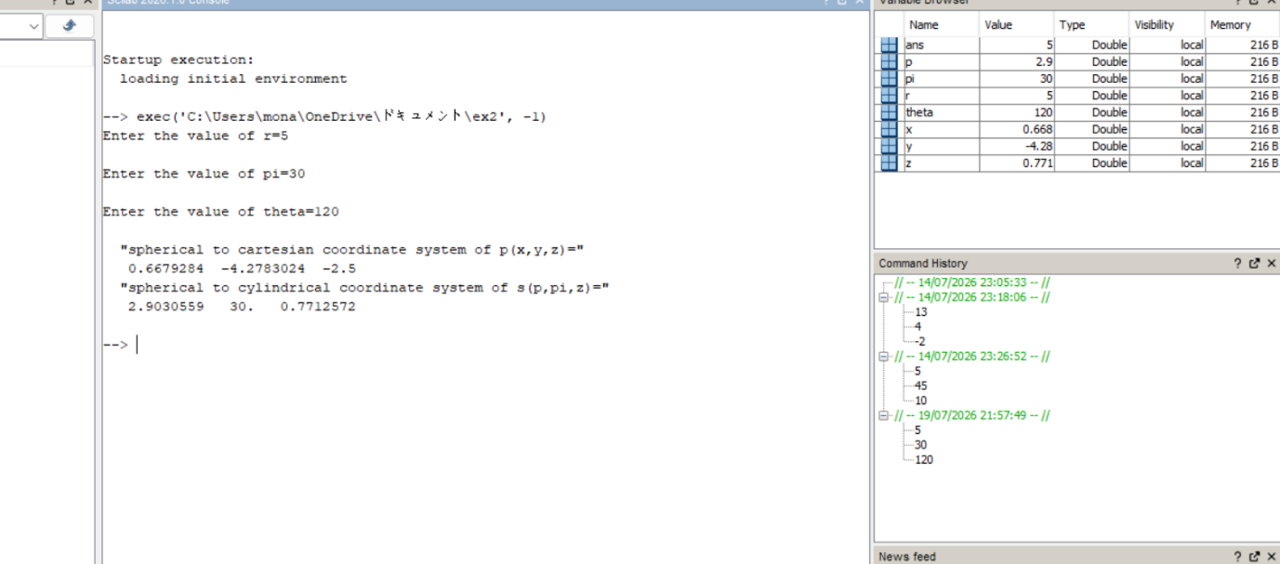
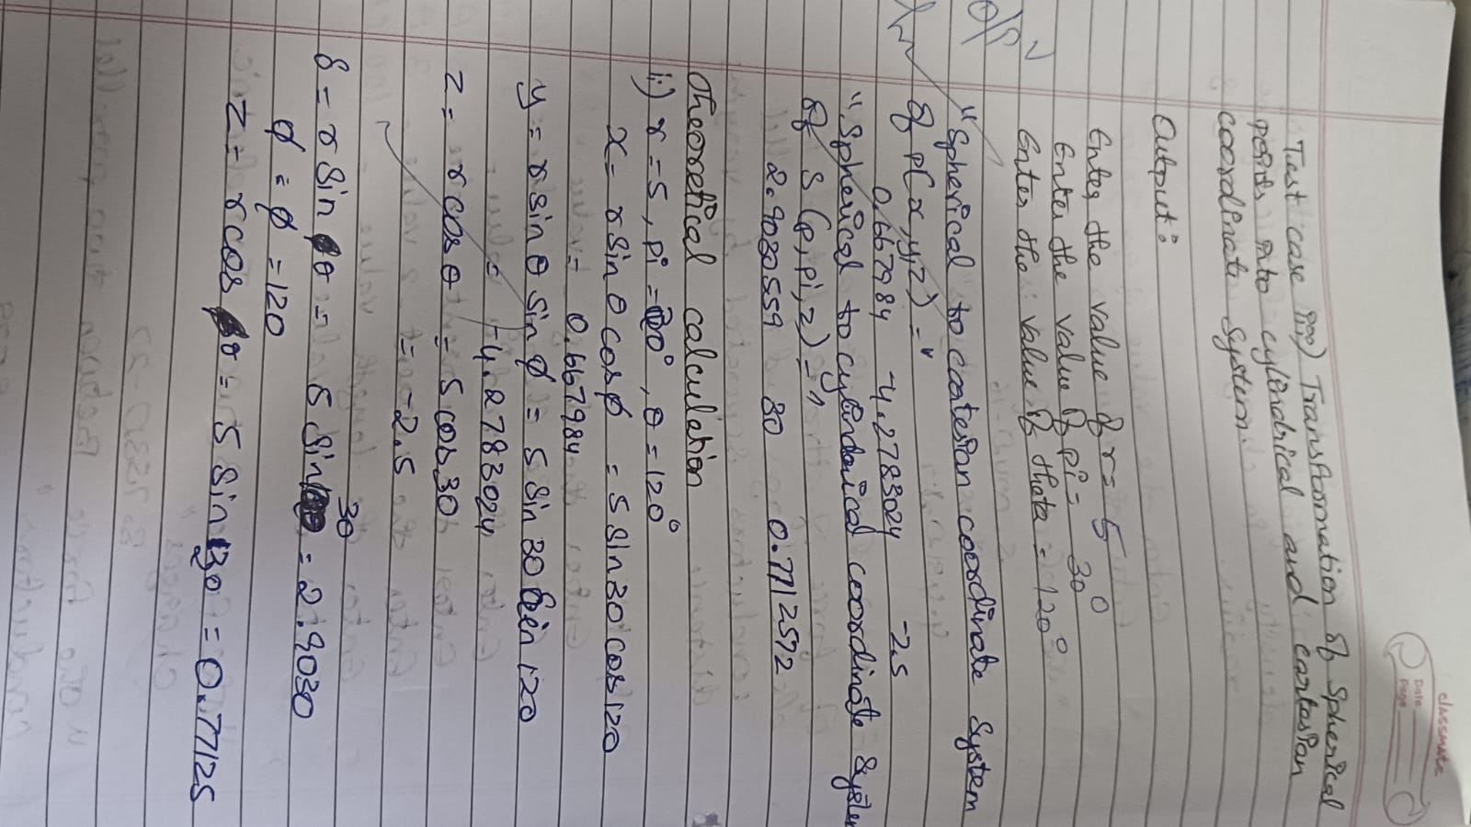
Result:
Thus, the program was verified Transformation between Cartesian and Cylindrical coordinate system its classified two categories (a) Cartesian to cylindrical and spherical coordinate system (b) Cylindrical to cartesian and spherical coordinate system (c) spherical to cartesian and cylindrical coordinate system using SCILAB was successfully.

