TRANSMISSION LINES & WAVEGUIDES – ECA1501
EXPERIMENT – 1
Estimation of Characteristic Impedance (Z₀) and Propagation Constant (γ) of a Transmission Line
Name | K.MONISHA | Reg. No. | 192412296
Date | 10/10/2026 | Experiment No. | 1

1. AIM
To investigate the characteristic impedance (Z₀) and propagation constant (γ) of a transmission line using its primary constants R, L, G and C, and to study the effects of resistance, inductance, frequency and capacitance.
2. SOFTWARE REQUIRED
SCILAB Version 6.1.1
3. THEORY / FORMULAE
Characteristic impedance: Z₀ = √[(R + jωL)/(G + jωC)]
Propagation constant: γ = √[(R + jωL)(G + jωC)] = α + jβ
Here, α is the attenuation constant in neper/km, β is the phase constant in radians/km, and ω = 2πf. R, L, G and C are specified per kilometre.
4. PROCEDURE
- Open SCILAB software and create a new file.
- Enter the required values of R, L, G, C and frequency.
- Type and execute the Scilab program.
- Record Z₀, α and β.
- Repeat the calculations for the specified parameter variations.
5. TEST CASE 1 – BASIC CALCULATION
Inputs used in the corrected Scilab program:
Parameter | Value | Unit
R | 10 | Ω/km
L | 3 | mH/km
C | 16 | µF/km
G | 4 | µS/km
f | 2 | kHz

6. TEST CASE 1 – CORRECT RESULT
Input | Z₀ (Ω) | α (neper/km) | β (rad/km)
R=10, L=3 mH/km, C=16 µF/km, G=4 µS/km, f=2 kHz | 13.81 - j1.80 | 0.3621 | 2.7769

Values above are calculated from the stated inputs without rounding the intermediate values.
7. TEST CASE 2 – EFFECT OF RESISTANCE AND INDUCTANCE
A. Variable resistance: L = 3.5 mH/km, C = 8 µF/km, G = 4 µS/km, f = 2.5 kHz.
R (Ω/km) | Z₀ (Ω) | α (neper/km) | β (rad/km)
10 | 21.00 - j1.89 | 0.2381 | 2.6392
20 | 21.25 - j3.74 | 0.4707 | 2.6702
30 | 21.63 - j5.52 | 0.6935 | 2.7184
40 | 22.12 - j7.19 | 0.9042 | 2.7796
50 | 22.68 - j8.77 | 1.1023 | 2.8502

B. Variable inductance: R = 10 Ω/km, C = 8 µF/km, G = 4 µS/km, f = 2.5 kHz.
L (mH/km) | Z₀ (Ω) | α (neper/km) | β (rad/km)
3.5 | 21.00 - j1.89 | 0.2381 | 2.6392
6 | 27.42 - j1.45 | 0.1824 | 3.4463
8.5 | 32.62 - j1.22 | 0.1534 | 4.0990
11 | 37.10 - j1.07 | 0.1349 | 4.6617

8. TEST CASE 3 – EFFECT OF FREQUENCY AND CAPACITANCE
A. Variable frequency: R = 10 Ω/km, L = 3.5 mH/km, C = 8 µF/km, G = 4 µS/km.
f (kHz) | Z₀ (Ω) | α (neper/km) | β (rad/km)
2 | 21.05 - j2.36 | 0.2376 | 2.1161
4 | 20.95 - j1.19 | 0.2387 | 4.2123
6 | 20.93 - j0.79 | 0.2389 | 6.3128
8 | 20.92 - j0.59 | 0.2390 | 8.4144
10 | 20.92 - j0.48 | 0.2390 | 10.5165

B. Variable capacitance: R = 10 Ω/km, L = 3.5 mH/km, G = 4 µS/km, f = 2 kHz.
C (µF/km) | Z₀ (Ω) | α (neper/km) | β (rad/km)
8 | 21.05 - j2.36 | 0.2376 | 2.1161
10 | 18.83 - j2.11 | 0.2656 | 2.3659
12 | 17.19 - j1.93 | 0.2910 | 2.5917
14 | 15.91 - j1.79 | 0.3143 | 2.7994
16 | 14.88 - j1.67 | 0.3360 | 2.9927

9. SCILAB PROGRAM
clear; clc;
R=10; L=0.003; f=2*10^3; G=4*(10^-6); C=16*(10^-6);
w=2*%pi*f;
Z=R+(%i*w*L);
Y=G+(%i*w*C);
Zo=sqrt(Z/Y);
C1=round(real(Zo));
D=round(imag(Zo));
printf('-Zo = %f + j(%f) ohms\\n',real(Zo),imag(Zo));
P=sqrt(Z*Y);
a=real(P);
a1=round(a*10000)/10000;
printf('-Attenuation constant alpha = %f neper/km\\n',a1);
b=imag(P);
b1=round(b*10000)/10000;
printf('-Phase constant beta = %f radians/km\\n',b1);
SCILAB RESULT SCREENSHOT

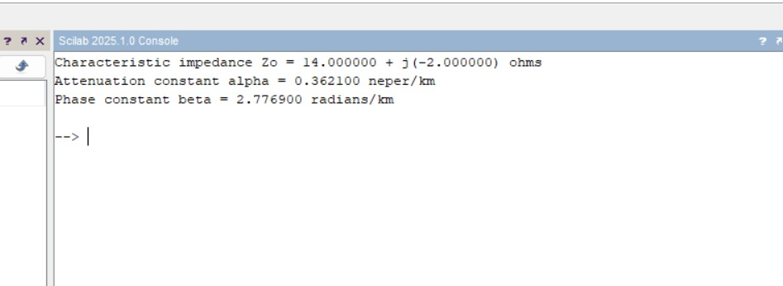
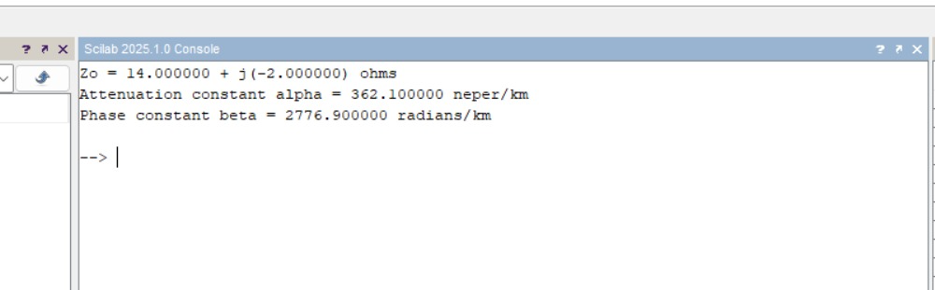
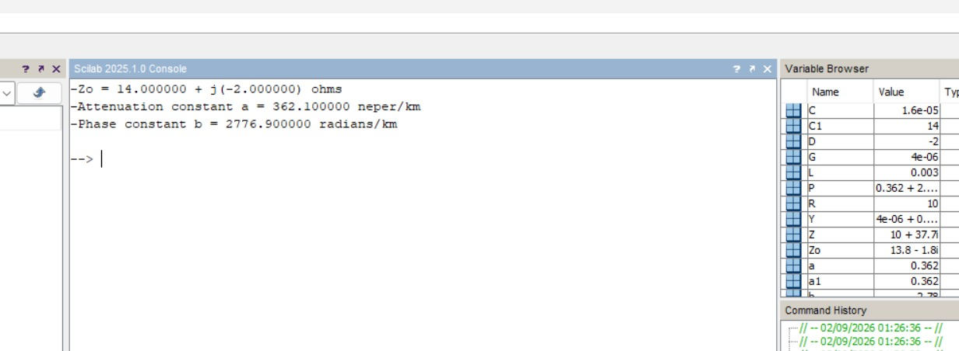

10. RESULTS
Test Case 1: Z₀ = 13.8110 -1.8005j Ω, α = 0.3360 neper/km and β = 2.9927 radians/km.
Test Cases 2 and 3: The effects of resistance, inductance, frequency and capacitance on characteristic impedance and propagation constants were evaluated using the values listed in the tables.

