TRANSMISSION LINES & WAVEGUIDES – ECA1501
EXPERIMENT – 2
Analysis of SWR (Standing Wave Ratio) by Varying Load Impedance and Characteristic Impedance

Name | K. MONISHA | Reg. No. | 192412296
Date | 12.10.2026 | Experiment No. | 2

1. AIM
To analyze the standing wave ratio (SWR) of a transmission line by (a) varying load impedance while keeping characteristic impedance fixed, and (b) varying characteristic impedance while keeping load impedance fixed. Verify that SWR = 1 when ZL = Z0, indicating no reflection.
2. SOFTWARE REQUIRED
SCILAB Version 6.1.1
3. THEORY / FORMULAE
Reflection coefficient: Γ = (ZL − Z0) / (ZL + Z0)
Magnitude of reflection coefficient: |Γ| = abs(Γ)
Standing Wave Ratio: SWR = (1 + |Γ|) / (1 − |Γ|)
For positive real impedances, |Γ| is between 0 and 1. When ZL = Z0, Γ = 0 and SWR = 1.
4. PROCEDURE
- Open SCILAB software and create a new file.
- Enter the characteristic impedance and load impedance values.
- Calculate the reflection coefficient and its magnitude.
- Calculate SWR using the formula given above.
- Run the program and compare the simulation values with the theoretical values.
- Repeat for each impedance value in both test cases.
5. TEST CASE 1 – VARYING LOAD IMPEDANCE (ZL)
Fixed characteristic impedance: Z0 = 50 Ω. Vary load impedance ZL = 25, 50, 75 and 100 Ω.
S. No. | Z0 (Ω) | ZL (Ω) | |Γ| (theory) | SWR (simulation) | SWR (theory)
1 | 50 | 25 | 0.3333 | 2.000 | 2.000
2 | 50 | 50 | 0.0000 | 1.000 | 1.000
3 | 50 | 75 | 0.2000 | 1.500 | 1.500
4 | 50 | 100 | 0.3333 | 2.000 | 2.000

SCILAB PROGRAM – TEST CASE 1
clc;
clear;
close;
// Test Case 1: Fixed characteristic impedance, varying load impedance
Zo = 50;
ZL_values = [25 50 75 100];
printf("Test Case 1: Zo = %g ohms\\n", Zo);
printf("ZL (ohms)\\t|Gamma|\\t\\tSWR\\n");
for k = 1:length(ZL_values)
ZL = ZL_values(k);
Gamma = (ZL - Zo) / (ZL + Zo);
ampGamma = abs(Gamma);
SWR = (1 + ampGamma) / (1 - ampGamma);
printf("%g\\t\\t%.4f\\t\\t%.3f\\n", ZL, ampGamma, SWR);
end
OUTPUT SCREENSHOT SPACE – TEST CASE 1
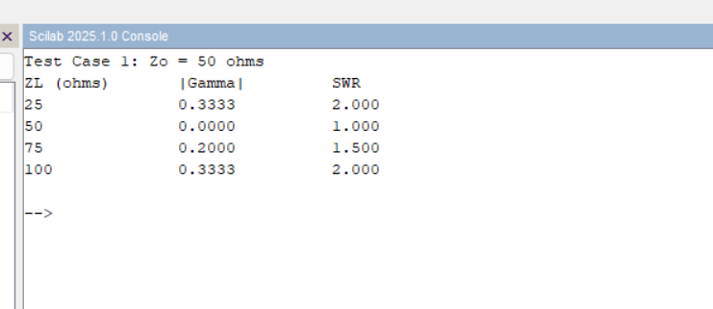
6. TEST CASE 2 – VARYING CHARACTERISTIC IMPEDANCE (Z0)
Fixed load impedance: ZL = 75 Ω. Vary characteristic impedance Z0 = 25, 50, 75 and 100 Ω. This follows the values specified in the AIM section.
S. No. | ZL (Ω) | Z0 (Ω) | |Γ| (theory) | SWR (simulation) | SWR (theory)
1 | 75 | 25 | 0.5000 | 3.000 | 3.000
2 | 75 | 50 | 0.2000 | 1.500 | 1.500
3 | 75 | 75 | 0.0000 | 1.000 | 1.000
4 | 75 | 100 | 0.1429 | 1.333 | 1.333

SCILAB PROGRAM – TEST CASE 2
clc;
clear;
close;
// Test Case 2: Fixed load impedance, varying characteristic impedance
ZL = 75;
Zo_values = [25 50 75 100];
printf("Test Case 2: ZL = %g ohms\\n", ZL);
printf("Zo (ohms)\\t|Gamma|\\t\\tSWR\\n");
for k = 1:length(Zo_values)
Zo = Zo_values(k);
Gamma = (ZL - Zo) / (ZL + Zo);
ampGamma = abs(Gamma);
SWR = (1 + ampGamma) / (1 - ampGamma);
printf("%g\\t\\t%.4f\\t\\t%.3f\\n", Zo, ampGamma, SWR);
end
OUTPUT SCREENSHOT SPACE – TEST CASE 2
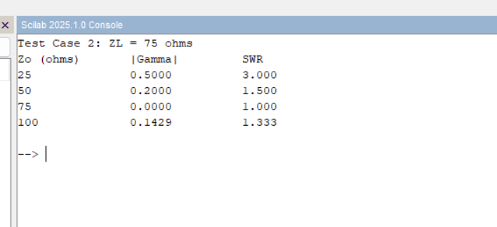
7. RESULTS
Test Case 1: For Z0 = 50 Ω, SWR values for ZL = 25, 50, 75 and 100 Ω are 2.000, 1.000, 1.500 and 2.000 respectively. The minimum SWR of 1 occurs when ZL = Z0 = 50 Ω.
Test Case 2: For ZL = 75 Ω, SWR values for Z0 = 25, 50, 75 and 100 Ω are 3.000, 1.500, 1.000 and 1.333 respectively. The minimum SWR of 1 occurs when Z0 = ZL = 75 Ω.
Note: The source prompt contains conflicting ranges in its descriptions. This report uses the explicit AIM values for each test case: ZL = 25, 50, 75, 100 Ω in Test Case 1, and Z0 = 25, 50, 75, 100 Ω with fixed ZL = 75 Ω in Test Case 2.

