CO1-AT2-CONCEPT MAPPING QUESTIONS

1. Design a machine learning system for health analysis to predict diseases such as heart disease or diabetes using patient data including age, blood pressure, glucose level, and lifestyle factors. Explain the choice of suitable algorithms and justify their selection. Describe the steps involved in data preprocessing, feature selection, and model training to ensure accurate and reliable predictions.

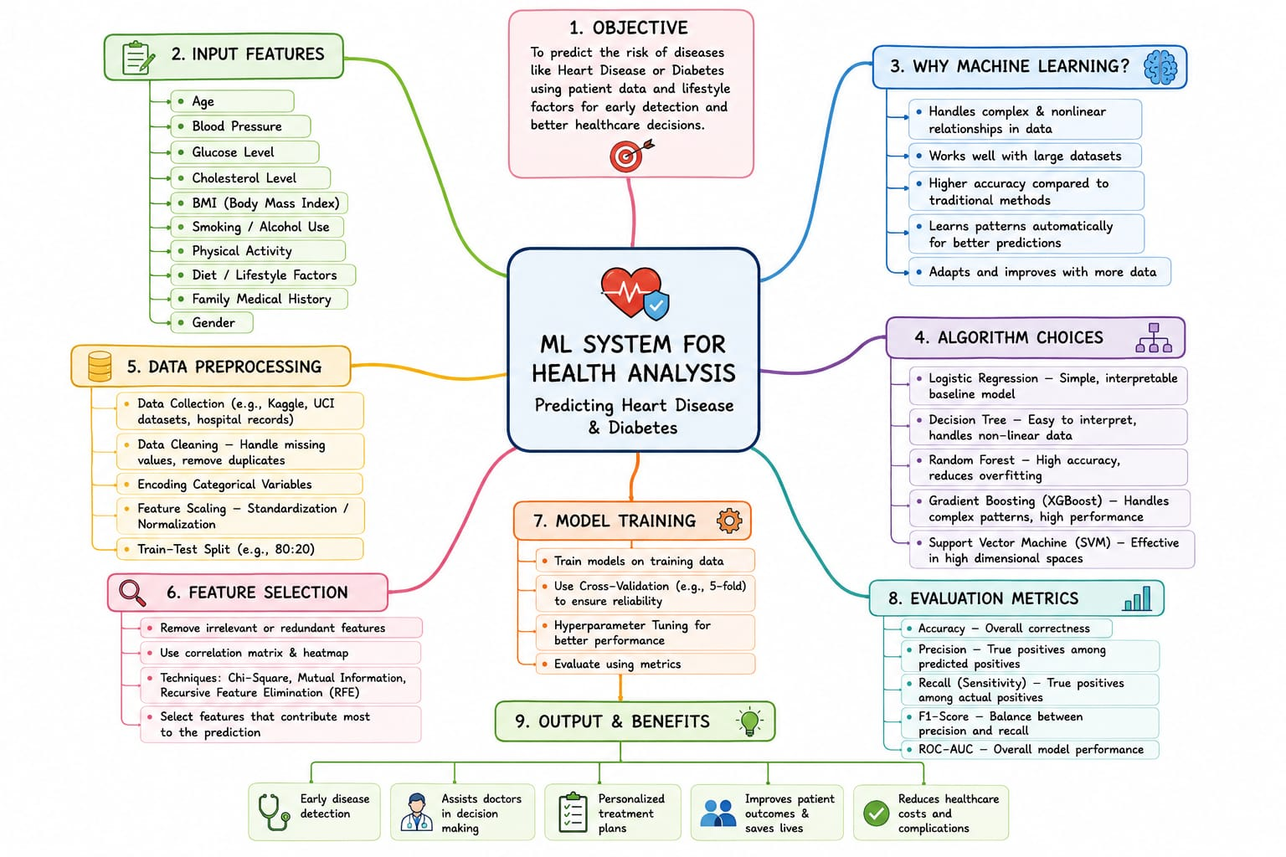

2. In the context of the Find-S algorithm, consider a dataset used to determine whether a loan should be approved based on attributes such as Employment Status, Salary Level, Credit Score, and Loan History. Apply the Find-S algorithm to derive the most specific hypothesis consistent with the positive examples.

