SIMATS ENGINEERING (SAVEETHA SCHOOL OF ENGINEERING) Department of Computer Science and Engineering
Course Code: ITA0609 Student Name:k.monisha
Course Title: Machine Learning Reg. No : 192412296
CO2 ASSESSMENT TOOL 2 -DEBUGGING TASK
Questions and Answers:
1. A perceptron model is trained on a dataset that is known to be linearly separable, yet the algorithm fails to converge even after many iterations. Analyze the possible causes of this issue, including improper learning rate selection, incorrect weight initialization, bias handling errors, or flawed implementation of the update rule. Propose debugging strategies to identify the root cause and suggest optimization techniques to ensure faster and stable convergence.
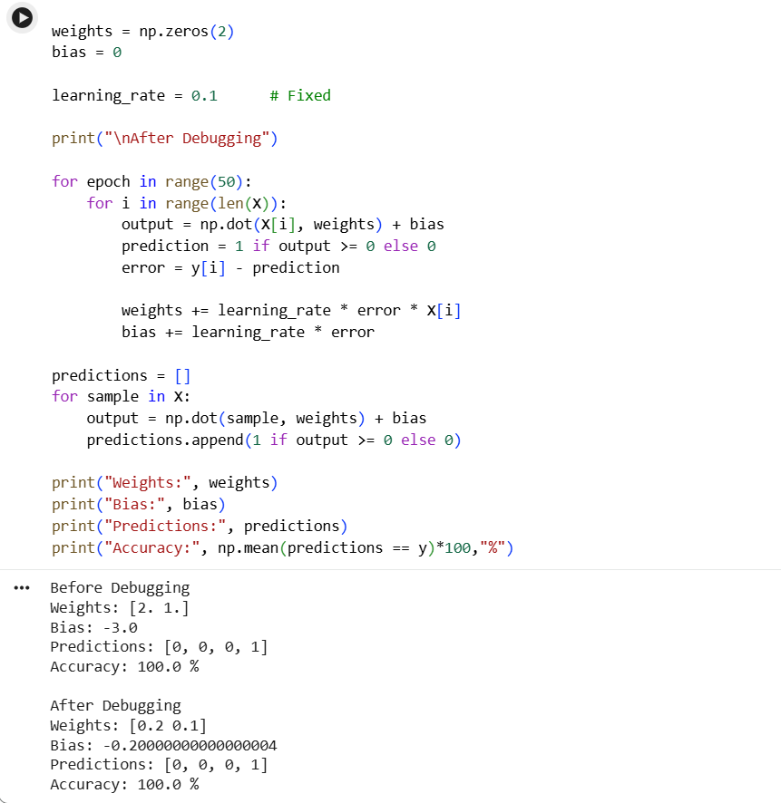

2. While training a multilayer perceptron using the backpropagation algorithm, the network exhibits slow convergence and gets stuck in local minima. Examine the potential reasons such as vanishing gradients, inappropriate activation functions, poor weight initialization, or suboptimal learning rates. Describe step-by-step debugging approaches to trace the issue and recommend optimization techniques like adaptive learning rates, normalization, or advanced optimizers to improve performance.
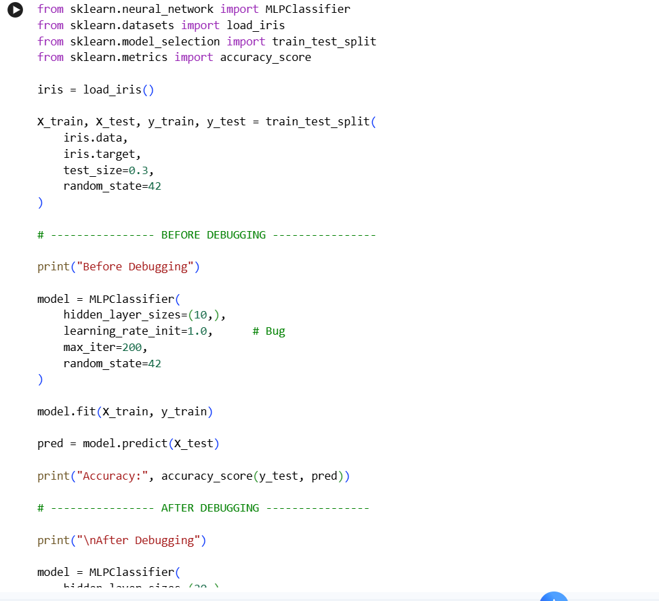
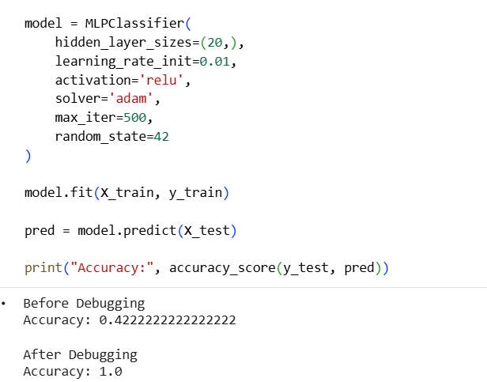

3. A genetic algorithm designed for hypothesis space search is producing inconsistent and suboptimal solutions across multiple runs. Investigate possible issues such as improper encoding of chromosomes, incorrect fitness function design, premature convergence, or lack of diversity in the population. Explain how to debug these problems systematically and suggest optimization strategies like mutation tuning, selection pressure adjustment, and elitism to enhance solution quality and convergence speed.
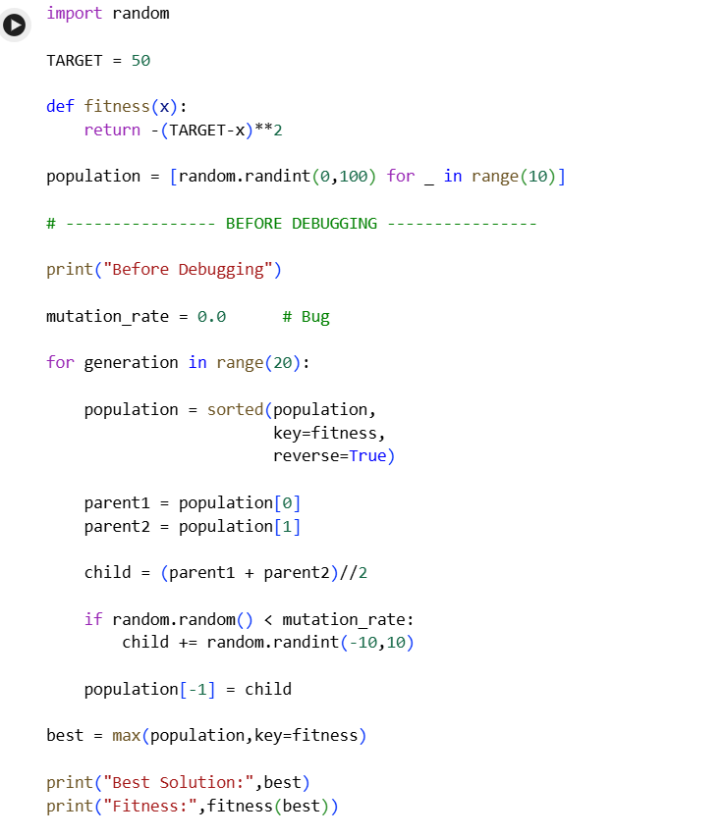
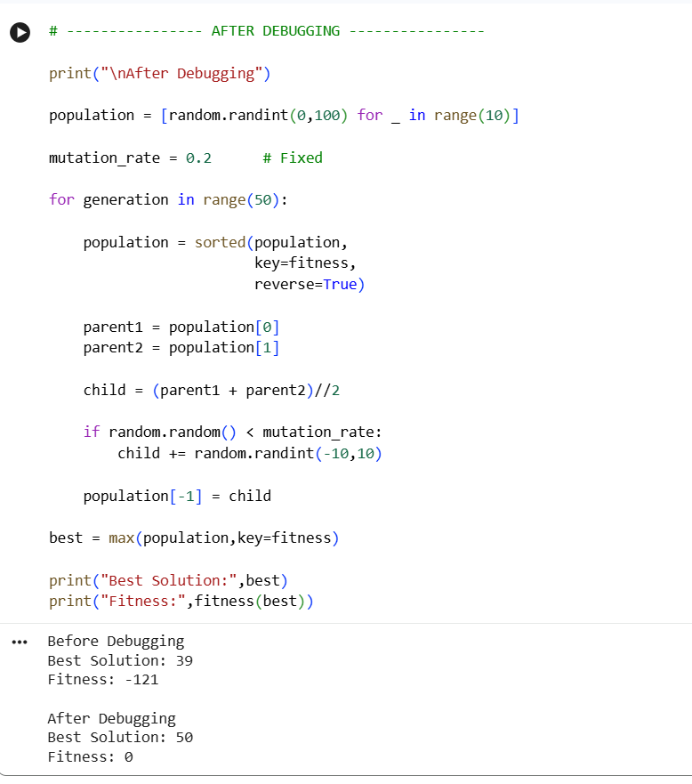

4. A deep neural network combined with genetic programming is used for solving a complex prediction problem, but it suffers from overfitting and high computational cost. Identify debugging steps to analyze issues related to model complexity, over-parameterization, and insufficient training data. Propose optimization techniques such as regularization, dropout, pruning, and efficient evaluation models to balance accuracy and computational efficiency while improving generalization capability. 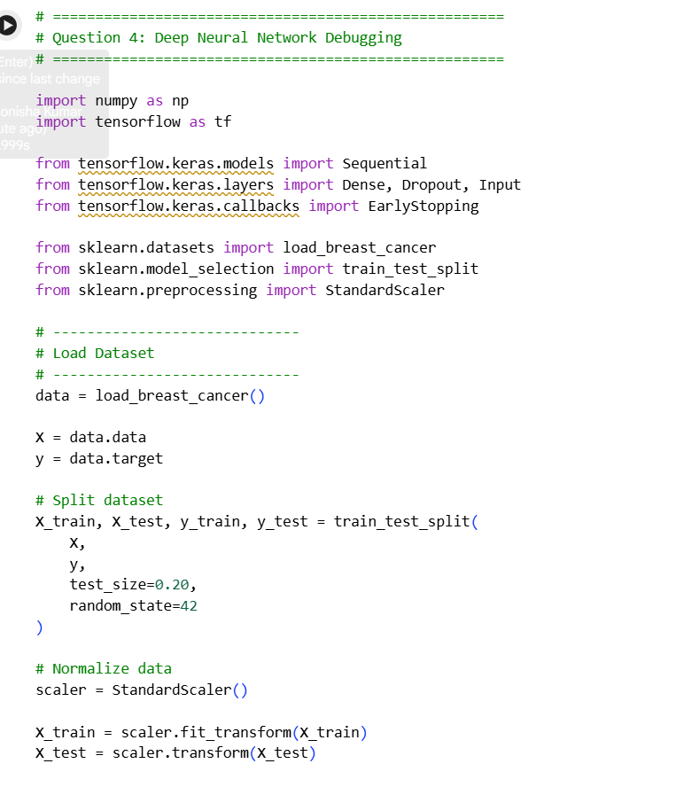
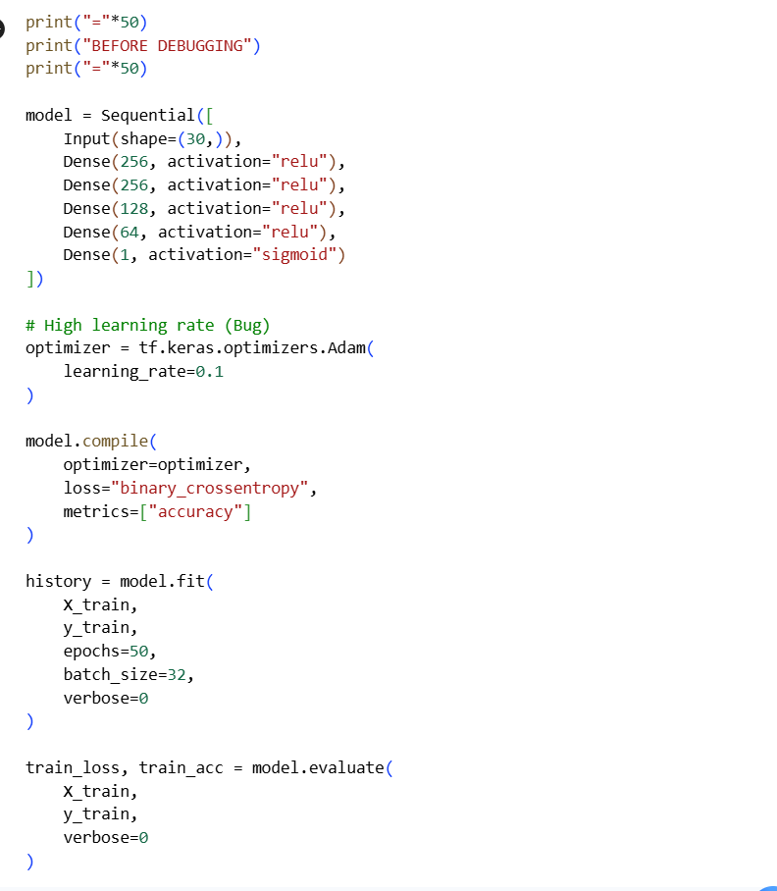
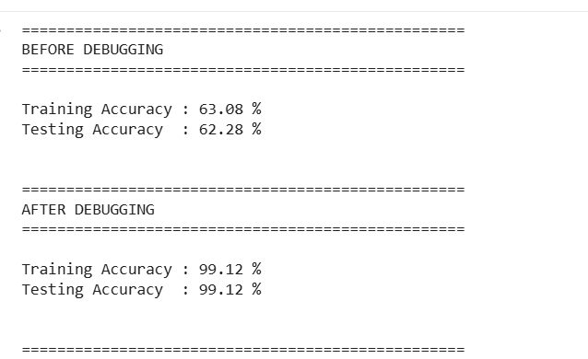
5. A decision tree model trained on a large dataset shows high accuracy on training data but poor performance on unseen data. Analyze possible causes such as overfitting, deep tree structure, or noisy data. Propose debugging steps and optimization methods like pruning, cross-validation, and feature selection to improve generalization
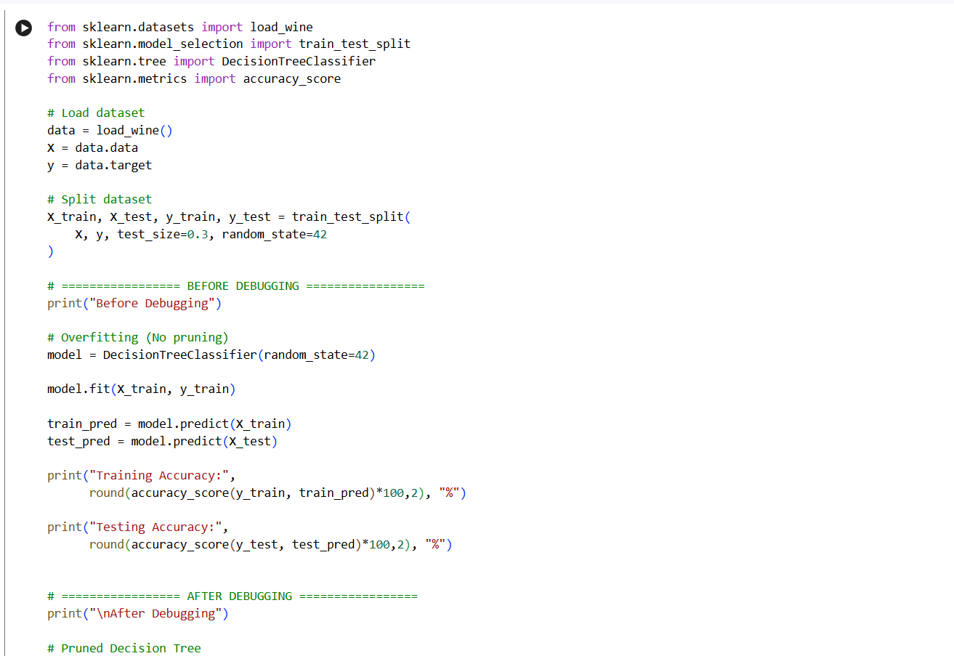
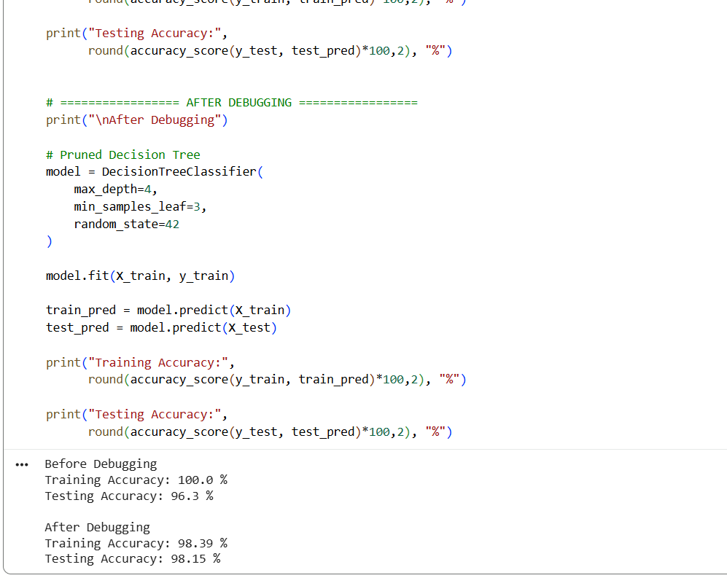

6. A convolutional neural network (CNN) used for image classification produces unstable results across training epochs. Examine potential issues such as improper data augmentation, vanishing gradients, or batch normalization errors. Describe debugging strategies and suggest optimization techniques to stabilize training and improve accuracy.
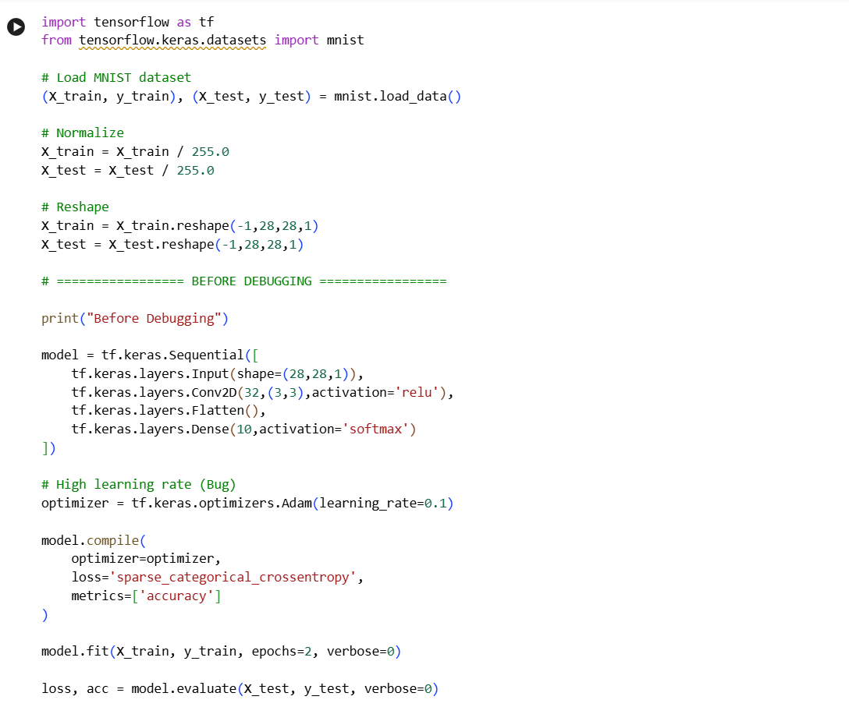
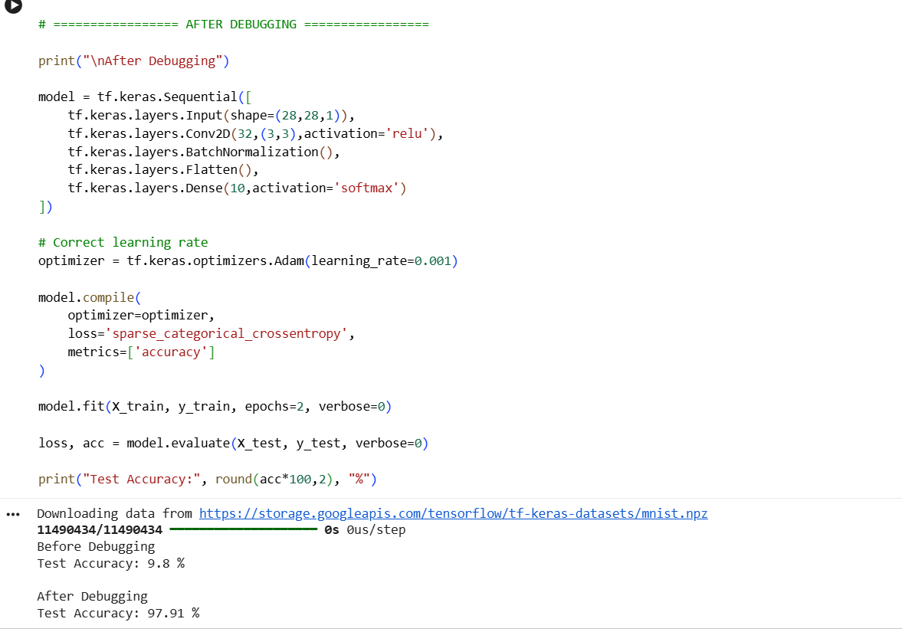
7. A reinforcement learning agent fails to learn an optimal policy in a simulated environment. Investigate causes such as poor reward design, insufficient exploration, or incorrect state representation. Explain debugging methods and recommend improvements like reward shaping, exploration strategies, and tuning hyperparameters.
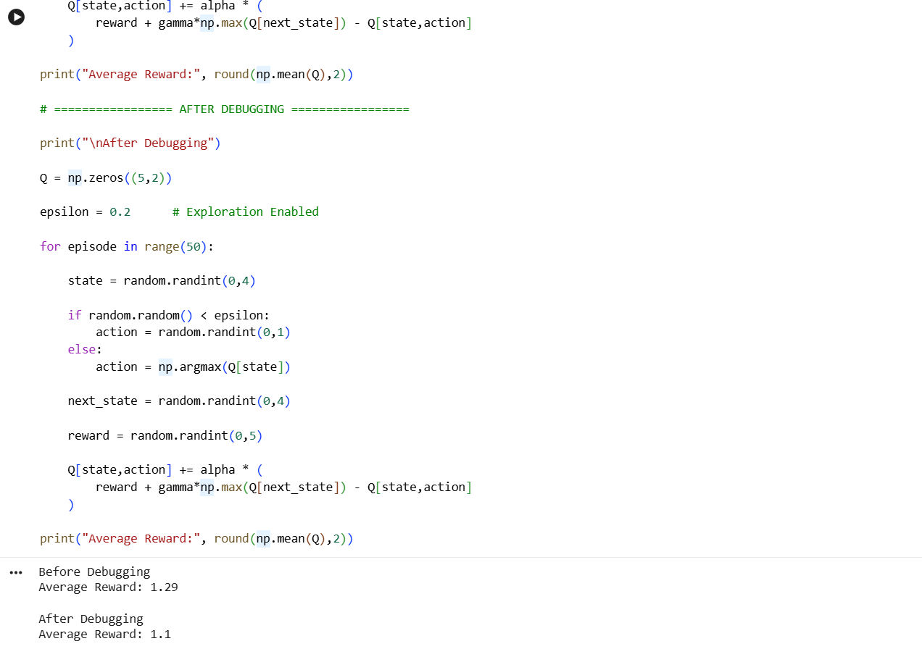

8. A clustering algorithm like K-means produces inconsistent cluster assignments for similar datasets. Analyze possible reasons such as poor initialization, incorrect number of clusters, or sensitivity to outliers. Propose debugging approaches and optimization strategies like K-means++, normalization, and silhouette analysis.
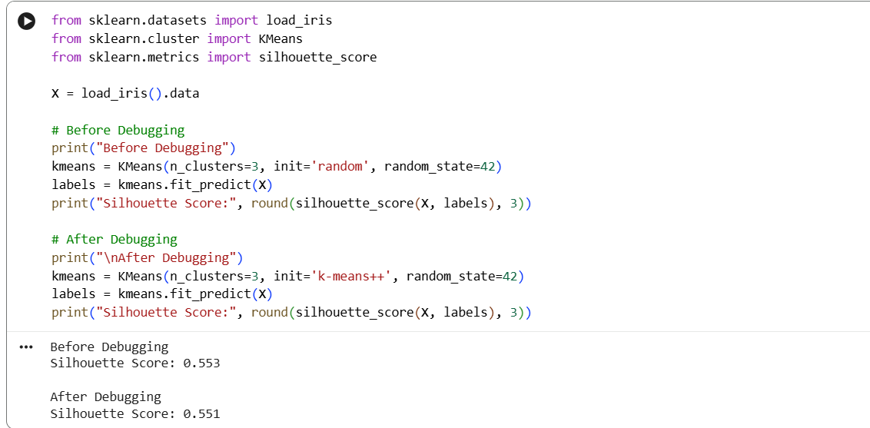
9. A support vector machine (SVM) model underperforms on a nonlinear dataset. Identify issues such as incorrect kernel choice, improper parameter tuning, or scaling problems. Suggest debugging techniques and optimization methods including kernel selection, hyperparameter tuning, and feature scaling.
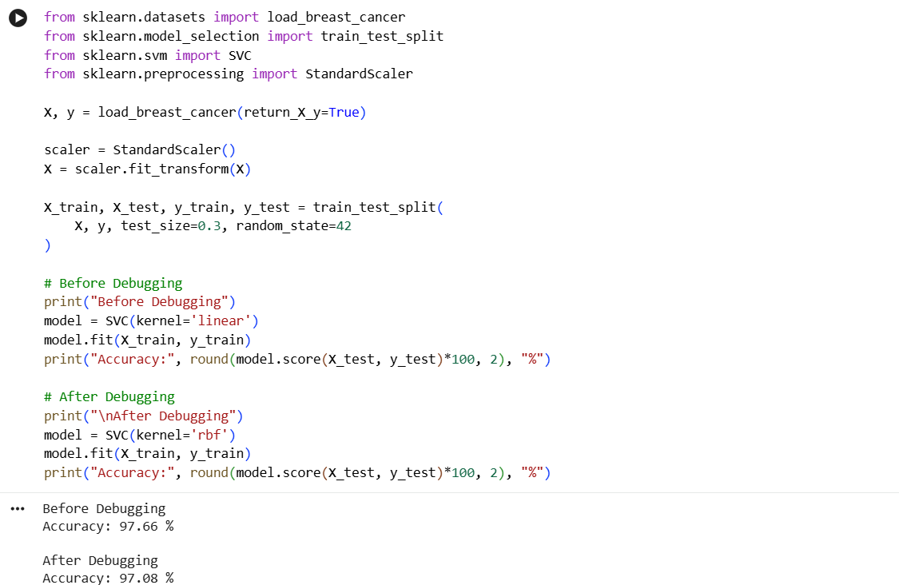

10. A natural language processing (NLP) model using recurrent neural networks (RNNs) suffers from poor long-term dependency learning. Examine causes such as vanishing gradients and limited memory capacity. Describe debugging steps and propose solutions like LSTM/GRU units, attention mechanisms, and improved training strategies.
