Exp. 3. Simulation of Energy States of Quantum Dot using NanoHub
T.Poojitha(192412318)
Slot-c ECA3102 NANO ELECTRONICS
OUTPUT
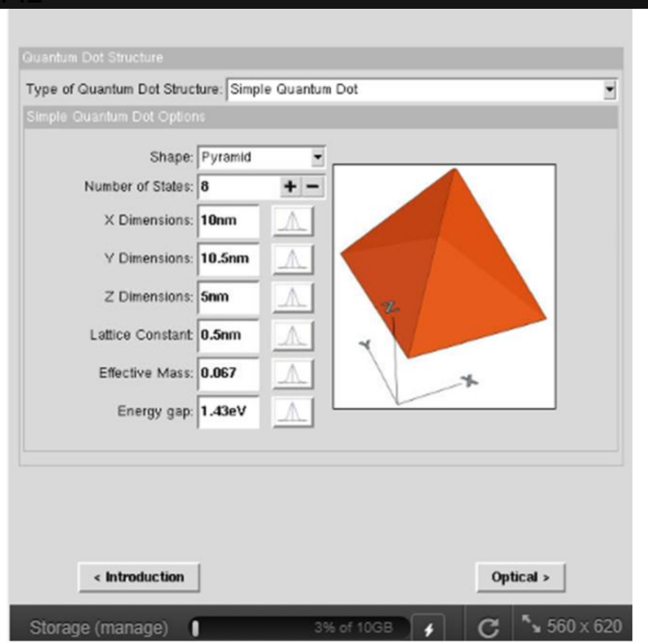
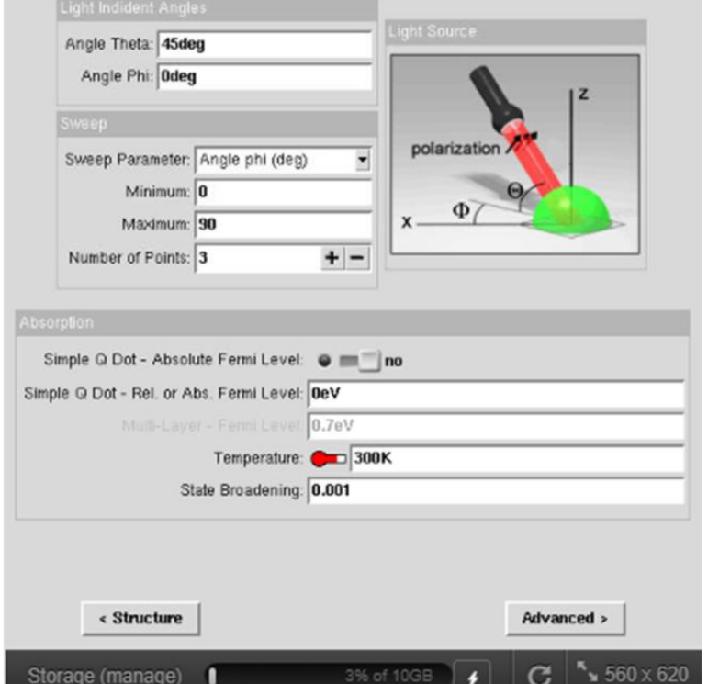
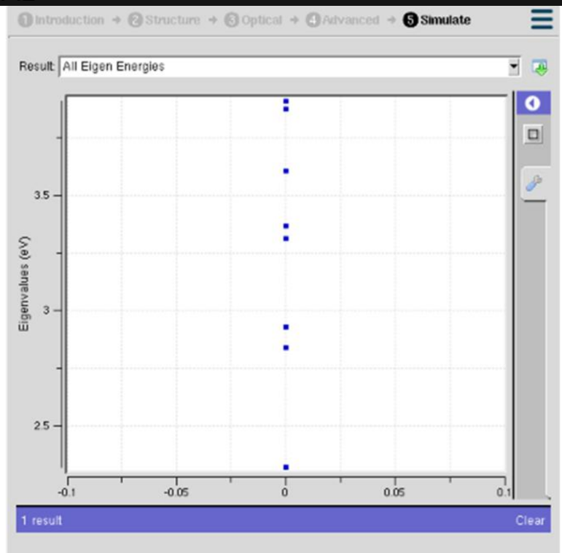
These figures show the complete quantum dot simulation process. First, a pyramid-shaped quantum dot is designed by defining its dimensions, material properties, and energy gap. Next, the optical simulation parameters, such as light incidence angle, temperature, and absorption settings, are configured. Finally, the simulation generates the eigen energy levels, showing the discrete energy states of the quantum dot caused by quantum confinement.

Case Study 1: Simulate the energy states of cylindrical quantum dots of X=15 nm, Y = 10.5nm
and Z = 8 nm.
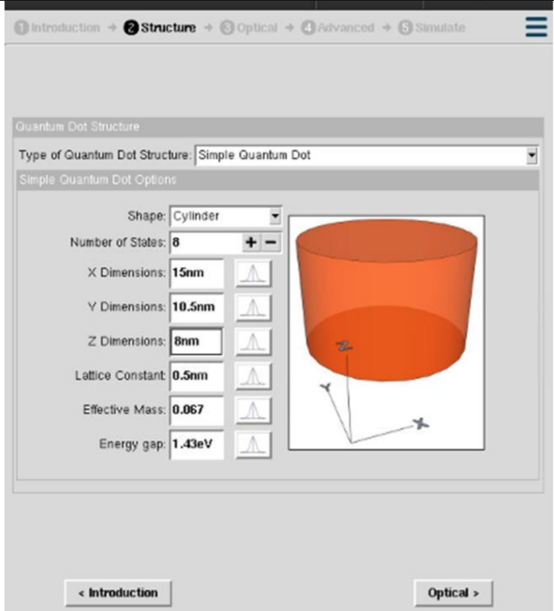
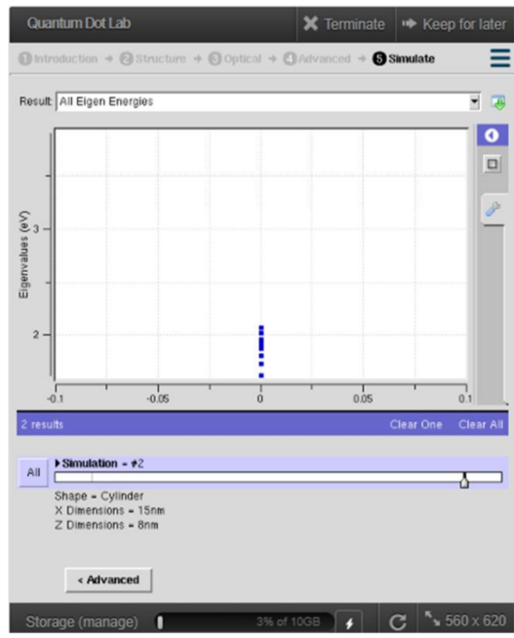
These figures show the simulation of a cylindrical quantum dot. The first image illustrates the quantum dot structure with its dimensions, material properties, and energy gap configured. The second image presents the eigen energy levels obtained from the simulation, showing the discrete energy states formed due to quantum confinement in the cylindrical quantum dot.

Case Study 2: Simulate the energy states of two layer cuboid quantum dots
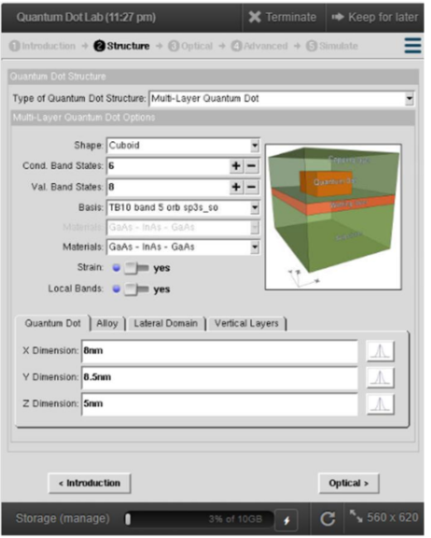
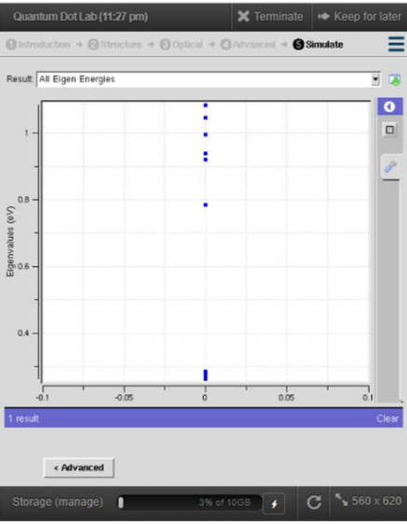
These figures show the simulation of a multi-layer cuboid quantum dot. The first image illustrates the quantum dot structure with multiple material layers, dimensions, and material properties configured. The second image presents the eigen energy levels obtained from the simulation, showing the discrete energy states formed due to quantum confinement in the multi-layer quantum dot.

